**Craig n Dave Video Links – Number Systems and Bases**

**[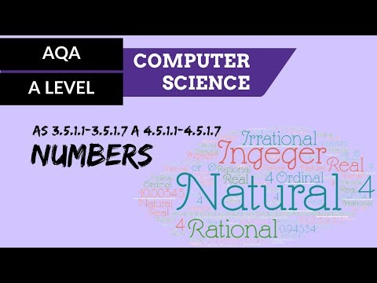](https://www.youtube.com/watch?v=PFSYJ7uOiOk)**

**[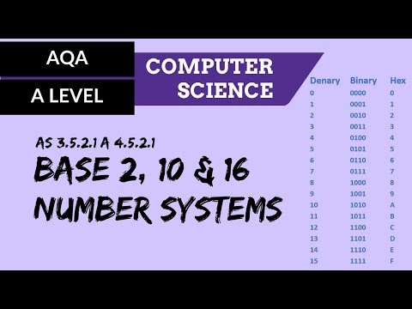](https://www.youtube.com/watch?v=HIRB99gDmB8)**

**[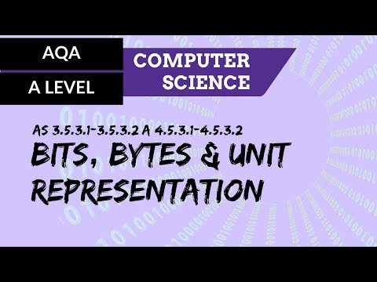](https://www.youtube.com/watch?v=9kzCoDFrMGE)**