**Craig & Dave Video Links – Binary**

[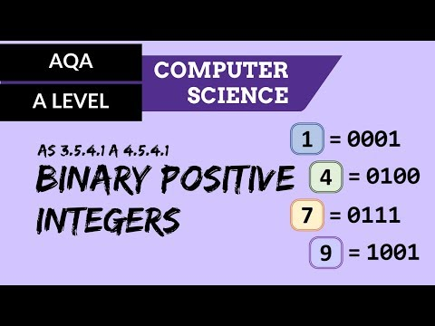](https://www.youtube.com/watch?v=y0QL02-bnhs)

[](https://www.youtube.com/watch?v=5-jez-dvY7Y)

[](https://www.youtube.com/watch?v=t15dhDG_WUA)

[](https://www.youtube.com/watch?v=vH7pQxWTTio)

[](https://www.youtube.com/watch?v=CglODZZm_Z4)[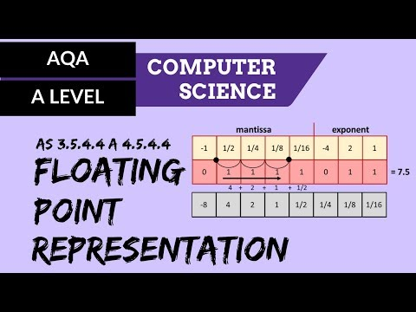](https://www.youtube.com/watch?v=dcIDAnfp8Dc)