# Worksheet 2 Role of an operating system Answers

1. One of the tasks of an operating system is **processor scheduling**.

One of the aims of a scheduling operation is to make sure that each process in a multiprocessing machine completes in as short a time as possible. Imagine there are four currently active processes:

**Process 1** involves a lot of calculations and has very little input or output

**Process 2** has very few calculations to perform, but spends a lot of time looking up information from disk

**Process 3** consists almost entirely of printing a very long word-processed document

**Process 4** involves a user typing a document into a word processor, with long pauses for thought in between typing

A currently executing process can be interrupted at any time.

One reason for an interrupt might be that a process has had its slice of processor time (a few milliseconds) and it is the turn of another to use the processor.

What other reason could there be for an interrupt?

An error condition like a program crashing, “file not found”, printer out of paper, job completed, hardware error

Which process above will you give the highest priority to? Why?

Generally one of the ways of maximising throughput is to keep all components of the computer system busy, so that a long queue does not develop for the printer, for example. So, high priority could be given to jobs that use the slowest peripherals.

There are various different scheduling algorithms, Round Robin being the simplest where each job gets the same amount of processor time in rotation, without any priority system. When the time slice is up, the job completes, or has to wait for an I/O operation to complete, the next job gets processor time.

(This is somewhat beyond the A Level requirements but is an interesting discussion!)

2. What is meant by virtual memory? Why is this necessary or desirable? What are the advantages and disadvantages of using virtual memory? Why is the use of virtual memory not so important as it was, say, 10 years ago?

Virtual memory is an area on disk that is used as RAM, if RAM is insufficient to hold all the data/instructions in a running process. The data is copied from RAM to disk while the next block of data or code is loaded in from virtual memory.

Advantage: It allows many processes to be running concurrently

Disadvantage: it takes time to keep copying data from disk to RAM and vice versa and noticeably slows down the computer.

Less common nowadays because RAM has become very inexpensive and computers have a lot more RAM than in the past.

3. What is the difference between multitasking and multiprocessing?

Multitasking means that several tasks are being performed in parallel. The CPU processes only one task at a time, but switches between processes so fast that it appears to be processing multiple processes at the same time.

Multiprocessing means that more than one processor is is being used. Different parts of a task may be distributed among processors in separate CPUs, or a CPU may have two or more processors (dual-core, quad-core).

The diagram below shows a computer using more than one CPU.

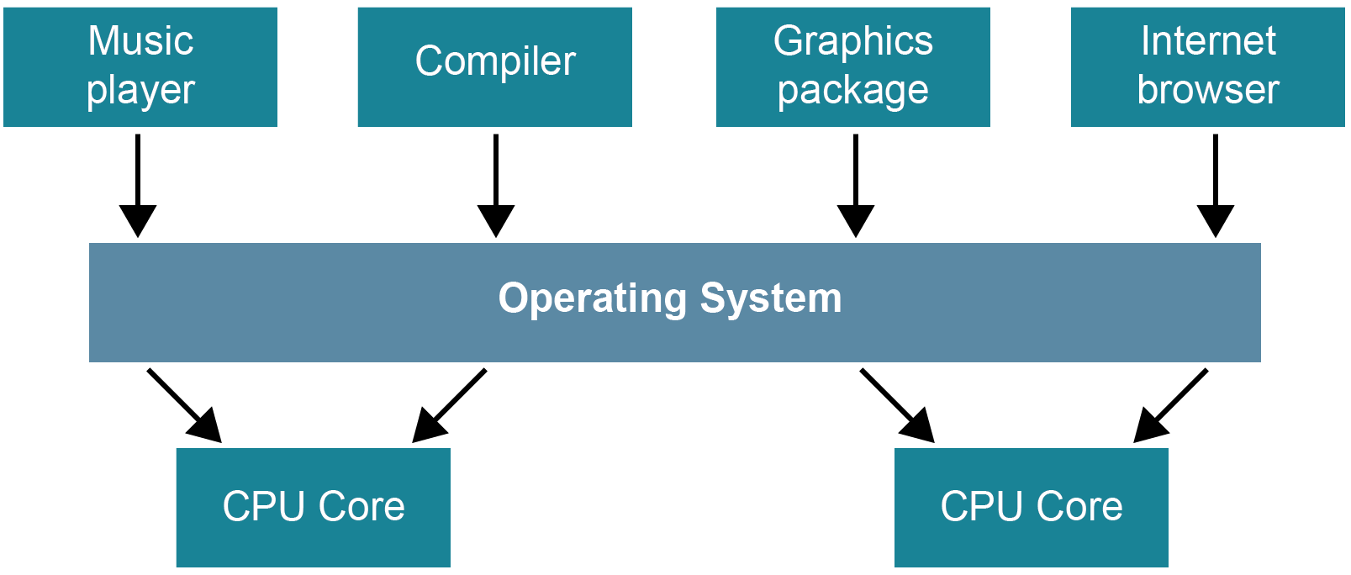

4. Backing store management is a task performed by the operating system. The OS maintains a **file allocation table** (**FAT**), which is a **table** that provides a map of the clusters (the basic units of logical storage on a hard disk) that a **file** has been stored in.

It updates this table whenever a file is created, added to, moved, copied, etc.

What other tasks are involved in backing store management?

Holding access rights and passwords and ensuring that no user can access or make changes to files for which they do not have the necessary permissions.