# Homework 1 Communication methods Answers

# Define the following terms:

(i) protocol A set of rules relating to communication between devices[1]

(ii) latency The time delay between the moment a communication starts and when it is received at its destination [1]

# What method of data transmission is being shown in the diagram below? [1]



Serial transmission

1. Serial data transmission has several advantages overall parallel data transmission. Discuss this statement. [3]

Reduction in the size and complexity (1) of physical connections, this leads to lower costs (1).

More reliable over much greater distances than parallel (1) as serial transmission does not

suffer from the problem of skew (1).

Lack of interference on serial lines due to single channel (1), unlike parallel which can suffer

from crosstalk (1).

1. State what type of data transmission is being show in the diagram below and explain this type of data transmission. [4]

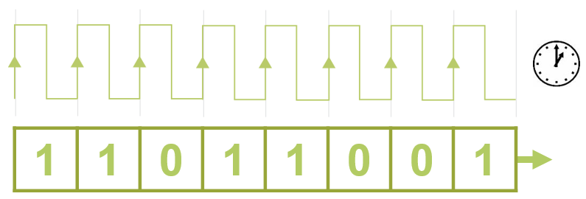

Synchronous (1)

Data is transferred at set/fixed intervals (1)...

...which are controlled/timed by a clock signal/pulse/internal heartbeat (1)

Internally within one computer the signal is controlled by the internal clock (1)

Across multiple devices a master clock takes control of the synchronisation (1)

Allows for constant and reliable transmission (1) such as that needed for real-time video (1)

5. A communications channel has a baud rate of 9600bps. A symbol consisting of 8 bits can be encoded at each signal change.

(a) What is the bit rate of the communications channel? 76,800bps [1]

(b) Is this a baseband or broadband mode of operation? Broadband

(c) Is the communications channel using serial or parallel transmission? Serial [1]

6. Jo is sitting in an airport trying to access the Internet on a computer terminal for public use. The connection is slow. Why might it be slower than accessing the Internet from his home computer? [2]

More people may be going through a single access point, sharing the connection speed

The connection may have less bandwidth

[Total 15 Marks]