Morse Code Decoding Tree

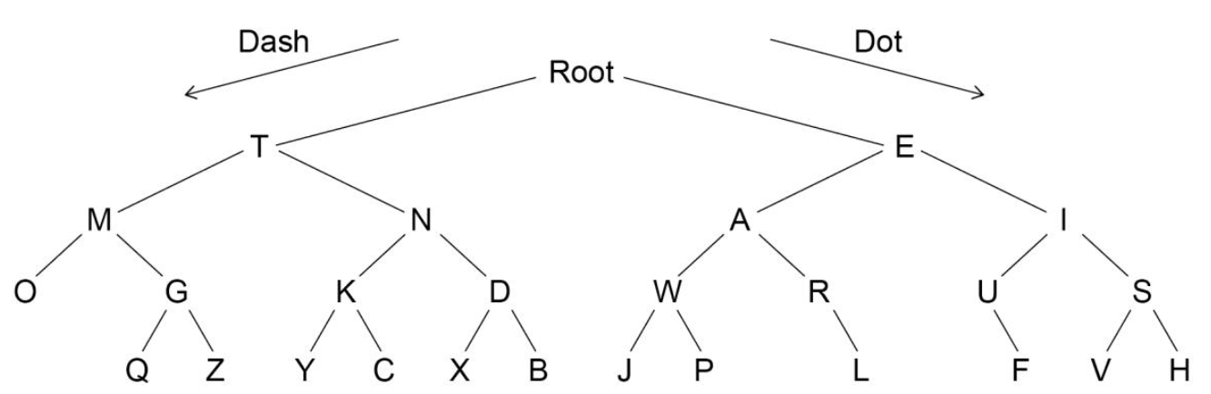

Rules

At the start of each letter (delimited by a space):

* Start at the root
* If a dash, follow the branch to the left
* If a dot, follow the branch to the right.

Until letter reached

Now decipher the following Morse code using the tree:

--. .. .-. .- ..-. ..-. .

-..- -.-- .-.. --- .--. …. --- -. .

-.-. --- -- .--. ..- - . .-.

…. . .-.. .-.. --- .-- --- .-. .-.. -..