# Worksheet 3 Introduction to SQL

**Task 1:**

Conditions in SQL are constructed from the following operators:

|  |  |  |  |
| --- | --- | --- | --- |
| **Symbol** | **Meaning** | **Example** | **Notes** |
| = | Equal to | CDTitle = “Autumn” | Different implementations use single or double quotes |
| > | Greater than | DatePublished > #01/01/2015# | The date is enclosed in quote marks or, in MS Access, # symbols. |
| < | Less than | DatePublished > #01/01/2015# |  |
| <> | Not equal to | RecordCompany <> “ABC” |  |
| >= | Greater than or equal to | DatePublished >= #01/01/2015# |  |
| <= | Less than or equal to | DatePublished <= #01/01/2015# |  |
| IN | Equal to a value within a set of values | RecordCompany IN (“ABC”, “DEF”) |  |
| LIKE | Similar to | CDTitle LIKE “S*” | Finds titles beginning with “S” (wildcard operator varies and can be %) |
| BETWEEN…AND | Within a range, including the two values which define the limits | DatePublished BETWEEN #01/01/2015# AND #31/12/2015# |  |
| IS NULL | Field does not contain a value | RecordCompany is NULL |  |
| AND | Both expressions must be true for the entire expression to be judged true | DatePublished > #01/01/2015# AND RecordCompany = “ABC” |  |
| OR | If either or both of the expressions are true, the entire expression is judged true. | RecordCompany = “ABC” OR RecordCompany = “DEF” | Equivalent to  RecordCompany IN (“ABC”, “DEF”) |
| NOT | Inverts truth | RecordCompany NOT IN (“ABC”, “DEF”) |  |

The questions in Task 1 all relate to **tblFilm**, shown below.

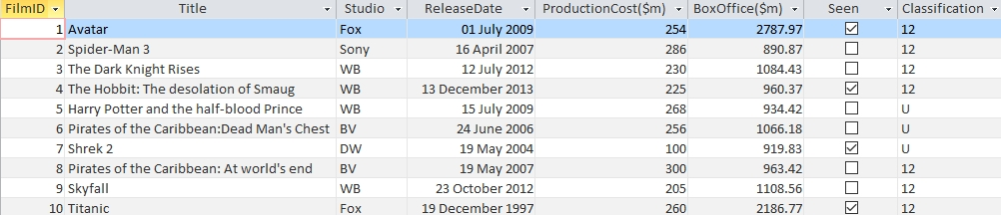

Write SQL statements to:

(a) select the Film ID, Title and Classification of all films with classification U or 12, which have been marked as “Seen”. The results should be ordered in Ascending order of Title

Which Film IDs will be selected, in what order?

(b) Select the Title and Studio of all films released in 2012 or 2013 which took more than £220m at the box office.

(c) Select all columns for films from Fox, Sony or WB and display in descending order of release date

# 

# Task 2

This is a practical task in which you make the queries in an MS Access database.

**Viewing the database table**

1. Load the database **Films3.accdb**. (This is in Access 2007 – Access 2013 compatible file format)

2. Double-click tblFilm to view the table tblFilm. It is the same table as the one displayed in Task 1.

3. Close the table by selecting the tab at the top of the table and selecting Close from the pop-up menu.

**Creating a query**

4. Select Create from the main menu, and then Query Design.

5. Add tblFilm in the Show Table window, and close the window.

6. In the Query window, double-click each field in turn to add them all to the query grid.

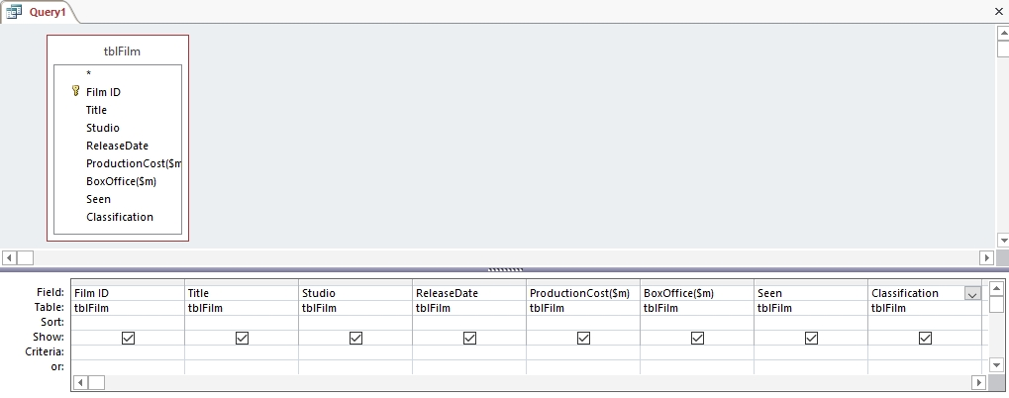

7. Righ-click the tab Query1 at the top of the query window and save the query as **Query1a**.

8. Look back at question 1a in Task 1. You are going to create this query. Deselect the fields that are not to be displayed, and write the conditions for Classification in the two rows “Criteria” and “or” , in the Classification column.

9. You will need to write the “Seen” criterion in both rows.

10. Click in the Sort row of the Title column and select Ascending.

11. Save the query again by pressing Ctrl-S.

12. Now run the query by clicking the Run icon, which looks like an exclamation mark (!)

Your results will be displayed. Are they what you expected?

**Viewing the SQL**

Access generates its own SQL. Click the View icon (on the left of the Run icon) and select SQL view.

The SQL displayed is a rather long-winded version of the SQL that you wrote yourself, but it does the same job.

**Task 3**

The database **RevisionSubs.accdb** has three tables:

**tblCustomer**

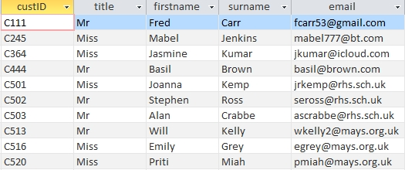

**tblSubscription**

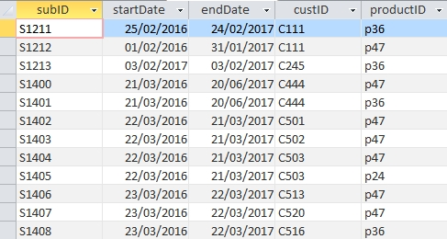

**tblProduct**

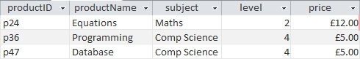

(a) List the IDs and surnames of all the customers who will be displayed by the following query:

SELECT tblCustomer.custID, firstname, surname, ProductName, tblProduct.productID

FROM tblCustomer, tblProduct, tblSubscription

WHERE tblCustomer.custID = tblSubscription.custID

AND tblProduct.productID = tblSubscription.productID

AND (productID = “p36” OR productID = “p24”)

(b) Write an SQL statement to display IDs and surnames all the customers at Mays School (identified by their email address) who have subscriptions for product p47.

**Practical task**

1. Open the database **RevisionSubs.accdb**.

2. Examine the tables, which are as shown in Task 2, and then close them.

3. Click Database Tools from the menu and select the Relationships icon.

4. Create the relationships as shown below. Remember to enforce referential integrity.

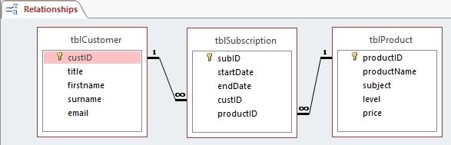

5. Now select Create from the menu, and click the Query Design icon. Add all three tables to the Query Design window.

6. Create the query in Question 2a using the Query By Example grid, as shown below.

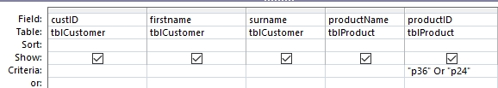

7. Run the query to check your answers to Question 2a.

8. Save the query as Query 2a.

9. View the query in SQL view. You will see the following:

SELECT tblCustomer.custID, tblCustomer.firstname, tblCustomer.surname, tblProduct.productName, tblProduct.productID

FROM tblProduct INNER JOIN (tblCustomer INNER JOIN tblSubscription ON tblCustomer.custID = tblSubscription.custID) ON tblProduct.productID = tblSubscription.productID

WHERE (((tblProduct.productID)="p36" Or (tblProduct.productID)="p24"))

10. Try creating a query by example corresponding to the query in Question 2b. (Use * not %)

What results are displayed?

