# Computing Theory Poster Revision

Produce a poster that is clear/bold and illuminating. About one of the following topics:

* Fetch-Decode-Execute Cycle
* Generations of Programming Languages (inc.. Assembly)
* Encryption
* Audio Data-Representation inc. Digital to analogue conversation
* Compression Techniques Mainly Lossless (maybe add lossy examples)
* Any Hardware device from the list
* Communication Methods
* Network topologies
* Wifi Theory (specifically CSMA/CA )(RTS/CTS)

A common misconception is that as posters are large, so a huge amount of information can be crammed onto them. This leads to confusing, busy and messy posters - this approach does not work.

The larger the poster, the less information can fit on, as the poster needs to be legible from a distance to attract people to it. For example, the text content of each of the "How thermals work" posters would fit onto a sheet of A5 paper, however, the text is large and clear as are the photographs and diagrams. The dark matter poster is a bit too light on content, but very striking.

I want you to create something that can go on the classroom wall and be seen from anywhere in the room. You should create an A4 Handout on the same topic that summarises all you need in a little more detail.

Showing an example of the theory is often a good starting point.

Here’s how the posters will be assessed.

|  |  |  |  |
| --- | --- | --- | --- |
|  | Pants | Good | Amazing |
| Accuracy | Some factual errors, Spilling mistakes etc.. | No Factual errors. No spelling/typo errors. But diagrams lack precision | Everything is perfect, with no ambiguity |
| Clarity | Words cannot be read from more than 1m away. confusing. | Content well organised. large titles, clear text from 3m. Diagrams/images aid understanding of the topic. | Very clear diagrams all with a clear purpose. well edited text. |
| Attraction | Little or no thought of how it will look! | Presentation has been considered, with layout, text, images well placed | The poster has a WOW factor. |
| Example | Chunky pens scrawled onto poster paper. Copied from book | Combination of computer produced and hand drawn work, from a number of sources | As for Good but done with greater flare ☺ |

It rarely works to create the poster entirely on the computer… The best approach is to create elements digitally.. print them off and mount on poster paper .. Although I won’t be dogmatic about how you create your posters.

Here are some examples of Posters:

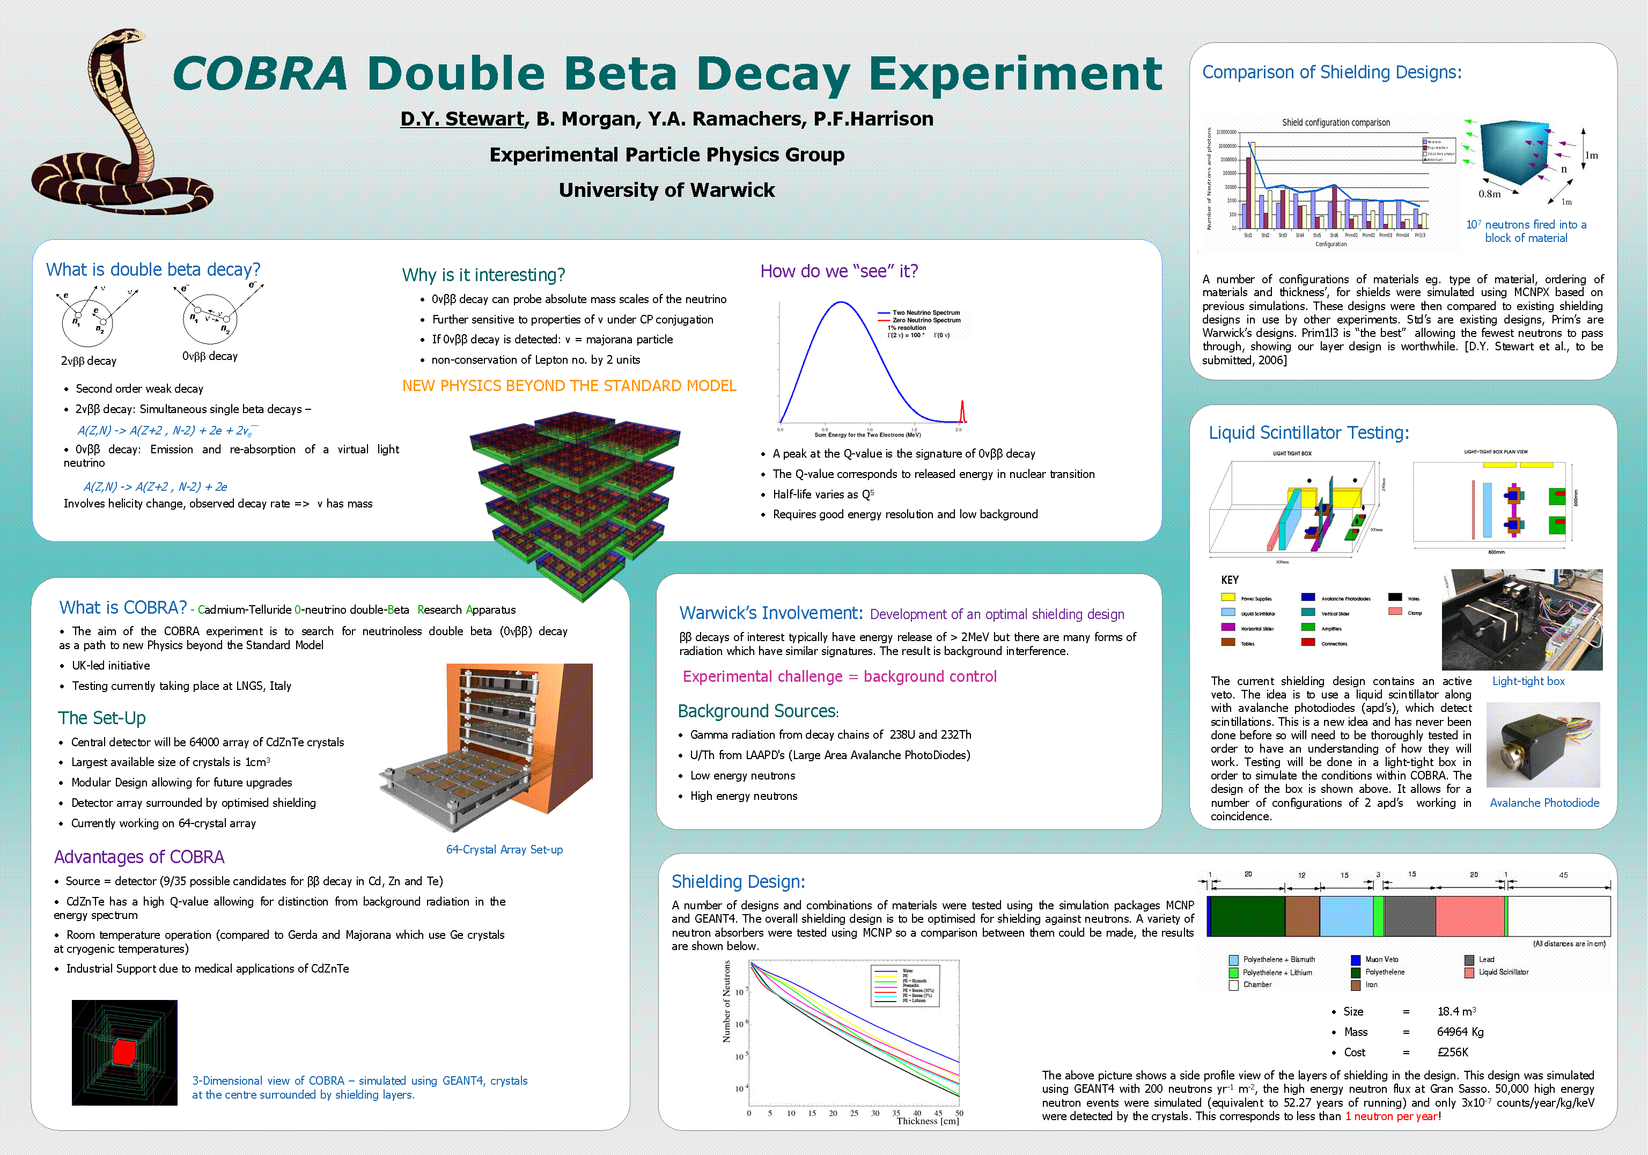 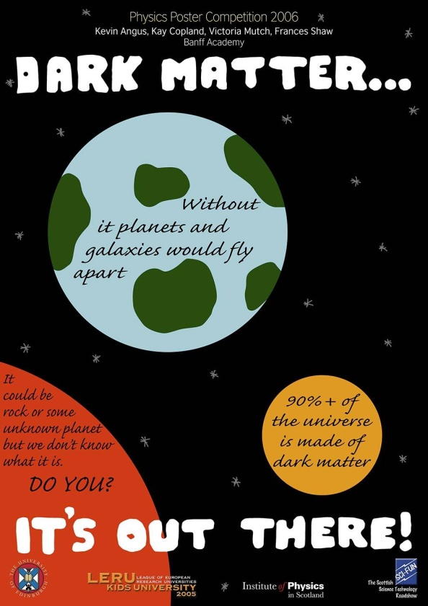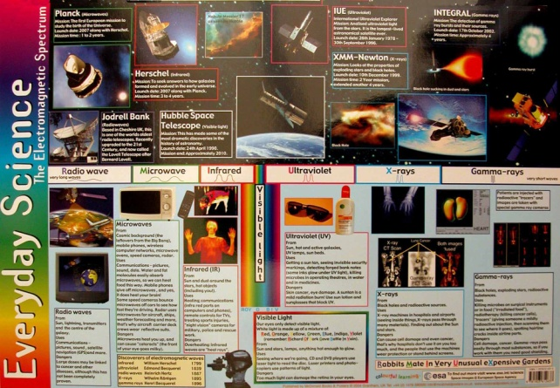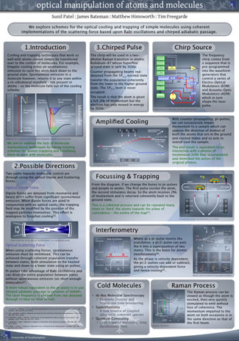 [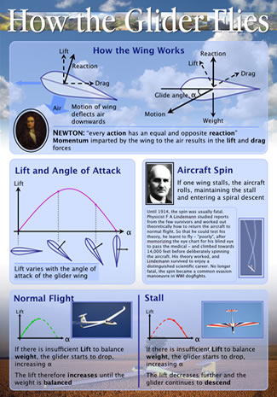](http://www.sunilpatel.co.uk/images/Posters/Physics%20of%20Flight%201.jpg) [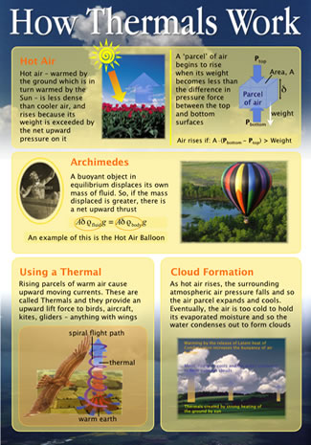](http://www.sunilpatel.co.uk/images/Posters/Physics%20of%20Flight%202.jpg)