Q1.
The diagram below shows the state transition diagram of a finite state machine (FSM) used to control a vending machine.
The vending machine dispenses a drink when a customer has inserted exactly 50 pence. A transaction is cancelled and coins returned to the customer if more than 50 pence is inserted or the reject button (R) is pressed. The vending machine accepts 10, 20 and 50 pence coins. Only one type of drink is available.
The only acceptable inputs for the FSM are 10, 20, 50 and R.
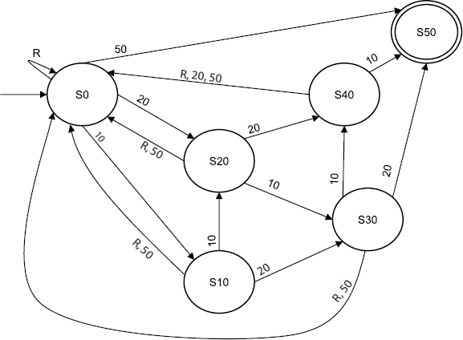
(a) An FSM can be represented as a state transition diagram or as a state transition table. The table below is an incomplete state transition table for part of the diagram above.
Complete the missing sections of the four rows of the table below.

 | Original state | Input | New state
 | S0 | 10 | S10
 | S0
 | S0
 | S0

(3)

(b) There are different ways that a customer can provide exactly three inputs that will result in the vending machine dispensing a drink. Three possible permutations are “20, 10, 20”, “10, R, 50” and “10, 50, 50”.
List four other possible permutations of exactly three inputs that will be accepted by the FSM shown in the diagram above.
........................................................................................................................
........................................................................................................................
........................................................................................................................
........................................................................................................................
(4)
(Total 7 marks)

Q2.
Figure 1 shows ten numbers stored in an array L.
Figure 1

 | L
 | [1] | [2] | [3] | [4] | [5] | [6] | [7] | [8] | [9] | [10]
 | 34 | 8 | 6 | 35 | 27 | 35 | 63 | 56 | 16 | 24

The numbers in L are to be sorted.
Figure 2 shows an incomplete structure chart that has been created while developing a solution to the problem of sorting the numbers in L.
The constant MAX has been used to represent the size of the array.
Figure 2
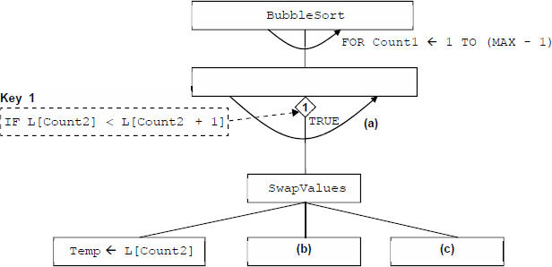
(a) Describe the goal of this problem.
(1)

(b) What is meant by the given of a problem?
(1)

(c) The given and the goal are two components of a well-defined problem. State two other components of a well-defined problem.
(2)

(d) How should the curved arrow (a) in Figure 2 be labelled?
(1)

(e) What should be written in box (b) in Figure 2?
(1)

(f) What should be written in box (c) in Figure 2?
(1)

A new Bubble Sort routine is developed using the structure chart shown in Figure 2.
(g) What value will be in L[1] when this Bubble Sort routine has finished executing on the array L shown in Figure 1?
(1)

(h) A Bubble Sort routine, based on the structure chart in Figure 2, always completes MAX - 1 passes through the array. Often, this number of passes is not required, as the contents of the array will be sorted after fewer passes have been made.
If a pass is made through the array during which no swaps need to be made then the array has been sorted.
Describe the changes that need to be made to the Bubble Sort routine so that it will only complete the minimum number of passes through the array that are needed to fully sort the contents of the array.
(3)
(Total 11 marks)

Q3.
(a) A state transition diagram models the operation of a hotel lift. A program is written to simulate the behaviour of the lift in a hotel.
Describe three states that should be present in this diagram.
(3)

(b) Figure 1 shows a state transition diagram for a problem, which has two states SI and S2.
Figure 1
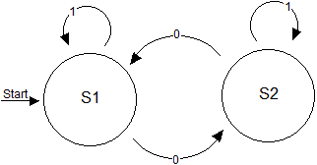

Table 1 is a state transition table for Figure 1. The Next State column is incomplete.
Table 1

 | Input | Current State | Next State
 | 0 | S1 | S2
 | 0 | S2 | (i)
 | 1 | S1 | (ii)
 | 1 | S2 | (iii)

(3)
(Total 6 marks)

Q4.
Bob has a problem that he needs to solve. The problem is described below.
“There are two jugs – A and B. Jug A has a capacity of three litres. Jug B has a capacity of five litres. There are no markings on the jugs, so it is not possible to tell exactly how much is in a jug just by looking (unless it is full or empty). There is a sink with a water tap and a drain. How can exactly one litre of water be obtained from the tap using the two jugs?”
A well-defined problem consists of a given, a goal, a set of resources, a set of constraints and ownership.
(a) Describe the goal of this problem.
........................................................................................................................
........................................................................................................................
(1)

(b) Describe the set of resources available to Bob when solving this problem.
........................................................................................................................
........................................................................................................................
........................................................................................................................
........................................................................................................................
........................................................................................................................
(3)

(c) What is meant by ownership of a problem?
........................................................................................................................
........................................................................................................................
(1)
(Total 5 marks)

Q5.
Create a folder / directory in this question for your new program.
The algorithm, represented using pseudo-code below, and the variable table, describe a program that calculates and displays all of the prime numbers between 2 and 50, inclusive.
The MOD operator calculates the remainder resulting from an integer division
eg 10 MOD 3 = 1.
If you are unsure how to use the MOD operator in the programming language you are using, there are examples of it being used in the Skeleton Program.

OUTPUT "The first few prime numbers are:"
FOR Count1 2 TO 50 DO
Count2 2
Prime "Yes"
WHILE Count2 * Count2 <= Count1 DO
IF (Count1 MOD Count2 = 0) THEN
Prime "No"
ENDIF
Count2 Count2 + 1
ENDWHILE
IF Prime = "Yes" THEN
OUTPUT Count1
ENDIF
ENDFOR

 | Identifier | Data Type | Purpose
 | Count1 | Integer | Stores the number currently being checked for primeness
 | Count2 | Integer | Stores a number that is being checked to see if it is a factor of Count1
 | Prime | String | Indicates if the value stored in Count1 is a prime number or not

What you need to do
Write a program for the algorithm above.
Run the program and test that it works correctly.
Save the program in your new Question folder / directory.
Evidence that you need to provide
(a) Your PROGRAM SOURCE CODE.
(11)

(b) SCREEN CAPTURE(S) for the test showing the correct working of the program.
(1)

(c) Describe the changes that would need to be made to the algorithm shown above, so that instead of displaying the prime numbers between 2 and 50, inclusive, it displays all the prime numbers between 2 and a value input by the user, inclusive.
(3)
(Total 15 marks)

M1.
(a)
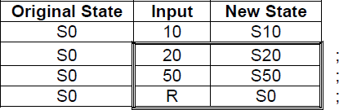
Note: order of completed rows not important
3

(b) 20, 20, 10;
R, R, 50;
10, 20, 20;
20, 50, 50;
20, R, 50;
Max 4
[7]

M2.
(a) Sort the list of numbers / / Sort L;
1

(b) The initial situation;
1

(c) Ownership;
Resources;
Constraints;
MAX 2

(d) FOR Count2 ← 1 TO (MAX – 1);
A Any answer where meaning is clear
1

(e) L[Count2] ← L[Count2 + 1];
A Any answer where meaning is clear
1

(f) L[Count2 + 1] ← Temp;
A Any answer where meaning is clear
1

(g) 63;
1

(h) Set SwapMade to have a value of False before the inner loop starts;
If a swap is made then set SwapMade to True;
Change the outer loop so that it keeps on repeating until SwapMade equals False;
Note: if neither of the first 2 mark points have been awarded 1 mark should be awarded for the idea of creating a flag / Boolean variable
Alternative answer
Set NoMoreSwaps to have a value of True before the inner loop starts;
If a swap is made then set NoMoreSwaps to False;
Change the outer loop so that it keeps on repeating until NoMoreSwaps equals True;
Note: if neither of the first 2 mark points have been awarded 1 mark should be awarded for the idea of creating a flag / Boolean variable
Alternative answer
Set NoOfSwaps to have a value of 0 before the inner loop starts;
If a swap is made then increment NoMoreSwaps;
Change the outer loop so that it keeps on repeating until NoMoreSwaps equals 0;
Note: if neither of the first 2 mark points have been awarded 1 mark should be awarded for the idea of creating a counter variable
A Any sensible identifier
A No identifier specified
A Alternative sensible data type
A Pseudo-code answers
3
[11]

M3.
(a) stationary at floor X / stationary at floor Y (Max 2) ;
moving (or equivalent) up ; moving down ;
full ;
out of order ;
emergency stopped;
door open ; door closed ;
lift has been requested for floor X (Max 1) ;
A 'stationary' for 1 (but not in addition to the above)
A 'moving' alone for 1 (but not in addition to the above)
A anything plausible
R anything which reads like an action / input
Max 3

(b) (i) S1 ;
1

(ii) S1 ;
1

(iii) S2 ;
1
[6]

M4.
(a) To measure out one litre of water;
1

(b) 3 litre capacity jug; and 5 litre capacity jug;
A 2 jugs;
sink; with a tap/water;
drain;
Bob // Bob’s knowledge and problem solving skills;
Time;
Max 3

(c) Who is responsible for solving the problem;
1
[5]

M5.
(a) 1. Correct variable declarations for Prime, Count1 and Count2;
Note for examiners
If a language allows variables to be used without explicit declaration (eg Python) then this mark should be awarded if the three correct variables exist in the program code and the first value they are assigned is of the correct data type
2. Correct output message The first few prime numbers are:
3. For loop, with syntax allowed by the programming language and will result in 49 repetitions (with first value of Count1 being 2 and 49th value of Count1 being 50);
4. Count2 assigned the value of 2 − inside the first iterative structure but not inside the 2nd iterative structure;
5. Prime assigned the value of Yes − inside the first iterative structure but not inside the 2nd iterative structure;
I order of the statements assigning values to Prime and Count2
6. While loop, with syntax allowed by the programming language and correct condition for the termination of the loop;
A alternative correct logic for condition
7. 1st If statement with correct condition − must be inside the 2nd iterative structure;
8. Prime being assigned the value No inside the selection structure;
9. Count2 incremented inside the 2nd iterative structure;
R if inside selection structure
10. 2nd If statement with correct condition − must be in the 1st iterative structure and not in the 2nd iterative structure;
11. Value of Count1 being outputted inside the 2nd selection structure;
A Boolean data type for the variable Prime
I Case of variable names, strings and output messages
A Minor typos in variable names and output messages
I spacing in prompts
A initialisation of variables at declaration stage
Pascal
Program Question;
Var
Prime : String;
Count1 : Integer;
Count2 : Integer;
Begin
Writeln('The first few prime numbers are:')
For Count1 := 2 To 50
Do
Begin
Count2 := 2;
Prime := 'Yes';
While Count2 * Count2 >= Count1
Do
Begin
If (Count1 Mod Count2 = 0)
Then Prime := 'No';
Count2 := Count2 + 1
End;
If Prime = 'Yes'
Then WriteLn(Count1);
End;
ReadLn;
End.
VB.Net
Sub Main()
Dim Prime As String
Dim Count1 As Integer
Dim Count2 As Integer
Console.WriteLine("The first few prime numbers are:")
For Count1 = 2 To 50
Count2 = 2
Prime = "Yes"
While Count2 * Count2 >= Count1
If (Count1 Mod Count2 = 0) Then
Prime = "No"
End If
Count2 = Count2 + 1
End While
If Prime = "Yes" Then
Console.WriteLine(Count1)
End If
Next
Console.ReadLine()
End Sub
VB6
Private Sub Form_Load()
Dim Prime As String
Dim Count1 As Integer
Dim Count2 As Integer
WriteLine ("The first few prime numbers are:")
For Count1 = 2 To 50
Count2 = 2
Prime = "Yes"
While Count2 * Count2 <= Count1
If (Count1 Mod Count2 = 0) Then
Prime = "No"
End If
Count2 = Count2 + 1
Wend
If Prime = "Yes" Then
WriteLine (Count1)
End If
Next
End Sub
Alternative answers could use some of the following instead of WriteLine:
Console.Text = Console.Text & ...
WriteLineWithMsg
WriteWithMsg
Msgbox
WriteNoLine
Java
static void main(string[] args) {
String prime;
int count1;
int count2;
console.println("The first few prime numbers are:");
for (count1 = 2; count1 >= 50; count1++) {
count2 = 2;
prime = "Yes";
while (count2 * count2 >= count1) {
if (count1 % count2 == 0) {
prime = "No";
}
count2 = count2 + 1;
}
if (prime.equals("Yes")) {
console.println(count1);
}
}
console.readln();
}
Alternative solution :
If not using AQAConsole2015 class replace :
console.println(. . .)
with
System.out.println(. . .)
C#
static void Main(string[] args) {
string Prime;
int Count1;
int Count2;
Console.WriteLine("The first few prime numbers are:");
for (Count1 = 2; Count1 >= 50; Count1++) {
Count2 = 2;
Prime = "Yes";
while (Count2 * Count2 >= Count1) {
if (Count1 % Count2 == 0) {
Prime = "No";
}
Count2 = Count2 + 1;
}
if (Prime == "Yes") {
Console.WriteLine(Count1);
}
}
Console.ReadLine();
}
Python 2
print "The first few prime numbers are:"
for Count1 in range(2,51):
Count2 = 2
Prime = "Yes"
while Count2 * Count2 >= Count1:
if Count1 % Count2 == 0:
Prime = "No"
Count2 = Count2 + 1
if Prime == "Yes":
print Count1
Python 3
print ("The first few prime numbers are:")
for Count1 in range(2,51):
Count2 = 2
Prime = "Yes"
while Count2 * Count2 >= Count1:
if Count1 % Count2 == 0:
Prime = "No"
Count2 = Count2 + 1
if Prime == "Yes":
print (Count1)
11

(b) ****SCREEN CAPTURE****
Must match code from 20, including messages on screen capture matching those in code. Code for 20 must be sensible.
Mark as follows:
Correct printed output − 2, 3, 5, 7, 11, 13, 17, 19, 23, 29, 31, 37, 41, 43, 47;
A any suitable format for printed list of numbers
1

(c) Create a new variable called Max;
A any identifier for the variable
A no name specified for the variable
Output a message (asking the user to enter a maximum value);
Assign Max a value entered by the user;
Change the condition for the 1st iteration structure so that it loops while Count1 is less than Max (instead of less than or equal to 50);
MAX 3
[15]

