**Card Predict Code Mock 2014 Mark Scheme**

**Question 1**

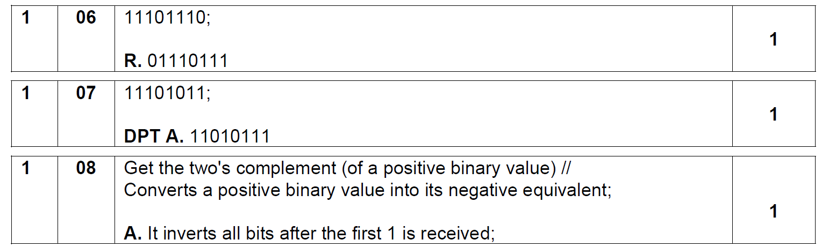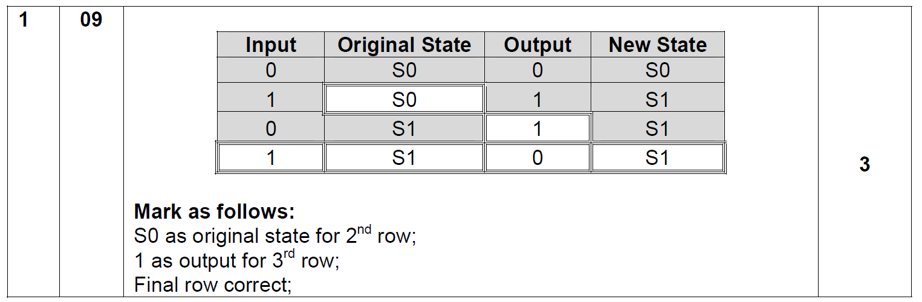

**Question 2**

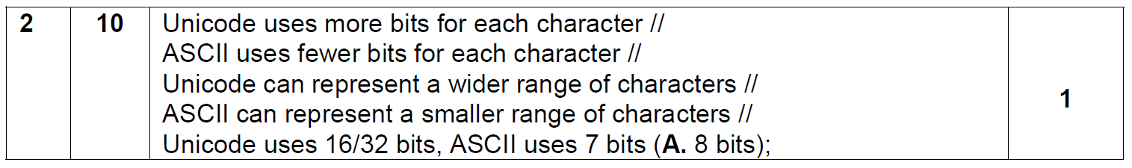

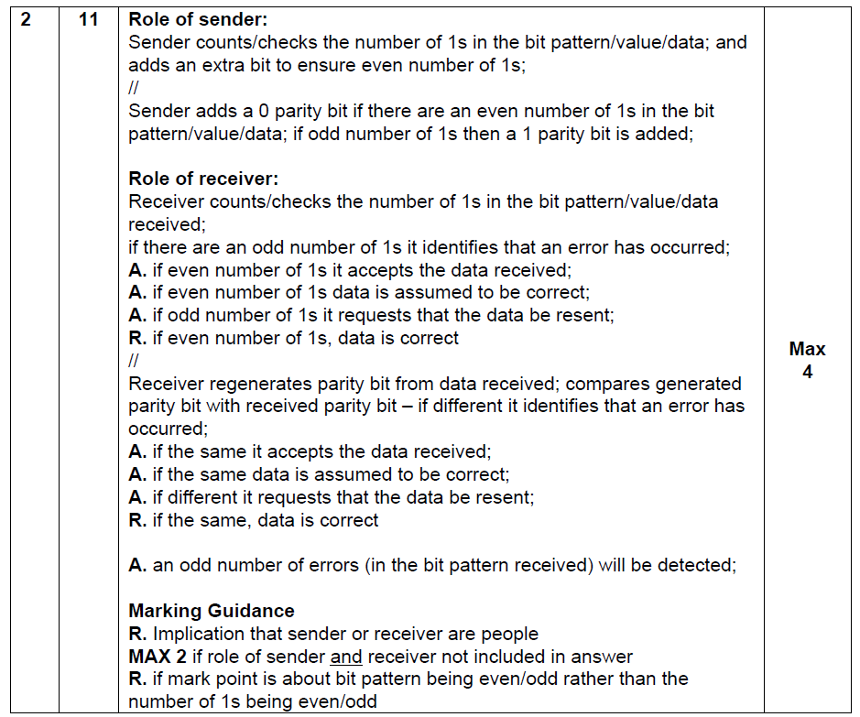

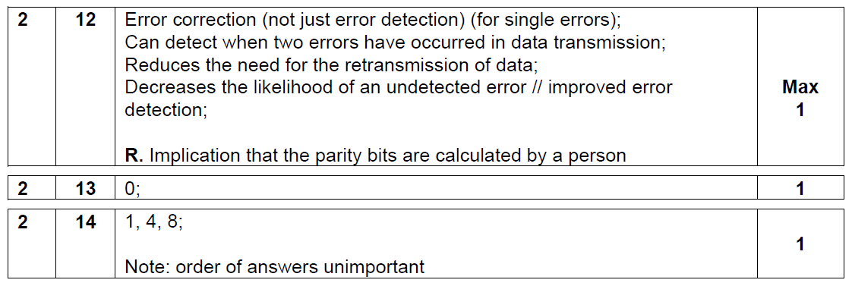

**Question 3**

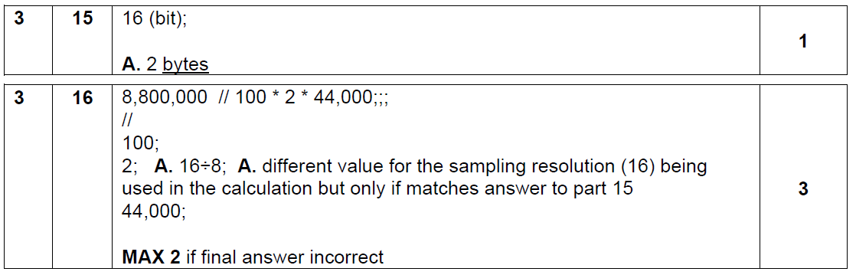

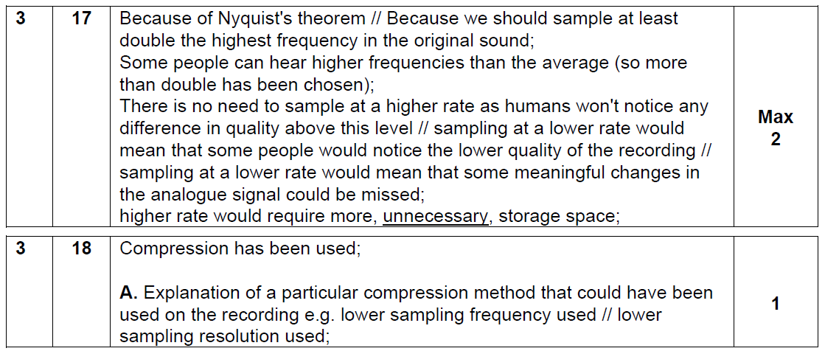

**Question 4**

|  |  |
| --- | --- |
| Sub Main()  Dim CurrentGuess As Char  Dim CurrentFlip As Char  Dim NumberOfCorrectGuesses As Integer  Const NumberOfFlips As Integer = 5  Dim FlipSequnce As String = "XHTHTT"  Do  Console.WriteLine("Plaese Guess Heads (H) or Tails (T)")  CurrentGuess = Console.ReadLine  Console.WriteLine("Coin Fliping....")  CurrentFlip = FlipSequnce(NumberOfCorrectGuesses)  Console.WriteLine("The coin landed " & CurrentFlip)  If CurrentGuess = CurrentFlip Then  Console.WriteLine("welldone. Lets flip again.")  If NumberOfCorrectGuesses = NumberOfFlips Then  Console.WriteLine("Congratuations You completed the sequence. Game Over")  End If  NumberOfCorrectGuesses = NumberOfCorrectGuesses + 1  Else  Console.WriteLine("sorry you guessed incorrectly. GAME OVER")  End If  Loop Until CurrentFlip <> CurrentGuess Or NumberOfCorrectGuesses = NumberOfFlips  Console.WriteLine("you guessed " & NumberOfCorrectGuesses & "flips correctly")  Console.ReadLine()  End Sub | 3 marks for correct declaration of all variables with initialisation.  -1 for each error down to 0  2 Marks for correct writeline statements A typos. -1 for each missed  2 marks for nested if’s  2 marks for loop with correct logic |

20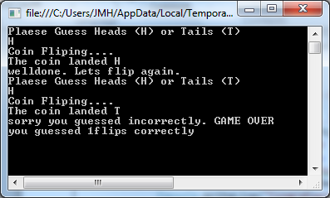 21 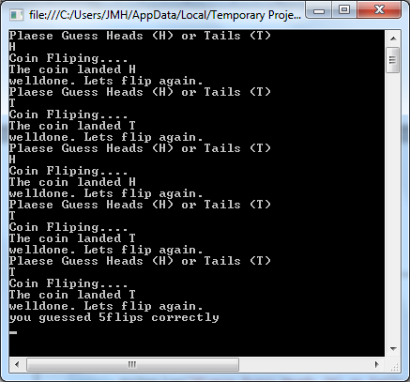

3(MARKS)

**Question 5**

25 NoOfRecentScores (1 mark)

26 Choice, PlayerName (may be others?) (1 mark)

27 IsNextCardHigher (1 mark)

28 Name and Score (need both for mark) (1 mark)

29 2 (1 mark)

30 0 (1 mark)

31 Higher (1 mark)

32 (c) and (d) (must have both and no others) (1 mark)

33 Because the scope; of the two variables is different; //

Because they are both local variables; in different subroutines; (2 marks)

(Total 10 marks)

**Question 6**

Function IsNextCardHigher(ByVal LastCard As TCard, ByVal NextCard As TCard) As Boolean

Dim Higher As Boolean

Higher = False

If NextCard.Rank > LastCard.Rank Then

Higher = True

ElseIf NextCard.Rank = LastCard.Rank And NextCard.Suit > LastCard.Suit Then

Higher = True

End If

Return Higher

End Function

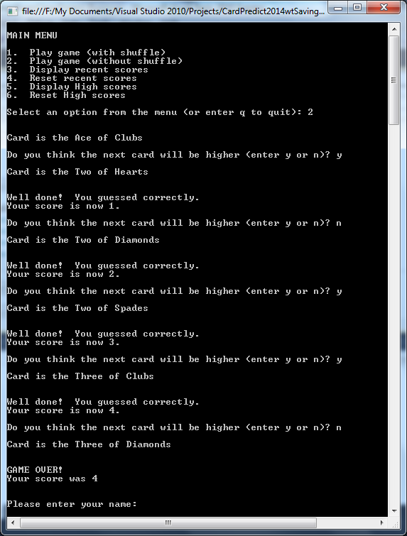

**Option 2**

**ynyyn entered**

**score of 4 reached**

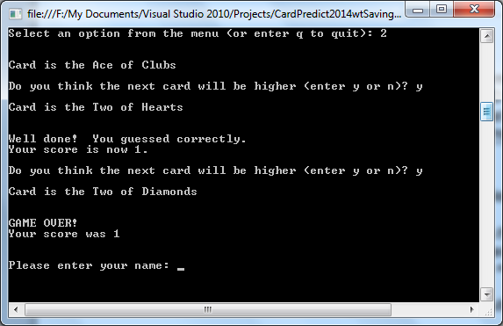

**YY enterd with score of 1**

**Question 7**

Sub UpdateRecentScores(ByRef RecentScores() As TRecentScore, ByVal Score As Integer)

Dim PlayerName As String

Dim Count, highscorePosition As Integer

Dim IsHighScore As Bo olean

PlayerName = GetPlayerName()

IsHighScore = False

Count = 1

While Not IsHighScore And Count <= NoOfRecentScores

If RecentScores(Count).Score < Score Then

IsHighScore = True

highscorePosition = Count

Else

Count = Count + 1

End If

End While

If IsHighScore Then

For Count = NoOfRecentScores - 1 To highscorePosition Step -1

RecentScores(Count - 1) = RecentScores(Count)

Next

Count = NoOfRecentScores

End If

RecentScores(highscorePosition).Name = PlayerName

RecentScores(highscorePosition).Score = Score

End Sub

Correctly Identifying a high score(3 Marks)  
Placing High score in correct place ( 4Marks)  
Moving other scores correctly (4 marks)   
Working procedure (3 Marks)

Credit recent score untouched with attempt at a sort.

Award 1 marks for testing if a sound display of the described tests are shown, regardless of algorithm. If test are in order for 4 games 2 marks. +1Mark for fifth score working shown