**Capture the Sarrum Code Mock 2015 Mark Scheme**

**Question 1**

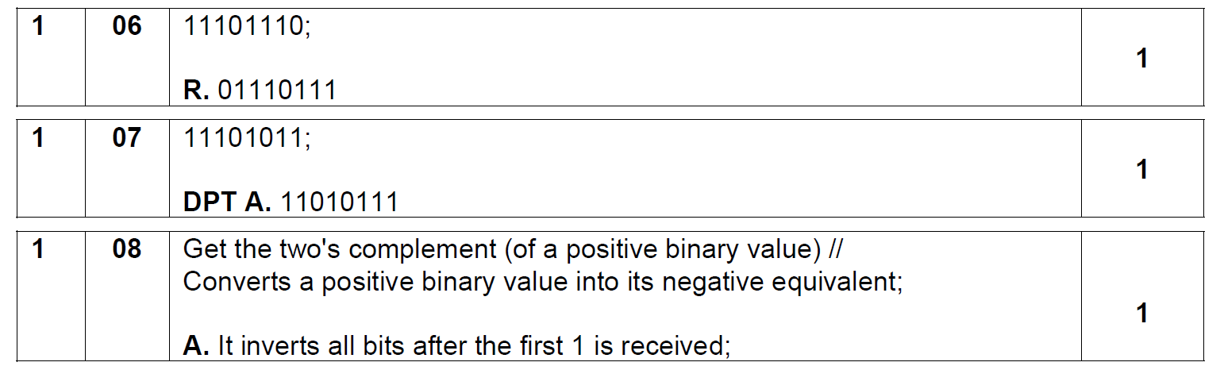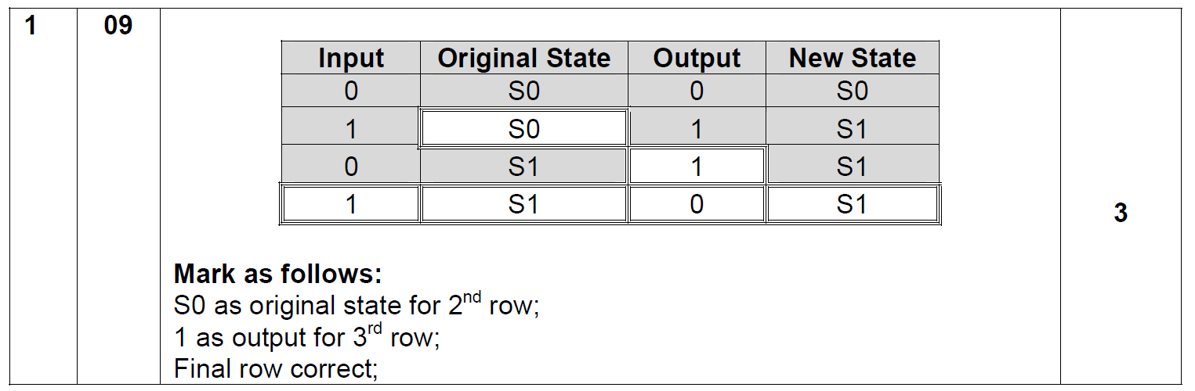

**Question 2**

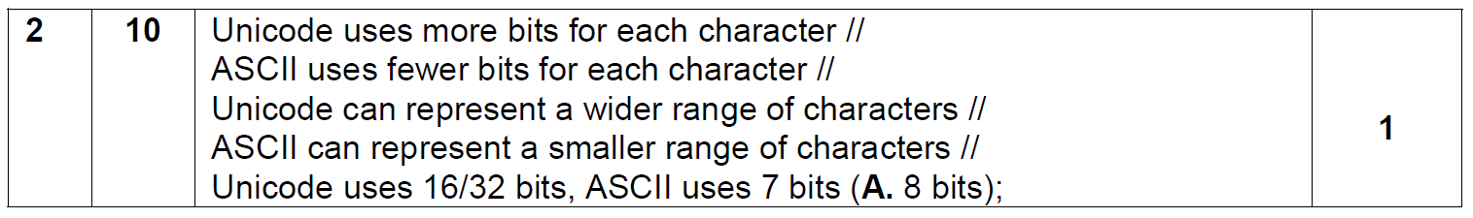

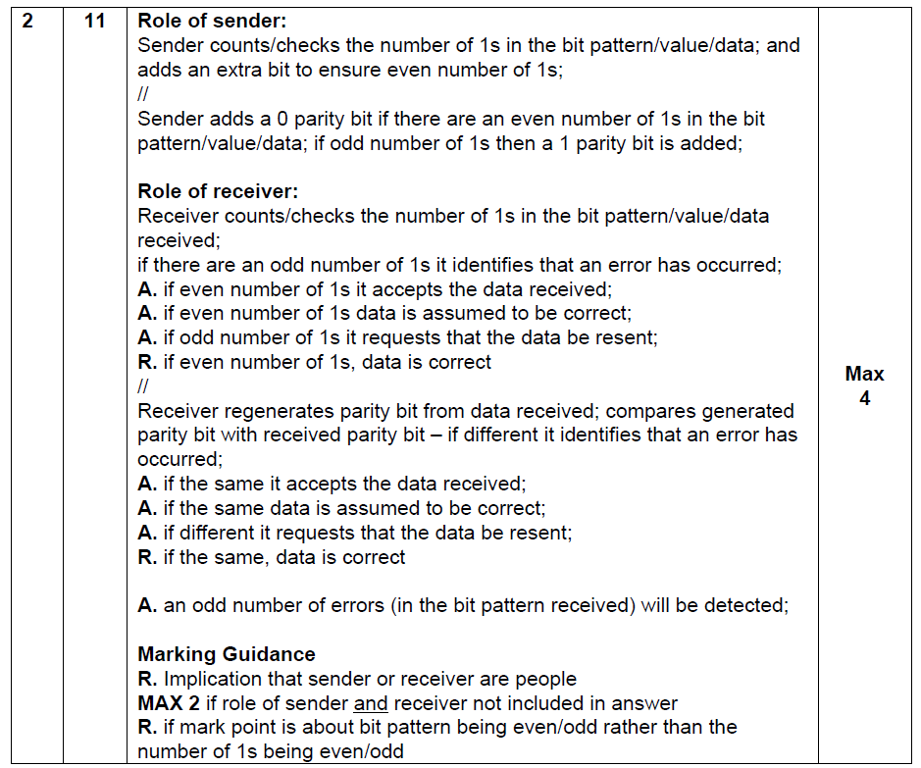

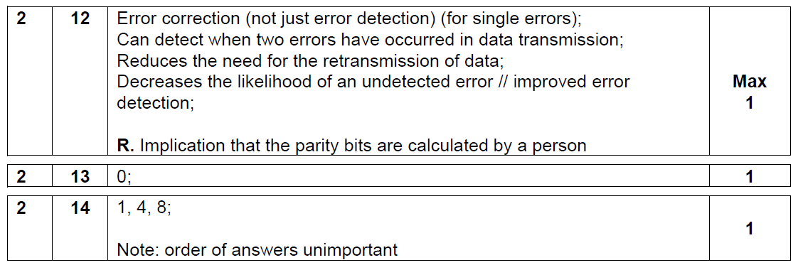

**Question 3**

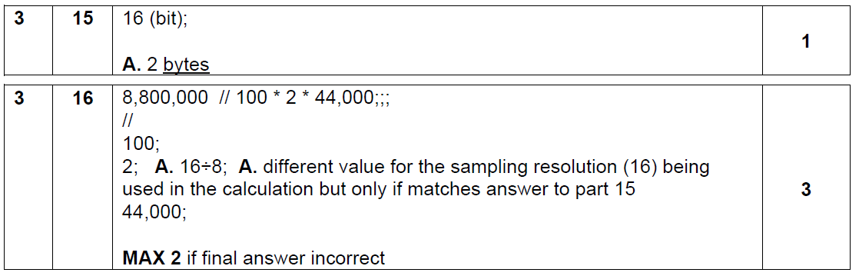

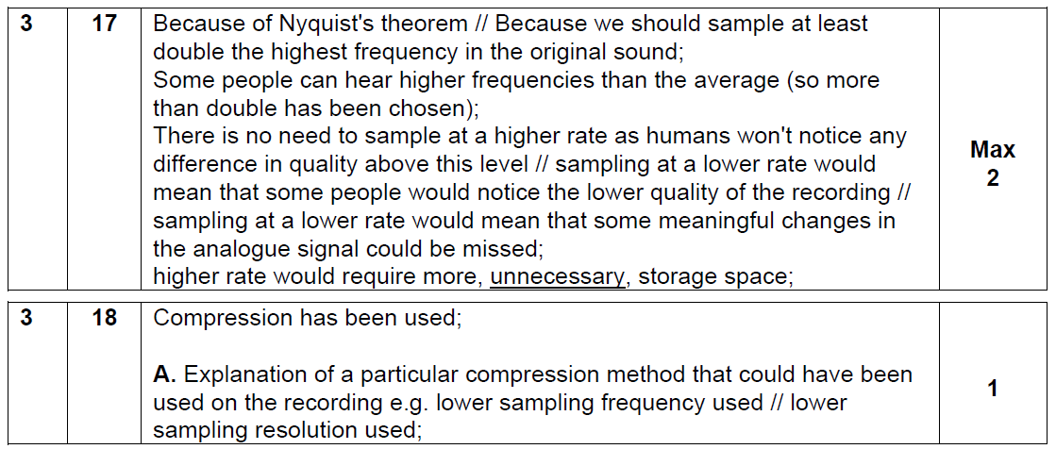

**Question 4**

|  |  |
| --- | --- |
| Sub Main()  Dim CurrentGuess As Char  Dim CurrentFlip As Char  Dim NumberOfCorrectGuesses As Integer  Const NumberOfFlips As Integer = 5  Dim FlipSequnce As String = "XHTHTT"  Do  Console.WriteLine("Plaese Guess Heads (H) or Tails (T)")  CurrentGuess = Console.ReadLine  Console.WriteLine("Coin Fliping....")  CurrentFlip = FlipSequnce(NumberOfCorrectGuesses)  Console.WriteLine("The coin landed " & CurrentFlip)  If CurrentGuess = CurrentFlip Then  Console.WriteLine("welldone. Lets flip again.")  If NumberOfCorrectGuesses = NumberOfFlips Then  Console.WriteLine("Congratuations You completed the sequence. Game Over")  End If  NumberOfCorrectGuesses = NumberOfCorrectGuesses + 1  Else  Console.WriteLine("sorry you guessed incorrectly. GAME OVER")  End If  Loop Until CurrentFlip <> CurrentGuess Or NumberOfCorrectGuesses = NumberOfFlips  Console.WriteLine("you guessed " & NumberOfCorrectGuesses & "flips correctly")  Console.ReadLine()  End Sub | 3 marks for correct declaration of all variables with initialisation.  -1 for each error down to 0  2 Marks for correct writeline statements A typos. -1 for each missed  2 marks for nested if’s  2 marks for loop with correct logic |

20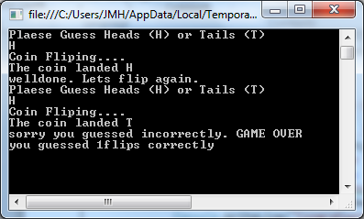 21 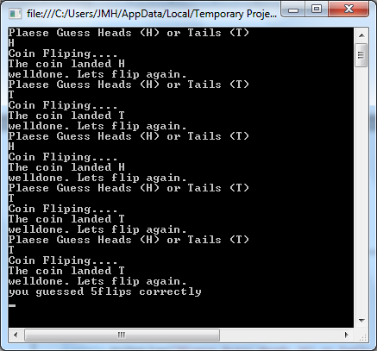

3(MARKS)

**Question 5**

25 BoardDimension (1 mark)

26 Board, moveIsLegal, GisgigirMoveIsLegal, RankDifference, FileDifference

Accept: GameOver, StartRank, FinishRank, StartFile, FinishFile, PieceType, PieceColour

(1 mark)

27 CheckSarrumMoveIsLegal, CheckGisgigirMoveIsLegal, CheckNabuMoveIsLegal,

CheckMarzazPaniMoveIsLegal, CheckEtluMoveIsLegal (1 mark)

28 “B”, “W”, …. (1 mark)

…. and “ “ (1 mark)

29 “S” (1 mark)

30 True (1 mark)

31 (a) and (d) (must have both and no others) (1 mark)

32 Because the scope; of the two variables is different; //

Because they are both local variables; in different subroutines; (2 marks)

(Total 10 marks)

### Question 6

**34**

While loop in correct position; (expect a local Boolean) (could be 2 loops)

startSquare input and math operations within try/catch;

Boolean statement that correctly selects for each digits between 1 and 8 ;;

Correct invalid statement displayed for all invalid inputs; (don’t be strict about spelling)

Repeated structures for finish square.

**35**

ScreenShots showing

|  |  |
| --- | --- |
| Input | output |
| 8 | Invalid… |
| 05 | Invalid… |
| 59 | Invalid |
| Four one | invalid |
| 17 / 09 | Invalid after finish square |
| Finish square = 27 | Move seen on board.. or “not a legal move if sample game |

½ mark for each correct test. Round down

Sample game screenshot 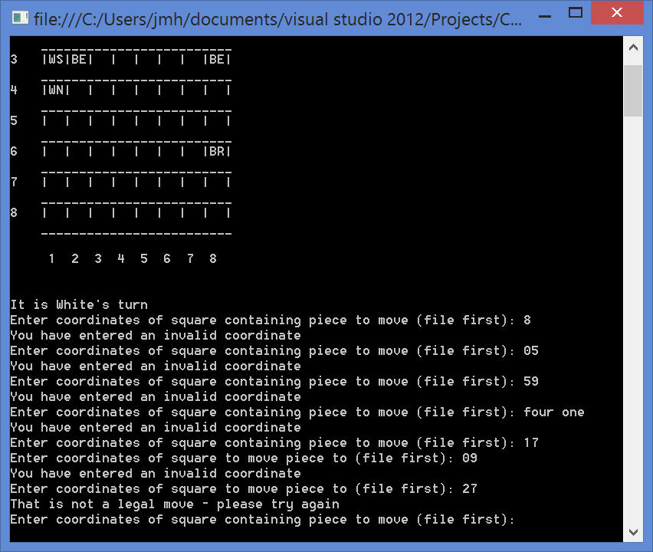

### Question7

**36**

In **checkMoveisLegal** –  
Addition of extra option in case statement Case “K” ;  
Correct call to new function;

In **MakeMove** -  
Assignments to Board(finishrank,finishfile) changed to WK, and BK respectively;

In **CheckKashshaptuMoveisLegal**() –

Correct Program interface(same as all the others!);  
correct boolean statement from Nabu;  
Correct sequence of selection statements lifted from Gisgigir; (accept any naming)  
selection statements sequenced /joined in a way that is valid logic;  
True/False ALWAYS returned; (award if logic is incorrect)

**37** (not sample game = no marks)

WK seen in 11 ;  
WK seen in 12;  
BK seen in 88, that is not a legal move seen after 22-28move;  
WK seen in 23;  
Black wins msg; (board still shows with BK in 18)