**Q1.**

A XOR B can be implemented as a logic circuit without using an XOR gate.

Using **only** AND, OR and NOT gates draw a circuit that will produce an output **Q** which is logically equivalent to **A XOR B**.

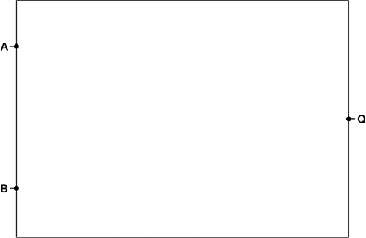

**(Total 3 marks)**

**Q2.**

State the name of the logic gate represented by the truth table shown in the table below.

|  |  |  |
| --- | --- | --- |
| **A** | **B** | **Q** |
| 0 | 0 | 1 |
| 0 | 1 | 0 |
| 1 | 0 | 0 |
| 1 | 1 | 0 |

**(Total 1 mark)**

**Q3.**

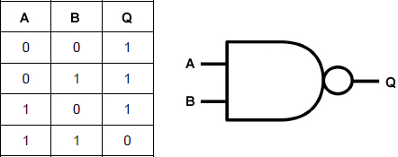

What is the name of the logic gate represented by the truth table and symbol shown above?

**(Total 1 mark)**

**Q4.**

Complete the truth table below to prove that **A +**  is equivalent to 

|  |  |  |  |  |  |  |
| --- | --- | --- | --- | --- | --- | --- |
| **A** | **B** |  |  |  |  |  |
| 0 | 0 |  |  |  |  |  |
| 0 | 1 |  |  |  |  |  |
| 1 | 0 |  |  |  |  |  |
| 1 | 1 |  |  |  |  |  |

**(Total 3 marks)**

**Q5.**

Using the rules and identities of Boolean algebra, simplify the following Boolean expression.



You **must** show your working.

**(Total 4 marks)**

**Q6.**

Using the rules and identities of Boolean Algebra, simplify the following Boolean expression.



**(Total 4 marks)**

**Q7.**

The diagram below shows some of the registers used in the fetch-execute cycle of a simple processor and the contents of a small section of main memory that it is connected to by the system bus ().

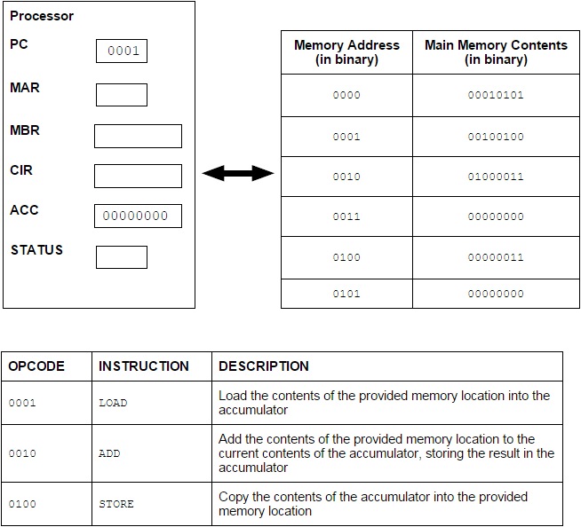

(a)     In the diagram above the first 4 bits of an instruction represent the opcode and give the type of instruction to be executed.

What name is given to the second 4 bits of an instruction?

**(1)**

(b)     (i)      Currently the value in the Program Counter (PC) is example 0001.

Complete the table below by writing the values, expressed in binary, in the following registers after completing the fetch part of the fetch-execute cycle.

|  |  |
| --- | --- |
| **Register** | **Value** |
| PC |  |
| MAR |  |
| MBR |  |

**(3)**

(ii)     Describe what will happen during the decode and execute part of the cycle.

**(3)**

(c)     What would be the outcome of executing the instruction 01000011?

**(1)**

**(Total 8 marks)**

**Q8.**

Describe **four** steps that a processor goes through during the fetch stage of the Fetch-Execute cycle.

You **must** explain the purpose of each step.

**(Total 8 marks)**