Mark schemes
Q1.
(a) All marks AO2 (apply)

Input string | Accepted by FSM?
111011x | NO
1110x | YES
111001x | NO
Mark as follows:
1 mark: one row correct
2 marks: all rows correct
2
(b) All marks AO2 (apply)

Strings that start with zero or more 1s; | A. starts with any number of 1s as BOD
which may or may not be followed by a 0; | A. there can be at most one 0 in the string
and end with an x; | A. 'end' being by implication
NOTE: 'ending with either x or 0x' is worth two marks
NOTE: MAX 2 if answer is not fully correct
3
[5]
Q2.
6 marks for AO2 (analyse)
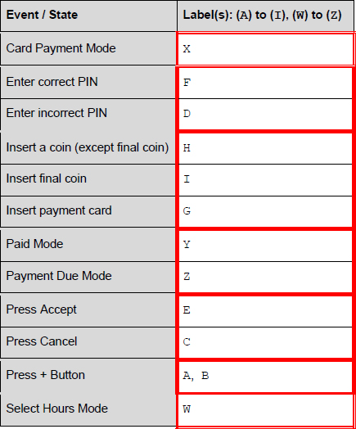
1 mark per group of correct labels:
X, W
F, D
H, I, G
Y, Z
E, C A. € ©
A, B
I. brackets around letters
R. any labels used more than once
Max 5 if any errors
[6]
Q3.
(a) 3 marks for AO2 (apply)

X | Result | Output
0 | 0 | -
4 | 4
6 | 10
3 | 13
2 | 15
−1 | 14 | 14
1 mark for correct X column (4, 6, 3, 2, -1);
1 mark for correct Result column (4, 10, 13, 15);
1 mark for final Result value (14) and Output column (14);
Max 2 if any errors
3
(b) 2 marks for AO2 (analyse)
The result is wrong // The sentinel value should not have been used in the calculation; Subtract the last value // input first value before the WHILE loop and swap the instructions within the WHILE loop // add 1 to result after loop is finished;
A. not add the value if it is the sentinel value
2
[5]
Q4.
(a) All marks for AO2 (apply)
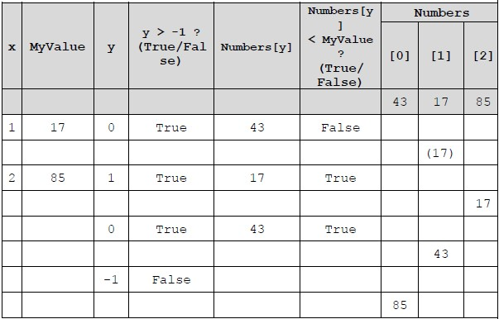
1 mark for correct x column and MyValue column;
1 mark for correct y column (0, 1, 0, -1);
1 mark for correct Boolean values in columns 4 and 6;
A. TRUE/true, FALSE/false, Yes/No, Y/N and any other suitable indicators
1 mark for final contents of Numbers correct;
4
(b) Mark is for AO2 (analyse)
sort from largest to smallest;
NE Sort on its own
A. bubble sort;
1
[5]
Q5.

(a) Mark is for AO1 (understanding)
Any number from the set of natural numbers;
{0,1,2,3,....}
1
(b) Mark is for AO1 (understanding)
Any number from the set of irrational numbers;
Examples: square root of 2, pi, Euler's number (e)
1
[2]
Q6.
2 marks are for AO2 (apply)
110;01011;
[2]
Q7.

(a) Analogue;
1
(b) Converts analogue signals into digital (signals); digitises signal;
Transforms the analogue input into digital form;
A data instead of signal
1
[2]

