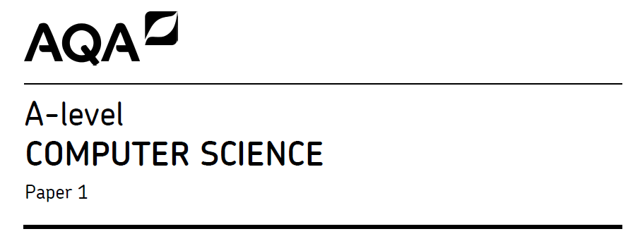

|  |  |  |  |  |  |  |  |  |  |  |
| --- | --- | --- | --- | --- | --- | --- | --- | --- | --- | --- |
| **Centre number** |  |  |  |  |  | **Candidate number** |  |  |  |  |
| **Surname** |  | | | | | | | | | | |
| **Forename(s)** |  | | | | | | | | | | |
| **Candidate signature** |  | | | | | | | | | | |
|  | I declare this is my own work. | | | | | | | | | | |
| **Programming Language** | **Python (7517/1D)** | | | | | | | | | | |

BM4 2023 Time allowed: 1 hours 15 minutes

|  |  |
| --- | --- |
| Question | Mark |
| **1** |  |
| **2** |  |
| **3** |  |
| **4** |  |
| **5** |  |
| **6** |  |
| **7** |  |
| **8** |  |
| **9** |  |
| **TOTAL** |  |

Instructions

* This is the Electronic Answer Document (EAD). Answer **all** questions by entering your answers into this document on screen. You **must save** this document at regular intervals.
* Before the examination begins, type the information needed in the boxes **at the top of this page**.
* Before the examination begins, type the information needed in the boxes **in the footers** (page 2 onwards) of this EAD.

**During the examination**

* You may print pages of your EAD. A print monitor will collect and deliver your print-out to you. You must **not** collect your own print-out.

**Exceptions**

* If you experience difficulty inserting screen shots into your EAD then you may print these separately and attach them to the back of the EAD with a reference in the correct place in the EAD. Ensure that your **Centre Number**, **Candidate Name** and **Candidate Number** are on each sheet.

**At the end of the examination**

* Save for the last time and print your EAD **on one side only** (not

double-sided). A print monitor will collect and deliver your print-out to you. Check that your details are in the footers from page 2 onwards. Write them in if they are not.

* Enter your signature on the front cover.
* Staple or tie all pages together in the top left-hand corner of the EAD.
* Hand in **all** pages of the EAD to the Invigilator.

**Warning**

* No extra time is allowed for printing and collating.
* It may not be possible to credit an answer if your:

– details are not printed on every page as instructed above

– screen captures are not legible to the Examiner.

|  |  |  |  |  |  |  |  |  |  |  |  |  |  |  |  |  |  |
| --- | --- | --- | --- | --- | --- | --- | --- | --- | --- | --- | --- | --- | --- | --- | --- | --- | --- |
| **Q1.** (a) | |  |  |  | | --- | --- | --- | | **x** | **y** | **Result** | | 5 | 3 | 1 | |  |  |  | |  |  |  | |  |  |  | | **(7)** |
| (b) |  | **(1)** |
|  |  | **/8** |

|  |  |  |  |  |  |  |  |  |  |  |  |  |  |  |  |  |  |  |  |  |  |  |  |  |  |  |  |  |  |  |  |  |  |  |  |  |  |  |
| --- | --- | --- | --- | --- | --- | --- | --- | --- | --- | --- | --- | --- | --- | --- | --- | --- | --- | --- | --- | --- | --- | --- | --- | --- | --- | --- | --- | --- | --- | --- | --- | --- | --- | --- | --- | --- | --- | --- |
| **Q2**  **(a)** | |  |  |  | | --- | --- | --- | | **X** | **Result** | **Output** | | 0 | 0 | - | |  |  |  | |  |  |  | |  |  |  | |  |  |  | |  |  |  | |  |  |  | |  |  |  | |  |  |  | |  |  |  | |  |  |  | | **3** |
| **(b)** |  | **2** |
|  |  | **/5** |

|  |  |  |
| --- | --- | --- |
| **Q3** |  | **/3** |
| **Q5.** |  | **/1** |
| **Q4** |  | **/1** |
| **Q6** |  | **/2** |
| **Q7** |  | **/2** |
| **Q8** |  | **/1** |
| **Q9 (a)** |  | **/1** |
| **(bi)** |  | **/1** |
| **(bii)** |  | **/1** |
|  |  | **/3** |

|  |  |  |
| --- | --- | --- |
| **Q10 (a)** |  | **/8** |
| **(b)** |  | **/1** |
|  |  | **/9** |

|  |  |  |  |  |  |  |  |  |  |  |  |  |  |  |  |  |  |  |  |  |  |  |  |  |  |  |  |  |  |  |  |  |  |  |  |  |  |  |  |  |  |  |  |  |  |  |  |  |  |  |  |  |  |  |  |  |  |  |  |  |  |  |  |  |  |  |  |  |  |  |  |  |  |  |  |  |  |  |  |  |  |  |  |  |  |  |  |  |  |  |  |  |
| --- | --- | --- | --- | --- | --- | --- | --- | --- | --- | --- | --- | --- | --- | --- | --- | --- | --- | --- | --- | --- | --- | --- | --- | --- | --- | --- | --- | --- | --- | --- | --- | --- | --- | --- | --- | --- | --- | --- | --- | --- | --- | --- | --- | --- | --- | --- | --- | --- | --- | --- | --- | --- | --- | --- | --- | --- | --- | --- | --- | --- | --- | --- | --- | --- | --- | --- | --- | --- | --- | --- | --- | --- | --- | --- | --- | --- | --- | --- | --- | --- | --- | --- | --- | --- | --- | --- | --- | --- | --- | --- | --- | --- |
| **Q11 (a)** | |  |  |  |  |  |  | | --- | --- | --- | --- | --- | --- | | **Table 2** | | | | | | | **S** | **X** | **Y** | **P** | **Z** | **List[Z]** | | 38 | 0 | 18 | −1 |  |  | |  |  |  |  |  |  | |  |  |  |  |  |  | |  |  |  |  |  |  | |  |  |  |  |  |  | |  |  |  |  |  |  | |  |  |  |  |  |  | |  |  |  |  |  |  | |  |  |  |  |  |  | |  |  |  |  |  |  | |  |  |  |  |  |  | |  |  |  |  |  |  | | **Result**: | | | | |  | | **/5** |

|  |  |  |
| --- | --- | --- |
| **Q12** |  | **/3** |

|  |  |  |
| --- | --- | --- |
| **Q13** (a) |  | **/1** |
| **(bi)** |  | **/1** |
| **(bii)** |  | **/1** |
| **C** | |  |  | | --- | --- | | Code | Number | | – | 0 | | 55 | 7 | |  |  | |  |  | |  |  | | **/6** |
|  |  | **/9** |