**Learner Workbook**

NCFE CACHE Level 1/2 Technical Award in Child Development and Care in the Early Years (603/7012/9)

**Content area 1: Child Development**

**Part 1 ~ Lessons 1-4**

|  |  |
| --- | --- |
| **Name** |  |
| **College ID** |  |
| **Teacher** |  |

# 

# Introduction

This content area will be exploring child development. You will learn what child development is and what the four key areas of child development are.

As you look at each area of development, you will explore the expected milestones for each age range within the early years.

You will experience a range of activities to support the areas of development and will have the opportunity to look at some of the resources available to support child development.

# Lesson 1: Introduction to child development

During this lesson we are going to learn all about child development, including what it is and what the four main areas of child development are.

|  |  |
| --- | --- |
| **Learning outcomes** |  |
| You must be able to:   * **Define** the term “child development”. * **List** the key areas of development. * **Explain** the key areas of development. * **Provide** examples of skills within each key area of development. | |

|  |  |
| --- | --- |
| **Starter activity: Developing skills** |  |
| **Children develop in 5 areas:**  **Can you name these 5 areas of development:**  **P**  **I**  **L**  **E**  **S** | |
| **Think of an activity** that will support **each of these areas of development?**  For example, shaking a rattle supports physical development of babies, they develop hand-eye co-ordination.  P  I  L  E  S | |

What are some of my **physical milestones** that I will achieve from birth to 5 years?



|  |  |
| --- | --- |
| **Can you put these PHYSICAL milestones in the order they are expected to happen:** |  |
| * Crawling * Walking * Doing up zip and fastening buttons * Able to sit unsupported, reach for finger food, place in mouth, chew and swallow * Sitting with support * Lying on tummy and lifting head and arms * Crawling * Rolling from tummy onto back * Drawing * Building a tower * Threading beads | |

What are some of my **language and communication** **milestones** that I will achieve from birth to 5 years?



|  |  |
| --- | --- |
| **Can you put these LANGUAGE AND COMMUNICATION milestones in the order they are expected to happen.** |  |
| * Asking ‘what’ and ‘why’ questions * Babbling and cooing. * Responding to name * Can say several single words * Listen and follow simple instructions – hold your cup, time to sleep, put the shape in the slot. | |

## Child development

|  |  |
| --- | --- |
| **Reflective question: What is child development?** |  |
| Use the **think – pair – share** approach to explore what the term “child development” means. | |
| You have:  **1 minute to think** what this term means and write a definition.  **1 minute to pair up** with a partner and share your ideas.  **1 minute to share** and feedback to the class | |
| **Child development meaning:**  **My definition of child development is:** | |

***Remember:*** *A child is someone who is under the age of 18 years old.*

*Early Years covers the age range from birth to 5 years.*

|  |  |
| --- | --- |
| **Activity 1: Developing skills** |  |
| **You are going to do 4 Tasks** where you will need to use certain skills to complete the tasks.  **Think about what skills you are using and which body parts you use and write these down.** | |
| **Task 1:** | |
| **Task 2:** | |
| **Task 3:** | |
| **Task 4:** | |

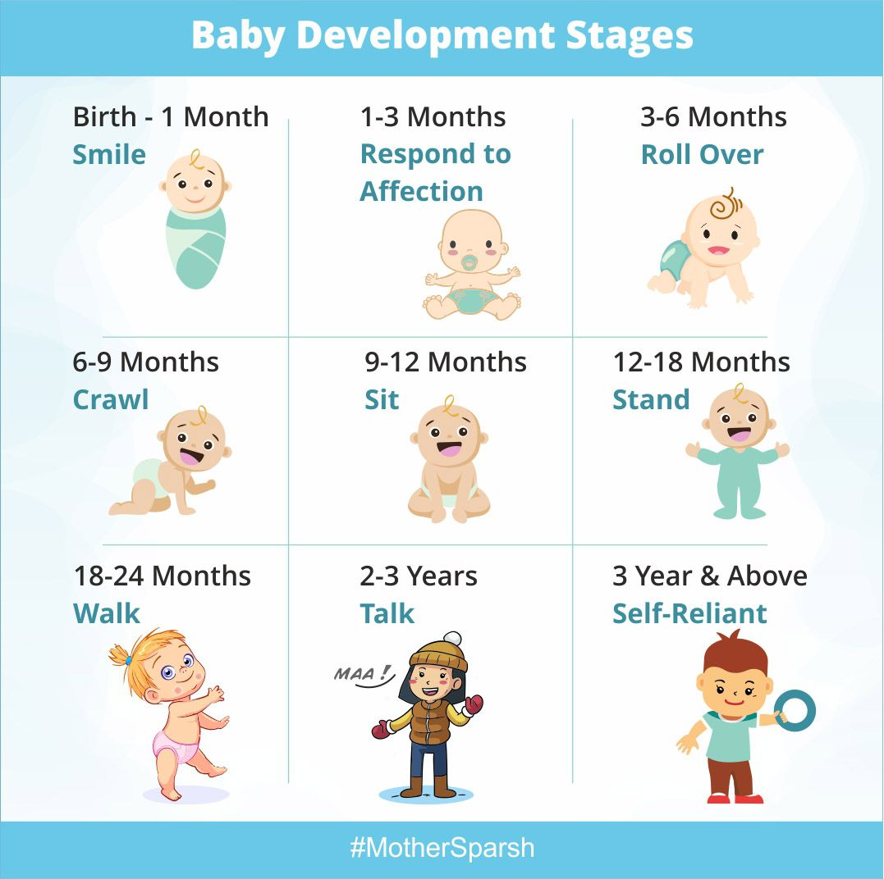

**When children are learning through play there are many important skills they will learn, practice and develop.**

They will develop **key skills such as:**

* Using big muscles to move their arms, legs and body.
* Using small muscles to move parts of their body such as hands and fingers, mouths, and eyes.
* Literacy and numeracy skills.
* Logical thinking skills.
* Problem solving skills.
* Controlling their emotions.
* Using empathy to think about how others might feel.
* Social skills to interact appropriately with others.

***Remember that children are not born with most of these skills and will learn them.***

## Four key areas of child development

|  |  |
| --- | --- |
| **Activity 2: Areas of child development** |  |
| Write down **a definition** for each of the 4 key areas of development:  **What skills** fit into each development area? | |
| **Physical development**  Definition:  Key skills: | |
| **Cognitive development**  Definition:  Key skills: | |
| **Communication and language development**  Definition:  Key skills: | |
| **Social and emotional development**  Definition:  Key skills: | |

Activities to support child development will often fit into more than one area of development.

This is called **holistic development** because you are looking at everything rather than just one area.

In this lesson, we have learned about child development. You should now be able to name the four key areas for development and may be able to provide examples of the types of activities that fit into each area.

|  |  |
| --- | --- |
| **Additional resources** |  |
| You could use the Development Matters document from the Department of Education to provide ideas for appropriate activities. Visit **gov.uk** and type “Development Matters” into the search box. | |

| **Progress check** |  |
| --- | --- |
| **Which areas do the following activities fit into?**   * Singing * Jigsaws * Playing football * Dancing * Sharing a story book * Having a dolls picnic * Playing a board game * Making playdough   Sort the list of activities into the correct areas of child development below.   | **Physical development** | **Cognitive development** | | --- | --- | |  |  | | **Communication and Language development** | **Social and Emotional development** | |  |  | | |

Think about what you have learned today. Remember that some activities support more than one area of development.

|  |  |  |
| --- | --- | --- |
| **Learning recap** | |  |
| Can you now: | | |
|  | **Define** the term “child development”. | |
|  | **List** the key areas of development. | |
|  | **Explain** the key areas of development. | |
|  | **Provide** examples of skills within each key area of development. | |

Here are some of the key terms we have learned this lesson. How many can you remember?

|  |  |
| --- | --- |
| **Key terms** |  |
| **Child development:** The way in which children grow and learn  **Physical development**: The way in which the body increases in skill and becomes more complex.  **Cognitive development**: The ability to think, recognise and remember.  **Communication and language development**: The ability to make sounds, talk, understand, and interact with others.  **Social and emotional development**: The ability to interact with others, develop, manage, and express feelings and become more independent.  **Holistic development:** Looking at all areas of development together as they are all connected. | |

|  |  |
| --- | --- |
| **Home study: Areas of development** |  |
| Draw a mind-map of the **four key areas of development**.  Under each development area, **list 5 activit**ies that children could do to **support their development**. Use different ideas from the ones identified in today’s lesson. | |

# Lesson 2: Introduction to physical development

* During this lesson **we are going to explore physical development** and the **different types of physical development**.
* You are also going to identify some appropriate activities to support physical development.
* By the end of this lesson, you will know what physical development is and what the expected milestones are for physical development.

|  |  |
| --- | --- |
| **Learning outcomes** |  |
| By the end of the lesson  You must be able to:   * **Define** the term physical development. * **Describe** the types of physical development. * **Identify** expected milestones for physical development. * **Explain** the difference between fine and gross motor skills. | |

|  |  |
| --- | --- |
| **Starter activity: Physical activities** |  |
| **Highlight all the physical activities in this list that use larger muscles**  **Tick the activities that use smaller muscles**   |  |  |  |  | | --- | --- | --- | --- | | A walk to the park |  | Skipping |  | | Baking |  | Pouring water into a cup |  | | Crawling |  | Threading beads |  | | Fastening buttons |  | Riding a bike |  | | Catching a ball |  | Folding a blanket |  | | Eating grapes out of a bowl |  | Cutting up food |  | | Patting a dog |  | Brushing hair |  | | Playing with Playdough |  | | Trampolining |  | | Writing |  | | Hopping |  | | Reading a book |  | | Yoga |  | | Doing a jigsaw |  | | |

## Motor skills

* **All the activities support physical development** as they require children to use **their muscles** to do them.
* Some activities encourage children to use their **big muscles** such as those in their arms and legs.
* Some activities encourage children to use their **smaller muscles** like the ones in their hands and fingers.

|  |  |
| --- | --- |
| **Reflective question** |  |
| Physical development consists of **2 types** of motor skills:   * **Fine** motor skills. * **Gross** motor skills.   Can you think of a definition for each of these?  **Fine motor skills are:**  **Gross motor skills are:**  You can check your answer in the key terms table at the end of this lesson. | |

## Physical development milestones

|  |  |
| --- | --- |
| **Activity 1: Expected milestones** |  |
| * **Group Activity First:** You have **2 minutes** to write as many **physical activities** as you can think of that a child of that age range would be able to do. Draw a circle around the activities that involve fine motor skills   **Individual workbook task:** Complete the sections below with as many activities you can think of. | |
| **Birth – 1 year** | |
| **1 – 2 years** | |
| **2 – 3 years** | |
| **3 – 4 years** | |
| **5 – 6 years** | |

**Milestones for Physical Development**

Every child is unique so they will not all do the same things at the same time. The examples you have been looking at are aimed at an approximate age range, but children will develop at their own rate.

These are the expected milestones for each age range within the early years.

**Complete the missing milestones from the PPT slides:**

|  |  |
| --- | --- |
| **At birth** |  |
| Often fold their thumb under their fingers. |
|  |
| Head lags when pulled to sitting position. |

|  |  |
| --- | --- |
| **One year** | Points using index finger |
| Passes and releases toy |
|  |
| Holds crayon with palmar grasp and makes random marks |
|  |
| Sits down from standing |
|  |

|  |  |
| --- | --- |
| **Two years** | Separates interlocking toys |
|  |
|  |
| Walks up and down stairs by holding adult’s hand |
| Runs with control |
|  |

|  |  |
| --- | --- |
| **Three years** | Begins to show preference for dominant hand |
| Fastens large zip |
|  |
| Can walk backwards and sideways |
|  |
| Jumps from a low step with both feet together |
| Throws a ball overhand and can catch a large ball with arms outstretched |

|  |  |
| --- | --- |
| **Four years** | Begins to fasten buttons |
|  |
| Can draw a figure that resembles a person showing head, legs, and body |
|  |
| Changes direction while running |
|  |

|  |  |
| --- | --- |
| **Five years** | Can use a knife and fork competently |
|  |
|  |
| Skips and moves rhythmically to music |
|  |
| Rides bicycle with stabilisers |

| **Progress check** | |  |
| --- | --- | --- |
| Are these statements **true** **(T)** or **false (F)**?  Add a T or F alongside the statements to show your answers. | | |
|  | New-born babies often fold their thumbs under their fingers. | |
|  | Babies will often use their gross motor skills to “cruise” around furniture when they are 1 year old. | |
|  | A 2-year-old can develop their fine motor skills by jumping up and down. | |
|  | A 5-year-old can develop their fine motor skills by using a knife and fork. | |
|  | A 4-year-old can develop their gross motor skills by fastening the buttons on their coat. | |
|  | The pincer grip is where the thumb and index finger come together to hold something small. | |
|  | Children usually begin to show preference for their dominant hand at the age of 2. | |
|  | A 4-year-old is usually capable of changing direction when they are running. | |
|  | Hopping on one foot without falling over is usually achieved by the age of 3 | |
|  | A 1-year-old may use their fine motor skills to clasp their hands together. | |

Think about what you have learned today. Can you remember the different types of physical development?

|  |  |  |
| --- | --- | --- |
| **Learning recap** | |  |
| Can you now: | | |
|  | **Define** the term physical development. | |
|  | **Describe** the types of physical development. | |
|  | **Identify** expected milestones for physical development. | |
|  | **Explain** the difference between fine and gross motor skills. | |

Here are some of the key terms we have explored during this lesson. Can you remember them?

|  |  |
| --- | --- |
| **Key terms** |  |
| **Fine motor skills –** These use your muscles to make small, and precisely co-ordinated movements.  **Gross motor skills** – These use your muscles to make large, co-ordinated movements.  **Pincer grip** – This is when your thumb and index finger come together to hold something small.  **Milestones** – These are the stages of development that children are expected to reach by a certain age. | |

# Lesson 3: Fine motor skills

During this lesson we are going to **explore fine motor skills** and **activities** that support the development of these.

By the end of this lesson, **you will know what fine motor skills** are and how you can support young children to develop these.

|  |  |
| --- | --- |
| **Learning outcomes** |  |
| By the end of the lesson you will be able to:   * **Identify** age-appropriate activities that support the development of fine motor skills. * **Explain** the benefits of fine motor skill activities * **Evaluate** the effectiveness of the fine motor skill activities experienced. | |

## Using fine motor skills

|  |  |
| --- | --- |
| **Activity 1: The importance of fine motor skills** |  |
| Remember that **fine motor skills** use your **muscles to make small**, and **precisely co-ordinated** movements.  Working in pairs tp discuss the following question:  **Why is it important to develop children’s fine motor skills?**  Write some ideas here to share with the class. | |
|  | |

|  |  |
| --- | --- |
| **Activity 1:** Choose 5 reasons from the PPT slides and explain below in your own words why it is important for children to develop their fine motor skills: |  |
| **Fine motor skills are vital for children’s development** as they support children to do a wide variety of tasks and become more independent.  **Why is it important to develop children’s fine motor skills?** | |
| **Write down 5 reasons here:** | |

|  |  |
| --- | --- |
| **Activity 2: Fine motor skills activities** |  |
| **You are going to participate in some fine motor skills activities around the classroom.**   * Each table has different resources on it. You can use them however you want to. **You will have 4 minutes at each table**. * After your 4 minutes you need to **write the resources into your workbook and describe how you used them.** * What skills did you use? | |
| **Table 1:**  Resources:  What did you do with them?  Which fine motor skills did you use? | |
| **Table 2:**  Resources:  What did you do with them?  Which fine motor skills did you use? | |
| **Table 3:**  Resources:  What did you do with them?  Which fine motor skills did you use? | |
| **Table 4:**  Resources:  What did you do with them?  Which fine motor skills did you use? | |

**Potential Risks for Children during play activities**

* It is important to make sure that the resources you use with the children are safe and will not cause any harm to the children.
* You need to consider the risks and what you can do to reduce these so that children are kept safe.
* All activities should be closely supervised to make sure children do not hurt themselves or others.

|  |  |
| --- | --- |
| **Potential Risks** |  |
| Write 4 potential risks for children when they are using these resources? | |

## Recap: Developing fine motor skills

There are lots of ways that resources can support the development of fine motor skills.

**They can help children to:**

* Practice their pincer grip which will help them to pick things up and do tasks such as fastening their coats.
* Develop hand-eye co-ordination as they need to watch what they are doing to be able to complete the small movement tasks.
* Develop strength in their fingers to support writing skills.
* Practice small muscle movement to become more co-ordinated in their tasks.

**Resources such as the ones you have used today can help support this development by providing children with the opportunity to:**

* Mark make – Writing, drawing, scribbling.
* Manipulate objects – This means to move things around by rolling, squeezing, poking, pinching, folding.
* Position objects – Stacking, lining up, sorting, separating piles, turn things over.
* Do everyday tasks – Pouring water, feeding themselves

We have been looking at fine motor skills. You should now know why we need to develop fine motor skills and be able to suggest some activities to support this development.

Think about what you have learned today. Can you explain why fine motor skills are important and suggest the most appropriate activities to support them?

|  |  |  |
| --- | --- | --- |
| **Learning recap** | |  |
| Can you now: | | |
|  | **Identify** age-appropriate activities that support the development of fine motor skills. | |
|  | **Explain** the benefits of fine motor skill activities | |
|  | **Evaluate** the effectiveness of the fine motor skill activities experienced. | |

These are some of the key terms we have looked at in this lesson. We have looked at some of them before so they should be familiar now, but some are new.

|  |  |
| --- | --- |
| **Key terms** |  |
| **Fine motor skills:** These use your muscles to make small, and precisely co-ordinated movements.  **Pincer grip:** This is when your thumb and index finger come together to hold something small.  **Hand-eye co-ordination:** This is when you use your eyes to make sure that your hands are moving in the right direction and touching the right things to complete tasks such as putting one Duplo brick on top of another. | |

|  |  |
| --- | --- |
| **Extra Task: Activity planning** |  |
| Research and identify an activity you could do with a young child to help them develop their fine motor skills.  **Think about:**   * What age range is it suitable for? * How will it support the development of fine motor skills? * What are the risks to consider?   Try to use ideas that you have not used in this lesson. | |
|  | |

# Lesson 4: Gross motor skills

* In this lesson you are going to **explore** how you can support the development of **children’s gross motor skills** by **exploring activities** that require the use of the **large muscles.**
* By the end of this lesson, you will know what gross motor skills are and how you can support young children to develop these

|  |  |
| --- | --- |
| **Starter activity: Gross Motor Skills** |  |
| **List 5** activities in your workbook that **support children’s gross motor skills** | |
|  | |

.

|  |  |
| --- | --- |
| **Learning outcomes** |  |
| By the end of the lesson  You must be able to:   * **Identify** activities that support the development of gross motor skills. * **Explain** the benefits of gross motor skill activities * **Evaluate** the effectiveness of the gross motor skill activities experienced. | |

## Using gross motor skills

* Remember that **gross motor skills** use your muscles to make large, co-ordinated movements.
* **Gross motor skills are vital for children’s development** as they support children to become more mobile and therefore enable them to explore their environment and broaden their opportunities for learning.

|  |  |
| --- | --- |
| **Activity 1: The importance of gross motor skills.** |  |
| Discuss this question in pairs:  **Why is it important to develop children’s fine motor skills?**  Write your ideas here to share with the class. | |
|  | |

|  |  |
| --- | --- |
| **Activity 2: Gross motor skills activities** |  |
| You are going to do some outdoor activities that will support your gross motor skills.  **Think about these questions:**   * What skills did you develop from each activity? * Were there any risks? * How effective were the activities at developing gross motor skills? | |
| **Feedback notes:** | |

## Developing gross motor skills

Gross motor skills are important to enable children to grow and explore the world around them.

**Activities that support the development of gross motor skills are vital to enable children to:**

* Strengthen large muscles to support everyday tasks such as climbing the stairs or getting dressed.
* Help children to stay fit and healthy by enabling them to move around and play sports.
* Help children to develop skills such as walking to enable them to interact with others.

| **Progress check** |  |
| --- | --- |
| Can you answer these questions? | |
| What are **3 benefits** of physical activities for gross motor skills?  1.  2.  3. | |
| What are **3 activities** that support the development of gross motor skills?  1.  2.  3. | |

Think about what you have learned today. Can you explain why gross motor skills are important and suggest the most appropriate activities to support them?

|  |  |  |
| --- | --- | --- |
| **Learning recap** | |  |
| Can you now: | | |
|  | **Identify** activities that support the development of gross motor skills. | |
|  | **Explain** the benefits of gross motor skill activities. | |
|  | **Evaluate** the effectiveness of the gross motor skill activities experienced. | |

**Notes Page:**