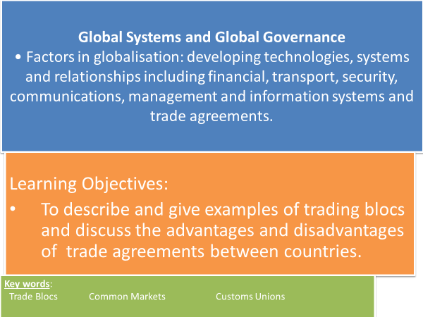

**Key Words**

* **Trade Bloc -** a group of countries that share trade agreements between each other, but with tariff walls that discourage imports from countries outside the bloc thereby protecting their own industries (protectionism)
* **Common markets** – A group formed by countries in geographical proximity in which trade barriers for goods and services are eliminated. (This may eventually apply to removing any labour market restrictions, as in the EU.)
* **Customs unions** – A trade bloc which allows free trade with no barriers between its member states but imposes a common external tariff to trading countries outside the bloc (for example, the European Union).

**Trade Agreements**

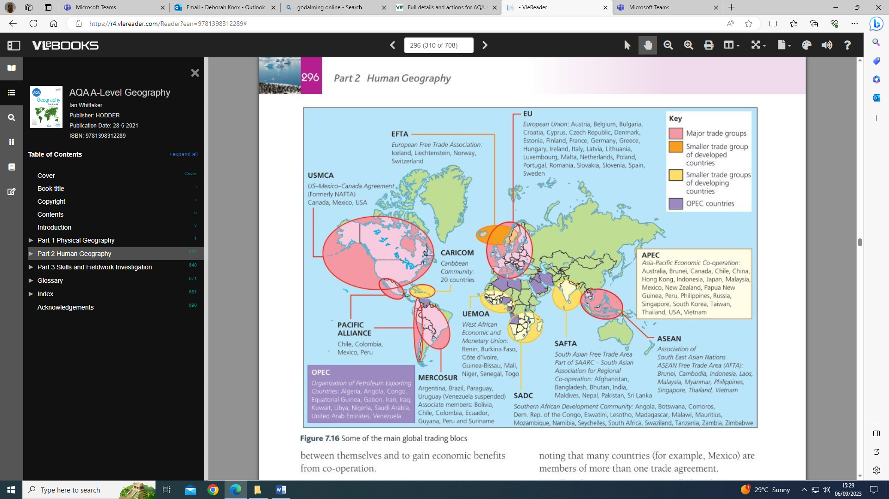

**How do different nations of the world group themselves together?**

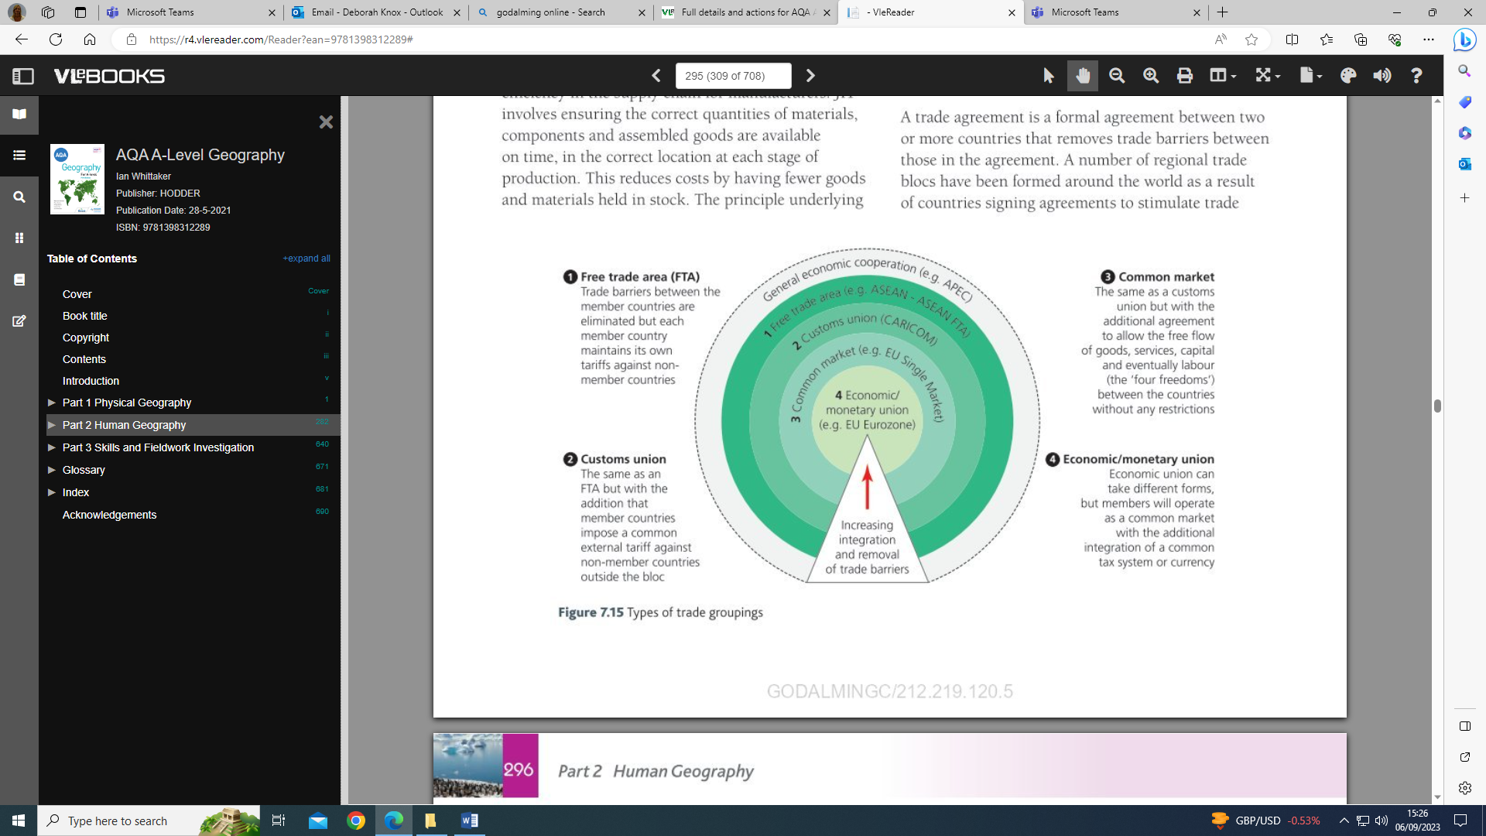

**Advantages and disadvantages of being in a trading group agreement**

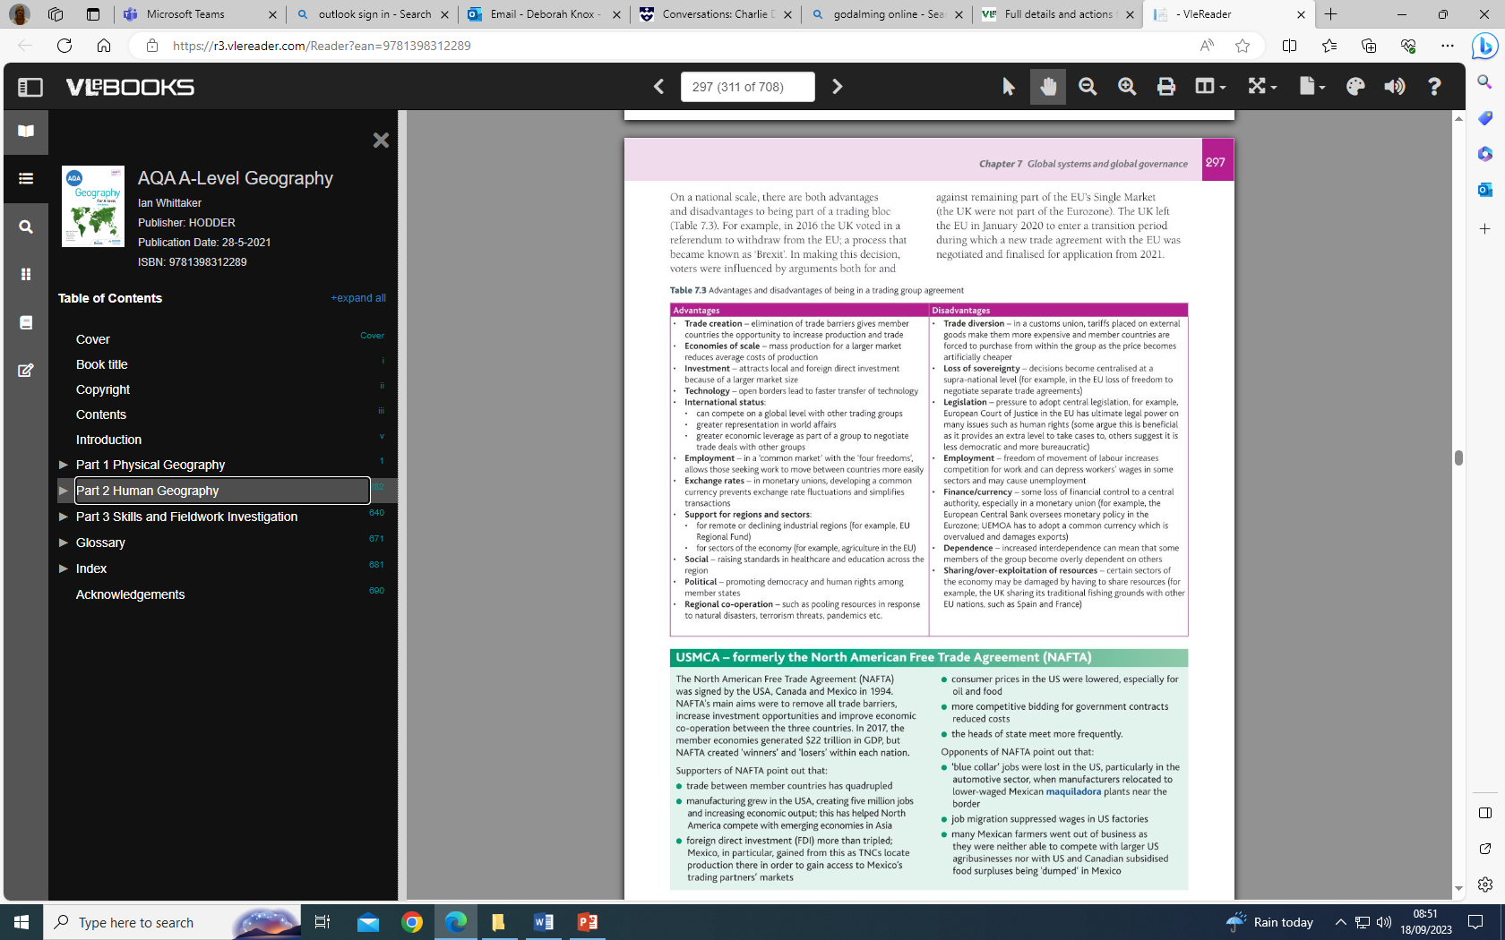

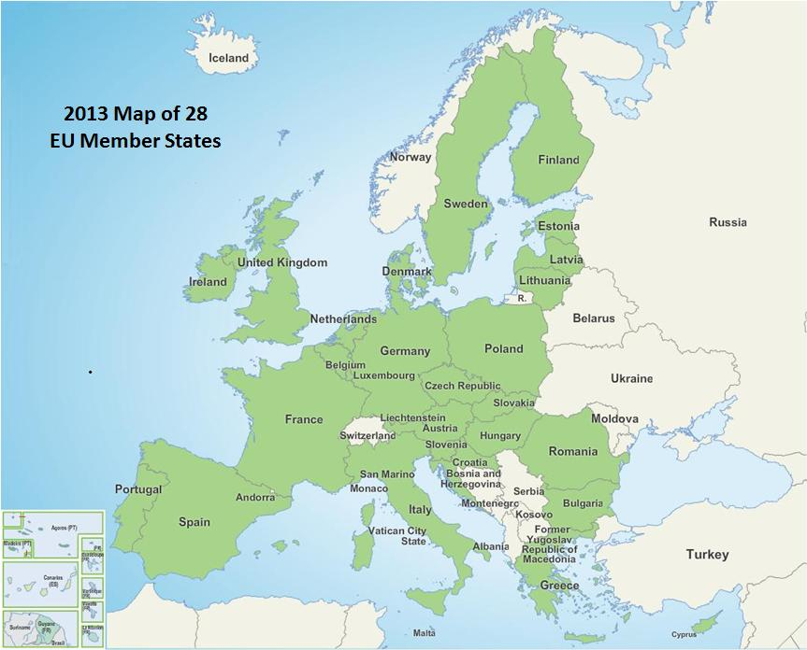**The European Union**

**TASK: Watch the video on the EU and answer the questions below.** [**https://www.youtube.com/watch?v=eOCLx01PAU4**](https://www.youtube.com/watch?v=eOCLx01PAU4)

* What 3 things does the EU underpin for its residents?
* When and why was it set up with how many original countries?
* What happened in 1989 and how did the affect the EU?
* How does the single market operate within the EU?
* How has the EU economically integrated?
* What are the 3 institutions at the heart of the EU?
* As a global player how has the EU taking responsibility?

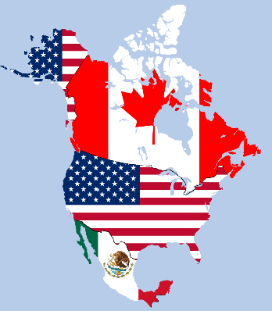**USMCA – formerly the North American Free Trade Agreement (NAFTA)**

* The United States has linked with Canada and Mexico to form a free trade zone, the North American Free Trade Agreement (NAFTA).
* The NAFTA agreement covers environmental and labour issues as well as trade and investment, but US unions and environmental groups argue that the safeguards are too weak.

**Key Term: Maquiladora** – A manufacturing operation (plant or factory) located in free trade zones in Mexico. They import materials for assembly and then export the final product without any trade barriers.

**TASK: Watch the clip ‘NAFTA explained with a toy car.’ Produce a mind map/notes on the benefits of NAFTA and how this is changing with the re-negotiated agreement.**

<https://www.bing.com/videos/search?q=nafta&&view=detail&mid=0C47F61FB98BB37CF64D0C47F61FB98BB37CF64D&&FORM=VRDGAR>

**Use the section titled ‘USMCA’ on the Powerpoint slide or p297-8 of the VLE online Hodder text book to add more detail on the aims, views of supporters, views of opponents of NAFTA.**

**TASK: Discussion question - How far do trade blocs encourage globalisation? E.g. To a large extent/to a partial extent or not at all? Look back at the advantages and disadvantages table on p2 of the booklet. Use evidence from the EU and USMCA (formerly NAFTA) in your answer.**

**Exam Style Question**

* **What are the benefits that may accrue (be received in regular or increasing amounts over time) a national economy that enters a trade bloc or becomes a member of an international trading organisation? (4 marks)**

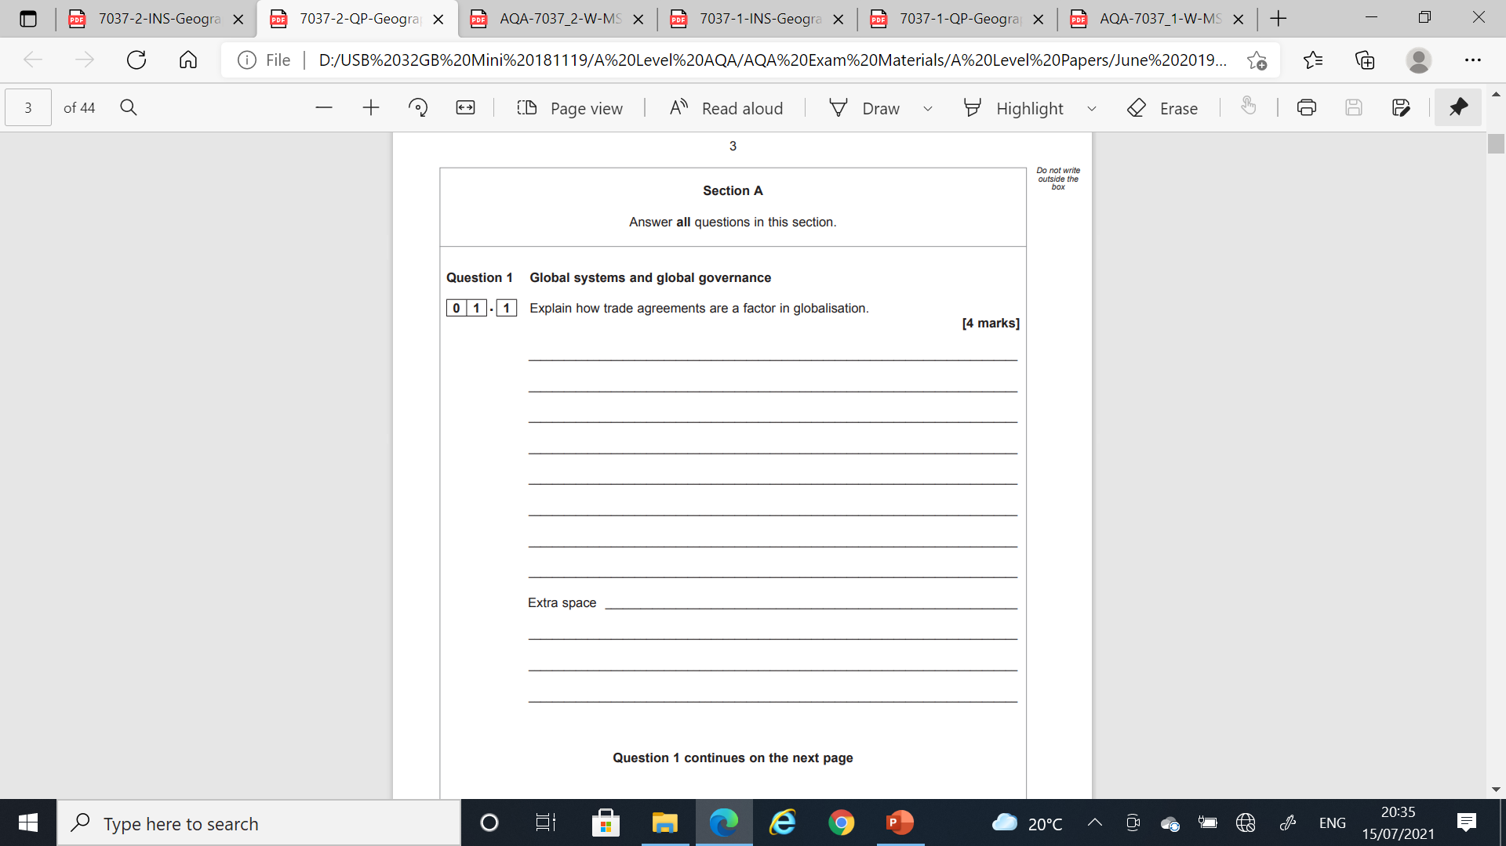

**TASK: Pre-work for next lesson**

* Read Hodder textbook ‘Global Systems’ extract in Folder 4 ‘Global Systems – World Bank, IMF and WTO’ on Godalming Online to produce a mind map of the role of financial institutions: the IMF & World Bank and the WTO and assess their role in global systems.
* What are the main criticisms of these institutions?
* Identify Problems and Successes of the WTO.