**3.1.5.5 Storm Hazards response and case studies**

* **Short and long-term responses: risk management designed to reduce the impacts of the hazard through preparedness, mitigation, prevention and adaptation.**
* **Impacts and human responses as evidenced by TWO recent tropical storms in contrasting areas of the world.**

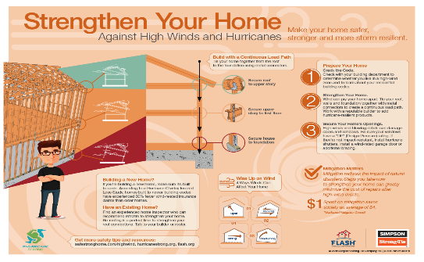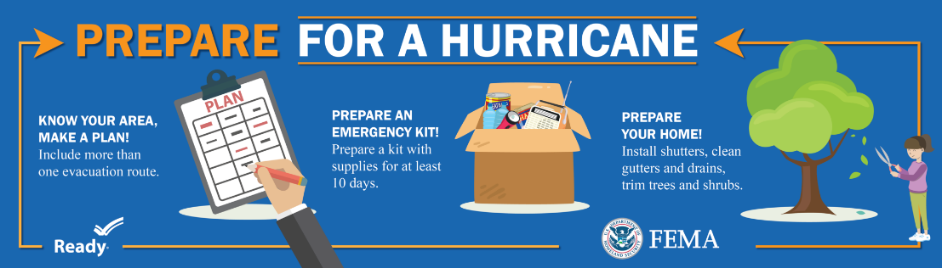**How can storm hazards be managed?**

**Mitigation includes any actions, strategies, measures or projects undertaken to offset the known detrimental impacts of a process. For storms, this could include direct intervention or post-event support in the form of aid or insurance.**

|  |  |
| --- | --- |
| Prevention | * Storms cannot be prevented (some tests into **cloud seeding** to reduce impact of heavy rainfall were unsuccessful) * However it is possible to modify the event (**build levees/sea defences** to prevent impacts of storm surges). Use of natural defences such as **mangroves** or **coral reefs** * and to prevent storms posing a risk to people (eg authorities can prevent the land prone to **flooding** from being developed on, land use mapping) |
| Preparedness | * **Authorities** can install monitoring systems (satellites and radar, computer modelling) to identify and track storms, can issue **warning systems** (eg ‘Hurricane Watch’ in USA and Caribbean), make plans for how they will **evacuate** people if there is a high magnitude storm. **Evacuation routes** well signposted. * **Authorities** can develop **Hurricane Centres** to estimate height and extent of storm surge and build **cyclone shelters**. * **Individuals and businesses** can have **plans** for how people should respond during a storm eg; Safe homes program, follow building codes and take out insurance cover for potential damage. * **Individuals** can make sure they are prepared, by finding out where their nearest emergency shelter is, or making an emergency kit containing a torch, medicine, dust masks etc. * **Communities** can set up search and rescue teams or fire response units to tackle the impacts of a storm |
| Adaptation | Adaptation is about how people change their behaviour or surroundings to minimise the risks of storm hazards   * Buildings can be designed and strengthened to improve resistance to wind * Buildings can be designed to reduce vulnerability to storm surges eg built on stilts and non-residential functions on ground floor. |

Study the table on the previous page, can you identify short term and long term responses?

|  |  |  |
| --- | --- | --- |
| **Preparation**  **Use p.257 to help and add examples** | **Prevention**  **Use p.259 to help and add examples** | **Adaptation**  **Use p.260 to help and add examples** |
|  |  |  |

Add the following storm hazard responses to the table above:

STORM PREDICTION CLOUD SEEDING EVACUATION HAZARD MAPPING

CYLCONE SHELTERS RETROFITTING MANGROVES RESCUE RECOVERY

LAND USE PLANNING BUILDING DESIGN SEA WALLS BREAKWATERS

FLOOD BARRIERS SATELLITE TRACKING WARNINGS PUBLIC EDUCATION

EVACUATION DRILLS STOCKPILING FOOD INSURANCE AID

**Read p257 Oxford textbook**

**What do they do in the USA to prepare for Hurricanes? How successful do you think that it is?**

**Why might preparedness and response be more challenging in less developed countries?**

You are required to study **two** storm events in detail. These will be:

* Hurricane Katrina
* Cyclone Nargis

**Hurricane Katrina**

In August 2005, Hurrican Katrina was the first Category 5 Hurricane in what was to become one of the most active hurricane seasons ever recorded in the Atlantic area. It made landfall in Louisiana on the morning of 29th August.

Use this clip to help you make brief notes on Katrina’s development and initial impacts:

<https://www.youtube.com/watch?v=HbJaMWw4-2Q>

**Read the information below, identify and highlight any endogenous or exogenous factors mentioned:**

***Hazard response Katrina:***

***Short term****:* Much of the short-term response revolved around the coast guard and other rescue groups trying to reach the residents who had chosen to stay in their homes. Out of the 60,000 people stranded in New Orleans, the coastguard rescued more than 33,500. The people left behind were the poorest and most vulnerable within the city. Authorities were criticised for being too slow to respond and the ensuing looting within the city which resulted in Marshall Law being invoked was testament to the lack of organisation regarding the rescue operation. For many who were rescued from their homes they sought refuge in the Superdome; this was criticised by many as conditions were unhygienic and there was a lack of food and water. $50 billion was given in aid by the US government.

***Long term:***Many areas had to be completely rebuilt, although there were some areas which were devastated and remain so today. One of the main impacts that affected the city of New Orleans was the failure of the levees to protect the city from the storm surge. The Army Corps has rebuilt the levee system and the barriers are much higher than before Katrina struck. The levees are supported by steel beams that are as deep as 65 feet. To ensure that future hurricanes have a less devastating impact, the city of New Orleans has also created a text and e-mail message system called “Nola Ready” that will alert residents regarding evacuation procedures before a hurricane strikes.

In 2006, Congress passed an act which allowed grants to be offered to cities to improve their evacuation plans. These improved plans included the provision of translators to allow non-English residents to be fully informed. Also, it was recognised that evacuation for the disabled and those people with pets had never been taken into consideration before and many of these people had remained in their homes during Hurricane Katrina because they weren’t properly taken care of.

**Cyclone Nargis**

Cyclone Nargis was an extremely destructive tropical cyclone that caused the worst [natural disaster](https://en.wikipedia.org/wiki/Natural_disaster) in the [recorded history](https://en.wikipedia.org/wiki/Recorded_history) of [Myanmar](https://en.wikipedia.org/wiki/Myanmar) (formerly Burma) during early May 2008Use these clips to help you make brief notes on Cyclone Nargis’ development and initial impacts:

<https://www.youtube.com/watch?v=JO7KngwfmeE> <https://www.youtube.com/watch?v=dS_ERzR2p-8>

**Complete a case study for both tropical storms.**

Use the resources on Godalming Online to help you.

You could produce this as a comparison table of the two events divided into sections (see below) if you wish.

1. Spatial/Temporal setting of hazard: Where did it occur and when? How frequent are the storms in this area? What was its track?
2. Causes of storm: What were the sea temperatures/wind speeds?
3. What were the social, economic, enviironmental and political impacts?
4. Assess the Impacts of the event – which were the worst?
5. What are the perceptions of event, How do people feel about tropical storms? The factors affecting: magnitude, past experience, population characteristics etc.
6. What were the responses? Assess them - what were the most successful strategies? Which strategies were ineffective or came too late?

**Exam Practice Questions**

**With reference to a tropical storm that you have studied, assess the extent to which exogenous factors (relationships with other places) assisted with the response to the hazard created. (9 marks)**

**Evaluate the impact that a tropical storm has had on the character of a place that you have studied and how the storm has affected people’s lived experience of this place after the storm. [9 marks]**



Guidance for answers:

* Use of exemplar material from two contrasting locations (e.g. developed country and developing).
* Differences in the level of preparation, development of warning systems and computerised modelling, and accuracy of prediction for storm tracks from contrasting areas of the world (although storm tracks can be hard to predict and constantly change).
* Reliance on domestic expertise or the international community.
* Evacuation and law enforcement are likely to differ between contrasting parts of the world.
* Countries at different levels of development will have different levels of expenditure on building design and therefore different levels of risk.