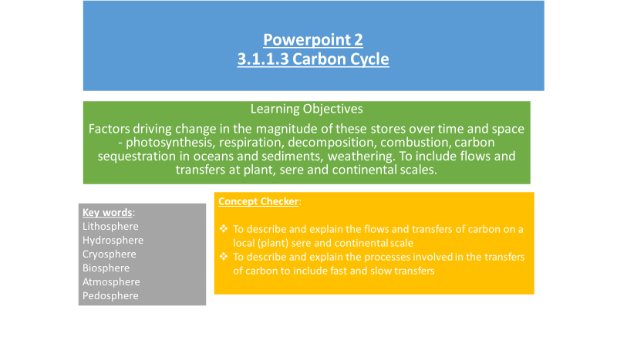

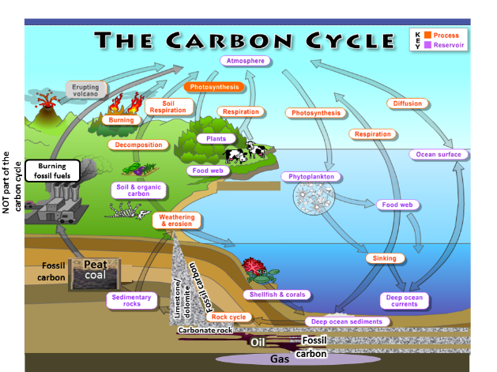

* The processes by which carbon moves between these stores are known as ________________________
* If more carbon enters a store than leaves it, that store is considered a ____________________________
* If more carbon leaves a store than enters it, that store is considered a ____________________________

net carbon sink transfers or fluxes net carbon source

**What are the factors driving change in the carbon cycle?**

|  |  |
| --- | --- |
| **Fast carbon cycle** | **Slow carbon cycle** |
| **The time it takes carbon to move through the fast carbon cycle is measured in a lifespan.**  Includes - photosynthesis, respiration, decomposition, biomass combustion, ocean-atmosphere exchange and biological carbon pump | **This can take place over many tens and hundreds of million years**  Includes - burial and compaction,  geological carbon cycle and weathering |

Use p27-28 Oxford textbook to make notes on the following:-

|  |  |
| --- | --- |
| Photosynthesis | **6CO2 + 6H2O + light energy = C6H12O6 (glucose) + 6O2** |
| Respiration | **C6H1206 + 6O2 = 6CO2 + 6H2O + energy** |
| Decomposition | **C6H12O6 = 6CO2 + 3CO2 + 3CH3 (methane)** |
| Biomass combustion |  |

**Carbon pump definition** – ­­­­­­­­­_________________________________________________

_______________________________________________________________________

**Ocean Atmosphere Exchange**

Water is able to dissolve CO2. At the surface of the ocean there is always an exchange of CO2; some dissolves into the water and some is vented out into the air above. **This is known as the oceanic carbon pump**. Carbon is carried by the oceans on the **thermohaline circulation/cycle**.

Watch the clip about ocean currents from the DVD ‘Power of the Planet – Ocean’ (estream 3495) 33 – 40 minutes

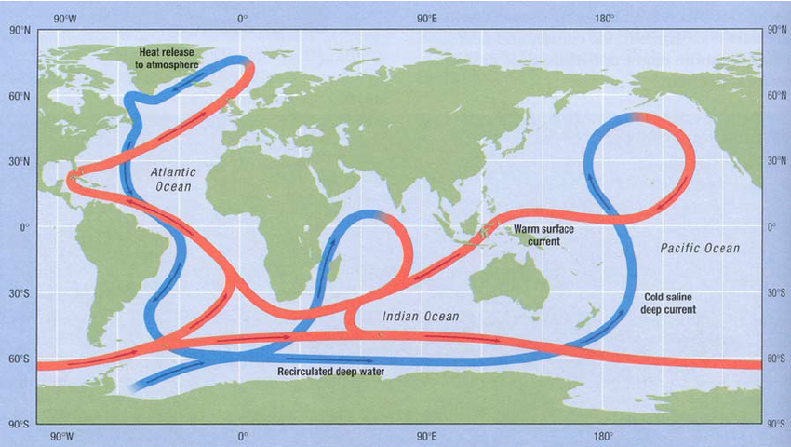

1. There is a negative correlation between the temperature of the water and the amount of CO2 that can be dissolved.
2. Warm water in oceanic surface currents is carried from the warm tropics to the cold polar regions. Here the water is cooled, making it dense enough to sink below the surface layer (downwelling), sometimes all the way to the ocean bed (vertical mixing).
3. When cold water returns to the surface (upwelling) and warms up again, it loses carbon dioxide to the atmosphere.
4. This enormous carbon pump gives the ocean a lot more carbon than it would have if the surface water was not being constantly replenished.

**There is evidence that the thermohaline cycle is weakening. What effect might this have on carbon storage in the oceans?**

**What impact might global warming have on oceanic carbon stores?**

**Using the information above, explain in your own words how the oceanic carbon pump and the thermohaline circulation acts as a carbon sink**

**The Biological Carbon Pump**

* Living things in the ocean move carbon from the atmosphere into surface waters then down into the deeper ocean and then eventually into rocks
* This action of organisms moving carbon in one direction is often called a biological pump
* Carbon gets incorporated into marine organisms as organic matter or structural calcium carbonate
* When organisms die, their dead cells, shells and other parts sink to the deep water. Some material sinks right to the bottom, where it forms layers of carbon-rich sediments.
* Over millions of years, chemical and physical processes may turn these sediments into rocks. This part of the carbon cycle can lock up carbon for millions of years.

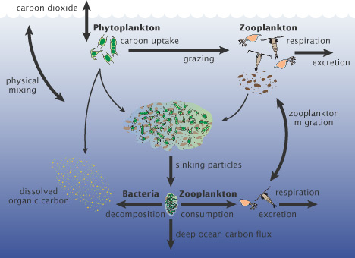

**Burial and Compaction**

* This is where organic matter is buried by sediments and becomes compacted. Over millions of years, these organic sediments containing carbon may form hydrocarbons such as coals and oil.
* Coral and shelled organisms take up carbon dioxide from the water and convert it to calcium carbonate, used to build their shells. When they die, the shells accumulate on the seabed. Some of the carbonates dissolve, releasing carbon dioxide. The rest become compacted to form limestone, storing carbon for millions of years.

**The Role of Weathering and Volcanoes**

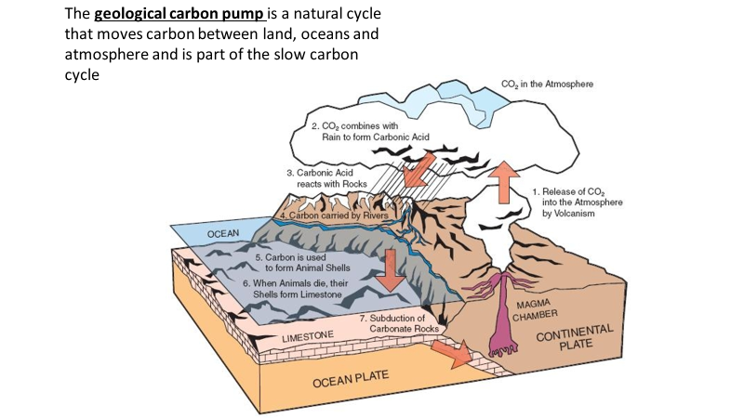

**Explain the role of volcanoes and weathering in the geological carbon cycle (6 marks)**

**Carbon Sequestration**

**Use the powerpoint to answer the following questions**

What is carbon sequestration?

How does terrestrial sequestration occur?

How does oceanic carbon sequestration occur?

There is another form of carbon sequestration called carbon capture. This is when CO2 is captured at source e.g. from power plant emissions and then injected in liquid form into stores underground. This will be discussed further in a later lesson)



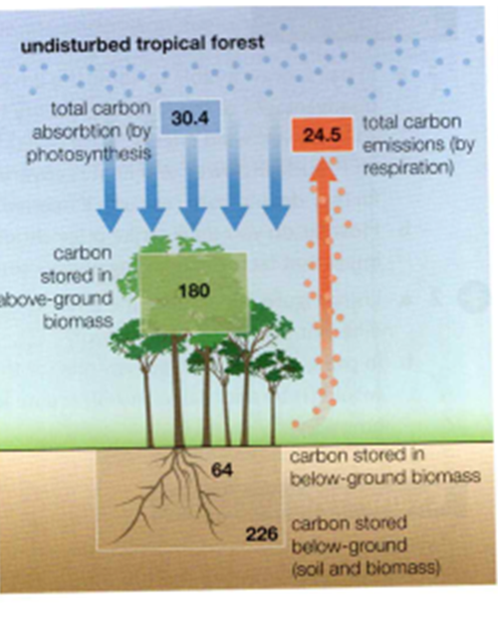

**The Carbon Budget**

What is it?

**The transfer between the carbon stores can occur at a range of scales**

**Local scale** – an individual tree

Carbon fixation is the process that turns gaseous CO2 into living organic compounds that grow. The amount of carbon stored within a tree, woodland or forest depends on the balance between photosynthesis and respiration

Think back to what you have already studied. What might cause a tree to be a net carbon sink or a net carbon source?

What different forms of carbon (C) are there on these diagrams?

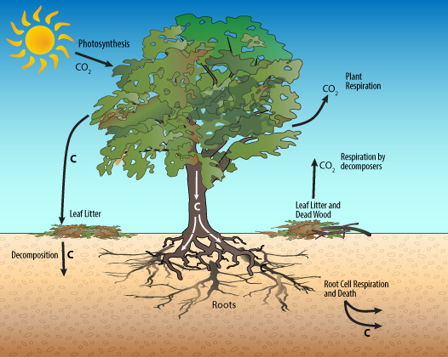

Why is the role of soil important in the carbon cycle?

**Seral Scale**

Use the powepoint to annotate this diagram to show the transfer of carbon along a sere

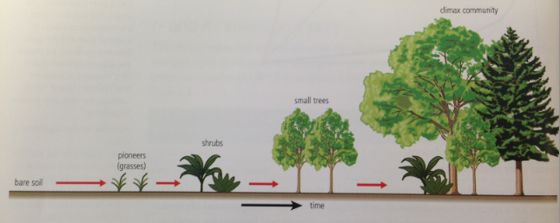

What is a sere?

How does the height of plants and the number of species change as the plant succession develops?

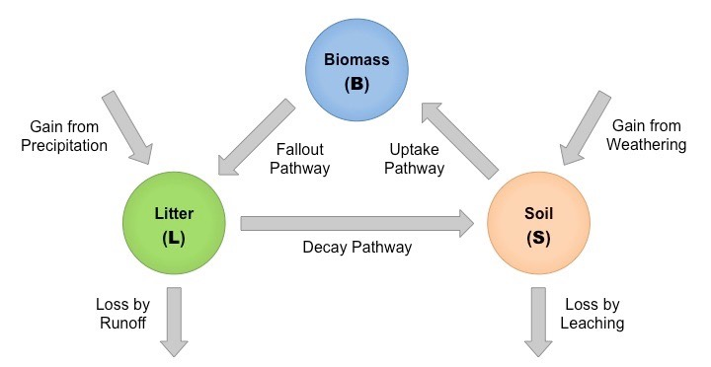

What does this diagram show? (What is the link between biomass, leaf litter and the soil?)

**Global Scale**

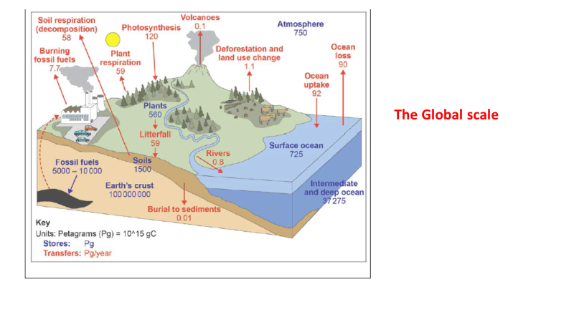

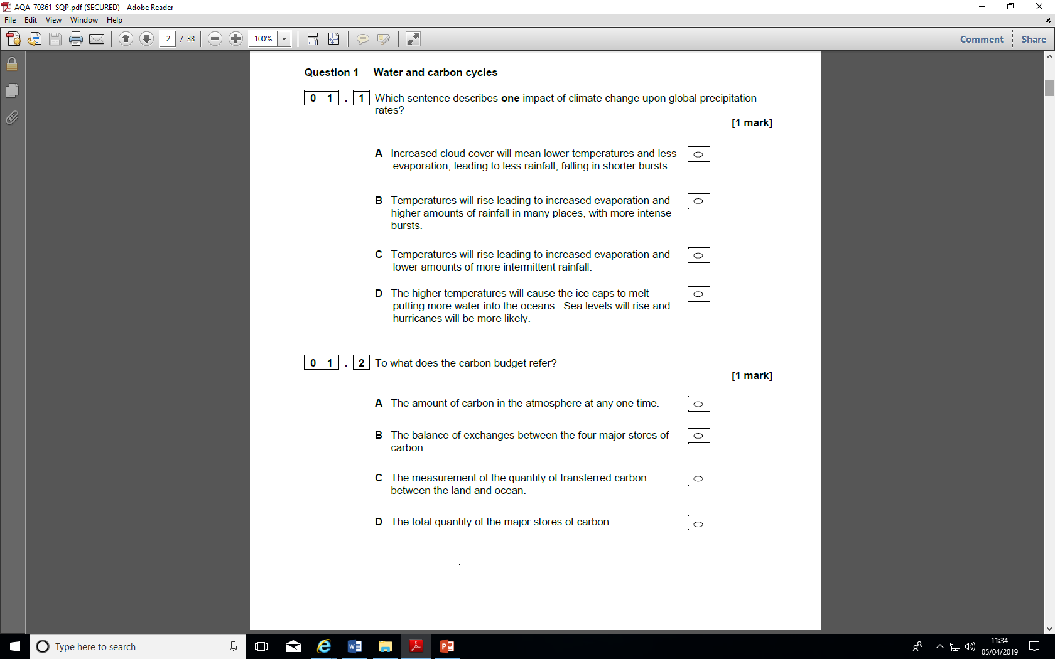

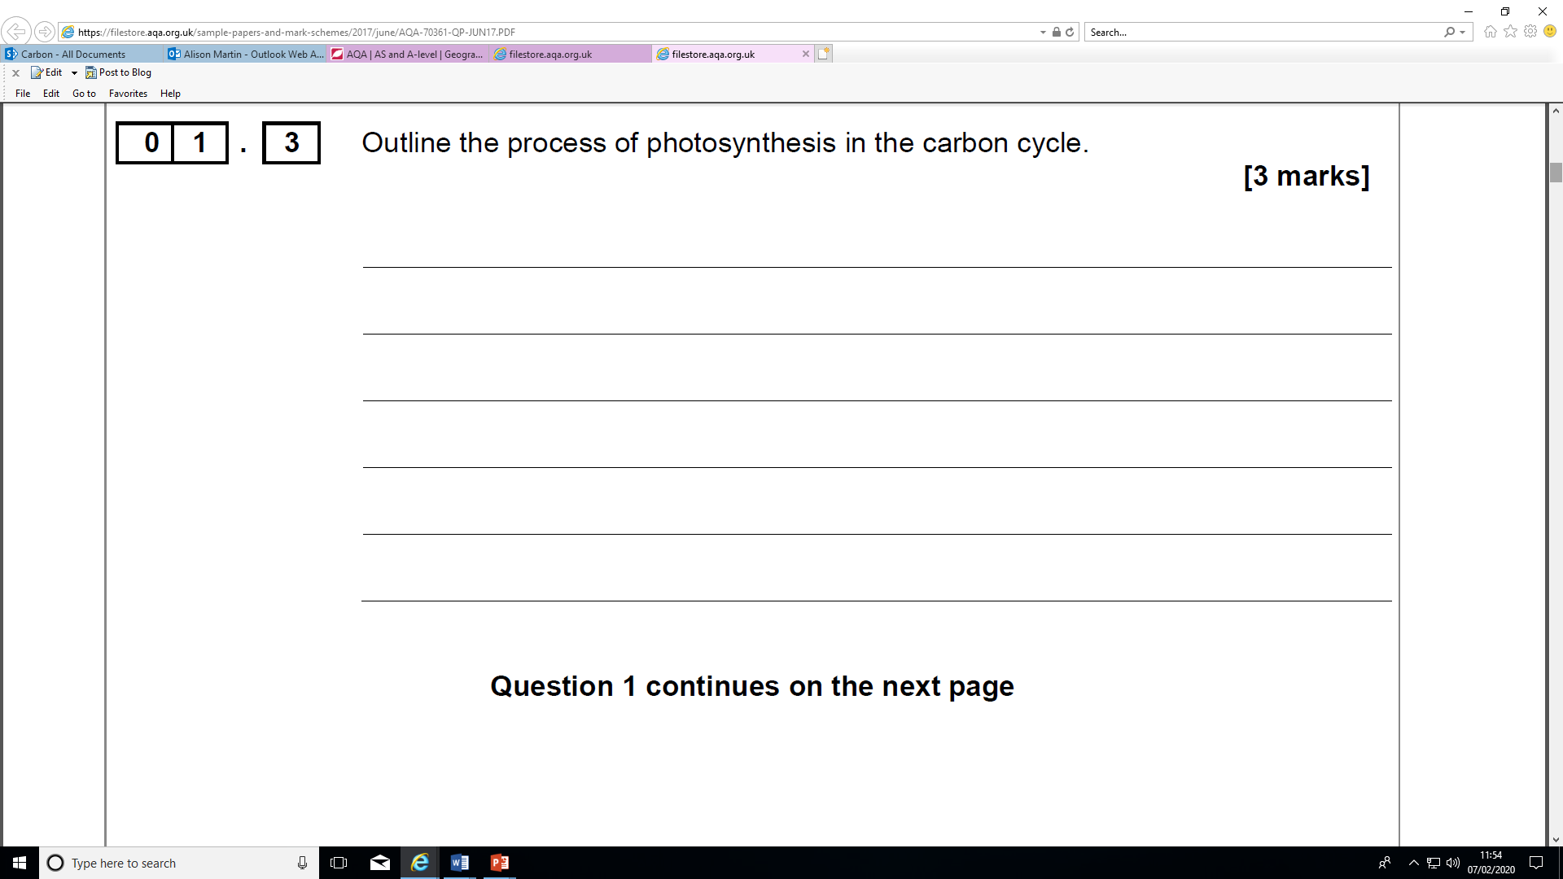

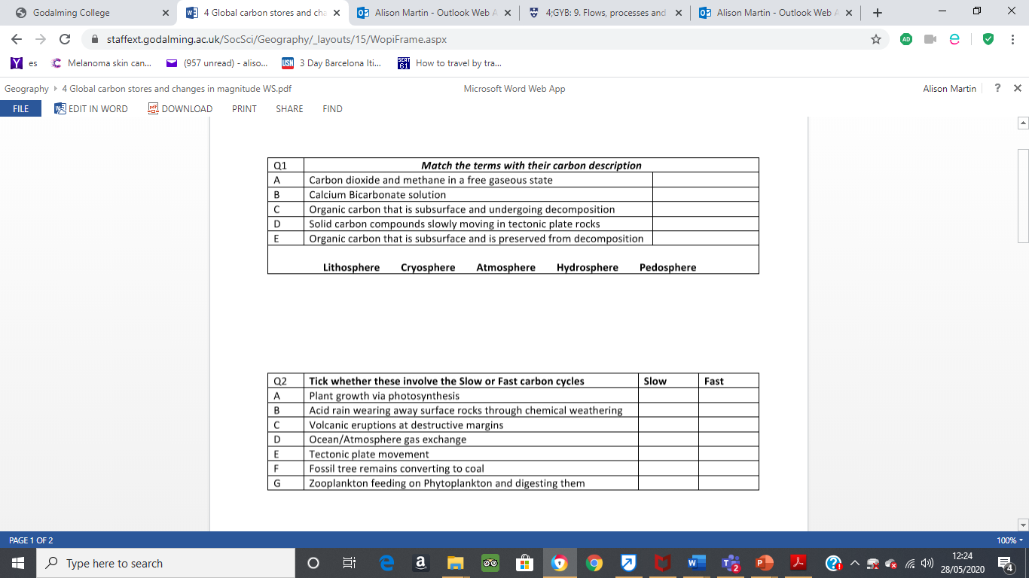

1. **With reference to the ocean carbon cycle describe a carbon ‘input’, ‘store’ and ‘output’ (6 marks)**
2. **Explain what is meant by the term ‘ocean pump’ in relation to carbon cycles (6 marks)**