# Homework 4 Wireless networking Answers

# 1 (a) What wireless protocol is shown in this flowchart? [2]

CSMA/CA (1) with RTS/CTS (1)

**Start**

Assemble a frame

Channel idle?

Transmit RTS (Request to send)

Transmit data

WAIT

**Stop**

No

No

Yes

Yes

CTS (Clear to Send) received?

(b) Complete the boxes marked A, B and C. [3]

# (c) Explain the procedure shown in the flowchart. [4]

The Carrier Sense Multiple Access / Collison Avoidance protocol (1)

CSMA/CA first constructs a frame ready for transmission (1).

It then checks/listens for signals to see if the another node is transmitting (1).

If the channel is clear it sends the data (1), otherwise it waits a random period of time

and then tries again (1).

At this point a Request to Send (RTS) is sent (1).

If a CTS signal is received, the data frame is transmitted. (1)

Otherwise, it waits a random time and sends another RTS.(1)

(d) Explain, with the aid of a diagram, why the steps at B and C are required. [4]

To counteract the problem of “hidden nodes”. Nodes A and B can each communicate with the WAP but cannot detect each others transmissions

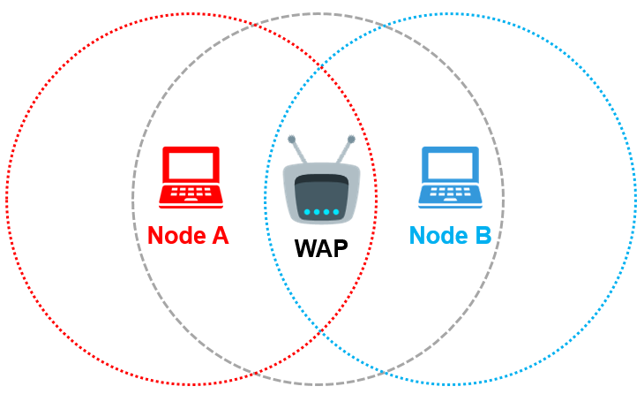

# 2. What does SSID stand for? Explain why it is needed. [3]

Service Set Indentifier (1)

Uniquely identifies a nework (1). It can be set manually or automatically (1) and can also be hidden so the network is harder to detect(1).

Can be set to broadcast to wireless devices in range of access point (1)

3. What is the purpose of the protocols WPA and WPA2? How is this purpose achieved? [2]

They ensure that network communications cannot be hacked. (1) They do this by using strong encryption to encrypt the data being transmitted.(1)

4. Explain what is meant by a **MAC address whitelist**. [2]

It is a list of devices (identified by their MAC addresses) (1) which are permitted to access a particular network.(1)

[Total 20 Marks]