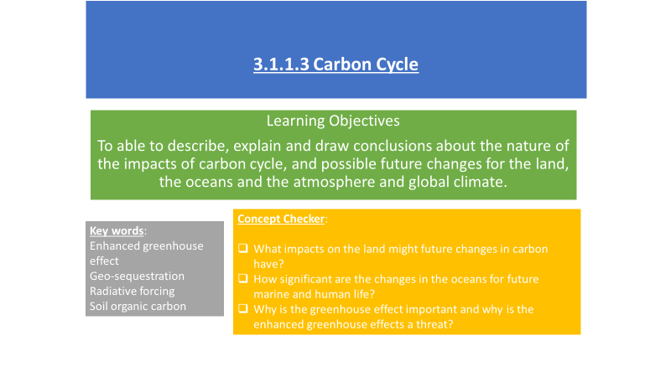

**Impacts on the land**

**Possible impacts on the land**

**Impacts on the ocean**

Again it is very difficult to predict the impacts on the oceans due to the complexity of the processes and a lack of understanding as to how they interact

We do know that it will have an impact on the:-

Acidity Salinity

Temperature Sea level

Sea ice

The impact of increasing atmospheric CO2 on the land has been subject to intense research.

Unfortunately, the results are unclear because the study has, so far, been over a relatively short period of time.

There are also many other variables that have an impact on the land and the atmosphere. These variables are both human and physical. What do you think these may be?

**Ocean acidity**

* About 30% of the CO2 that has been released into the atmosphere has diffused into the oceans
* This creates carbonic acid which makes the oceans slightly less alkaline
* Since 1750, the pH of the ocean’s surface has dropped by 0.1, a 30% change in acidity

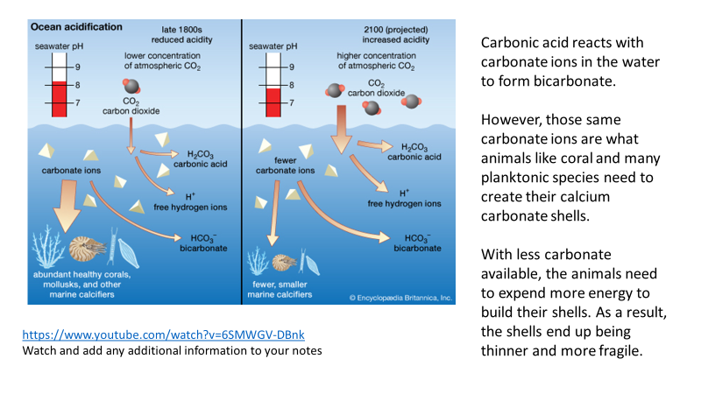

Space for additional notes from the video clips

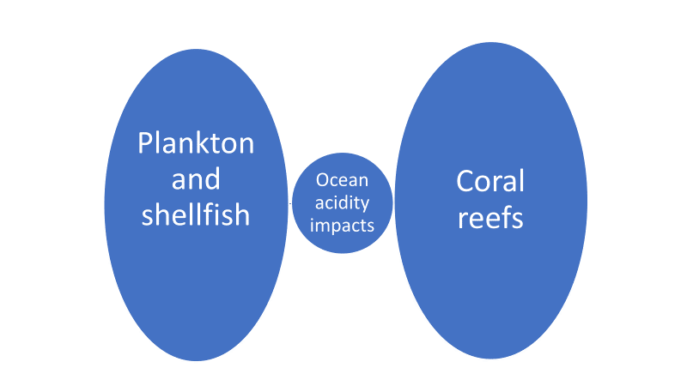

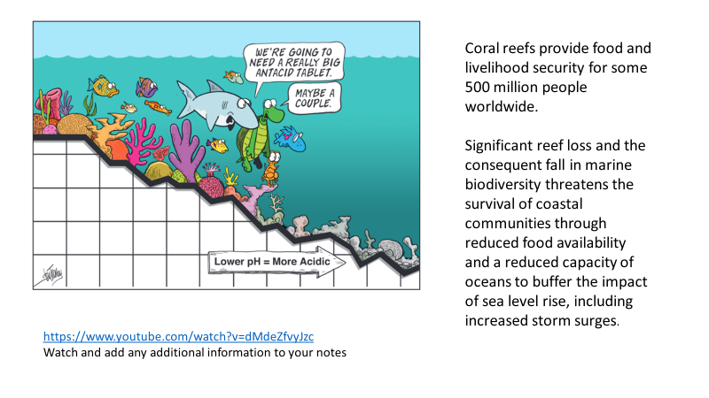

**Ocean warming**

|  |  |
| --- | --- |
| The negatives | The positives |
|  |  |

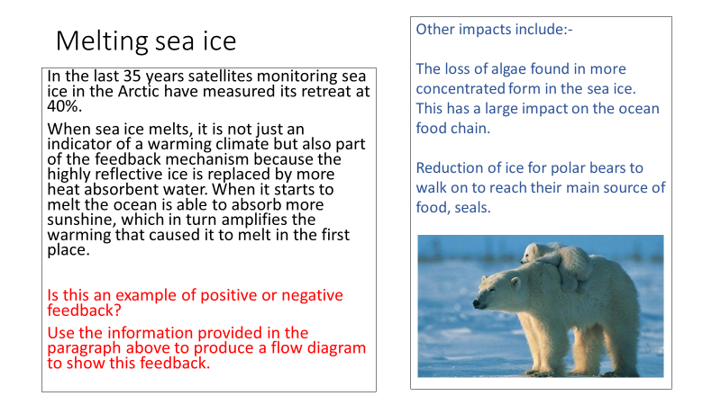

**Ocean salinity** [**https://www.youtube.com/watch?v=UuGrBhK2c7U**](https://www.youtube.com/watch?v=UuGrBhK2c7U)

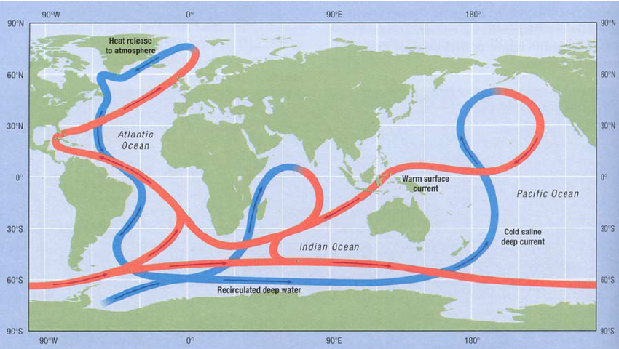

**What effects might the disruption of the North Atlantic Drift have on the climate of NW Europe?**

The water in the far North Atlantic is cold and very saline (salty), which makes it denser and heavier – causing it to sink.

There has been an observed decrease in salinity in the North Atlantic. This is probably due to higher river run-offs and the melting of the Greenland ice sheet.

These changes have been linked to a possible slowing down of the large scale oceanic circulation in the North-East Atlantic.

**Sea level rise**

Research now indicates that sea levels worldwide have been rising at a rate of 3.5mm/year since the 1990s

Causes include:-

* + Melting of terrestrial ice
  + Thermal expansion

If the earth continues to warm-up then we can expect the oceans to rise between 20 and 60cm by 2100. This is not an exact science. Notice the huge variation in predictions? Why is this?

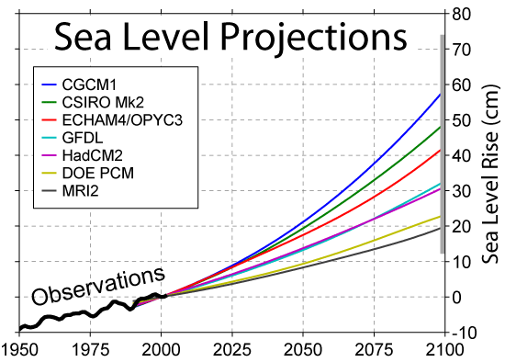

**What are the likely effects of the predicted sea level rises on coastal communities?**

**How might the response of those communities depend on their level of development?**

**Impacts on the atmosphere**

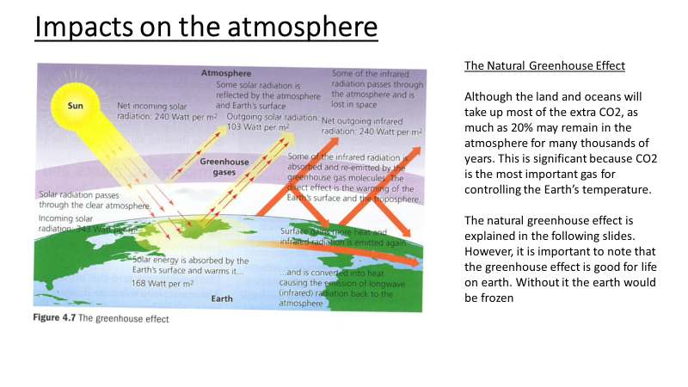

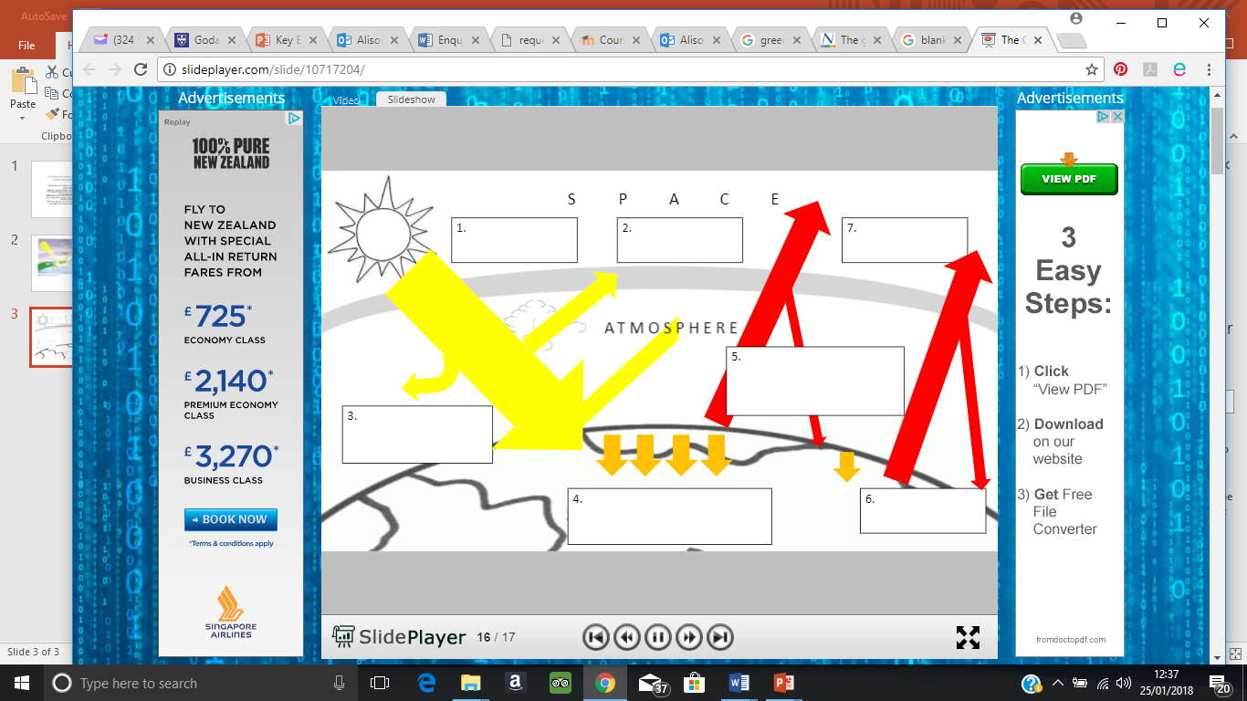

|  |  |
| --- | --- |
| Step |  |
| 1 |  |
| 2 |  |
| 3 |  |
| 4 |  |
| 5 |  |
| 6 |  |
| 7 |  |

**The Enhanced Greenhouse Effect**

The problem that we are facing us is that of an enhanced greenhouse effect. This is where the extra CO2 and other greenhouse gases in the atmosphere are causing something called **radiative forcing.**

The concept of radiative forcing is that if the balance between the incoming and the outgoing energy is anything other than zero there has to be warming (or cooling, if the number is negative) going on.

The amount that the Earth’s energy budget is out of balance is called the radiative forcing and is a measure of recent human activities. It is measured in watts/m2 of the earth’s surface.

Studies have shown that prior to 1750 radiative forcing was negligible. Since then it has increased, not only because of increased greenhouse emissions but also changing albedos due to land use changes.

Measurements of the actual amount of radiative forcing is difficult because of many complicating factors including natural changes in solar radiation and the effects of aerosols such as carbon particles from diesel exhausts.

**How might the way people live in various parts of the world contribute to rising levels of CO2?**

