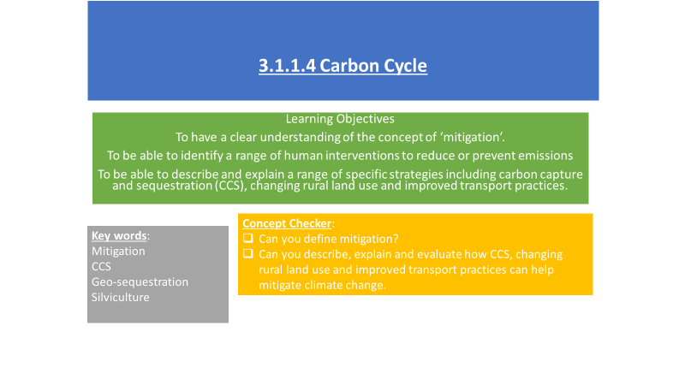

**Definition of mitigation –**

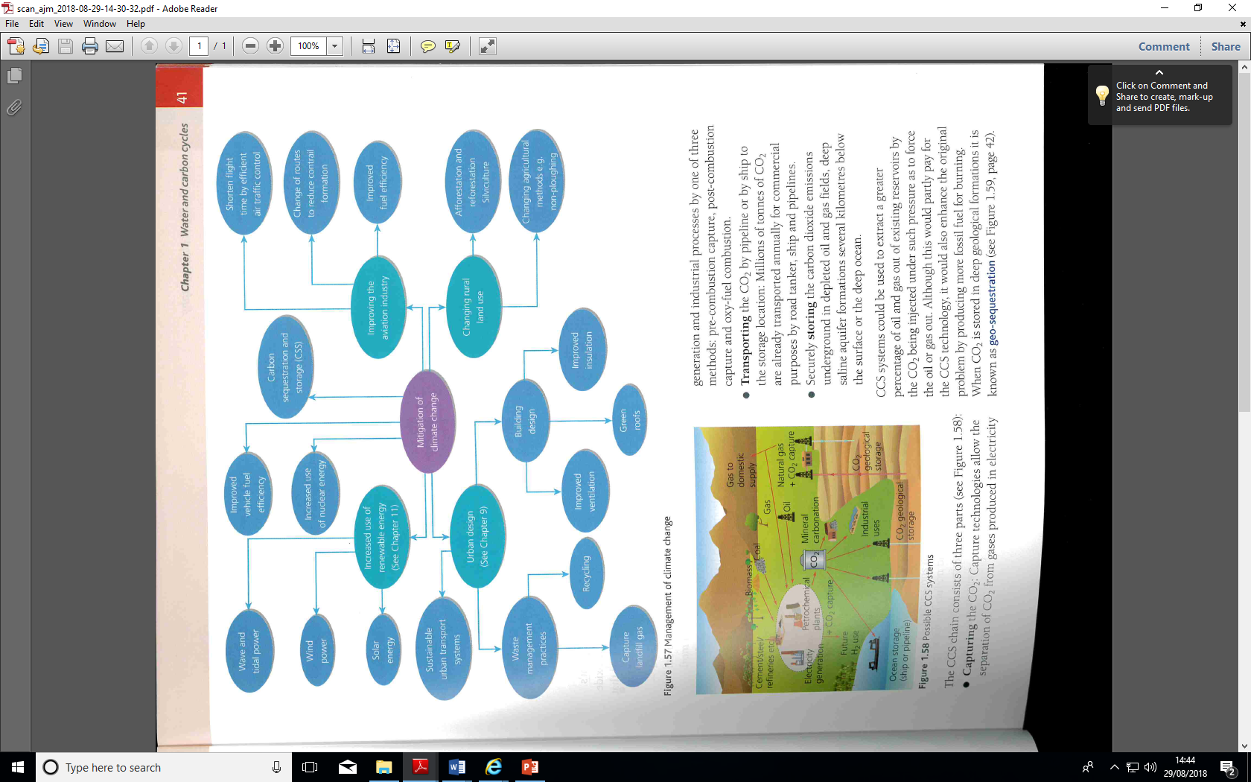**Read the Geography Review article – How can we manage global warming?**

Answer the following questions

1. What does the Intergovernmental Panel on Climate Change (IPCC) say may happen if the climate warms by 2°C above pre-industrial levels?
2. What does the 2015 Paris Agreement commit the world’s governments to do?
3. Why is ‘transnational governance’ required?
4. Do you think that the Paris Agreement will work? Why?
5. How long does the IPPC think that we have in the ‘carbon budget’, after which time we will be experiencing warming over 1.5°C?
6. What is the biggest problem that is making it hard to reduce emissions?
7. Why are some countries arguing that they should follow China and Brazil and base future economic growth on GHG – emitting fuel sources?
8. What are NETs? Explain the different NETs summarised in Figure 1
9. What is SRM? How does it work?
10. What are the difficulties of reforestation as a form of carbon capture and storage?
11. What are the difficulties with bioenergy with carbon capture and storage?
12. What are the issues with large scale SAI?
13. What is Plan A and why is it politically unpopular?
14. What is Plan B and what are the problems with this plan?
15. Why might geopolitical tensions rise?

COP27: Key climate goal of 1.5C rise faces new challenge BBC 11th November 22

**Emissions of CO2 are rising so quickly there is now a 50% chance the world will cross a crucial climate change threshold soon, a new report suggests.**

Emissions for 2022 are expected to remain at record levels, lifted by people flying again after Covid.

The report said that if emissions stay so high, the world faces a 50% risk of breaching a key 1.5C temperature rise threshold in nine years.

This would have sweeping consequences for poorer and developing countries.

Average temperatures are now 1.1C above pre-industrial levels, and that increase has already caused [**major climate disasters**](https://www.bbc.co.uk/news/world-asia-63080101) this year.

If global average temperatures were to rise to more than 1.5C, [**the UN says**](https://www.ipcc.ch/sr15/) it would expose millions more people to potentially devastating climate impacts.

The researchers have said emissions were rising in 2022 because of an increase in flying and the use of coal.

The report, published by the Global Carbon Project (GCP), used monthly energy data to estimate that global greenhouse gas emissions will rise by 1% this year.

This is in stark contrast to a recent UN report that global emissions need to fall by 45% by 2030 to keep temperatures below 1.5C.

Nations agreed in 2015 to "pursue efforts" to limit global temperature rises to 1.5C above pre-industrial levels.

The UN climate body, the IPCC, has said keeping temperature rises below 1.5C, rather than 2C, would mean:

* 10 million fewer people would lose their homes to rising sea levels
* a 50% reduction in the number of people experiencing water insecurity
* a reduction in coral reef loss from 99% to 70%

[**The GCP report**](https://doi.org/10.18160/gcp-2022) - prepared by more than 70 scientists - is launched today at the UN climate summit COP27 in the Egyptian resort of Sharm el-Sheikh, where countries are in the middle of climate change negotiations.

Dr Robin Lamboll, Research Associate in Climate Science and Policy at Imperial College London said: "The report should remind negotiators at COP27 that their actions so far have been inadequate."

At last year's Glasgow climate summit, COP26, countries were asked to prepare more ambitious targets before coming to Egypt - but only 29 turned up with new plans.

And on Thursday, another group of climate experts at Climate Action Tracker predicted that even with these new pledges, world temperatures would rise 2.7C above pre-industrial levels by 2100.

India is expected to be the largest contributor to the growth in emissions in 2022 as it continues to increase its use of coal - the most polluting of fossil fuels.

But Dr Kamya Choudhary, India policy fellow at London School of Economics, thinks this is a short-term measure to cope with the ongoing energy crisis.

One of the report's authors, Robbie Andrew, a senior researcher at CICERO, pointed out that even though developing countries like India are increasing their emissions quickly, they are still significantly lower per person than in Europe.

And European countries are also turning to dirtier fossil fuels to cope with energy shortages driven by the Russian invasion of Ukraine.

Germany is burning more coal this year than last, and the UK has asked energy firms to delay the closure of end-of-life coal plants.

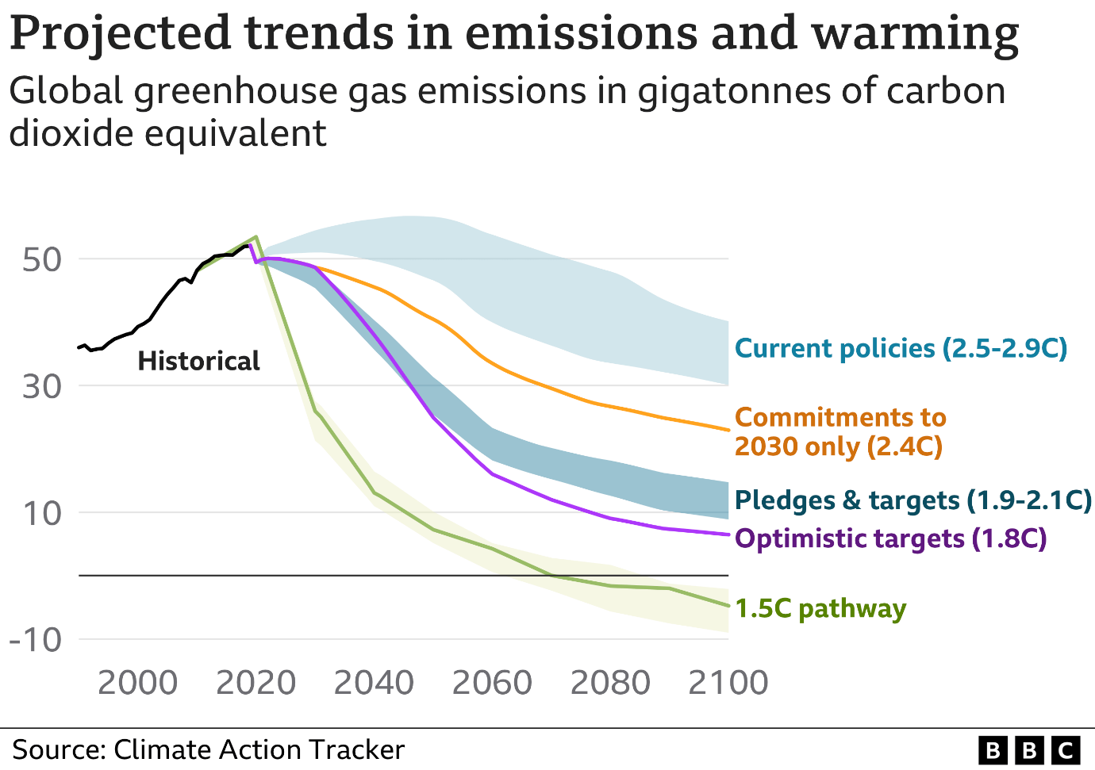

Although Professor Vanesa Castán Broto, UN climate expert, acknowledges that the report is "bleak", she says there are reasons to be hopeful: "There is evidence of responses from the public and private sectors, and from NGOs, community organisations, and individuals."

"These voluntary efforts must be accompanied by agreements to regulate the use of fossil fuels," she added.

But there have been divisions emerging here in Egypt at the UN climate summit. Some developing nations such as Senegal and South Africa want to make use of their gas resources whilst they transition to fossil-free energy sources.

The Idy Niang, head of climate change programme, Department of the Environment, Senegal told the BBC at COP27: "We just discovered gas and petroleum, and we start exporting it, so we cannot abandon it as we are LDC and need to enforce our economy for development."

**TASK**

1. **Why is 1.5°C such a critical threshold?**

1. **Identify all the challenges identified in this article in trying to limit global warming to 1.5°C.**

**Negative Emission Schemes**

[The carbon cycle is key to understanding climate change - YouTube](https://www.youtube.com/watch?v=yhlg9txl7yM)

Negative emission technologies (NETs) focus on the removal of carbon from the atmosphere. These can be either by creating a new sink or by amplifying the actions of an existing sink. **Watch the clip above and give an example of each:-**

**Creating a new sink:-**

**Amplifying and existing sink:-**

**Why is it dangerous to focus on negative emissions schemes (NETs?**

**Direct Air Capture**

[**https://www.youtube.com/watch?v=XxjNhLZCae0**](https://www.youtube.com/watch?v=XxjNhLZCae0)

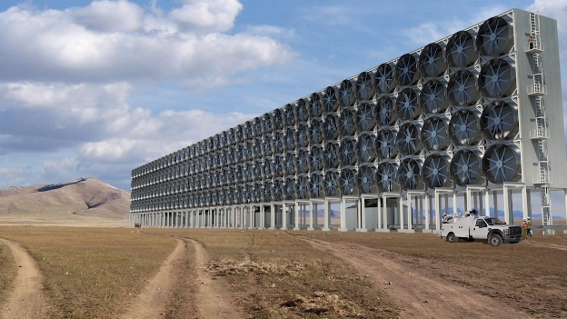 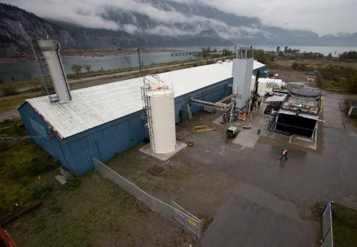

What is it?

Where is it taking place?

How does it work?

What will detremine its success?

How many direct air capture plants will we need worldwide to remove the carbon we emit into the atmosphere?

Carbon Capture and Sequestration

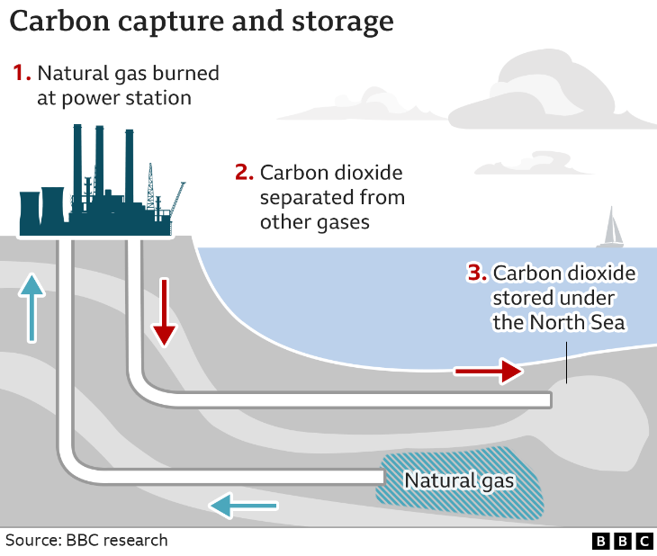

Burning fossil fuels like oil, gas and coal to generate electricity emits CO2, which is the main driver of climate change.

The carbon capture process stops most of the CO2 produced from being released, and either re-uses it or stores it underground.

**Boundary Dam CCS Plant in Saskatchewan Canada**

**Make notes on the above case study using p43 of the Hodder textbook (New edition textbook – scanned page on GoL)**

Time for Geography Video clip on energy sustainability

[Achieving energy sustainability: eco-homes, energy sources, efficiency adaptations and challenges (timeforgeography.co.uk)](https://timeforgeography.co.uk/videos-list/resource-management/achieving-energy-sustainability/)

**List the different strategies included in the video clip that are regarded as sustainable**

**What are the challenges of energy sustainability included in the video clip?**

**UK National Grid Electricity Generation**

**What evidence is there that the UK is making good progress with its transition from fossil fuels to renewable energy? Quote data.**

**What are the challenges it faces?**

**Fossil Fuels V Renewable in the UK**

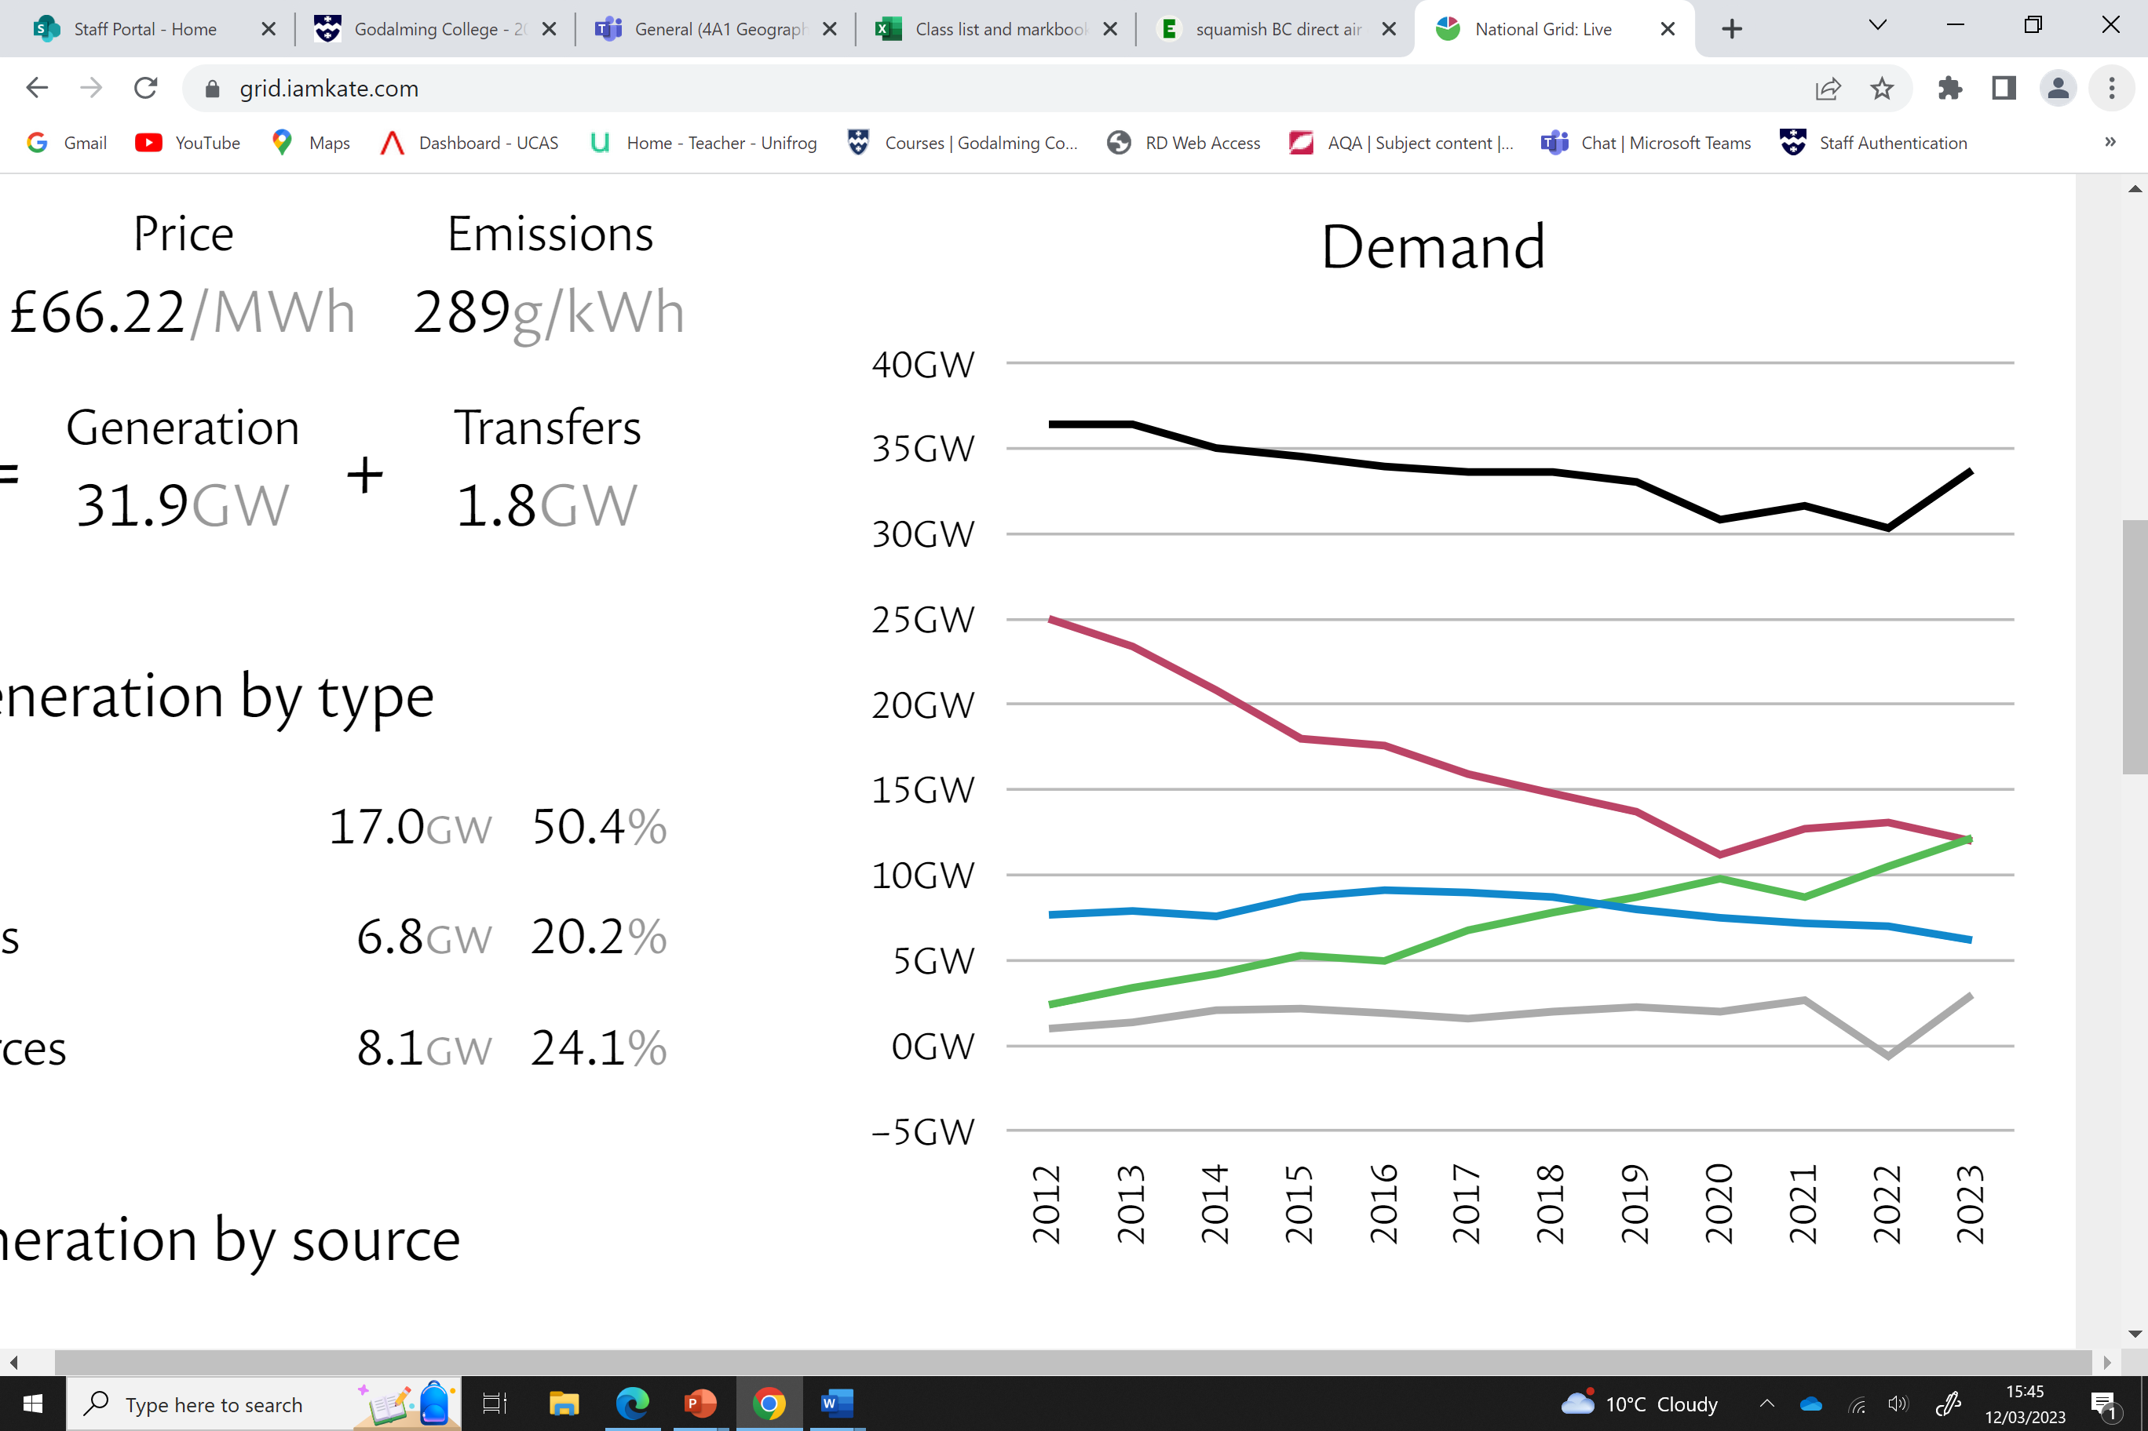 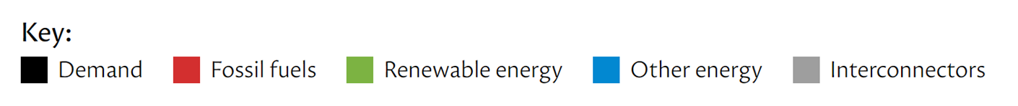 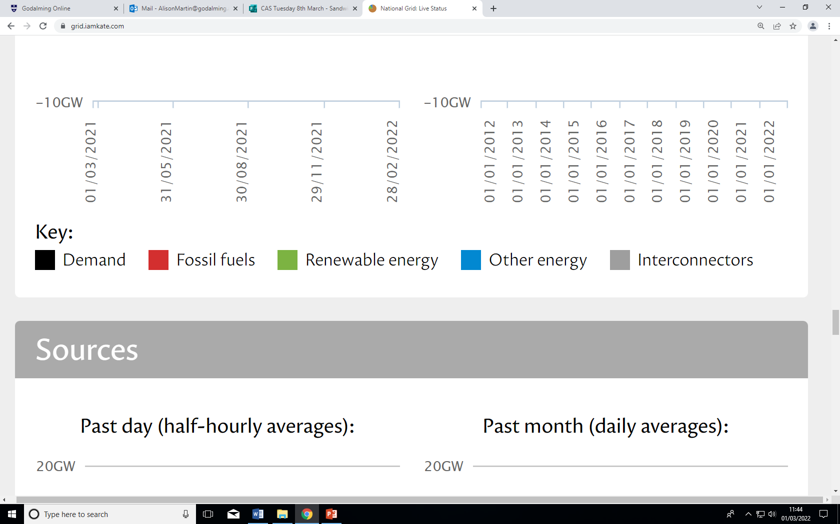

**Mitigation strategies – Changing rural land use**

**Make notes on the following using the Hodder textbook:-**

Grasslands

Croplands

Forest and tree crops

**Mitigation strategies -Improved aviation strategies**

**Make notes on how the aviation industry could reduce its emissions?**

Despite the aviation industry making major strides in reducing its production of CO2 in 2020 the global emissions of CO2 will be 70% more than in 2005 and could be 300% more by 2050. **Why do you think that this may be the case?**

**Critically evaluate the different mitigating strategies for reducing global CO2 levels (20 marks)**

1. **Break down the Q – identify the command word and the different mitigation strategies**
2. **What is your judgement/argument? (you will need to have a judgement/argument for each strategy you mention)**
3. **What evidence do you have to back up your argument? Can you include facts and figures or case study evidence?**
4. **Overall conclusion – which strategies you think may be the most effective and least effective?**

