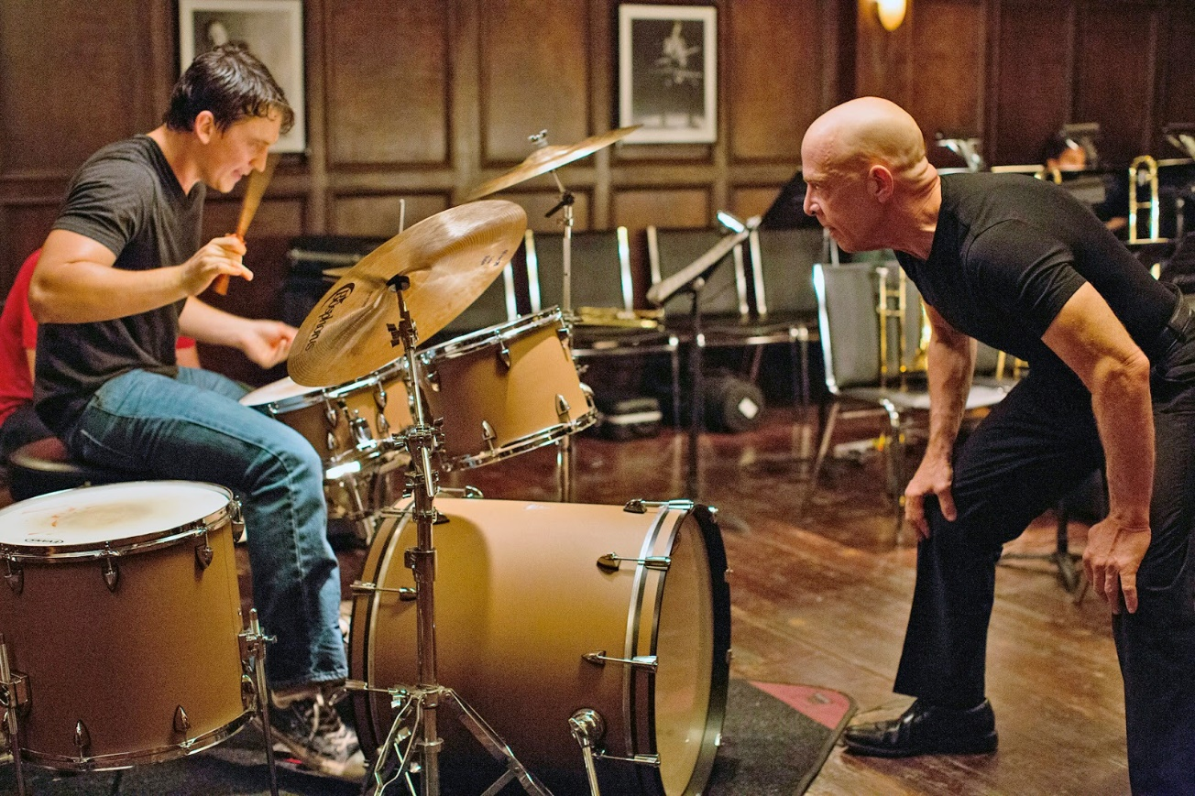

‘He craves approval, but has a somewhat sterile relationship with his father, who doesn’t seem to understand what Andrew is doing.’

‘For Andrew, his first real female connection is nothing more than a distraction from his work at winning the approval of the uber-macho Fletcher.’

**Cinematography** – *Describe the cinematography-* *Shot types and movement. Who are we being asked to align ourselves with? When do we see the use of POV? When are particular angles used?*

‘ . . . .Oscars 2015 was dominated by films about men and about masculinity itself.’

‘Masculinity becomes a performance and a competition between two figures battling to outalpha the other is the film’s finale.’

‘Even Fletcher’s appearance is one of masculine performance. He is stripped down, in terms of his shaven head and his plain black clothing, with no sort of flourish upon his body.’

‘The notion of being approved by Fletcher – a recognised alpha male – excites Andrew to the degree that he is prepared to do just about anything.’