**Q1.**

Lactose is a disaccharide found in milk. In the human small intestine, the enzyme lactase catalyses the hydrolysis of lactose to the monosaccharides, galactose and glucose. These monosaccharides are then absorbed into the blood.

Complete the diagram to show the hydrolysis of lactose to galactose and glucose.

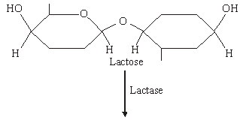

**(Total 2 marks)**

**Q2.**

(a)     Glycogen and cellulose are both carbohydrates.

Describe **two** differences between the structure of a cellulose molecule and a glycogen molecule.

1. _________________________________________________________________

___________________________________________________________________

___________________________________________________________________

2. _________________________________________________________________

___________________________________________________________________

___________________________________________________________________

**(2)**

(b)     Starch is a carbohydrate often stored in plant cells.

Describe and explain **two** features of starch that make it a good storage molecule.

1. _________________________________________________________________

___________________________________________________________________

___________________________________________________________________

2. _________________________________________________________________

___________________________________________________________________

___________________________________________________________________

**(2)**

(c)     Tick (✔) the box that identifies the test which would be used to show the presence of starch.

|  |  |
| --- | --- |
| Acid hydrolysis test |  |
| Benedict’s test |  |
| Emulsion test |  |
| Iodine/potassium iodide test |  |

**(1)**

**(Total 5 marks)**

**Q3.**

Sucrose is a disaccharide. It is formed from two monosaccharides **P** and **Q**. The diagram shows the structure of molecules of sucrose and monosaccharide **P**.

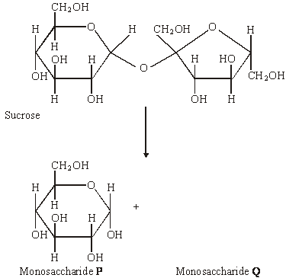

(a)     (i)      Name monosaccharide **Q**.

______________________________________________________________

**(1)**

(ii)     Draw the structure of a molecule of monosaccharide **Q** in the space above.

**(1)**

(b)     The enzyme sucrase catalyses the breakdown of sucrose into monosaccharides. What type of reaction is this breakdown?

___________________________________________________________________

**(1)**

**(Total 3 marks)**

**Q4.**

In mammals, in the early stages of pregnancy, a developing embryo exchanges substances with its mother via cells in the lining of the uterus. At this stage, there is a high concentration of glycogen in cells lining the uterus.

(a)     Describe the structure of glycogen.

___________________________________________________________________

___________________________________________________________________

___________________________________________________________________

___________________________________________________________________

___________________________________________________________________

___________________________________________________________________

___________________________________________________________________

___________________________________________________________________

**(2)**

**(Total 2 marks)**

**Q5.**

(a)    Name the monosaccharides of which the following disaccharides are composed.

(i)      Sucrose

monosaccharides___________________and___________________

**(1)**

(ii)     Lactose

monosaccharides___________________and___________________

**(1)**

**(Total 2 marks)**

**Q6.**

(a)    The table shows some statements about three carbohydrates. Complete the table with a tick in each box if the statement is true.

|  |  |  |  |
| --- | --- | --- | --- |
| **Statement** | **Starch** | **Cellulose** | **Glycogen** |
| Found in plant cells |  |  |  |
| Contains glycosidic bonds |  |  |  |
| Contains β-glucose |  |  |  |

**(3)**

(b)     Name the type of reaction that would break down these carbohydrates into their monomers.

___________________________________________________________________

**(1)**

(c)     Give **one** feature of starch and explain how this feature enables it to act as a storage substance.

Feature ____________________________________________________________

Explanation _________________________________________________________

___________________________________________________________________

**(2)**

**(Total 6 marks)**

**Q7.**

The diagram shows one end of a cellulose molecule.

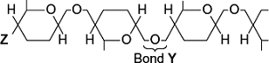

(a)     (i)      Name the monomers that form a cellulose molecule.

______________________________________________________________

**(1)**

(ii)     Name bond **Y**.

______________________________________________________________

**(1)**

(iii)    What chemical group is at position **Z**?

______________________________________________________________

**(1)**

(b)     (i)      Complete the table to show **two** ways in which the structure of cellulose is different from the structure of starch.

|  |  |
| --- | --- |
| **Starch** | **Cellulose** |
|  |  |
|  |  |

**(2)**

(ii)     Explain **one** way in which the structure of cellulose is linked to its function.

______________________________________________________________

______________________________________________________________

______________________________________________________________

______________________________________________________________

**(2)**

**(Total 7 marks)**

**Q8.** (b)     The diagram shows two molecules of β-glucose.

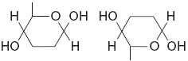

On the diagram, draw a box around the atoms that are removed when the two β-glucose molecules are joined by condensation.

**(2)**

(c)     (i)      Hydrogen bonds are important in cellulose molecules. Explain why.

______________________________________________________________

______________________________________________________________

______________________________________________________________

**(2)**

(ii)     A starch molecule has a spiral shape. Explain why this shape is important to its function in cells.

______________________________________________________________

______________________________________________________________

**(1)**

**(Total 5 marks)**

**Q9.**

The diagram represents a triglyceride.

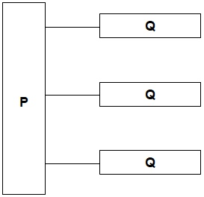

(a)     Name the molecules represented in the diagram by:

Box **P** _____________________________________________________________

Box **Q** _____________________________________________________________

**(2)**

(b)     Name the type of bond between **P** and **Q** in he diagram.

___________________________________________________________________

**(1)**

(c)     Describe how you would test a liquid sample for the presence of lipid **and** how you would recognise a positive result.

___________________________________________________________________

___________________________________________________________________

___________________________________________________________________

___________________________________________________________________

___________________________________________________________________

___________________________________________________________________

**(2)**

**(Total 5 marks)**

**Q10.**

(a)     Some seeds contain lipids. Describe how you could use the emulsion test to show that a seed contains lipids.

___________________________________________________________________

___________________________________________________________________

___________________________________________________________________

___________________________________________________________________

___________________________________________________________________

___________________________________________________________________

___________________________________________________________________

**(3)**

(b)     A triglyceride is one type of lipid. The diagram shows the structure of a triglyceride molecule.

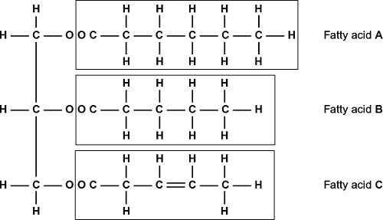

(i)      A triglyceride molecule is formed by condensation. From how many molecules is this triglyceride formed?



**(1)**

(ii)     The structure of a phospholipid molecule is different from that of a triglyceride.  
Describe how a phospholipid is different.

______________________________________________________________

______________________________________________________________

______________________________________________________________

______________________________________________________________

**(2)**

(iii)    Use the diagram to explain what is meant by an unsaturated fatty acid.

______________________________________________________________

______________________________________________________________

______________________________________________________________

______________________________________________________________

______________________________________________________________

**(2)**

**(Total 8 marks)**