**Q1.**

The diagram shows the structure of the amino acid serine.

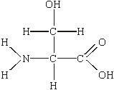

(a)     (i)      Draw a box on the diagram around the R group of serine and label the box with the letter **R**.

**(1)**

(ii)     Draw a circle around each of the parts of the serine molecule which would be removed when **two** other amino acid molecules join directly to it.

**(1)**

(b)     (i)      Which **two** substances are formed when two amino acid molecules join together?

1. ____________________________________________________________

2. ____________________________________________________________

**(1)**

(ii)     Name the type of bond formed between the joined pair of amino acid molecules.

______________________________________________________________

**(1)**

**(Total 4 marks)**

**Q2.**

(a)     Describe how a peptide bond is formed between two amino acids to form a dipeptide.

___________________________________________________________________

___________________________________________________________________

___________________________________________________________________

___________________________________________________________________

___________________________________________________________________

___________________________________________________________________

**(2)**

(b)     The secondary structure of a polypeptide is produced by bonds between amino acids.

Describe how.

___________________________________________________________________

___________________________________________________________________

___________________________________________________________________

___________________________________________________________________

___________________________________________________________________

___________________________________________________________________

**(2)**

(c)     Two proteins have the same number and type of amino acids but different tertiary structures.

Explain why.

___________________________________________________________________

___________________________________________________________________

___________________________________________________________________

___________________________________________________________________

___________________________________________________________________

___________________________________________________________________

___________________________________________________________________

**(2)**

**(Total 6 marks)**

**Q3.**

(a)     Describe the induced-fit model of enzyme action.

___________________________________________________________________

___________________________________________________________________

___________________________________________________________________

___________________________________________________________________

___________________________________________________________________

**(2)**

(b)     A scientist investigated the hydrolysis of starch.  
He added amylase to a suspension of starch and measured the concentration of maltose in the reaction mixture at regular intervals.

His results are shown in the graph below.

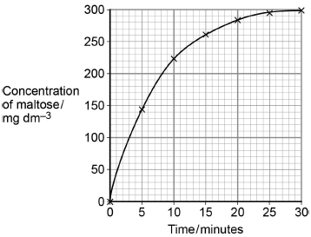

Determine the rate of the reaction **at** 10 minutes.

Show how you obtained your answer.

Rate of reaction ____________________ mg dm−3 min−1

**(2)**

(c)     Explain the results shown in the graph.

___________________________________________________________________

___________________________________________________________________

___________________________________________________________________

___________________________________________________________________

___________________________________________________________________

**(2)**

**(Total 6 marks)**

**Q4.**

A student investigated the effect of substrate concentration on the initial rate of an enzyme-catalysed reaction.

She added 10 cm3 of an enzyme solution to 10 cm3 of substrate solutions of different concentrations. At 30-second intervals, she tested samples of each mixture for the presence of substrate.

•        **A** – in the absence of an inhibitor.

•        **B** – with a competitive inhibitor added to the substrate solution.

•        **C** – with a non-competitive inhibitor added to the substrate solution.

Her results are shown in the graph below.

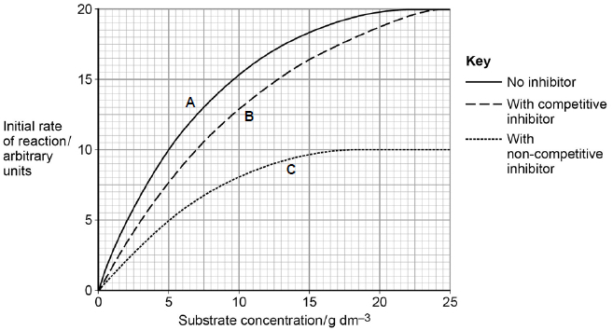

(a)     Explain the results **without** inhibitor (curve **A**) shown in the graph.

___________________________________________________________________

___________________________________________________________________

___________________________________________________________________

___________________________________________________________________

___________________________________________________________________

**(2)**

(b)     The graph shows that the maximum initial rate of reaction (Vmax) when a competitive inhibitor was present (curve **B**) is different from that when a non-competitive inhibitor was present (curve **C**).

Explain this difference.

___________________________________________________________________

___________________________________________________________________

___________________________________________________________________

___________________________________________________________________

___________________________________________________________________

___________________________________________________________________

___________________________________________________________________

**(4)**

(c)     The Michaelis constant (Km) is the substrate concentration at which the initial rate of reaction is half its maximum value (Vmax).

How could you use the Michaelis constant to determine the type of inhibition occurring in an enzyme-catalysed reaction?

Use information from the graph to support your answer.

___________________________________________________________________

___________________________________________________________________

**(1)**

**(Total 7 marks)**

**Q5.**

A technician investigated the effect of temperature on the rate of an enzyme-controlled reaction. At each temperature, he started the reaction using the same volume of substrate solution and the same volume of enzyme solution.

The figure below shows his results.

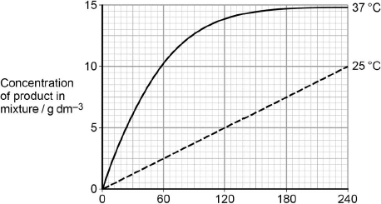  
                Time after start of reaction / s

(a)     Give **one** other factor the technician would have controlled.

___________________________________________________________________

___________________________________________________________________

**(1)**

(b)     Calculate the rate of reaction at 25 °C.

Answer ____________________

**(2)**

(c)     Describe and explain the differences between the two curves.

___________________________________________________________________

___________________________________________________________________

___________________________________________________________________

___________________________________________________________________

___________________________________________________________________

___________________________________________________________________

___________________________________________________________________

___________________________________________________________________

___________________________________________________________________

___________________________________________________________________

**(5)**

**(Total 8 marks)**

**Q6.**

Read the following passage.

|  |  |
| --- | --- |
| Aspirin is a very useful drug. One of its uses is to reduce fever and inflammation. Aspirin does this by preventing cells from producing substances called prostaglandins. Prostaglandins are produced by an enzyme-controlled pathway. Aspirin works by inhibiting one of the enzymes in this pathway. Aspirin attaches permanently to a chemical group on one of the monomers that make up the active site of this enzyme. | 5 |
| The enzyme that is involved in the pathway leading to the production of prostaglandins is also involved in the pathway leading to the production of thromboxane. This is a substance that promotes blood clotting. A small daily dose of aspirin may reduce the risk of myocardial infarction (heart attack). | 10 |

Use information from the passage and your own knowledge to answer the following questions.

(a)     Name the monomers that make up the active site of the enzyme (lines 6 – 7).

___________________________________________________________________

**(1)**

(b)     The diagram shows the pathways by which prostaglandins and thromboxane are formed.

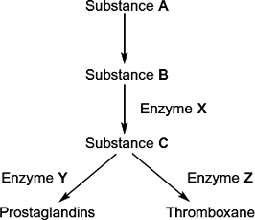

(i)      Aspirin only affects one of the enzymes in this pathway. Use information in lines 5 - 7 to explain why aspirin does **not** affect the other enzymes.

______________________________________________________________

______________________________________________________________

______________________________________________________________

______________________________________________________________

**(2)**

(ii)     Which enzyme, **X**, **Y** or **Z**, is inhibited by aspirin? Explain the evidence from the passage that supports your answer.

Enzyme _______________________________________________________

Explanation ____________________________________________________

______________________________________________________________

**(2)**

(c)     Aspirin is an enzyme inhibitor. Explain how aspirin prevents substrate molecules being converted to product molecules.

___________________________________________________________________

___________________________________________________________________

___________________________________________________________________

___________________________________________________________________

**(2)**

**(Total 7 marks)**

**Q7.**

The graph shows the effect of substrate concentration on the rate of an enzyme-controlled reaction.

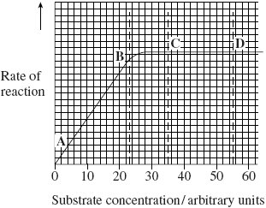

(a)     (i)      Describe what the graph shows about the effect of substrate concentration on the rate of this enzyme-controlled reaction.

______________________________________________________________

______________________________________________________________

______________________________________________________________

______________________________________________________________

**(2)**

(ii)     What limits the rate of this reaction between points **A** and **B**? Give the evidence from the graph for this.

______________________________________________________________

______________________________________________________________

______________________________________________________________

**(2)**

(iii)     Suggest a reason for the shape of the curve between points **C** and **D**.

______________________________________________________________

______________________________________________________________

**(1)**

(b)     Sketch a curve on the graph to show the rate of this reaction in the presence of a competitive inhibitor.

**(1)**

(c)     Methotrexate is a drug used in the treatment of cancer. It is a competitive inhibitor and affects the enzyme folate reductase.

(i)      Explain how the drug lowers the rate of reaction controlled by folate reductase.

______________________________________________________________

______________________________________________________________

______________________________________________________________

______________________________________________________________

______________________________________________________________

**(2)**

(ii)     Methotrexate only affects the rate of the reaction controlled by folate reductase.

Explain why this drug does not affect other enzymes.

______________________________________________________________

______________________________________________________________

**(1)**

**(Total 9 marks)**

**Q8.**

A protease is an enzyme that digests protein. The graph shows how the activity of a protease varies with temperature.

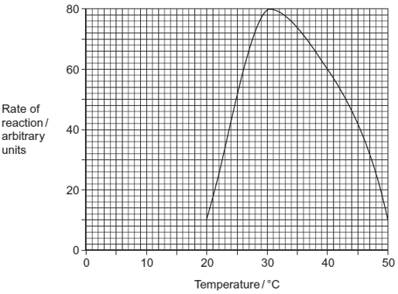

(a)     (i)      Describe what the graph shows about the effect of temperature on the rate of reaction.

______________________________________________________________

______________________________________________________________

**(1)**

(ii)     Explain the shape of the curve between 30 °C and 50 °C.

______________________________________________________________

______________________________________________________________

______________________________________________________________

______________________________________________________________

______________________________________________________________

**(3)**

(b)Students investigated the effect of pH on the activity of the protease.

•        The students used agar plates containing protein. The protein made the agar cloudy.

•They made four wells of equal size in the agar of each plate.

•They added a drop of protease solution to each of the wells. The protease solution in each well was at a different pH.

•The students incubated the agar plates for 4 hours at a constant temperature.

The diagram shows the agar plates after they were incubated and the pH of the protease solution in each well.

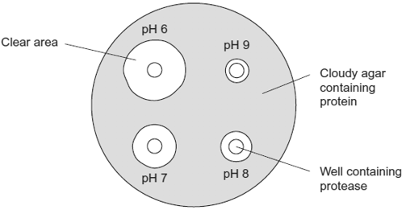

(i)      How should the students make sure that the pH of the protease solution did **not** change?

______________________________________________________________

**(1)**

(ii)     Use the graph to suggest a suitable temperature for incubating the agar plates.

Explain your answer.

______________________________________________________________

______________________________________________________________

______________________________________________________________

**(1)**

(iii)     Use the diagram to describe the effect of pH on the activity of this protease.

______________________________________________________________

______________________________________________________________

______________________________________________________________

**(1)**

**(Total 7 marks)**

**Q9.**

Gangliosides are lipids found in the cell surface membranes of nerve cells. Hexosaminidase is an enzyme present in blood that breaks down gangliosides. If gangliosides are not broken down, they damage nerve cells.

(a)     Hexosaminidase only breaks down gangliosides. It does not break down other lipids.

Explain why this enzyme only breaks down gangliosides.

___________________________________________________________________

___________________________________________________________________

___________________________________________________________________

___________________________________________________________________

___________________________________________________________________

___________________________________________________________________

**(3)**

(b)     Hexosaminidase is found in the blood of healthy people. People with Tay Sachs disease do not have this enzyme in their blood.

Doctors confirm Tay Sachs disease by using a blood test. The technician carrying out the test adds a solution containing a high concentration of gangliosides to a sample of blood from the person being tested. The technician then measures the concentration of gangliosides in the person’s blood at regular intervals.

(i)      Complete the graph below by sketching a curve to show the results you would expect for a person with Tay Sachs disease. Label this curve **T**.

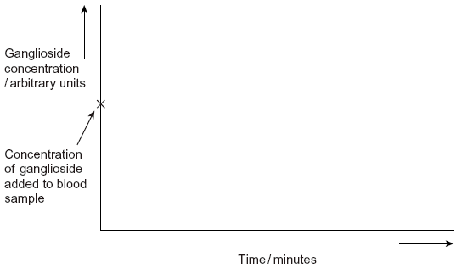

**(1)**

(ii)     Sketch a curve on the same graph to show the results you would expect for a healthy person who does **not** have Tay Sachs disease. Label this curve **H**.

**(1)**

(c)     Scientists are trying to find a way to give the missing enzyme to people with Tay Sachs disease. Suggest why they cannot give the enzyme as a tablet that is swallowed.

___________________________________________________________________

___________________________________________________________________

___________________________________________________________________

**(2)**

**(Total 7 marks)**