**Q1.**The diagram shows part of a DNA molecule.

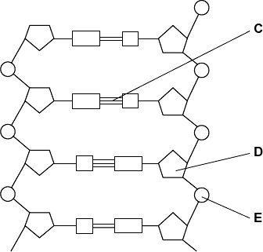

(a)     (i)      DNA is a polymer. What is the evidence from the diagram that DNA is a polymer?

...............................................................................................................

...............................................................................................................

...............................................................................................................

**(1)**

(ii)     Name the parts of the diagram labelled **C**, **D** and **E**.

|  |  |  |
| --- | --- | --- |
|  | Part **C** | ....................................................................... |
|  | Part **D** | ....................................................................... |
|  | Part **E** | ....................................................................... |

**(3)**

(iii)    In a piece of DNA, 34% of the bases were thymine.

Complete the table to show the names and percentages of the other bases.

|  |  |  |
| --- | --- | --- |
|  | **Name of base** | **Percentage** |
|  | Thymine | 34 |
|  |  |  |
|  |  | 34 |
|  |  |  |

**(2)**

**(Total 6 marks)**

**Q2.**          (a)     Nucleic acids, such as DNA, are polymers, made up of many repeating monomer units. Name the monomer from which nucleic acids are made.

......................................................................................................................

**(1)**

(b)     The table shows the percentage of different bases in the DNA of some organisms.

|  |  |  |  |  |
| --- | --- | --- | --- | --- |
| **Organism** | **Percentage of each base** | | | |
| **Adenine** | **Guanine** | **Cytosine** | **Thymine** |
| Human | 31.2 | 18.8 | 18.8 | 31.2 |
| Cow | 27.9 | 22.1 | 22.1 | 27.9 |
| Salmon | 29.4 | 20.6 | 20.6 | 29.4 |
| Rat | 28.6 |  |  |  |
| Virus | 24.7 | 24.1 | 18.5 | 32.7 |

(i)      Calculate the missing figures for rat DNA and write them into the table.

**(2)**

(ii)     The virus has single-stranded DNA as its genetic material. Explain the evidence from the table which suggests that the DNA is single-stranded.

.............................................................................................................

.............................................................................................................

.............................................................................................................

.............................................................................................................

**(2)**

**(Total 5 marks)**

**Q3.**The following figure represents part of a DNA molecule.

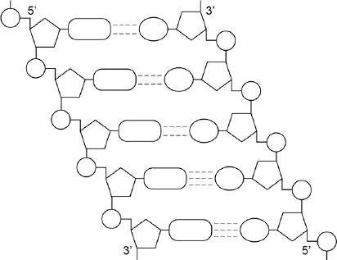

(a)     Draw a box around a single nucleotide.

The table below shows the percentage of bases in each of the strands of a DNA molecule.

|  |  |  |  |  |  |
| --- | --- | --- | --- | --- | --- |
|  | **DNA strand** | **Percentage of each base** | | | |
|  | **A** | **C** | **G** | **T** |
|  | Strand **1** | 16 |  |  |  |
|  | Strand **2** |  | 21 | 34 |  |

**(1)**

(b)     Complete the table by adding the missing values.

**(2)**

(c)     During replication, the two DNA strands separate and each acts as a template for the production of a new strand. As new DNA strands are produced, nucleotides can only be added in the 5’ to 3’ direction.

Use the figure in part (a) and your knowledge of enzyme action and DNA replication to explain why new nucleotides can only be added in a 5’ to 3’ direction.

........................................................................................................................

........................................................................................................................

........................................................................................................................

........................................................................................................................

........................................................................................................................

........................................................................................................................

........................................................................................................................

........................................................................................................................

*(Extra space)* ................................................................................................

........................................................................................................................

........................................................................................................................

**(4)**

**(Total 7 marks)**

**Q4.Figure 1** shows one base pair of a DNA molecule.

**Figure 1**

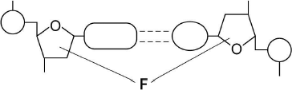

(a)     Name part **F** of each nucleotide.

........................................................................................................................

**(1)**

(b)     Scientists determined that a sample of DNA contained 18% adenine.

What were the percentages of thymine and guanine in this sample of DNA?

|  |  |  |
| --- | --- | --- |
|  | Percentage of thymine |  |
|  | Percentage of guanine |  |

**(2)**

During replication, the two strands of a DNA molecule separate and each acts as a template for the production of a new strand.

**Figure 2** represents DNA replication.

**Figure 2**

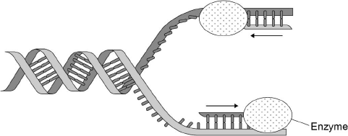

(c)     Name the enzyme shown in **Figure 2**.

........................................................................................................................

**(1)**

The arrows in **Figure 2** show the directions in which each new DNA strand is being produced.

(d)     Use **Figure 1, Figure 2** and your knowledge of enzyme action to explain why the arrows point in opposite directions.

........................................................................................................................

........................................................................................................................

........................................................................................................................

........................................................................................................................

........................................................................................................................

........................................................................................................................

........................................................................................................................

........................................................................................................................

**(4)**

**(Total 8 marks)**

**Q5.**(a)     DNA helicase is important in DNA replication. Explain why.

........................................................................................................................

........................................................................................................................

........................................................................................................................

........................................................................................................................

........................................................................................................................

**(2)**

Scientists investigating DNA replication grew bacteria for several generations in a nutrient solution containing a heavy form of nitrogen (15N). They obtained DNA from a sample of these bacteria.

The scientists then transferred the bacteria to a nutrient solution containing a light form of nitrogen (14N). The bacteria were allowed to grow and divide twice. After each division, DNA was obtained from a sample of bacteria.

The DNA from each sample of bacteria was suspended in a solution in separate tubes. These were spun in a centrifuge at the same speed and for the same time. The diagram shows the scientists’ results.

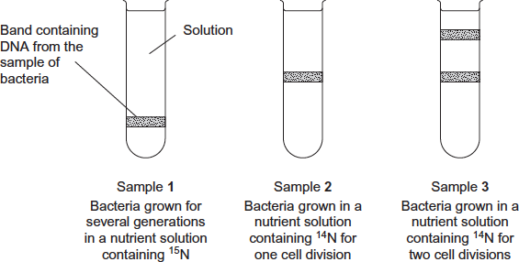

(b)     The table shows the types of DNA molecule that could be present in samples **1** to **3**.  
Use your knowledge of semi-conservative replication to complete the table with a tick if the DNA molecule is present in the sample.

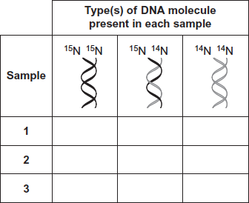

**(3)**

(c)     Cytarabine is a drug used to treat certain cancers. It prevents DNA replication. The diagram shows the structures of cytarabine and the DNA base cytosine.

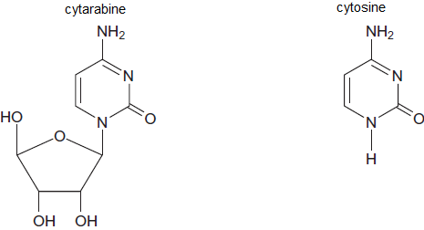

(i)      Use information in the diagram to suggest how cytarabine prevents DNA replication.

...............................................................................................................

...............................................................................................................

...............................................................................................................

...............................................................................................................

...............................................................................................................

**(2)**

(ii)     Cytarabine has a greater effect on cancer cells than on healthy cells. Explain why.

...............................................................................................................

...............................................................................................................

...............................................................................................................

**(1)**

**(Total 8 marks)**

**Q6.** The diagram shows the process of DNA replication. The horizontal lines represent the positions of bases.

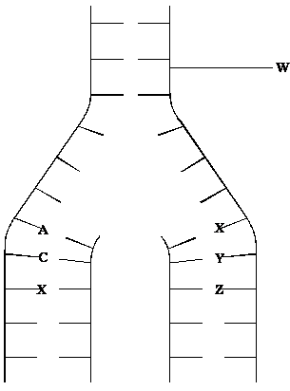

(i)      What is represented by the part of the DNA molecule labelled **W**?

......................................................................................................................

**(1)**

(ii)      In the diagram, **A** represents adenine and **C** represents cytosine.

Name the base found at

position **X**; .....................................................................................................

position **Y**; .....................................................................................................

position **Z**. .....................................................................................................

**(3)**

**(Total 4 marks)**