PowerPoint |  | Printing the Presentation

PowerPoint allows you to print your presentation as Slides, Handouts or Notes pages. Use the File and Print options on the toolbar.

Slides will only print out what appears on the screen, not your notes. Each slide will take a side of A4. |  | 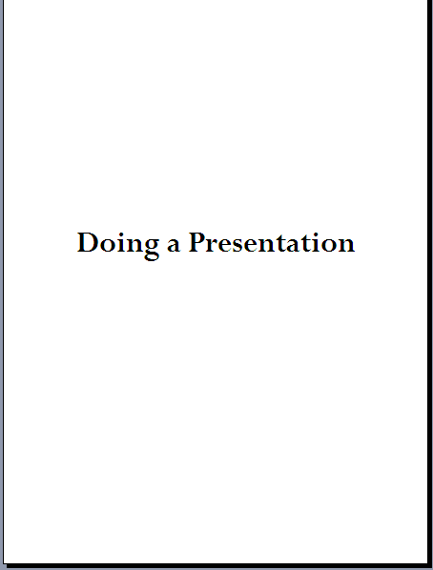
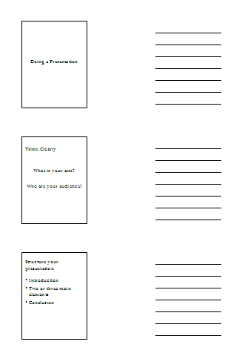 | Handouts are useful for your audience.  The default setting for handouts is six to a page. Change it to three to a page which allows your audience space to make their own notes.  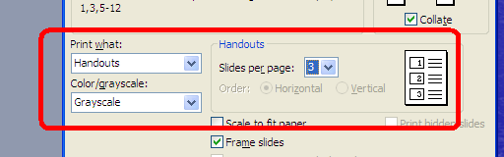
Notes pages are the easiest way to print out the whole presentation for portfolio evidence. You will get the screens of text and your accompanying notes. Each slide will take a side of A4. |  | 