Biology Department Name: ……………………..

**Transport across Cell Membranes**

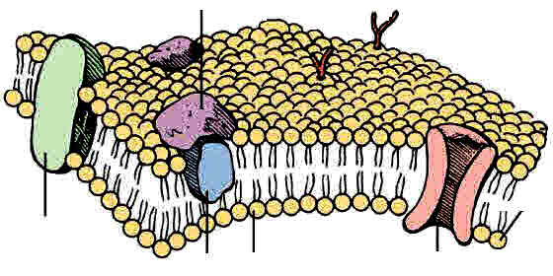Specification 2015 Section 3.2.3

Additional Resources required: Biofactsheet 54 Water Potential. Also useful:- Biofactsheet 225 Synoptic Biology: Water Potential

**Learning Objectives**

* Specification reference 3.2.3
* The fluid mosaic model of cell membranes, including the arrangement of phospholipids, proteins, glycoproteins and glycolipids.
* The role of cholesterol.
* The movement of water across partially permeable membranes by osmosis.
* The concept of water potential and hypotonic, hypertonic and isotonic solutions.
* Movement of molecules and ions down concentration gradients by simple diffusion or facilitated diffusion.
* Movement of molecules and ions against concentration gradients by active transport.
* The adaptations of cells for rapid transport across internal and external membranes.
* Movement of molecules and ions against concentration gradients by co-transport.

**What you should know from GCSE**

* Cell membranes control the passage of substances into and out of the cells.
* Dissolved substances can move into and out of cells by diffusion. The greater the difference in concentration, the greater the rate of diffusion.

**Preparatory Work**

1. **Complete** the 8 Introductory GCSE recall questions on the next page.
2. **Watch** the Bozeman video Cell membranes

<http://www.bozemanscience.com/015-cell-membrane>

1. **Then answer** the review questions on the next page.

**What Do You Know From GCSE?**

1. Where are membranes found? .................................................................................
2. What is the purpose of cell membranes? ..................................................................

………………………………………………………………………………………………

1. Do plants have cell membranes? .............................................................................
2. Do bacteria have cell membranes? ..........................................................................
3. How can dissolved substances pass across membranes? ......................................
4. How can water pass across membranes? ................................................................
5. Name 4 substances required by cells and what each needed for.

…………………………………………………...............................................................

………………………………………..……………………………………………………..

…………………………………………...………………………………………………….

………………………………………………………………………………………………

………………………………………………………………………………………………

1. Name 3 end products of metabolic processes that may pass out of a cell.

…....................................................……………….

…………………………….………………………….

………………………………………………..………

**Bozeman Video Review Questions**

1. Why does soap dissolve the membranes easily?
2. What is selective permeability? How does the cell achieve this?
3. What are the 2 main molecules that make up cell membranes?
4. Phospholipids are described as AMPHIPATHIC. What does this mean?
5. What sort of particles do phospholipids allow to pass between themselves?
6. What is the role of many membrane proteins?
7. What is the role of cholesterol?
8. Name one function of glycolipids
9. Name one function of glycolipids.

**NOTE**: Bozeman talks about water passing through the membrane by **Aquaporins** rather than through the phospholipids. Aquaporins are small membrane proteins that allow passage of water and were discovered in 1992 by Peter Agre who was awarded a **Nobel Prize in Chemistry** for this in 2002. There have now been discovered many different varieties of aquaporins.

However **our syllabus** does **not include aquaporins** and it is thought some water can pass through the phospholipids, because although it is polar it is small enough to pass through slowly. However membranes that possess aquaporins can increase the rate of water movement and this is very important in cells like kidney tubule cells.

In any case, the principles of osmosis and water potential that you must learn, are the same for both aquaporins and conventional movement through phospholipids.

**What are Membranes?** *(ref slide / use info from pages 52 &53 T&T old text /p84&85 new)*

* List the 6 functions of cell surface membranes

1. 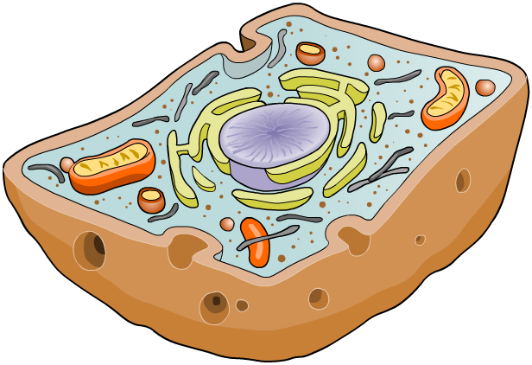………………………………..……………………

……………………...……...……………………………..

1. ……………………………………………………… ………………………………………………….…
2. ……………………………………………………...

.................................................................................

1. ……………………………………………………… ……………………………………………...............
2. …………………………………………………….

..............................................................................

1. ………………………………………...............................................................................

* List 3 functions of internal membranes

1. …………………………………………………………………………………………………

…………………………………………………………………………………………………

1. …………………………………………………………………………………………………
2. …………………………………………………………………………………………………

**The Structure of the cell Surface Membrane**

Describe how a membrane looks like when seen under an electron microscope. *(Ref slide)*

****………………………………………………………………………………………………………..

**Draw below** a diagram of the membrane as seen under the electron microscope.

*EM of a plasma membrane*

* On your diagram **label** what the dark lines represent and what the space in between represents. (You may need to do this AFTER learning more about membrane structure.)
* In 1972 a model was suggested to describe the structure of the cell surface membrane. What is the name of this model? …….......................................…………
* What is another name for a cell membrane?...............................................................

**The Molecular Components of a membrane**

* **List** the main molecule components of a membrane *(ref slide)*

.............................................................. ........……....................………………

……..................………………............... .........…….......................……………

……..............................…………………

**The Fluid Mosaic Model of Membrane Structure**

* **Label** the 2D diagram *(ref slides)*

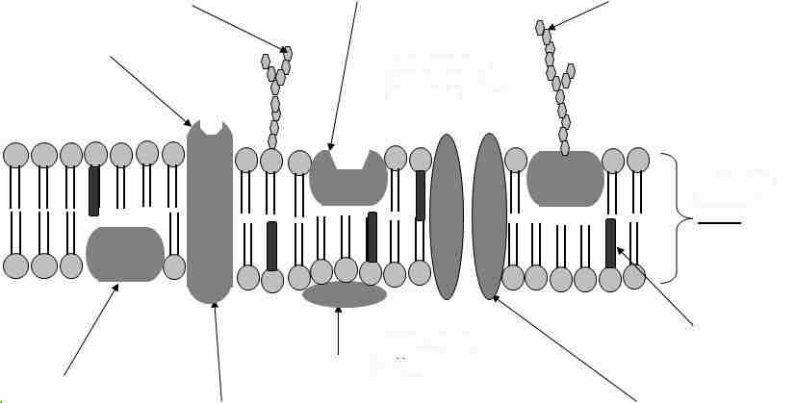

Now **Label** the 3D diagram *(ref: slide or T&T p53 [old spec] or p86 [new spec]).*

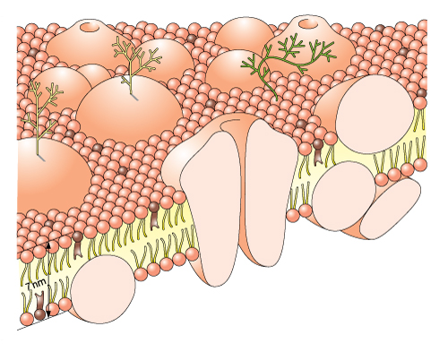

What Does the Model Name **Fluid Mosaic** mean? *(Ref slide or text)*

* Fluid …….............................................................................................……………..

.................................................................................................................................

* Mosaic …..........................……………………………………………………………....

.................................................................................................................................

* What is meant by saying the membrane forms a bilayer? …....……………………..

..................................................................................................................................

..................................................................................................................................

* **Draw** a phospholipid bilayer and annotate your diagram to explain why the phospholipids are arranged that way. *(ref slide)*
* Some organelles have a double membrane. **Name** these organelles and **draw** an annotated double membrane. *(ref slide)*

…............……………........

….........................……......

…...................................…

Membranes have **hydrophobic** and **hydrophilic** regions. **Add labels** stating the hydrophobic parts and hydrophilic parts of your bilayers if it is not included on your annotated diagram. *(Ref slide)*

* Explain below what these words mean.

Hydrophobic …………………………………………………………..

Hydrophilic …………………………………………………………….

* How does this affect the way the membrane is arranged? Think of the composition of cytoplasm and of intercellular spaces between cells. ………………………………

………………………………………………………………………………………………..

………………………………………………………………………………………………..

**Functions of the Different Membrane Component**

**Protein functions**

* List below the 6 functions of **PROTEINS** in the membrane. *(Ref. slide & T&T p52-53 old spec or p85 new spec).*

1. ....................................................................................................................................
2. ....................................................................................................................................
3. ....................................................................................................................................
4. ....................................................................................................................................
5. ....................................................................................................................................
6. ....................................................................................................................................

Membrane proteins may be either EXTRINSIC or INTRINSIC. What does this mean? *(ref T&T old spec text p52)*

**Intrinsic Proteins**……................................................................................................

…………………...........................................................................................................

**Extrinsic proteins**…...................................................................................................

......................................................................................................................................................Now state the functions of the other membrane components.

**Phospholipid Functions**…...................................................................................................

................................................................................................................................................ ................................................................................................................................................

**Cholesterol functions**…......................................................................................................

...............................................................................................................................................

................................................................................................................................................ …………………………………………………………………………...........................................

................................................................................................................................................

**Glycolipid functions**…........................…………………………………………………………..

................................................................................................................................................

**Glycoprotein functions**.........................................................................................................

................................................................................................................................................

**Independent Work** – Text Summary Questions 1-4 T&T p 53 old text / p86 new text.

Answer on lined paper in **full sentences** and attach to this pack

**Transport across Membranes**

* List 5 ways that substances cross membranes and say whether each is an active or passive process. *(ref. slide)* …………………………………………………

…………………………………………………

…………………………………………………

…………………………………………………

…………………………………………………

**1 Diffusion (Simple or Lipid Diffusion)** Independent Work Section

* Watch the animations and make rough notes in the space below.

<http://highered.mheducation.com/sites/0072495855/student_view0/chapter2/animation__how_diffusion_works.html>

**Definition of Diffusion** *(ref p 54 old spec text / p 87 new spec text)*

**Diffusion is**

Read text *p 54 (old spec) / p 87 (new spec)* then explain diffusion in terms of kinetic energy of molecules.

……………………………………………………………………………………………………….

………………………………………………………………………………………………………..

……………………………………………………………………………………………………….

……………………………………………………………………………………………………….

……………………………………………………………………………………………………….

**What Affects the Rate of Diffusion?**

Complete the following table on factors that affect diffusion.

|  |  |
| --- | --- |
| **Factor** | **Effect** |
| Temperature |  |
| Concentration gradient |  |
| Stirring |  |
| Surface area |  |
| Diffusion distance |  |
| Size of molecule |  |

**How Does Diffusion Occur Through a Membrane?**



* Between which molecules of a membrane does simple diffusion occur? .....................................
* What types of particles can pass through?

…….............................................…

……............................………………

* Name some examples of particles that pass through this way…..............................................
* What effect do the hydrophobic fatty acid tails of the phospholipid have on what can pass through this way……………………………………

...............................................................................................................................................

* What is meant by NET Movement of particles? ……...................................................

.....................................................................................................................................

Oxygen and Carbon dioxide can pass through the phospholipid bilayer of membranes by simple diffusion. They are both soluble in lipids.

**Maths Skills – Calculating A Rate from a Time Graph (MS 3.5 & 3.6)**

You could be asked to calculate the rate of diffusion of a substance from a graph that shows the concentration of the substance in a cell over a period of time.

You could be presented with a straightforward linear graph that shows the concentration increasing over a period of time as the substance diffuses into the cell. Ie

What would be the rate of diffusion into the cell?

0

Time /s

*Concentration in cell /M*

0 1 2 3 4 5 6 7 8

1.2

0.8

0.6

1.0

0.4

0.2

……………………………………………….....

………………………………………………….

………………………………………………….

………………………………………………….

You are more likely to get a curved graph where the rate of diffusion is not constant over the whole time period. Why is this more likely? ……………………………………………… …..……………………………………………………… ……………………………………….. ………………………………………………………………………………………………………

So you could be given a curved graph and have to find the rate of diffusion at a particular time. Here is a graph showing how the concentration of a substance in a cell decreases as it diffuses out of the cell.

0

Time /s

*Concentration in cell /M*

0 1 2 3 4 5 6 7 8

1.2

0.8

0.6

1.0

0.4

0.2

* How could you find the rate of diffusion outwards at 3 seconds? ……………………. ..………………………………………………… …………………………………………………. …………………………………………………. ………………………………………………….
* Now calculate the answer.

…………………………………………………. …………………………………………………. ………………………………………………………………………………………………

**Maths skills 3.5 & 3.6 Assignment Questions**

1 Do Q. from Question pack

2 Following oral administration, a particular drug diffuses across the cell-surface membranes of cells in the digestive tract into the blood plasma. The graph shows how the concentration of the drug in the blood plasma changes over time.

**Calculate** the rate of diffusion 10 – 30 minutes after taking the drug.

……………………………………………

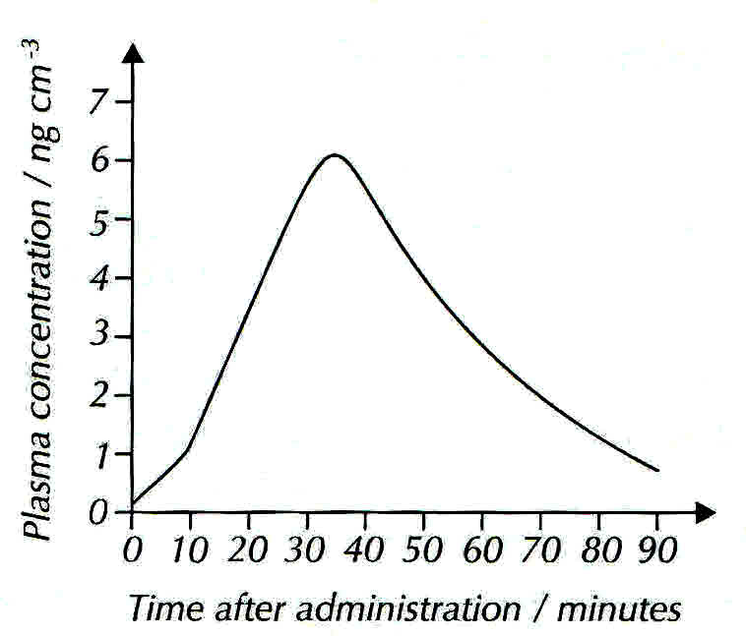

…………………………………………….

…………………………………………...

………………………… ANS.

**Cross Link your topics!** What is an **ng**? ……………………………………………….. ………………………………………….……………………………………………………..

**Extension Material:** Fick’s law is mentioned in the AQA SOW as extension material but you need to know the effects of its 3 variables!

**Fick’s Law and the Rate of Diffusion** *(not mentioned in spec. but referenced in SOW as extension material to help understanding) (ref slide)*

The **rate** of diffusion **through a membrane** (exchange surface) is proportional to:



So this means: *(ref slide)*

**Surface area**: - the greater the surface area, the ......................the rate of diffusion

**Difference in concentration**: - the greater the difference in concentration, the ........................ the rate of diffusion.

**Thickness of membrane**: - the thicker the membrane the ......................... the rate of diffusion

Sketch a graph to show the relationship between external concentration of a solute and its rate of uptake by a cell by simple diffusion. *(ref slide)*

In your own words **describe** this relationship.

…...........................................................................................................................................................................................……………………………………………….

Now **explain** it .............................................................

......................................................................................

......................................................................................

(Facilitated Diffusion is discussed After Osmosis in this booklet as we will do more work on it after the Required Practicals)!

**2 Osmosis**

* Watch the animations: *(links also on slide)*
* <http://highered.mcgraw-hill.com/sites/0072495855/student_view0/chapter2/animation__how_osmosis_works.html>
* <https://www.youtube.com/watch?v=5KOkt9dyN1w> 7 min 32 s Leslie Walters tutorial Water potential calculation explanation

Diagram to illustrate Osmosis *(ref slide)*

**Label** the water molecules and the solute molecules. Use the slide to label which solution is **hypertonic** and which is **hypotonic**. Complete the definition of osmosis.

Osmosis Definition *(ref slide or text)*

NET movement of Water

What is meant by saying that 2 solutions are isotonic? ………………………………………..

**Osmosis and Water Potential**

A solution with a high water potential has many **free** water molecules. They are free to move and can exert a **pressure** on the membrane. This pressure is called **WATER POTENTIAL**. A solution with a low water potential has few free water molecules.

**Label** the diagrams below either **high** or **low** water potential and also state which has a high solute concentration and which has a low one. Also label the partially permeable membrane.

…......…Water Potential ..........… Water Potential

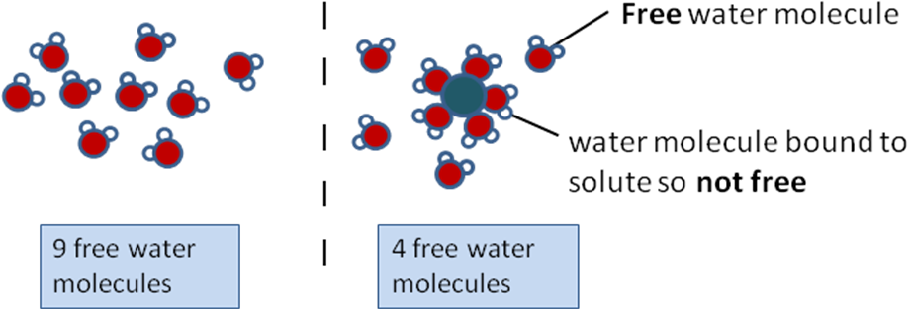

…Solute Concentration …..........…. Solute Concentration

* Draw an arrow to show the direction of water movement.

Water Potential Definition

**Water potential** is …….................................................................................................

.....................................................................................................................................

...........................................................................*. (ref slide and new spec text p89)*……………………………………………

**Water potential ( or psi)** is measured in units of ...................... eg.................................

**Complete** the next statements and highlight them.

**Water Potential of Pure Water** is ....................

**Water Potential of Solutions** is .......................

A concentrated solution has a .............… negative water potential than a dilute solution.

**Concentrated Solutions** have a **very negative** water potential

**Dilute Solutions** have a **less negative** water potential

**Pure water** has the **highest** possible water potential of **zero**.

Very negative less negative zero

Water potential water potential water potential

**Concentrated solution** **dilute solution** **pure water**

The rule is that water always ‘falls from a high to a low water potential ie in the direction of

the arrows in the above diagram.

**Applying This to Cell Water Potential Questions**

1. a) Show the direction of the net movement of water molecules by an arrow drawn on the two cells below.

b) Label the **cell solutions** as concentrated or dilute appropriately.

c) Label the cells as having high or low water potentials appropriately.

**Cell A**

**       = - 400 kPa**

**Cell B**

** = - 350 kPa**

2 Why does water have a higher water potential in dilute solutions than in concentrated solutions?

....................................................................................................................................

....................................................................................................................................

3 If **cell X** has a water potential of – 500 kPa, and **cell Y** next to it has a water potential of – 800 kPa which way will water move by osmosis and what will the water potential of each one be when equilibrium is reached?

........................................................................................................

........................................................................................................

4 What would be the effect on the water potential of a cell if starch present in a cell is hydrolysed to sugar?

....................................................................................................................................

**Comprehension and Research Activity**

**Read** the **Biofactsheet 54** page2 on Water Potential and make notes in your own words under the following headings:

Parts of a Cell water Must Cross to reach the Vacuole

Effect of Water Movement on the Vacuole

What is meant by Solute Potential and Pressure Potential?

**Effects of Osmosis on cells.**

What happens to cells when placed in solutions that are hypertonic, isotonic or hypotonic to the cell contents? Use *T&T (p59 /60 [old spec text] /p91-92 [new spec text] / PowerPoint to complete table.*

|  |  |  |  |
| --- | --- | --- | --- |
|  | In Higher Water potential than Cell ie a …...................…solution | In Equal Water potential to Cell ie an ........................solution | In Lower Water potential than Cell ie a ..........................solution |
| Animal Cell | Water ................... cell by **.................** Cell **.......................** |  |  |
| Plant Cell | Water ….................. cell by **osmosis.** Cell… ..................…. is pushed tight against ……....... ..................Cell is…................... |  | Water .................. cell by **osmosis.** ................. shrinks pulling membrane from cell wall. Cell is .........................and said to be ........................................ |

* Is a plant cell wall permeable, impermeable or semi-permeable? …................……..
* What is in the gap between the cell wall and the membrane in the cell in a hypertonic solution........................................………………………………………….
* Why are arrows drawn both ways on the diagrams?…..........................………………

.....................................................................................................................................

.....................................................................................................................................

* What is meant by the word PROTOPLAST ….............................................................

........................................................................................

**Maths Skills and Osmosis**

Answer summary question 3 (p 59 T&T) and Application questions 2 and 3 (p60) [p 91 &92 in new text].

2 ……….................................................................

2………...................... ................................... ......................................

...................................

3.................................

**3 Facilitated Diffusion**

**Watch the animation:**

<http://highered.mheducation.com/sites/9834092339/student_view0/chapter5/how_facilitated_diffusion_works.html>

* What types of particles are transported by channel proteins? …..............….

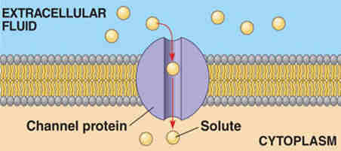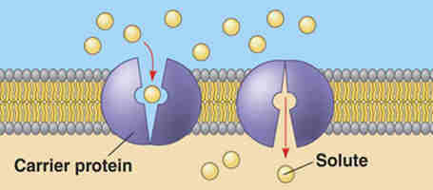

*(Ref slides)*

* What is meant by saying that the channels are selective.................................................……….

............................................................................

* What types of particles are transported by carrier proteins?............................................................
* How do these proteins work……........................
* ...................................................................................................................................
* ...................................................................................................................................

|  |  |
| --- | --- |
| **CHANNEL PROTEIN** | **CARRIER PROTEIN** |
|  |  |
|  |  |
|  |  |

**Fill in the table** to make notes on these two types of facilitated diffusion proteins. *(ref slide)*

**Comparing Rate of Uptake Graphs of Simple and Facilitated Diffusion** *(ref slide)*

External Concentration

Rate of Uptake into Cell

Rate of Uptake Graph for a Molecule that enters a cell By Simple Lipid Diffusion

External Concentration

Rate of Uptake into Cell

Rate of Uptake Graph for a Molecule that enters a cell By Facilitated Diffusion

Explain why these two graphs differ………...........................................................................

...............................................................................................................................................

...............................................................................................................................................

...............................................................................................................................................

...............................................................................................................................................

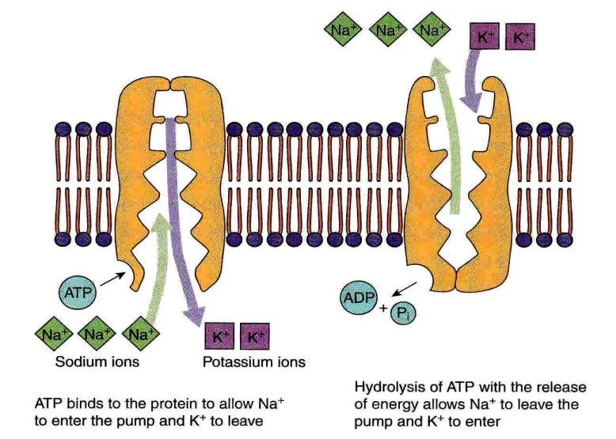**4 Active Transport** *(ref slide)*

What does ATP stand for?.

...............................................................

What does Pi stand for?

...............................................................

What does ADP stand for?

...............................................................

How can you describe the binding sites of the active transport protein? ..............................

...............................................................................................................................................

* Complete the definition of Active transport

**Active transport** is ............................................................................................................

............................................................................................................................................

............................................................................................................................................

**Rich Questions for You to Work Out**

* Why do poisons which inhibit respiration, result in active transport stopping?

……………………………………………………………………………………………………………..

……………………………………………………………………………………………………………..

……………………………………………………………………………………………………………..

* Suggest why overwatering of plants can kill the plant

……………………………………………………………………………………………………………….

……………………………………………………………………………………………………………….

**The Adaptations of Cells for Rapid Transport across external & internal membranes**

Intestinal epithelium cells must allow transportation of soluble products of digestion from the lumen of the gut to the blood capillaries where they can then be transported to the liver. Diffusion alone would be too slow and inefficient. The cells are adapted to ensure efficient transportation across their structure.

**Past Exam Question**: (Biol 1 June 11 listed in SOW). The epithelial cells that line the small intestine are adapted for the absorption of glucose. Explain how. 6 marks

Use the diagram, your own existing knowledge and the text to answer the question.

……………………………………………………………………………..

……………………………………………………………………………..

……………………………………………………………………………..

……………………………………………………………………………..

……………………………………………………………………………..

……………………………………………………………………………..

……………………………………………………………………….........

……………………………………………………………………………..

……………………………………………………………………………..

**Extension Activity**: Examine microscope slides / histology photos on web of cells adapted for rapid transport. .see SOW

**5 Co-transport**

Co transport is an indirect form of active transport. Two types of protein carriers are involved. The first actively transports a particle eg sodium across a membrane against its gradient. This results in this particle diffusing passively back in through a second carrier protein (the co-transport protein) and pulling in another substance that the cell needs at the same time eg glucose. The second substance is pulled against its gradient, so it travels because of the energy needed to originally pump the first!

**Co-transport Research Task**

**1 Watch the animation**

[**http://highered.mheducation.com/sites/9834092339/student_view0/chapter5/secondary_active_transport.html**](http://highered.mheducation.com/sites/9834092339/student_view0/chapter5/secondary_active_transport.html)

**Co-transport DARTS Task – Group work and Presentation Activity***. (ref slide and SOW)*

* (to produce a poster / presentation along these lines with appropriate explanations)*

**Membranes Glossary**

|  |  |
| --- | --- |
| **Glycoprotein** |  |
| **Glycolipid** |  |
| **Phospholipid** |  |
| **Extrinsic Protein** |  |
| **Intrinsic Protein** |  |
| **Peripheral Protein** |  |
| **Integral Protein** |  |
| **Hydrophobic** |  |
| **Hydrophilic** |  |
| **Hypotonic Solution** |  |
| **Hypertonic Solution** |  |
| **Isotonic Solution** |  |
| **Plasmolysed**  **(the process is called plasmolysis)** |  |
| **Incipient Plasmolysis** |  |
| **Flaccid Plant Cell** |  |
| **Haemolysed** |  |
| **Turgid Plant Cell** |  |
| **Crenate** |  |
| **Solute potential** |  |
| **Pressure potential** |  |
| **Protoplast** |  |

**Specification Content:**

The basic structure of all cell membranes, including cell surface membranes and the membrane around the cell organelles of eukaryotes, is the same.

The arrangement and any movement of phospholipids, proteins, glycoproteins and glycolipids in the fluid mosaic model of membrane structure. Cholesterol may also be present in cell membranes where it restricts the movement of other molecules making up the membrane.

Movement across membranes occurs by:

* **Simple diffusion** (involving limitations imposed by the nature of the phospholipid bilayer)
* **Facilitated diffusion** (involving the roles of carrier proteins and channel proteins)
* **Osmosis** (explained in terms of water potential).
* **Active transport** (involving the role of carrier proteins and the importance of the hydrolysis of ATP)
* **Co-transport** (illustrated by the absorption of sodium ions and glucose by cells lining the mammalian ileum).

Cells may be adapted for rapid transport across their internal or external membranes by an increase in surface area of, or by an increase in the number of protein channels and carrier molecules in, their membranes.

**Students should be able to**:

* Explain the adaptations of specialised cells in relation to the rate of transport across their internal and external membranes.
* Explain how surface area, number of channel or carrier proteins and differences in gradients of concentration or water potential affect the rate of movement across cell membranes.

**Required Practical 3**: production of a dilution series of a solute to produce a calibration curve with which to identify the water potential of plant tissue.

**Required practical 4**: Investigation into the effect of a named variable on the permeability of cell surface membranes.