Biology Department Name: …………………

**Teacher**

**Booklet**

**Cell Recognition and the Immune System**

Specification 2015 Section 3.2.4

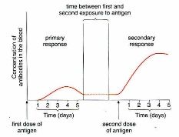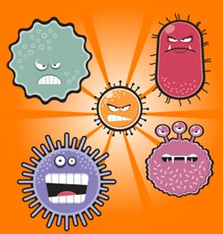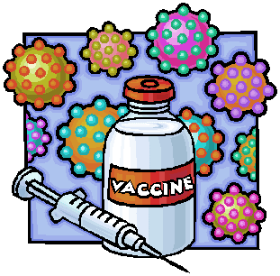

Additional resources required: Biofactsheet 99 Vaccines

**Learning Objectives**

* **Specification reference 3.2.4**
* The definition of Antigens. Antigen presence allows the immune system to identify **pathogens, cells from other individuals’ abnormal body** cells and **toxins.**
* Phagocytosis of pathogens and the subsequent destruction of ingested pathogens by **lysozymes**.
* The response of **T lymphocytes** to a foreign antigen. **(The cellular response / cell mediated response)** The role of **antigen presenting ells** in the cellular response.
* The role of **Helper T cells (TH cells)** in stimulating **Cytotoxic T cells (TC cells**), **B cells** and **phagocytes.**
* The definition of an antibody and the structure of an antibody.
* The formation of **antigen-antibody complexes** and the subsequent destruction of pathogens.
* The response of **B lymphocytes** to a foreign antigen, **clonal selection** and the release of **monoclonal antibodies, (the Humoral Response).**
* The roles of **plasma cells** and of **memory cells** in producing **primary** and **secondary immune responses.#**
* The effect of **antigen variability** on disease and disease prevention.
* The difference between **active** and **passive immunity.**
* The use of vaccines to provide protection for individuals and populations against disease and the concept of **herd immunity**.
* Ethical issues associated with the use of vaccines.
* Structure of the human immunodeficiency virus (HIV) and its replication in Helper T cells. How HIV causes the symptoms of AIDS.
* Why antibiotics are ineffective against viruses.
* The use of **monoclonal antibodies** in targeting medication at particular cell types, medical diagnosis and **ELISA.**
* Ethical issues associated with the use of monoclonal antibodies.

**What you should know from GCSE**

* White blood cells help to defend against pathogens by: ingesting pathogens; producing antibodies; and producing antitoxins.
* The immune system of the body produces specific antibodies to kill a particular pathogen. This leads to immunity from that pathogen.
* People can be vaccinated by introducing small quantities of dead or inactive forms of pathogen into the body stimulating white blood cells to produce antibodies and forming immunity against future infections.
* MMR is used to vaccinate against measles, mumps and rubella.
* If a large proportion of the population is immune to a pathogen, the spread of the pathogen is very much reduced.

**Preparatory Work**

**Watch** the Introductory video overview **Virtual body – The Immune System** on e- stream then **answer** the questions below about the video. <http://estream.godalming.ac.uk/View.aspx?id=1298~4u~vx7bUQN6&chapID=1582>

**Questions On the Video – The Immune System**

1. Give 4 mechanisms that are part of the body’s first line of defence.

* Skin (is a physical barrier);
* Mucus membranes lining orifices and hairs / cilia lining airways.
* Chemical methods: sweat, saliva tears and stomach acid.
* Our own harmless bacteria in and around our skin.

1. State 3 chemical defence mechanisms
   * Sweat
   * Saliva
   * Tears / stomach acid.
2. Name 2 white cells produced in the bone marrow Phagocytes and lymphocytes
3. What is puss made up of? Dead phagocytes, destroyed bacteria and other cell debris
4. What is an antigen? Any substance that triggers an immune response. Can be a protein or carbohydrate and can also be a toxin.
5. What is a toxin? A chemical released by certain invaders.
6. Name a bacterium that releases a toxin. Tetanus bacterium
7. What is a toxoid?

A modified toxin able to be safely used in a vaccination.

1. How do killer T cells kill pathogens and also infected body cells? Punch holes in the cells so they die.

**Overview of defence Mechanisms**

* **Complete** the overview map of the body’s defence mechanisms  *p 101 0ld T&T, p103 new)*

See slide 10

**Defence mechanisms**

**Non specific**

response is immediate

and the same for all pathogens

**Specific**

response is slower and

specific to each pathogen

**Physical barrier**

e.g. skin

**phagocytosis**

**Cell-mediated response**

T lymphocytes

**Humoral response**

B lymphocytes

Slide 11

* **Suggest 2 ways** that the specific response differs from the non-specific response.

1….The specific response targets particular types of invaders but the non-specific response does not…….

Slide 12

2….The specific response is slower than the non-specific response………

**Antigens and Self-antigens**

Self-antigens are specific molecules on a cells surface that provide self-identification.

Antigens (non-self-antigens) are molecules on the surface of a foreign cell, pathogen cell, abnormal body cell e.g. cancer cell or damaged cell, and toxins.

* **Complete** the definition of an antigen.

**Definition of an Antigen** *(ref slide 13, old T&T p 104, new p 106)*

Any part of an organism or substance that is recognized as non-self (foreign) by the immune system and triggers an immune response.

* **List below** the types of molecules that act as antigens and trigger an immune response.

Proteins that are part of the cell surface membrane (in some cases carbohydrates on the membrane) of invading cells eg pathogens.

Slide 14

Cell walls of invading cells

Cancerous cell antigens which are abnormal and act as foreign antigens

Toxins (poisonous molecules) eg those produced by some bacteria.

Cell surface membrane molecules from cells of individuals of the same species.

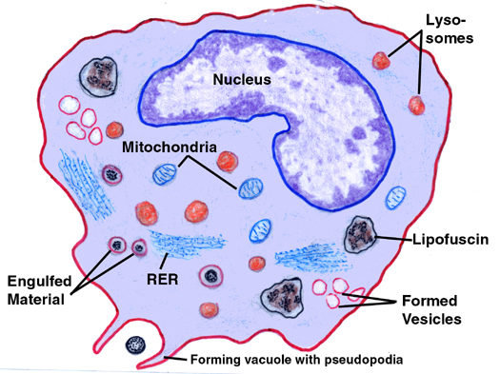**Phagocytosis – A non-specific response**

**Watch:**

1. <http://www.dnatube.com/video/116/Neutrophil-attacts-on-bacteria> 1 min video clip of neutrophil chasing a bacterium and then engulfing it by phagocytosis.
2. <http://highered.mheducation.com/sites/0072495855/student_view0/chapter2/animation__phagocytosis.html> 1 min detailed animation of phagocytosis including coating with complement (opsonisation) to enhance phagocytosis.

A phagocyte, e.g. a **macrophage** is a type of **white blood cell** that carries out phagocytosis (engulfment of a pathogen). They’re found in the **blood** and in the **tissues** and are the first cells to respond to a pathogen inside the body.

See slide 17

Arrange the following statements into the correct order and write them again below to describe the process of **phagocytosis.**

*(Reference: p102/103* ***old text Toole & Toole****):or p104/105* ***new text Toole & Toole****)*

**Jumbled Statements:**

1. The phagocyte then **presents** the pathogen’s antigens – it sticks the antigens on its **surface** to **activate** other immune cells.
2. The phagocyte **recognises** the **antigens** on a pathogen and binds to it.
3. A **lysosome** (containing **lysozymes**) **fuses** with the phagocytic vesicle. The lysozymes **hydrolyse** the pathogen.
4. The cytoplasm of the phagocyte moves round the pathogen, **engulfing** it in a phagocytic vesicle within the cytoplasm.
5. A phagocyte moves towards a pathogen as it is attracted to chemicals released by the pathogen

**Write them in the correct order here:**

1. A phagocyte moves towards a pathogen as it is attracted to chemicals released by the pathogen
2. The phagocyte **recognises** the **antigens** on a pathogen and binds to it.
3. The cytoplasm of the phagocyte moves round the pathogen, **engulfing** it in a phagocytic vesicle within the cytoplasm.
4. A **lysosome** (containing **lysozymes**) **fuses** with the phagocytic vesicle. The lysozymes **hydrolyse** the pathogen.
5. The phagocyte then **presents** the pathogen’s antigens – it sticks the antigens on its **surface** to **activate** other immune cells.

Slide 17 & p 104 new T&T

What are lysozymes? Enzymes found in lysosomes.

**Independent Consolidation Work**

* **Complete** the summary questions on page 103 of **old Toole & Toole**. / p 105 **new T&T**.

Slide 23 has animation links to help with this.

* **Answer** on file paper and attach to your booklet.

**The Cellular Response and the Role of T-Lymphocytes (T-cells)**

The diagrams below represent a story board of the cell mediated response. Write a description of these events incorporating the following words in your description. ***Mitosis; clonal selection; helper T cell; antigen presentation; cytokines; clones***

Slide 25

* **Give** each diagram a **suitable title**

**1** Phagocyte encounters pathogen **2** Phagocyte presents Antigens

See slide 25

Phagocyte

Pathogenic bacterium

Antigen presenting phagocyte

……………………………………………….. ……………………………………………

………………………………………………. ……………………………………………

……………………………………………….. ……………………………………………

……………………………………………….. ……………………………………………

**3** T-helper cell Binds to antigen **4** Proliferation of T-cells

Antigen presenting phagocyte

T-Cell

………………………………………………..

……………………………………………….. …………………………………………….

……………………………………………….. …………………………………………….

……………………………………………….. …………………………………………….

………………………………………………. …………………………………………….

See slide 25

* List the 4 main roles of the cell resulting in diagram 4.

1. Become memory T-cells that respond to a future infection of the same pathogen
2. Stimulate phagocytosis by phagocytes
3. Work as helper T-cells that stimulate B cells to divide and then produce antibodies

Slide 27

1. Activate cytotoxic T cells (TC cells)

**Action of Cytotoxic T cells** *(ref p106 old T&T, p 107-108 new T&T)*

* Use text or slides to explain how cytotoxic T-cells kill infected cells.

They punch holes in the cell surface membrane using a protein called perforin. This makes the cell freely permeable so it dies.

* What is the name of the protein involved in this process? ….Perforin………………

See slide 34

**Antibodies and the Humoral Response**

**Antibody Structure**

* **Label** the diagram of an antibody. *(ref slide or old T&T p 109, new T&T p111)*

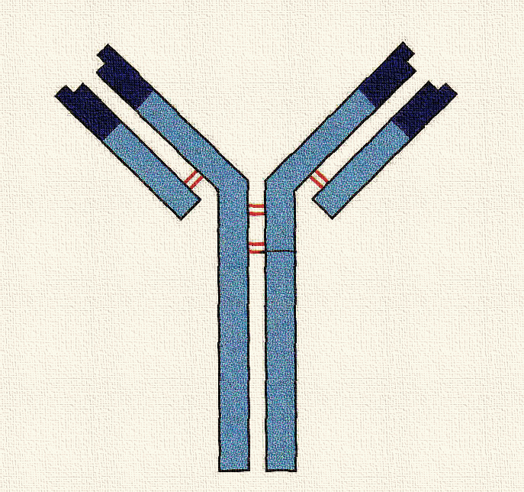

Variable region

Constant region

Light chain (short chain)

Heavy chain (long chain)

Antigen binding site

Antigen binding site

Disulphide bonds holding polypeptides together

Receptor binding site – such as to a receptor on a B-cell

* What type of molecule is an antibody? ............Globular proteins called immunoglobulins………………………………….

Slide 34

**Topic cross link Question:** Does it have tertiary structure? Explain your answer

**…**Yes because it is globular so is highly folded…

Does it have Quaternary structure? Explain your answer.

…Yes because it is made of more than one polypeptide chain …

* What type of cells produce antibodies? …….B-cells….

**The Action of Antibodies**

* Using the words **antibody antigen complex**, **antigen binding site**, and **complementary,** write a brief description in your own words about how antibodies bind with antigens. (ref slides

…When an antibody comes into contact with an antigen it will attach to the antigen if it has the correct shaped antigen binding site ie a binding site that is complementary to the antigen. It forms an antibody antigen complex. ………………….

Links on slide 36

**Watch the animations**

1. <http://highered.mheducation.com/sites/0072507470/student_view0/chapter22/animation__the_immune_response.html> same link as in cell mediated response as does both.
2. <http://www.sbs.utexas.edu/psaxena/MicrobiologyAnimations/Animations/HumoralImmunity/micro_humoral.swf> good clear animation. Some screen shots shown in PowerPoint and booklet diagrams

* Describe 2 ways that antigens prepare an antigen for destruction. *(ref: animations, and slides)*

……………………………………………………………………………………………………………………………………………………………………………………………………………………………………………………………………………………………………………………………………………………………………………………………………………………

Slides 38, 39

**NOTE** Animation gives 2 methods: - agglutination *(referred to in spec)* and neutralisation*, (not referred to in spec).* The text mentions agglutination and acting as markers for phagocytes (which is part of the purpose of agglutination anyway I assume).So **Neutralisation** as such seems to be not required. Hence next slide 39 just gives the info from p 111 new text

**Definition of an Antibody** *(ref text glossary and slide)*

**An antibody is** a protein produced by the immune system (by B-lymphocytes) in response to the presence of an antigen.

Slide 35

**Fill in the gaps in the passage about antibodies**. Use p. 109 old T & T / p. 111 new T & T and the key words below:

***Constant; variable; protein; peptide; complementary; amino acid***

Antibodies are made of … protein…. They’re made up of chains of ……. amino acid….. monomers linked by …. Peptide….. bonds.

The specificity of an antibody depends on its …..variable ... regions. Each antibody has a different shaped variable region (due to different amino acid sequences), that’s complementary…….. to one specific antigen. The ….constant… regions are the same in all antibodies.

**Diagrams of Main Events in Stimulating the Humoral Response**

See slides 37 & 40

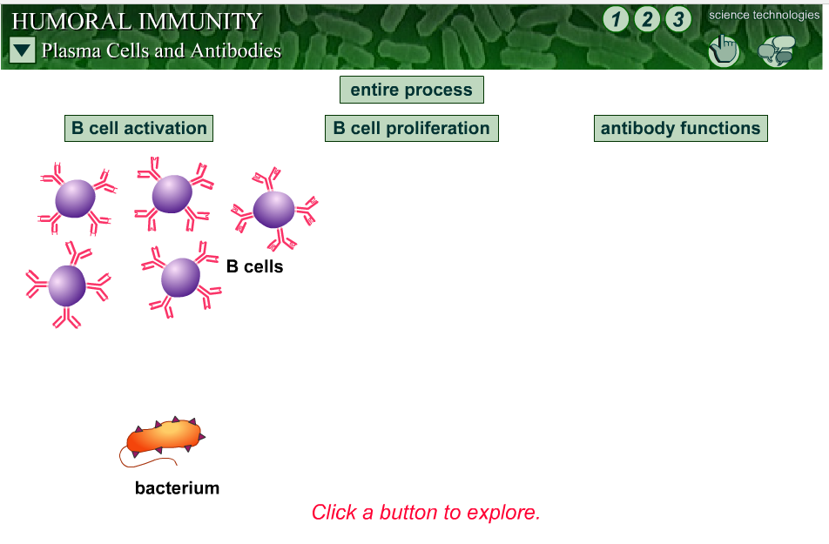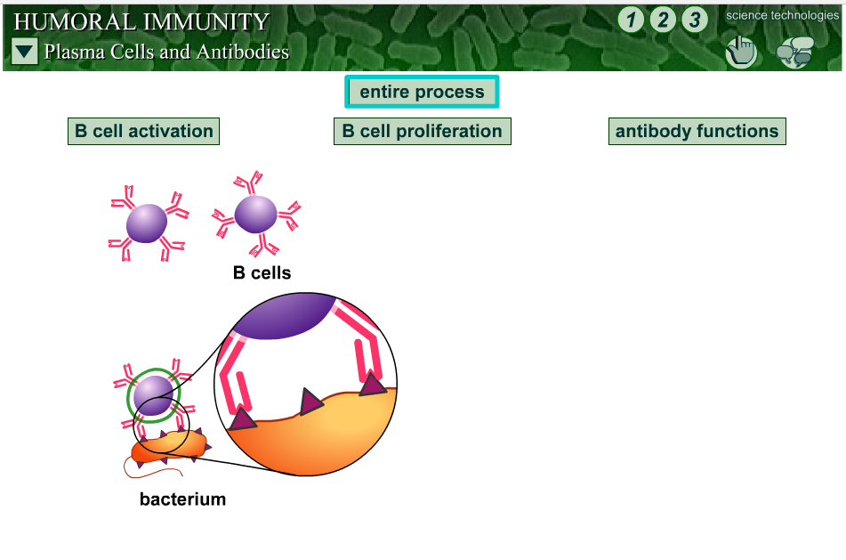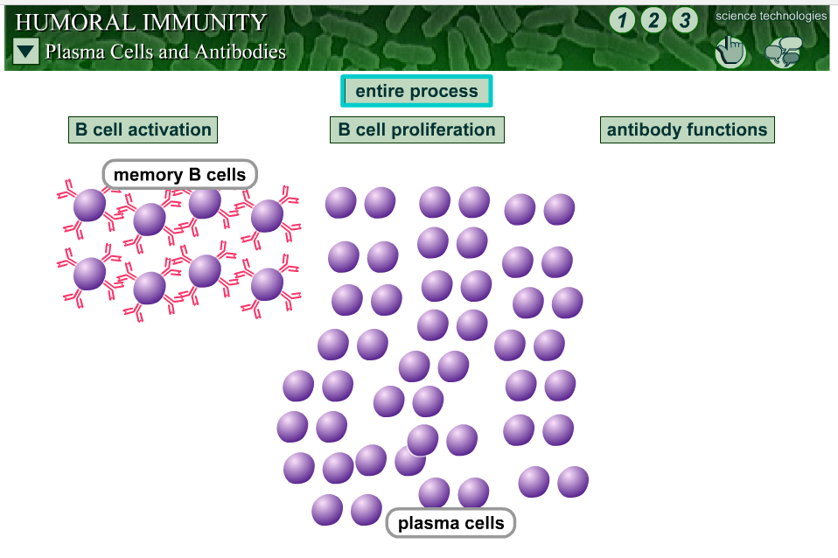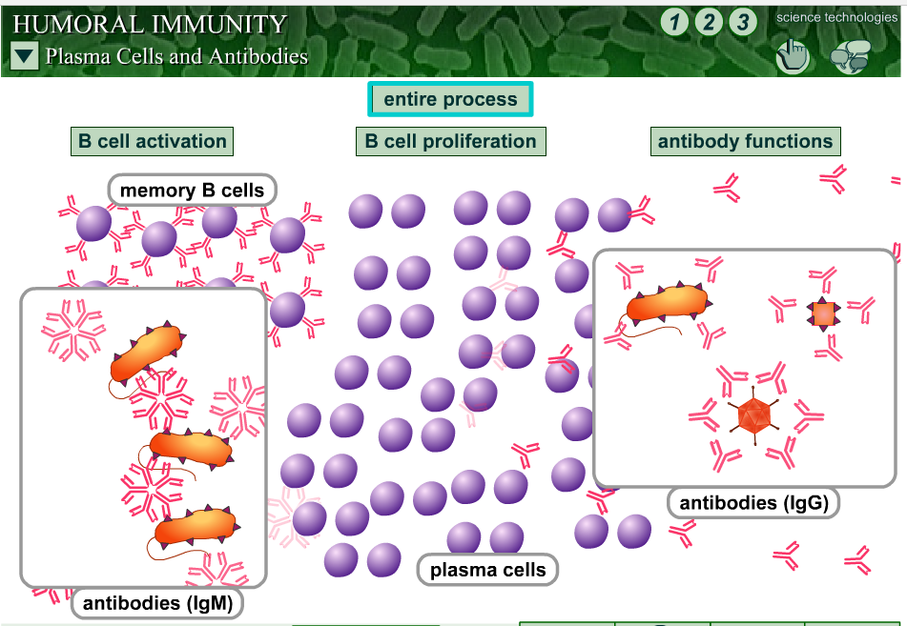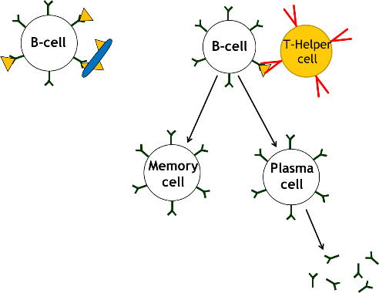

**1**

**2**

Action of T-Helper Cell

**3**

**4**

* What is the main type of lymphocyte is involved in the humoral response?

…..B lymphocytes (B-cells)…………

* By what process does this cell take up the antigens and then what does it do with the antigens?

It takes up the antigen by ENDOCYTOSIS then processes them and presents them on its surface

* What other type of lymphocyte binds to the processed presented antigens and helps to activate the presenting cell (…B-cell…) to divide by **mitosis**?
* .....T-helper cells………
* …Now explain what is meant by **CLONAL SELECTION** *(ref text p 109 new T&T and slide 42, not in old text!)* …………It is the way that specific antigens **‘select’** specific B-cells with complementary antibodies on their surfaces, thus stimulating them to divide and form clones with the help also of helper T-cells……………

Slide 42

**Watch the animation** <http://highered.mheducation.com/olcweb/cgi/pluginpop.cgi?it=swf::600::480::/sites/dl/free/0073532215/788107/Clonal_Selection.swf::Clonal%20Selection> Animation of clonal selection

**The Primary and Secondary Response**

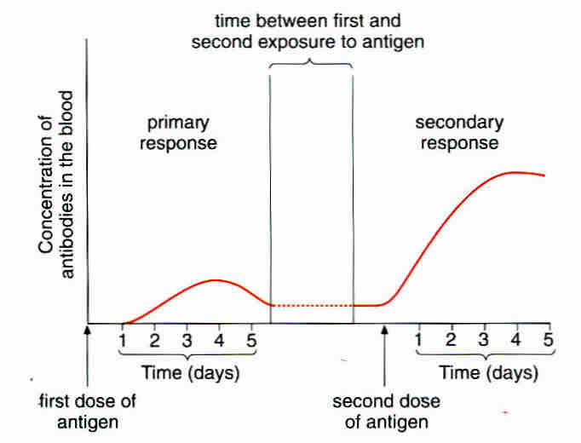The graph shows the concentration of antibodies in the blood of a person after a first infection with a particular antigen and then again after a second exposure some time later.

Slide 43

**Study** the graph and explain what is happening in the body using the headings provided

**Primary Response**: This is the response to the first exposure to antigens of a particular infection. Plasma cells are produced and secrete antibodies which destroy the pathogen and any toxins it produces. These plasma cells survive only a few days.

Slide 44

**Secondary response**:-.This is the response to the second and subsequent exposures to a particular pathogen and its antigens. Memory cells, (produced during the first exposure) have been circulating in the blood and tissue fluid. They now rapidly divide to produce plasma cells which produce many antibodies very rapidly.

* Using the graph, give 3 differences between the primary and secondary responses.
* .....More antibodies are produced........
* ....They are produced more rapidly.....
* ....More are in the system for longer.

**Independent Learning**: **Answer** the summary questions from p 110 new T&T / p108 old T&T on lined paper. Ensure you give them a title stating the page they are from

**Antigenic Variability** *(ref p 116-117 new T&T, p112-113 old T&T)*

Antigens on the surface of **pathogens** activate the **primary response**. When you’re infected a second time with the same pathogen they activate the **secondary response** and you don’t usually get ill.

However some pathogens change their **surface antigens**. This is called **antigenic variation**. This means that when you are infected for a second time, the memory cells produced from the first infection will not recognise the different antigens. So the immune system has to start from the beginning and carry out a primary response against these new antigens.

Slide 50

* Can you think of any pathogens who use this tactic to avoid immune responses?

……….**E.g. Influenza,**…….

Slide 51

**Types of Immunity and Vaccines**

**Types of Immunity**

1. Active Immunity …Results from your immune system producing memory cells following exposure to an antigen …. …………………………………………………………………
2. Passive Immunity …Results from being given antibodies from a different organism (mother to baby via placenta or via blood injection eg to combat a tetanus infection) ………………………………………………………………
3. Herd Immunity …Where unvaccinated people are protected because occurrence of a disease is reduced by the number of people who are vaccinated. …………………………………………………………………..

Slide 52

|  |  |
| --- | --- |
| **Vaccinated Not vaccinated Infected**  **But healthy** | |
| **Population with few people vaccinated** | **Population with many people vaccinated** |
| C:\Users\Kaykays PC\Documents\My PaperPort Documents\School\Defence and Immune Response\Copy 3 of Herd Immunity Diagrama.jpg | C:\Users\Kaykays PC\Documents\My PaperPort Documents\School\Defence and Immune Response\Copy 4 of Herd Immunity Diagrama.jpg |

<http://www.nhs.uk/conditions/vaccinations/pages/how-vaccines-work.aspx> NHS information including 2 short (2 min) videos Video 2 explains herd immunity.

<http://www.ovg.ox.ac.uk/herd-immunity> scroll down information page to find good clear information on problems of herd immunity in real populations

**Comparison of Active and Passive Immunity**

* **Complete** the table below answering **Yes** or **NO**

|  |  |  |
| --- | --- | --- |
| **Features** | **Active Immunity** | **Passive Immunity** |
| Requires exposure to an antigen | Yes | No |
| Requires time for immunity to develop | Yes | No |
| Memory cells produced | Yes | No  Not on Slides |
| Protection is long term or short term | Yes | No |

**Natural and Artificial Immunity**

* Both Active and Passive immunity can be natural or artificial. What is artificial Immunity? *(Ref new text p 115 or old text p112 and slides)*

**Active Artificial Immunity** is gained through inducing an immune response to a particular pathogen in a person in order that they produce memory cells able respond to subsequent infections. It is usually produced by vaccination (immunisation)……………………………………………………………………..

**Passive Artificial Immunity** is gained by being injected with antibodies from another person. You don’t make memory cells and it only fights an infection that is already present e.g. tetanus. *(Ref CGP A level Biology Year 1 p120)*

Slide 53

**Vaccines**

A vaccine is a preparation of antigens from a pathogen.

**Read Biofactsheet 99 ‘Vaccines’** and make your own notes about vaccines and immunity

* Explain how vaccines work*.(ref slides, p 115 T&T New text, p 112 old text but less information!)*

……The vaccine antigens stimulate the immune response and cause the production of memory cells which can be activated rapidly on subsequent real infections. The response to the vaccine is slight because the vaccine antigens have been prepared so that they do not cause the disease. …..................................................................

Slide 54

* How are vaccines made harmless? *(ref slide)*

1. …killing the pathogen but leaving the antigens unaffected eg cholera vaccine……………………………………………
2. …weakening the pathogen (attenuation) eg polio vaccine Sabin oral …………………………………
3. …removing the antigens from the surface of a pathogen and using purified antigens without pathogen itself eg Hepetitis B vaccine…

* Suggest a disadvantage of taking vaccines orally. …may be broken down by enzymes in gut or may be too large to pass into bloodstream……………………….

………………………………………………………………………………………………

**Read** the information about the problems in controlling cholera, TB and Flu disease eg cholera on p 112 -113 (old text) or p 116 – 117 (new T&T). Make notes below on why each of these is difficult to control.

Notes for Teachers

Cholera being an intestinal disease hides in the digestive system where the immune system has difficulties reaching it. Also it exhibits antigenic variability and thirdly human global mobility presents issues.

Increase in HIV means more people have impaired immune systems, poverty, wars, refugees living in overcrowded accommodation exacerbate the problem Also the issue of general global mobility, and the problem of an increasing elderly and so more vulnerable population. (Jackie, I took this from the old text but realise TB is your research speciality so you may have a more specific input. –Kay

The flu virus exhibits antigenic variability regularly see Big Picture issue on Flu and Biofactsheet 200

**Ethical Issues Surrounding the Use of Vaccines**

**Discuss and note** in rough your thoughts. **Make a list below** of things your group and class as whole have brought up. **Read** the BIR article on the issues around MMR vaccine and pages 117-118 new T&T, p115 old T&T.

*Things that might be considered: (Ref textbooks: old & new T&T & CGP text*

* *Use of animals during development of new drugs – for testing and some animal based substances might be used in the drugs.*
* *Balancing risks of bad / long term side effects against a serious harmful disease*
* *Risks associated with human trials, unknown health effects and trials on whom?*
* *Should vaccination be compulsory if it benefits the population as a whole? What about people’s individual beliefs?*
* *Costs of vaccination. Continue vaccinating when disease virtually eradicated? What about need to treat other disease?*
* *Can the individual risks of vaccinating be balanced against advantages of controlling disease for benefit of whole population?*
* *Who should be first to receive a new vaccine especially if supplies are limited?*

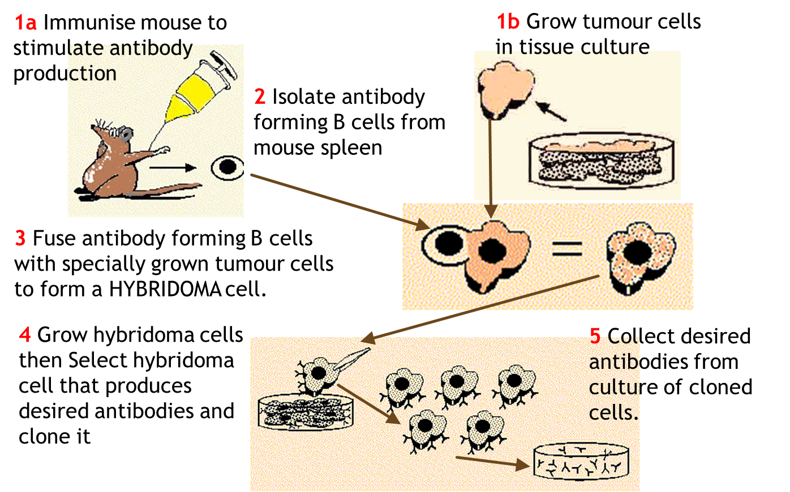**Monoclonal Antibodies**

Slides 58-62

“Details of monoclonal antibody production is not required” AQA spec.

* What are monoclonal antibodies? *(ref slides, p112 new text, p 109 -110 old text)*

…Antibodies of a single desired type specific to a particular antigen………..

* What are they used for?

…T target specific cells or substances for treatment of a disease or for diagnosis of a disease or condition. ……………………………………………..

* State some examples of their uses.

Treatment and diagnosis of cancer, diagnosis of flu and chlamydia, pregnancy testing, prostate cancer diagnosis.

* How do they work?

1. 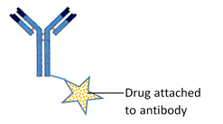Direct Monoclonal Antibody Therapy……. -Attach to the receptors of cancer cells and block chemical signals that stimulate uncontrolled growth. Eg Herceptin, a monoclonal antibody for treating breast cancer…………………………………………………….
2. Indirect Monoclonal Antibody Therapy…….-A drug eg a cytotoxic drug is attached to the antibody and when the antibody finds its target cell, the drug gets activated and kills the infected / abnormal cell…………………………..
3. Pregnancy testing ……monoclonal antibodies specific to hCG hormone are present on the test strip and are linked to coloured particles. If hCG is present in the urine the antibodies on the strip bind with it then links to another antibody placed in the test line of the strip and a clout shows up………

**Note**: Determining the amount of a chemical in a mixture is known as an **immunoassay** *(ref old text p110)*

**Definition of Immunoassay –“**A biochemical test that measures the presence or concentration of a macromolecule in a solution through the use of an antibody or immunoglobulin.” *(Wikipedia)*

**Ethical Issues Surrounding the Use of Monoclonal Antibodies**

Discuss and write down a list of issues related monoclonal antibody use.

**The ELISA Test (Enzyme Linked Immunosorbent Assay)**

Slide 63

This enables you to see if a patient has a particular antibody to a certain antigen and so diagnose the presence of a disease.

**Independent Preparation Work**. Carry out the **Virtual Lab Interactive ELISA Test** using the link below or from the slide. Read new T&T p 120-121 (not in old) or CGP p125 -126. Make notes and complete the exercise below.

Explain how the test works using the diagrams below to guide you as a story board

|  |  |
| --- | --- |
| KEY | |
|  | Antibody with enzyme attached |
|  | antigen |
|  | Substrate for enzyme |
|  | Coloured product acts as a marker |

Start with an antibody with an attached enzyme!

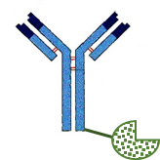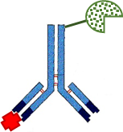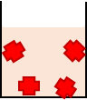

Antigens in sample are bound to the surface of the container

+ =

2 …Antibody binds to antigen to form an antibody antigen complex

1 .. enzyme is added to a monoclonal antibody then mixed with solution from body eg urine or blood…………

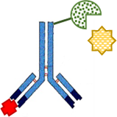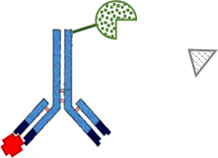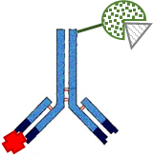

5 .. product is visible / coloured acting as a marker for the presence of the antibody antigen complex………….

4 .. substrate and enzyme form enzyme substrate complex………….

3 .. substrate is added to solution………….

Since the antibodies added to the sample all contained the enzyme, all could have reacted with the substrate that was also added to produce a colour marker. How can this technique prove the presence of the antigen in the sample?

…..The container must be rinsed of any loose antibodies leaving only those bound to antigens that are attached to the container surface. If there are coloured antibodies attached to the surface, it shows that the antigen of concern was present in the sample…………………………………………………………………………………………..

**Maths Skills – (MS 0.5)** ‘Calculate and understand the use of percentages or values per 100 000 when looking at data within populations’ *statement from AQA SOW*

The graph below shows the results of a study in Japan by **Hideo Honda** in 2005. It shows the number of children diagnosed with autism before the age of seven in the Yokohama region of Japan. It involved a study of more than 30 000 children.

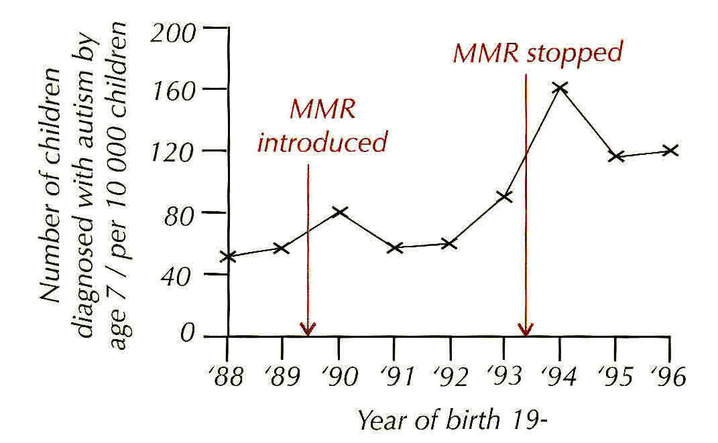

What happened to the incidence of children with autism after the MMR vaccine was stopped? …..It continued to rise…….

In 1994 the incidence of autism peaked in this region.

1. What percentage of the study population were diagnosed with autism in 1994?

160 out of 10 000 =160/10 000 X 100 = 1.6%

1. What was the lowest percentage diagnosed with autism during the time the vaccine was in use?

55 out of 10 000 = 55/10 000 X 100 = 0.55%

1. Does this information suggest there is any link between autism and MMR? No
2. Explain your reasons and using information given in the introductory sentences and the information on the graph.

…..There was a large sample size of 30 000………………………………….

…..The data was from children at similar stages of development, taken when they were 7 years old………………………………………………………………………….

…..The incidence of autism continued to rise after the MMR vaccination was stopped in Japan…………………………………………………………………………

There could be other factors involved in the increase in autism. Also diagnostic testing over the period concerned became more sophisticated as technology advanced.

**Read again** page 118 new T&T (not in old). Make notes below on why the earlier research of **Dr. Wakefield** does not seem reliable.

…….The sample size was very small…………………………………….

…….The author of the research had a conflict of interests……………..

…….No other scientists could repeat his findings……………………….

**HIV - The Human Immunodeficiency Virus**

This virus causes AIDS (Acquired Immune deficiency Syndrome) and was first diagnosed in 1981.

**Structure**

Slide 64

Label the structure of HIV*. (ref new text p 119 or slides not in old text)*

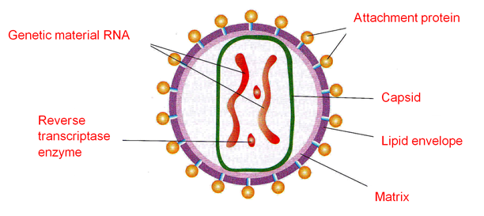

**Topic Cross Link Questions –**

* What is the **Capsid** of a virus? ........ A protein coat………….
* What is the function of the **lipid envelope**? ......... Helps the virus avoid the host’s immune system…………………………
* What type of proteins are the attachment proteins? ... Glycoproteins……….
* What is the name of the host receptors that these attachment proteins bind to? CD4 receptors.
* Which type of white blood cell contains these receptors? …T-cells *(ref ‘Prokaryotic cells and Viruses’ PowerPoint and new text p 119)*

**Action of HIV in the Body**

It causes the symptoms of AIDS. Explain below how it does this. *(ref slide or p 120 new text)*

Slide 65

* Kills or interferes with normal functioning of helper T-cells
* So body can’t produce adequate numbers of B-cells to produce antibodies or cytotoxic T-cells to kill infected cells.
* So body’s immune response is reduced and it is more susceptible to infections and cancer.
* These secondary infections ultimately cause death.

**HIV Life Cycle**

Slide 66 & 67

**Watch** the video clip. (link also on slides)

<http://www.wellcome.ac.uk/Education-resources/Education-and-learning/Resources/Animation/WTDV026676.htm> HIV Life Cycle video clip 5 min 12 s

**Jumbled Statements** – write the following statements in order 1 to 9 in the boxes of the HIV life cycle diagram. *(Diagrams snipped from Welcome trust video) ref video / text p119-120*

* *m-RNA goes to cytoplasm and makes viral proteins and RNA for new virus.(7)*
* *Immature HIV. (9)*

Slide 68

* *Attaches to white blood cell. (1)*
* *Viral strand made double stranded. (4)*
* *New virus buds off human cell. (8)*
* *Fusion of cell membrane and viral envelope. (2)*
* *Viral DNA enters nucleus. (5)*
* *Viral DNA integrates into human chromosomes and makes viral m-RNA (6)*
* *Released viral RNA copied into single stranded DNA. (3)*

Slide 68

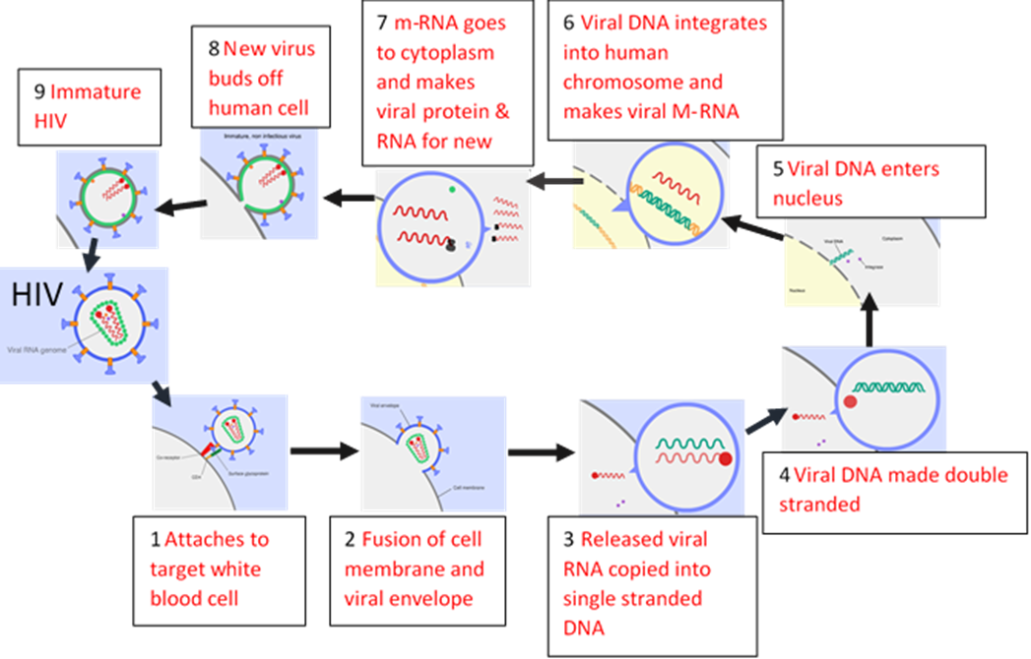

**Why Antibiotics are Ineffective against Viral Diseases.**

Slide 69

First consider the structure of bacterial cells. Topic Crosslink!

* + Bacterial cell wall made of murein…….
  + Water enters by …..osmosis……
  + Cell wall prevents excessive expansion because it is ..inelastic….

Some Antibiotics inhibit enzymes needed for cell wall synthesis. This means the cell wall is weakened, too much water enters by osmosis and the cell suffers osmotic lysis. (death by osmosis!)

Others bind to bacterial ribosomes, so inhibit protein synthesis.

Some antibiotics inhibit DNA replication.

Slide 70

Some work by disrupting cell membranes.

**IE they all interfere with the bacterial metabolism!**

Now explain below why antibiotics are no use against viruses.

…………………………………………………………………………………………………….

……………………………………………………………………………………………………………………………………………………………………………………………………………………………………………………………………………………………………………………..

Practice Question - Diagnosis

**5.** (a) What is vaccination?

.....................................................................................................................................

.....................................................................................................................................

.....................................................................................................................................

.....................................................................................................................................

(2)

(b) A test has been developed to find out whether a person has antibodies against the mumps virus. The test is shown in the diagram.



(i) Explain why this test will detect mumps antibodies, but not other antibodies in the blood.

...........................................................................................................................

...........................................................................................................................

(1)

(ii) Explain why it is important to wash the well at the start of **Step 4**.

...........................................................................................................................

...........................................................................................................................

...........................................................................................................................

...........................................................................................................................

(2)

(iii) Explain why there will be no colour change if mumps antibodies are not present in the blood.

...........................................................................................................................

...........................................................................................................................

...........................................................................................................................

...........................................................................................................................

(2)

(Total 7 marks)

**ANSWER to Question**

**5.** (a) Injection of antigens/toxoids;

(Antigen from) attenuated microorganism/non-virulent microorganisms/dead

microorganisms/isolated from microorganism;

Stimulates the formation of memory cells; max 2

(b) (i) Antibodies are specific to mumps antigen;  
2nd antibodies specific to mumps antibody; 1

(ii) Removes unbound 2nd antibodies;  
Otherwise enzyme may be present/may get colour change  
anyway/false positive; 2

(iii) No antibodies to bind (to antigen);  
Therefore 2nd antibody (with the enzyme) won’t bind;  
No enzyme/enzyme-carrying antibody present  
(after washing in step 4); max 2

[7]

**Specification Content: Section 3.2.4 Cell Recognition and the Immune System**

Each type of cell has specific molecules on its surface that identify it. These molecules include proteins and enable the immune system to identify:

* Pathogens
* Cells from other organisms of the same species
* Abnormal cells
* Toxins

Definition of an antigen. The effect of antigen variability on disease and disease prevention.

Phagocytosis of pathogens. The subsequent destruction of ingested pathogens by lysozymes.

The response of T lymphocytes to a foreign antigen. (The cellular response).

* The role of antigen-presenting cells in the cellular response.
* The role of helper T cells (TH cells) in stimulating cytotoxic T cells (TC cells), B cells and phagocytes. The role of other T cells is not required.

The response of B lymphocytes to a foreign antigen, clonal selection and the release of monoclonal antibodies (the humoral response).

* Definition of antibody
* Antibody structure
* The formation of an antigen-antibody complex, leading to the destruction of the antigen, limited to agglutination and phagocytosis of bacterial cells.
* The roles of plasma cells and of memory cells in producing primary and secondary immune responses.

The use of vaccines to provide protection for individuals and populations against disease. The concept of herd immunity.

The difference between active and passive immunity.

Structure of the human immunodeficiency virus (HIV) and its replication in helper T cells.

How HIV causes the symptoms of AIDS. Why antibiotics are ineffective against viruses

The use of monoclonal antibodies in:

* Targeting medication to specific cell types by attaching a therapeutic drug to an antibody.
* Medical diagnosis.

Details of the production of monoclonal antibodies is **not** required.

Ethical issues associated with the use of vaccines and monoclonal antibodies.

The use of antibodies in the ELISA test.

**Students should be able to:**

* Discuss ethical issues associated with the use of vaccines and monoclonal antibodies.
* Evaluate methodology, evidence and data relating to the use of vaccines and monoclonal antibodies.

**Cell Recognition and the Immune System Glossary**

|  |  |
| --- | --- |
| antigen |  |
| antibody |  |
| Antigenic variation |  |
| lysozymes |  |
| lymphocytes |  |
| phagocytes |  |
| phagocytosis |  |
| Cytotoxic T-cells |  |
| Helper T-cells |  |
| B-cells |  |
| Plasma cells |  |
| Memory cells |  |
| Monoclonal antibodies |  |
| ELISA test |  |
| agglutination |  |
| Clonal selection |  |

|  |  |
| --- | --- |
| Antigen presentation |  |
| phagosome |  |
| toxin |  |
| Self-antigen |  |
| cytokines |  |
| perforin |  |
| immunoglobulin |  |
| Primary response |  |
| Secondary response |  |
| Pandemic |  |
| epidemic |  |
| attenuation |  |
| Hybridoma cell |  |
| ELISA test |  |
| agglutination |  |
| Clonal selection |  |