**3.2.2 All cells arise from other cells. (2015 Student Work book)-Answer**

All cells arise from other cells by binary fission in prokaryotic cells and by mitosis and meiosis in eukaryotic cells

**GCSE Recall**

* In body cells the chromosomes are normally found in pairs
* Body cells divide by mitosis producing genetically identical body cells
* Mitosis occurs during growth or to produce replacement cells

**Specification**

Within multicellular organisms, not all cells retain the ability to divide.

Eukaryotic cells that do retain the ability to divide show a cell cycle.

• DNA replication occurs during the interphase of the cell cycle.

• Mitosis is the part of the cell cycle in which a eukaryotic cell divides to produce two daughter cells, each with the identical copies of DNA produced by the parent cell during DNA replication.

The behaviour of chromosomes during interphase, prophase, metaphase, anaphase and telophase of mitosis. The role of spindle fibres attached to centromeres in the separation of chromatids.

Division of the cytoplasm (cytokinesis) usually occurs, producing two new cells.

Meiosis is covered in section 3.4.3

Students should be able to:

• recognise the stages of the cell cycle: interphase, prophase, metaphase, anaphase and telophase (including cytokinesis)

• explain the appearance of cells in each stage of mitosis.

Mitosis is a controlled process. Uncontrolled cell division can lead to the formation of tumours and of cancers. Many cancer treatments are directed at controlling the rate of cell division.

Binary fission in prokaryotic cells involves:

• replication of the circular DNA and of plasmids

• division of the cytoplasm to produce two daughter cells, each with a single copy of the circular DNA and a variable number of copies of plasmids.

Being non-living, viruses do not undergo cell division. Following injection of their nucleic acid, the infected host cell replicates the virus particles.

Required practical 2: Preparation of stained squashes of cells from plant root tips; set-up and use of an optical microscope to identify the stages of mitosis in these stained squashes and calculation of a mitotic index.

Students should measure the apparent size of cells in the root tip and calculate their actual size.

**Introduction**

Good video by Bozeman

<https://www.youtube.com/watch?v=1cVZBV9tD-A>

1. **Structure of chromosomes**

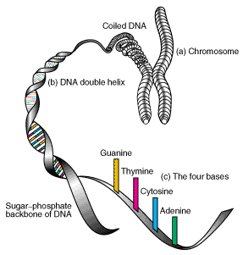Composed of long strands of DNA tightly coiled many times around proteins called histones that support its structure and a small amount of RNA

The DNA is in the form of a double helix running up the centre of the chromosome

Before division (in interphase) the DNA is partly uncoiled and appears as thin tangled threads. Individual chromosomes can not be seen. Described as chromatin

Draw and label a chromosome:

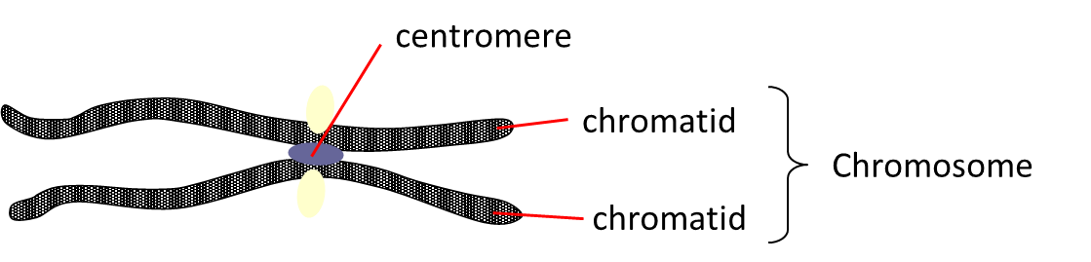

After replication, but before cell division the chromosomes can be seen as double structures, attached by the CENTROMERE

The 2 strands are called Sister Chromatids

During Interphase the chromosomes are long and thin and they cannot be seen individually.

When not distinguishable as individual chromosomes nuclear genetic material is termed CHROMATIN

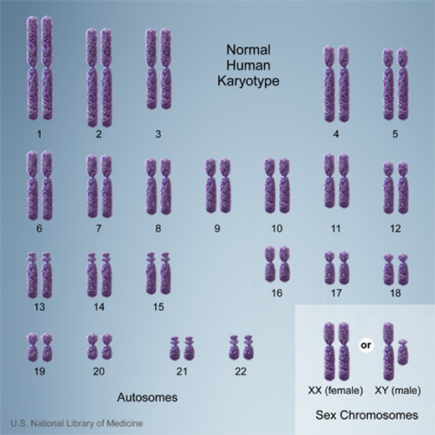This is a photograph of the human karyotype

2n=46 (the diploid number)  
23 pairs of homologous chromosomes, each pair: one maternal, one paternal.

The haploid number is n=23 and found in gametes

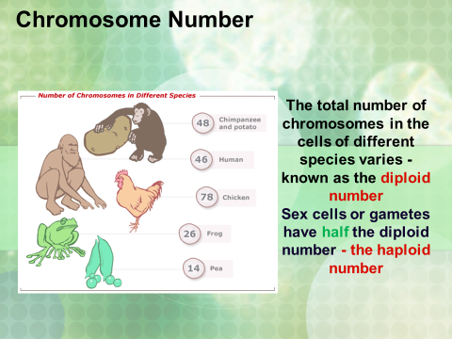 The total number of chromosomes in the cells of different species varies - known as the diploid number

Sex cells or gametes have half the diploid number - the haploid number

1. **Cell Cycle**

**In Eukaryotic cells**

Eukaryotic cellsdivide either by mitosis or meiosis.

* Mitosis produces two daughter cells that are genetically identical to each other and to the parent cell.
* Meiosis: division into four unique daughter cells with half the chromosomes of the parent cell. Genetically different. Produces the sex cells

**Mitosis**

Why is mitosis important?

1. 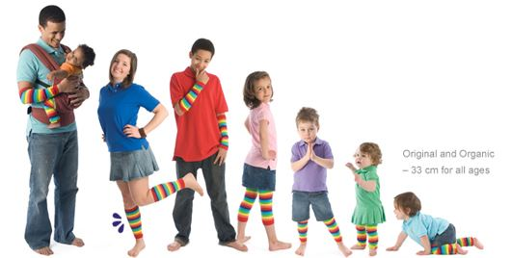Genetic stability………………………………

2. Growth

3. Repair

4 Reproduction (a sexual)

**A sexual reproduction**

Can you list any advantages or disadvantages of producing genetically identical offspring

Advantages : All adapted to a stable environment, Rapid

Disadvantages : Less able to adapt to environmental change, identical individuals makes them vulnerable to disease.

**The cell cycle**

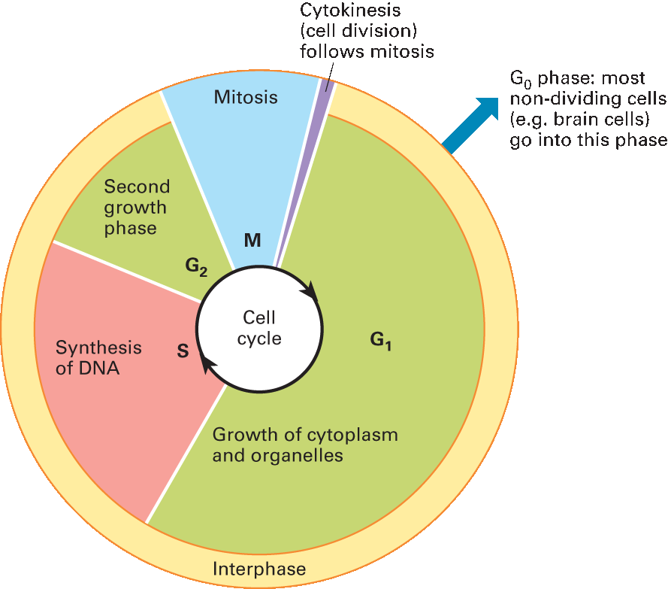Not all cells in a multicellular organism retain the ability to divide. An example of a cell that retains its ability to divide is a stem cell. A cell that has the ability to continuously divide follows a process called the cell cycle.

The cell cycle involves three phases

1. Interphase-DNA replicates and cell grows
2. Mitosis – Division of the nucleus
3. Cytokinessis-Division of the cytoplasm

**Interphase**

Interphase is the longest phase of the cell cycle.Alot of activity occurs in this stage. The proteins required for DNA replication are produced in this phase, organelles are replicated and the cell grows therefore a lot of ATP is required and produced during interphase. Interphase is split into three phases:

Gap 1 phase (G1)-cell grows and new organelles and proteins are made

Synthesis phase (S)-DNA replicates

Gap 2 phase (G2)-cell keeps growing and proteins needed for cell division are made Interphase is split into three phases:

**Mitosis**

Mitosis is a relatively short phase of the cell cycle where nuclear division occurs. It consists of four phases

1. Prophase
2. Anaphase
3. Metaphase
4. Telophase

|  |  |
| --- | --- |
| Phase | Description |
| Prophase | Several events occur during prophase that visibly indicate the cell is about to divide. The two pairs of centrioles outside the nucleus begin moving away from each other toward opposite ends of the nucleus. Spindle ﬁbres appear between the separating centriole pairs, the nuclear envelope begins to fragment, and the nucleolus begins to disappear. The chromosomes are now fully visible. Spindle ﬁbres attach to the centromeres as the chromosomes continue to shorten and thicken. During prophase, chromosomes are randomly placed in the nucleus. |
| Metaphase  earlymetaphase | During metaphase, the spindle occupies the region formerly occupied by the nucleus. The paired chromosomes are now at the equator (centre) of the spindle. Metaphase is characterized by a fully formed spindle, and the chromosomes, each with two sister chromatids, are aligned at the equator |
| Anaphase | At the start of anaphase, the sister chromatids separate. Once separated, the chromatids are called chromosomes. Separation of the sister chromatids ensures that each cell receives a copy of each type of chromosome and thereby has a full complement of genes. During anaphase, the daughter chromosomes move to the poles of the spindle. Anaphase is characterized by the movement of chromosomes toward each pole and thus, to opposite sides of the cell. |
| Telophase | Telophase begins when the chromosomes arrive at the poles. During telophase, the chromosomes become indistinct chromatin again. The spindle disappears as nucleoli appear, and nuclear envelope components reassemble in each cell. Telophase is characterized by the presence of two daughter nuclei. |

**Cytokinesis**

It is the physical process of cell division, where the parental cytoplasm divides and get production of two daughter cells

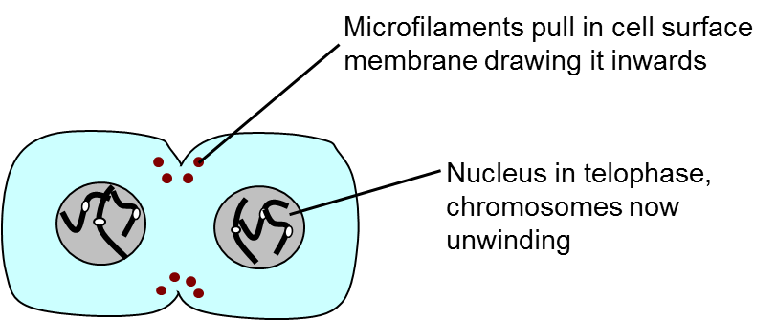

In Plant cells cytokinesis is slightly different. Golgi vesicles carrying materials to make the cell wall accumulate in the centre region of the cell. The vesicles then fuse together to form a cell plate. Inside the vesicles a middle lamella forms with cellulose either side of it. Two separate cells are formed.

Recall : In 3.2.1 you should know that the middle lamella is a pectin (gelatinous polysaccharide) layer which functions to cement the cell walls together of two adjoining cells. This is essential to plants as it gives them stability, and allows plants to form plasmodesmata between cells.

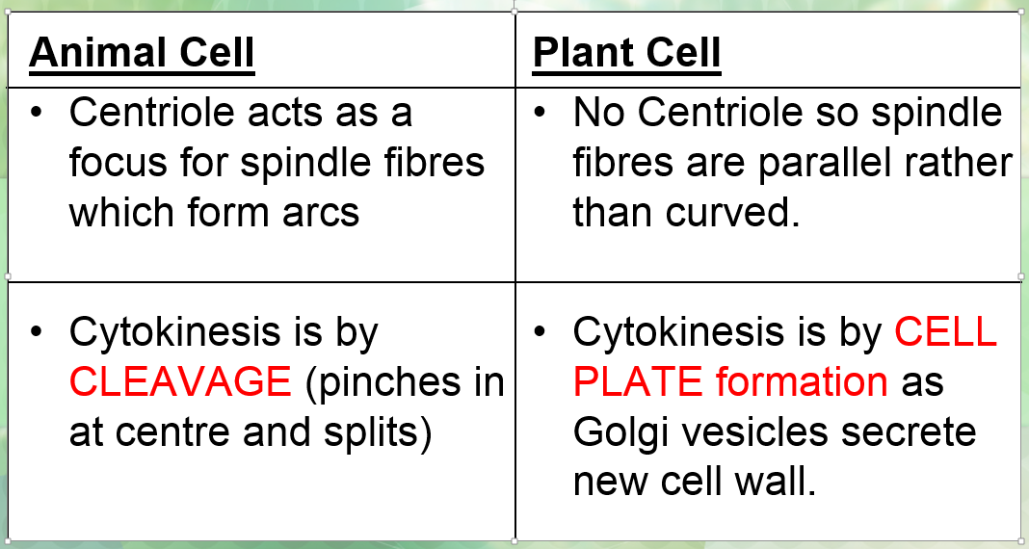Differences in mitosis in plant and animal cells

**DNA content within the cell cycle**

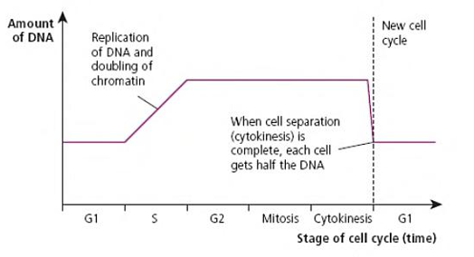

What Phase is DNA replication occurring in?

S phase in interphase

What is the phase when the DNA content is halved?

Cytokinesis as cell splits into two

**Cell cycle timing**

Every cell that divides goes through the cell cycle. Interphase is always the longest part of the cycle, followed by telophase, prophase, metaphase and anaphase, however how long they are in each stage depends on the type of cell.

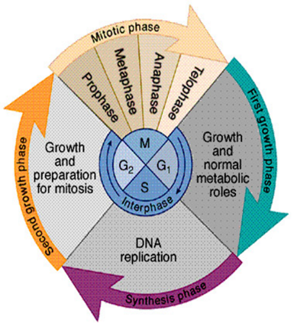Intestinal cells: Divide every 8hrs

Liver: divide once per year

Skin epidermal cells: Divide every 24hrs

Onion root tip: divide every 20hrs

Nerve cells: do not divide

Question: A scientist is looking at a tissue sample under a microscope. She counts 150 cells undergoing mitosis. Of those 12 cells are in prophase. One complete cycle lasts 0.70 days. How long do the cells spend in prophase? Give your answer in hours.

proportion of cells in prophase = 12/150=0.08

Cell cycle lasts 0.7 days so 0.7 x 24=16.8hrs

The cells spend 0.08 x 16.8 = 1.3 hrs in prophase

**Cancer**

Define a mutation : A mutation is a permanent, heritable change in the nucleotide sequence in a gene or a chromosome

Caused by :-

1. Environmental factors
2. Errors in replication of DNA during mitosis

Mutations can be harmless or pathogenic

How do you measure if a tissue is cancerours or not?

Measure Mitotic index which is the proportion of cells in a tissue sample undergoing mitosis. Some tissues you would expect a high mitotic index like root tip cells (meristem cells) and others you would not (liver cells). Write down the equation for mitotic index

Mitotic index = number of cells with visible chromosomes

total number of cells observed

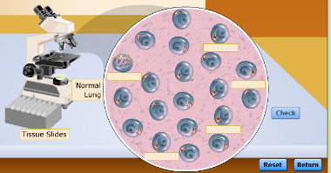**Virtual Lab**

Using the mitotic index as a prognostic tool in cancer therapy.

Key Terms

|  |  |
| --- | --- |
| Mitotic index | The ratio of the number of cells in mitosis to the total number of cells. |
| Prognostic tool | A method of predicting the future growth of cancer cells. (e.g. mitotic index) |

To do:

1. Navigate to The virtual lab: http://www.mhhe.com/biosci/genbio/virtual_labs_2K8/labs/BL_03/index.html

2. Read Purpose, objectives and procedure in the “Question” column on the left side.

3. Click on the TV in the centre of the image, watch the video if you need reminding of the details of the chromosome movements in the different stages of mitosis.

4. Click the microscope – and make a brief note of the appearance of each stage of mitosis in the table below.

|  |  |  |  |  |
| --- | --- | --- | --- | --- |
| The Stages of Mitosis | | | | |
| Interphase | Prophase | Metaphase | Anaphase | Telophase |
|  |  |  |  |  |

5. Start the lab simulation to examine the different stages of mitosis. Drag and drop the labels into place in the spaces in the circle of cells. Then check your answers. Count the cells and record the total number of cells and the number of cells undergoing a phase of mitosis in the table below.

6. Six types of tissue are available for examination. Click the tissue slides box and choose a cell type. Label each stage of the cell cycle, and then check your answers by clicking “check”. Record the number of cells in each stage of the cell cycle in the Data Table.

7. Examine both normal and cancerous tissue for each tissue type.

|  |  |  |  |  |
| --- | --- | --- | --- | --- |
| Tissue Type | Number of cells in interphase | Number of cells in any phase of mitosis | Mitotic index=Number of cells in mitosis/total number of cells | % mitotic index |
| Normal lung Tissue |  |  |  |  |
| Cancerous lung tissue |  |  |  |  |
| Normal stomach tissue |  |  |  |  |
| Cancerous stomach tissue |  |  |  |  |
| Normal Ovarian Tissue |  |  |  |  |
| Cancerous Ovarian Tissue |  |  |  |  |

Note: You can collect repeats of each tissue type by clicking “reset”.

Analysis of data

Calculate the mitotic index. Using a calculator, sum up the total number of cells you counted by adding the number of mitotic cells and cells in interphase together. Divide the number of mitotic cells by the total number of cells you counted to calculate the mitotic index of your tissue sample. Multiply this number by 100 to get the percentage of cells undergoing mitosis in your sample.

Questions

1. What does your data show about the rate of cell division in cancerous tissue compared to the rate of cell division in normal tissue? What data supports your answer to this question?

…………………………………………………………………………………………………………………………………………….……………………………………………………………………………………………………………………………………………….……………………………………………………………………………………………………………………………………………….…………………………………………………………………………………………………………………………………………………………………

2. Which type of cancer is the fastest growing? Explain your answer, using relevant data to support your claim.

……………………………………………………………………………………………………………………………………………….……………………………………………………………………………………………………………………………………………….……………………………………………………………………………………………………………………………………………….………………………………………………………………………………………………………………………………………………………………..

What Causes Cancer?

A mutation in a gene that controls the cell cycle causing uncontrolled growth leading to the development of a tumour. Cancer is a group of about 200 diseases and can occur in any organ but most common in lungs, prostate gland, breast, ovaries, stomach, oesophagus and pancreas.

Two Types of tumour

1. Benign (non Cancerous)- – tumours that do not spread from their point of origin but they may still be painful because they compress surrounding tissues and displace them. Benign tumours are usually encased in a fibrous capsule and do not invade the tissue in which they originate. Do not cause cancer and do not metastasise
2. Malignant (Cancerous)- divide in a more uncontrolled way than benign tumours and can be carried by the blood stream or lymphatic system to invade other tissues, causing secondary cancers. This process is called metastasis

Both tumours my damage organ concerned, cause blockages and exert pressure on other organs

Malignant tumour

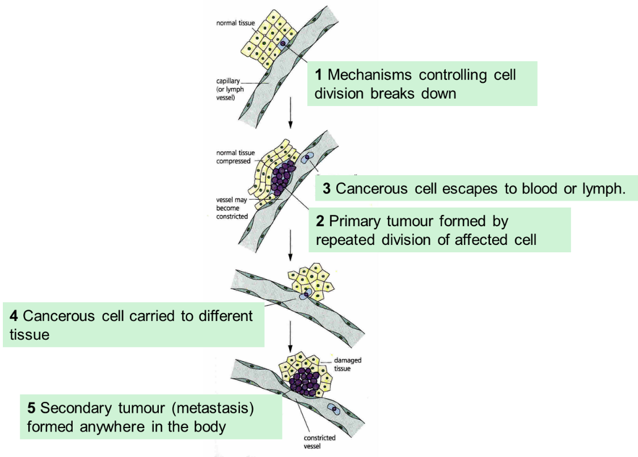

Two types of genes that control the cell cycle

1. Proto-oncogenes- stimulate cell division
2. Tumour suppressor factors-stop (supress) cell division

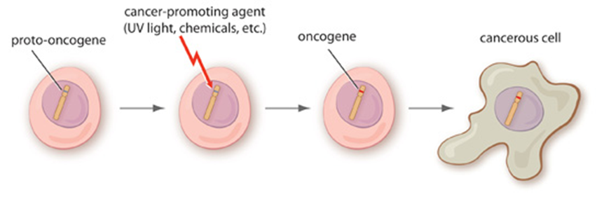A proto-oncogene is a gene that encodes a protein that is involved in regulation of cell growth or proliferation

Can be mutated into a cancer promoting oncogene where the gene is stuck in a state of constant activity leading to uncontrolled growth

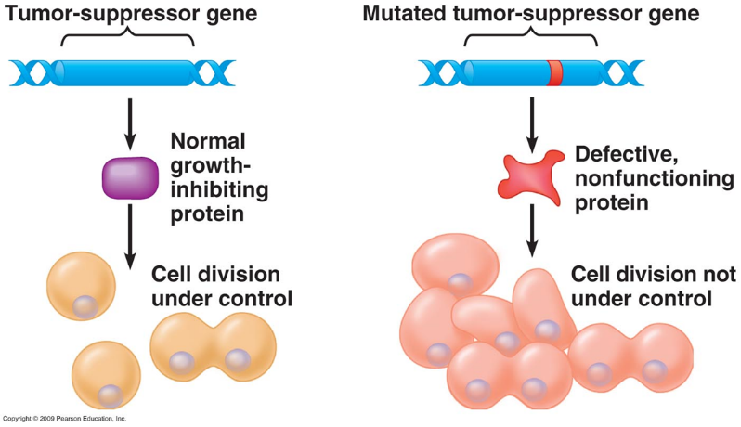Tumour suppressor genes encode proteins that inhibit cell proliferation.

Loss of these genes can contribute to the development of cancer

Treatments for cancer are designed to **control the rate of cell division in tumour cells by disrupting the cell cycle.**

Will normal cells be killed by cancer treatments?

Yes

Why are treatments more effective against cancerous cells than normal cells?

Cancer cells divide more frequently

How to treat cancer

Three approaches to cancer treatment

1. Surgery-removal of the tumour
2. Radiotherapy-radiation damages the DNA and causes cells to kill them selves
3. Chemotherapy- drugs are used to kill cancerous cells preventing them from dividing or damaging them so they kill themselves.

Two types of chemotherapy:

1. Prevent the DNA from replicating

Some drugs target G1 region in interphase

Prevent the synthesis of enzymes needed for DNA replication and therefore cell is unable to enter S phase

Some drugs target the S phase

Includes radiation as DNA becomes so damaged cell will kill itself (checkpoints)

1. Inhibit the metaphase stage of mitosis by interfering with spindle formation

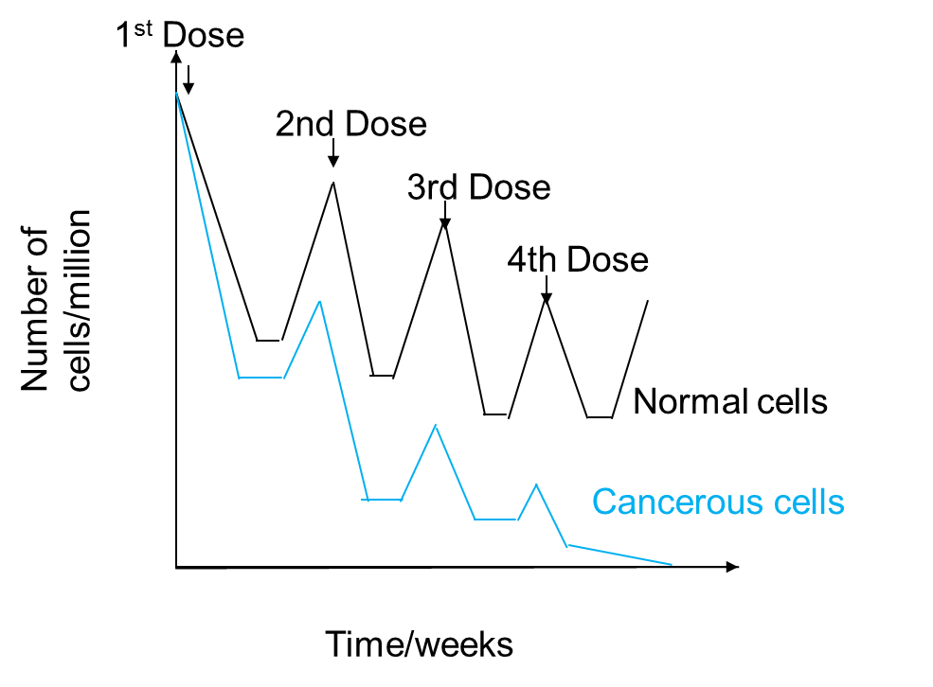

Suggest why

1.The drug was not given more frequently

If frequency increased the healthy body cells would not have time to recover and numbers would decline and could kill the patient

2.The dose of the drug was not increased

The increased dose would kill even more healthy cells and again numbers would decline rapidly after a few treatments-could kill patients

Cell Division in Prokaryotes (Binary Fission)

A sexual reproduction to form two identical daughter cells

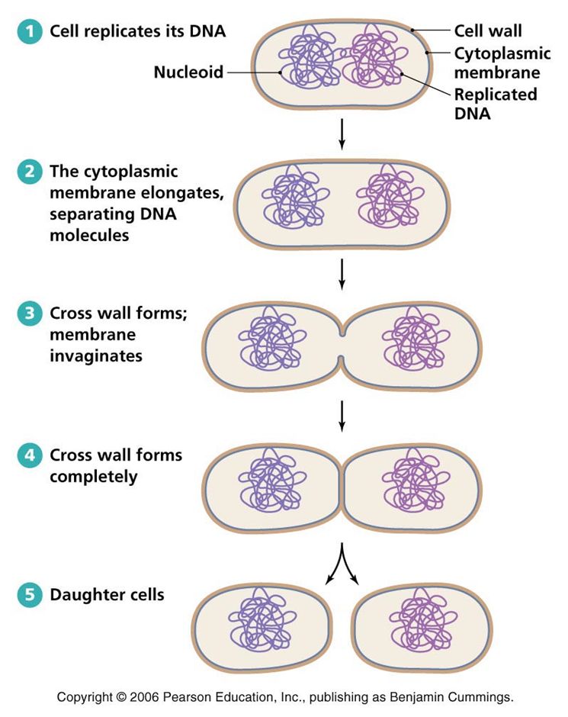Write down the stages of Binary fission

Very similar to mitosis genetic material is replicated before the prokaryote splits Into two.

Replicated large loop of DNA attaches to cytoplasmic membrane. As cell grows the DNA is separated

The main DNA loop is only replicated once, but plasmids can be replicated numerous times

Daughter cells can contain variable numbers of plasmids

Write a synopsis of viral replication (recall)

Remember as viruses are non living they do not undergo cell division. Host cell replicates the virus particle

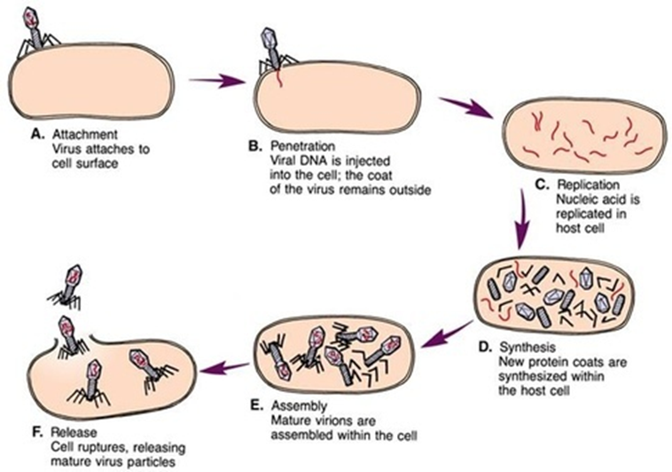

Attachment: The virus attaches to a host cell via attachment proteins on virus and a receptor protein on the cell. In the case of the bacteriophage it will attach to a bacterium.

Entry: The virus forms a hole in the membrane or cell wall of the host. The nucleic acid of the virus enters the host cell.

Synthesis: The virus’ nucleic acid is used to make new viral nucleic acid and proteins for the new viruses being produced. (The host cells’ DNA becomes deactivated)

Assembly: New viruses are made inside the host cell.

Release: The host cell bursts to release the new viruses. The bursting is called lysis.

**Practical-Root Tip Squash**

**Key points:**

Why do you add acetic orcein stain?

Make chromatids visible

Why do you add 1M hydrochloric acid?

Softens cell wall and lets stain enter the cell

Why do you heat the root tip?

Speeds up softening and staining

Why do you squash the root tip?

So it is one cell thick making it easier to see dividing cells

**Glossary**

|  |  |
| --- | --- |
| Meiosis |  |
| Mitosis |  |
| Binary Fission |  |
| Chromosome |  |
| Chromatin |  |
| Centromere |  |
| Histone |  |
| Cancer |  |
| Benign tumour |  |
| Malignant tumour |  |
| Proto oncogene |  |
| Oncogene |  |
| Tumour supressing factor |  |
| Chemotherapy |  |
| Radiotherapy |  |
| Interphase |  |
| Gap 1 phase |  |
| Gap 2 phase |  |
| S phase |  |
| Prophase |  |
| Metaphase |  |
| Anaphase |  |
| Telophase |  |
| Cytokinesis |  |
| Spindle fibre | The spindle brings about chromosome movement. Two types of spindle fibers are involved in the movement of chromosomes during anaphase. One type extends from the poles to the equator of the spindle; there, they overlap. As mitosis proceeds, these ﬁbers increase in length, and this helps push the chromosomes apart. Spindle ﬁbers, as stated earlier, are composed of microtubules. Microtubules can assemble and disassemble by the addition or subtraction of tubulin (protein) subunits. This is what enables spindle ﬁbers to lengthen and shorten, and it ultimately causes the movement of the chromosomes. |
| Meristem |  |
| Virion |  |