Biology Department Name: ……………………..

**Teacher**

**Booklet**

**Transport across Cell Membranes**

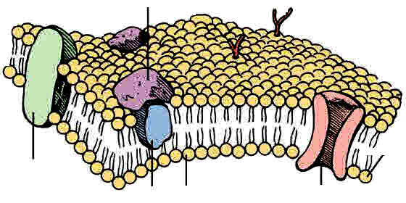Specification 2015 Section 3.2.3

Additional Resources required: Biofactsheet 54 Water Potential. Also useful:- Biofactsheet 225 Synoptic Biology: Water Potential

**Learning Objectives**

* Specification reference 3.2.3
* The fluid mosaic model of cell membranes, including the arrangement of phospholipids, proteins, glycoproteins and glycolipids.
* The role of cholesterol.
* The movement of water across partially permeable membranes by osmosis.
* The concept of water potential and hypotonic, hypertonic and isotonic solutions.
* Movement of molecules and ions down concentration gradients by simple diffusion or facilitated diffusion.
* Movement of molecules and ions against concentration gradients by active transport.
* The adaptations of cells for rapid transport across internal and external membranes.
* Movement of molecules and ions against concentration gradients by co-transport.

**What you should know from GCSE**

* Cell membranes control the passage of substances into and out of the cells.
* Dissolved substances can move into and out of cells by diffusion. The greater the difference in concentration, the greater the rate of diffusion.

**Preparatory Work**

1. **Complete** the 8 Introductory GCSE recall questions on the next page.
2. **Watch** the Bozeman video Cell membranes

<http://www.bozemanscience.com/015-cell-membrane>

1. **Then answer** the review questions on the next page.

**What Do You Know From GCSE?**

1. Where are membranes found? ...surrounding cells and around some organelles...
2. What is the purpose of cell membranes? To control passage of substances into and out of cells
3. Do plants have cell membranes? ...............yes.......................................................
4. Do bacteria have cell membranes? ............yes.......................................................
5. How can dissolved substances pass across membranes? Diffusion & active transport.
6. How can water pass across membranes? .....osmosis……………………………....
7. Name 4 substances required by cells and what each needed for.

……oxygen for aerobic respiration…………..

……glucose for aerobic respiration………….

……amino acids for growth and repair………

……water to be a solvent, to be a component of cytoplasm, blood, tissue fluid and needed by plants for photosynthesis……………..

1. Name 3 end products of metabolic processes that may pass out of a cell.

…....carbon dioxide from respiration……………….

……water from respiration………………………….

……Urea from deamination of amino acids………

**Bozeman Video Review Questions**

1. Why does soap dissolve the membranes easily? Because membranes are made of lipids.
2. What is selective permeability? How does the cell achieve this? Only allows certain things in and certain things out ie regulates what gets in and out. Does this by the cell membrane.
3. What are the 2 main molecules that make up cell membranes? Phospholipids and proteins.
4. Phospholipids are described as AMPHIPATHIC. What does this mean? That they have a part that likes water and a part that does not. Ie they are dual natured.
5. What sort f particles do phospholipids allow to pass between themselves? Small and uncharged particles.
6. What is the role of many membrane proteins? Regulate transport and allow larger and charged particles through.
7. What is the role of cholesterol? Keeps phospholipids from drifting apart as well keeping them apart enough from each other.
8. Name one function of glycolipids antibodies
9. Name one function of glycolipids. Cell signalling.

**NOTE**: Bozeman talks about water passing through the membrane by **Aquaporins** rather than through the phospholipids. Aquaporins are small membrane proteins that allow passage of water and were discovered in 1992 by Peter Agre who was awarded a **Nobel Prize in Chemistry** for this in 2002. There have now been discovered many different varieties of aquaporins.

However **our syllabus** does **not include aquaporins** and it is thought some water can pass through the phospholipids, because although it is polar it is small enough to pass through slowly. However membranes that possess aquaporins can increase the rate of water movement and this is very important in cells like kidney tubule cells.

In any case, the principles of osmosis and water potential that you must learn, are the same for both aquaporins and conventional movement through phospholipids.

**What are Membranes?** *(ref slide / use info from pages 52 &53 T&T old text /p84&85 new)*

* List the 6 functions of cell surface membranes

1. 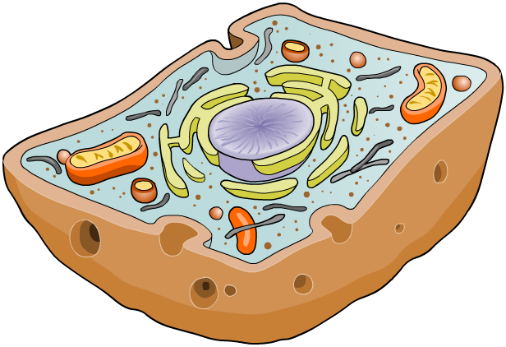Define boundary of cell…………………………..
2. Controlling what substances pass into (nutrients and oxygen) and out of the cell (secretion)…………
3. Play a role in cell recognition (immune system)……
4. Provide receptor sites for hormones, neurotransmitters and enzymes.................................
5. Allowing the cell to change shape (be flexible)……..

Slides 9 & 10

1. Help cells stick together

* List 3 functions of internal membranes

1. **Compartmentalsation:** Isolating organelles from the rest of the cytoplasm, allowing cellular processes to occur separately.
2. a site for biochemical reactions
3. control which substances pass into and out of organelles

**The Structure of the cell Surface Membrane**

Describe how a membrane looks like when seen under an electron microscope. *(Ref slide)*

****………………………………………………………………………………………………………..

**Draw below** a diagram of the membrane as seen under the electron microscope.

Phosphate heads of phospholipids

Fatty acid tails of phospholipids

Slides 12 & 13

* On your diagram **label** what the dark lines represent and what the space in between represents. (You may need to do this AFTER learning more about membrane structure.)

*EM of a plasma membrane*

* In 1972 a model was suggested to describe the structure of the cell surface membrane. What is the name of this model? ……fluid mosaic model…………
* What is another name for a cell membrane? .........plasma membrane ………..

Slides 15

**The Molecular Components of a membrane**

* **List** the main molecule components of a membrane *(ref slide)*

.........phospholipids................... …….proteins………………….

……..glycolipids………………... …….glycoproteins………….,..

……..cholesterol………………..

**The Fluid Mosaic Model of Membrane Structure**

* **Label** the 2D diagram *(ref slides)*

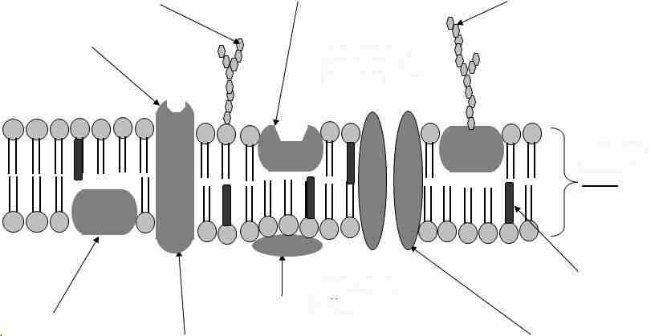

Slides 16

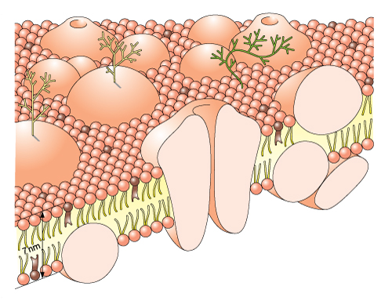

Glycoprotein acts as a recognition site

Protein molecule partly embedded (extrinsic protein)

Cholesterol adds strength - stability, rigidity and flexibility

Hydrophobic tails of phospholipids point inwards

Protein molecule spanning the phospholipid layer – (intrinsic protein)

Protein molecule lying on surface (extrinsic protein)

Pore

Hydrophilic heads of phospholipid molecules point outwards

Glycolipid – acts as a recognition site

Slides 17

Now **Label** the 3D diagram *(ref: slide or T&T p53 [old spec] or p86 [new spec]).*

What Does the Model Name **Fluid Mosaic** mean? *(Ref slide or text)*

Slides 18

* Fluid ……because the individual phospholipids can move laterally (sideways) and change places with each other. …………………
* Mosaic …because when seen from above, the membrane is like a mosaic of phospholipids with proteins of different shapes and sizes embedded in it ……………………………………………………………..
* What is meant by saying the membrane forms a bilayer? …It is made up of two layers of phospholipids arranged with their fatty acid tails facing each other and the phosphate heads on the outside……………………

Slides 19 & 20

* **Draw** a phospholipid bilayer and annotate your diagram to explain why the phospholipids are arranged that way. *(ref slide)*

**Hydrophilic heads** are next to the watery environment of cytoplasm and intercellular fluid

**Hydrophobic tails** are sandwiched in the centre away from the watery regions

* Some organelles have a double membrane. **Name** these organelles and **draw** an annotated double membrane. *(ref slide)*

2 bilayers but 4 layers of phospholipids

…nucleus……………..

…mitochondrion……

…chloroplast……

Membranes have **hydrophobic** and **hydrophilic** regions. **Add labels** stating the hydrophobic parts and hydrophilic parts of your bilayers if it is not included on your annotated diagram. *(Ref slide)*

Slides 21

* Explain below what these words mean.

Hydrophobic ……repelled by water……………………..................

Hydrophilic ……attracted to water………………………………….

* How does this affect the way the membrane is arranged? Think of the composition of cytoplasm and of intercellular spaces between cells. ………………………………

………………………………………………………………………………………………..

………………………………………………………………………………………………..

**Functions of the Different Membrane Component**

**Protein functions**

* List below the 6 functions of **PROTEINS** in the membrane. *(Ref. slide & T&T p52-53 old spec or p85 new spec).*

Slides25

1. Provide structural support
2. Act as transporting channels water soluble substances across the membrane
3. Allow active transport across the membrane through carrier proteins
4. Form cell-surface receptors for identifying cells
5. Help cells adhere together
6. Act as receptors for example for hormones

Membrane proteins may be either EXTRINSIC or INTRINSIC. What does this mean? *(ref T&T old spec text p52)*

**Intrinsic Proteins**…… completely span phospholipid bilayer. Some act as channels, carriers or as enzymes(eg ATPase) …………………

**Extrinsic proteins**… on the surface of the membrane or are only partly embedded in it. ……………………………………………………………………………………

* Now state the functions of the other membrane components.

**Phospholipid Functions**…allow lipid-soluble substances to enter and leave cells, prevent water soluble substances entering and leaving, and make membrane flexible and self-healing...................................................................................................................................

**Cholesterol functions**…..reduce lateral movement of other molecules, make membrane less fluid at high temperatures, prevent leakage of water and dissolved ions from the cell… (ie helps regulate rigidity, stability and fluidity) ………………………………………………………………………….

**Teacher note:** Cholesterol functions detailed in new spec text but not in old one. Ditto glycolipids and glycoproteins

**Glycolipid functions**…. act as recognition sites (eg for toxins), help cell attachment and help with membrane stability …………………………………………………………..

**Glycoprotein functions**... act as recognition sites, help cell attachment and allows cells to recognize one another……………………………………………………………….

**Independent Work** – Text Summary Questions 1-4 T&T p 53 old text / p86 new text.

Answer on lined paper in **full sentences** and attach to this pack

**Transport across Membranes**

* List 5 ways that substances cross membranes and say whether each is an active or passive process. *(ref. slide)* …simple (lipid) diffusion……(passive)……

Slides 32

…..facilitated diffusion….……(passive)….…

…..osmosis……………………(passive)……

…...active transport (direct active transport).

……co-transport (indirect active transport)...

**1 Diffusion (Simple or Lipid Diffusion)** Independent Work Section

* Watch the animations and make rough notes in the space below.

<http://highered.mheducation.com/sites/0072495855/student_view0/chapter2/animation__how_diffusion_works.html>

**Definition of Diffusion** *(ref p 54 old spec text / p 87 new spec text)*

**Diffusion is** the **net** movement of molecules or ions from a region where they are more highly concentrated to one where their concentration is lower until evenly distributed.

Read text *p 54 (old spec) / p 87 (new spec)* then explain diffusion in terms of kinetic energy of molecules.

……………………………………………………………………………………………………….

………………………………………………………………………………………………………..

……………………………………………………………………………………………………….

……………………………………………………………………………………………………….

……………………………………………………………………………………………………….

**What Affects the Rate of Diffusion?**

Complete the following table on factors that affect diffusion.

|  |  |
| --- | --- |
| **Factor** | **Effect** |
| Temperature | Increasing temperature increases kinetic energy and the rate of random movements so diffusion rate increases. |
| Concentration gradient | Having more molecules on one side than the other increases diffusion by increasing concentration gradient. |
| Stirring | Stirring liquids and gases increases movement / kinetic energy and so increases diffusion rate |
| Surface area | Greater the surface area the greater the rate of diffusion e.g. RBC are biconcave, alveoli, epithelial microvilli. |
| Diffusion distance | Thicker membranes slow diffusion, thinner membranes increase diffusion rate (shorter diffusion pathway) |
| Size of molecule | Smaller molecules diffuse more quickly than larger ones (have more kinetic energy). |

**How Does Diffusion Occur Through a Membrane?**



* Between which molecules of a membrane does simple diffusion occur? ...phospholipids......
* What types of particles can pass through?

……small…

……non polar (so lipid soluble)………………

* Name some examples of particles that pass through this way…O2, CO2, steroids, glycerol
* What effect do the hydrophobic fatty acid tails of the phospholipid have on what can pass through this way? … They prevents water soluble polar molecules getting through by this route……………………………………..
* What is meant by NET Movement of particles? …….. All particles move at random. Net movement is the movement where more particles move in one direction compared to another.

Oxygen and Carbon dioxide can pass through the phospholipid bilayer of membranes by simple diffusion. They are both soluble in lipids.

**Maths Skills – Calculating A Rate from a Time Graph (MS 3.5 & 3.6)**

You could be asked to calculate the rate of diffusion of a substance from a graph that shows the concentration of the substance in a cell over a period of time.

You could be presented with a straightforward linear graph that shows the concentration increasing over a period of time as the substance diffuses into the cell. Ie

What would be the rate of diffusion into the cell?

0

Time /s

*Concentration in cell /M*

0 1 2 3 4 5 6 7 8

1.2

0.8

0.6

1.0

0.4

0.2

……………………………………………….....

………………………………………………….

………………………………………………….

………………………………………………….

You are more likely to get a curved graph where the rate of diffusion is not constant over the whole time period. Why is this more likely? …As the concentration inside the cell builds up, the diffusion gradient between inside and outside decreases so diffusion will slow down.……………………………………………………… ………………………………………..

So you could be given a curved graph and have to find the rate of diffusion at a particular time. Here is a graph showing how the concentration of a substance in a cell decreases as it diffuses out of the cell.

0

Time /s

*Concentration in cell /M*

0 1 2 3 4 5 6 7 8

1.2

0.8

0.6

1.0

0.4

0.2

* How could you find the rate of diffusion outwards at 3 seconds? …Draw a tangent to the curve at 3 s and calculate the gradient of the tangent, (change in y /change in x) then give your answer with the correct units i.e per unit of time such as seconds..…………………
* Now calculate the answer.

Gradient = 0.4 /3.75 = 0.106 or 0.1 to one decimal place. …..

= 0.1 M s-1

**Maths skills 3.5 & 3.6 Assignment Questions**

1 Do Q. from Question pack

2 Following oral administration, a particular drug diffuses across the cell-surface membranes of cells in the digestive tract into the blood plasma. The graph shows how the concentration of the drug in the blood plasma changes over time.

**Calculate** the rate of diffusion 10 – 30 minutes after taking the drug.

Between 10 and 30 minutes the gradient is constant so a tangent need not be drawn.

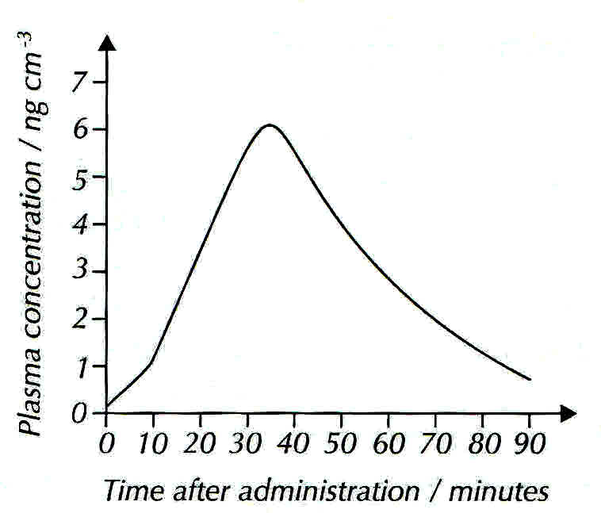

Change in y = 5.6 – 1.2 (i.e4.4) ng cm-3

Change in x = 30 – 10 (20) minutes

Gradient = 4.4/20 ng cm-3 min-1

= 0.22 ng cm-3 min-1

…**0.22 ng cm-3 min-1** ANS.

**Teacher note**: this question is taken from the new CGP text book! I could not find equivalent in past paper questions. Not sure where we stand on direct copying as this is not a class text we have bought!

**Cross Link your topics!** What is an ng? ………A Nano gram which is a thousandth of a microgram or a millionth of a gram! (1-6 g) ……………………………………………………..

**Extension Material:** Fick’s law is mentioned in the AQA SOW as extension material but you need to know the effects of its 3 variables!

**Fick’s Law and the Rate of Diffusion** *(not mentioned in spec. but referenced in SOW as extension material to help understanding) (ref slide)*

The **rate** of diffusion **through a membrane** (exchange surface) is proportional to:

* **Surface area X difference in concentration**

**Thickness of exchange surface** *(in this case a membrane)*

So this means: *(ref slide)*

**Surface area**: - the greater the surface area, the faster the rate of diffusion

**Difference in concentration**: - the greater the difference in concentration, the faster the rate of diffusion.

**Thickness of membrane**: - the thicker the membrane the slower the rate of diffusion

Sketch a graph to show the relationship between external concentration of a solute and its rate of uptake by a cell by simple diffusion. *(ref slide)*

In your own words **describe** this relationship.

…As the concentration of the external solution increases the uptake of the solute by the cell increases.……………………………………………….

Now **explain** it …At higher solute concentrations more solute molecules collide with the cell membrane so more pass through between the phospholipids…..

*Rate* of uptake into a cell

External concentration

Facilitated Diffusion is discussed After Osmosis in this booklet as we will do more work on it after the Required Practicals!

**2 Osmosis**

Slides 33

* Watch the animations: *(links also on slide)*
* <http://highered.mcgraw-hill.com/sites/0072495855/student_view0/chapter2/animation__how_osmosis_works.html>
* <https://www.youtube.com/watch?v=5KOkt9dyN1w> 7 min 32 s Leslie Walters tutorial Water potential calculation explanation

Diagram to illustrate Osmosis *(ref slide)*

**Label** the water molecules and the solute molecules. Use the slide to label which solution is **hypertonic** and which is **hypotonic**. Complete the definition of osmosis.

Slides 34

Osmosis Definition *(ref slide or text)*

Osmosis is the passage of water from a region where it has a higher water potential to a region where it has a lower water potential through a selectively permeable membrane.

NET movement of Water

**Hypertonic**

**Hypotonic**

What is meant by saying that 2 solutions are isotonic? ………………………………………..

**Osmosis and Water Potential**

A solution with a high water potential has many **free** water molecules. They are free to move and can exert a **pressure** on the membrane. This pressure is called **WATER POTENTIAL**. A solution with a low water potential has few free water molecules.

**Label** the diagrams below either **high** or **low** water potential and also state which has a high solute concentration and which has a low one. Also label the partially permeable membrane.

…High…Water Potential ..Low… Water Potential

Slides 35

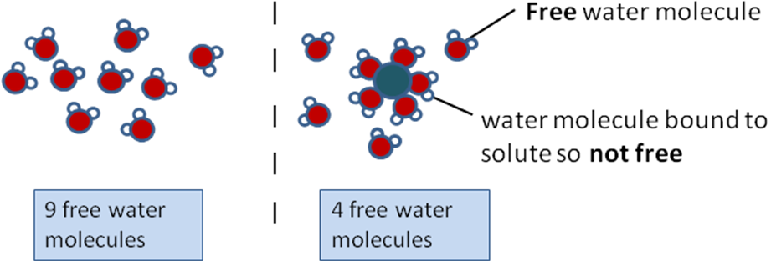

…Low…Solute Concentration ….High…. Solute Concentration

* Draw an arrow to show the direction of water movement.

Water Potential Definition

Slides 36

**Water potential** is ……the pressure created by water molecules trying to diffuse out of a solution down a gradient from a higher water potential to a lower water potential*. (ref slide and new spec text p89)*……………………………………………

**Water potential ( or psi)** is measured in units of ...pressure, eg…. kilopascals (kPa)…

**Complete** the next statements and highlight them.

**Water Potential of Pure Water** is …zero…

**Water Potential of Solutions** is …negative…

A concentrated solution has a …more… negative water potential than a dilute solution.

**Concentrated Solutions** have a **very negative** water potential

**Dilute Solutions** have a **less negative** water potential

**Pure water** has the **highest** possible water potential of **zero**.

Very negative less negative zero

Water potential water potential water potential

**Concentrated solution** **dilute solution** **pure water**

The rule is that water always ‘falls from a high to a low water potential ie in the direction of

the arrows in the above diagram.

**Applying This to Cell Water Potential Questions**

1. a) Show the direction of the net movement of water molecules by an arrow drawn on the two cells below.

b) Label the **cell solutions** as concentrated or dilute appropriately.

c) Label the cells as having high or low water potentials appropriately.

**Cell A**

**       = - 400 kPa**

**Concentrated**

**Low water potential**

**Cell B**

** = - 350 kPa**

**Dilute**

**High water potential**

2 Why does water have a higher water potential in dilute solutions than in concentrated solutions?

In dilute solutions there are fewer solute particles restricting the movement of water molecules.

3 If **cell X** has a water potential of – 500 kPa, and **cell Y** next to it has a water potential of – 800 kPa which way will water move by osmosis and what will the water potential of each one be when equilibrium is reached?

From cell X to cell Y

- 650 kPa (the average of the 2 cells)

4 What would be the effect on the water potential of a cell if starch present in a cell is hydrolysed to sugar?

It increases the number of solute particles present and lowers the water potential

**Comprehension and Research Activity**

**Read** the Biofactsheet 54 page2 on Water Potential and make notes in your own words under the following headings:

Parts of a Cell water Must Cross to reach the Vacuole

Effect of Water Movement on the Vacuole

What is meant by Solute Potential and Pressure Potential?

**Effects of Osmosis on cells.**

Slides 46

What happens to cells when placed in solutions that are hypertonic, isotonic or hypotonic to the cell contents? Use *T&T (p59 /60 [old spec text] /p91-92 [new spec text] / PowerPoint to complete table.*

|  |  |  |  |
| --- | --- | --- | --- |
|  | In Higher Water potential than Cell ie a …Hypotonic…solution | In Equal Water potential to Cell ie an …Isotonic…solution | In Lower Water potential than Cell ie a …Hypertonic…solution |
| Animal Cell | Water enters cell by **osmosis.** Cell **bursts open** | No NET movement of water although it passes both ways across the membrane. No change in cell shape. | Water leaves cell by **osmosis.** Cell **shrinks and shrivels Red blood cells** are said to be **HEAMOLYSED** |
| Plant Cell | Water …enters………. cell by **osmosis.** Cell… membrane …. is pushed tight against ……cell ….wall…. Cell is ……**TURGID…..** | No NET movement of water although it passes both ways across the membrane. No change in cell shape. | Water leaves cell by **osmosis.** Cytoplasm shrinks pulling membrane from cell wall. Cell is flaccid and said to be **PLASMOLYSED** |

* Is a plant cell wall permeable, impermeable or semi-permeable? …permeable……..
* What is in the gap between the cell wall and the membrane in the cell in a hypertonic solution.......the external solution…………………………………………….
* Why are arrows drawn both ways on the diagrams?…..membranes are permeable to water so it can move in either direction randomly, but if there is a water potential gradient there will be a net movement by osmosis down the gradient…………………
* What is meant by the word PROTOPLAST…..the living part of a PLANT CELL, i.e. membrane, cytoplasm and its contents but not the cell wall……

**Maths Skills and Osmosis**

Answer summary question 3 (p 59 T&T) and Application questions 2 and 3 (p60) [p 91 &92 in new text].

2 ……….C, D, A, B

2………..A = Turgid, B = Incipient plasmolysis, C = Plasmolysed,

…………D = Turgid

3………..A, B and D

Slides 57 - 59

**3 Facilitated Diffusion**

Watch the animation:

<http://highered.mheducation.com/sites/9834092339/student_view0/chapter5/how_facilitated_diffusion_works.html>

* 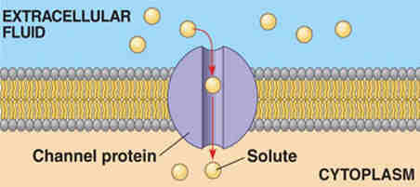What types of particles are transported by channel proteins? ….ions….

* What is meant by saying that the channels are selective....the channels only open in the presence of a particular ion…………………….

*(Ref slides)*

* 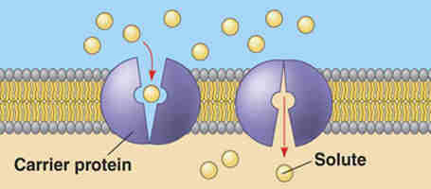What types of particles are transported by carrier proteins?.......larger molecules eg glucose
* How do these proteins work……they change shape in the presence of a specific molecule, and then bind with it and release it the other side.

|  |  |
| --- | --- |
| **CHANNEL PROTEIN** | **CARRIER PROTEIN** |
| Form water filled pores (lined with polar groups) so the channel is hydrophilic | Able to bind with a specific shaped molecule |
| Charged substances (usually ions) diffuse through | Larger molecules such as glucose and amino acids are taken across. |
| Most channels can be gated so the cell can control entry and exit of ions. | The carrier changes shape to release the molecules the other side of the membrane. |

* Fill in the table to make notes on these two types of facilitated diffusion proteins. *(ref slide)*

Slides 60

**Comparing Rate of Uptake Graphs for Simple and Facilitated Diffusion** *(ref slide)*

External Concentration

Rate of Uptake into Cell

Rate of Uptake Graph for a Molecule that enters a cell By Simple Lipid Diffusion

External Concentration

Rate of Uptake into Cell

Rate of Uptake Graph for a Molecule that enters a cell By Facilitated Diffusion

Slides 61

Explain why these two graphs differ……….. Facilitated diffusion uses membrane proteins and as the external concentration increases more of these proteins will be in use at any one time. At higher concentrations they will all be in use limiting the number of solute molecules that can pass the membrane at any one time. So the rate of entry will be constant.

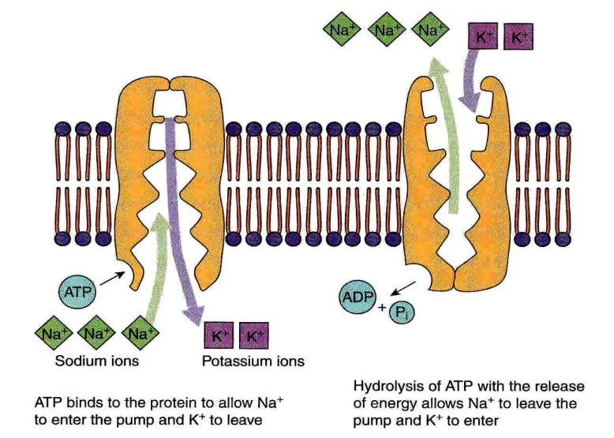**4 Active Transport** *(ref slide)*

What does ATP stand for?.

Slides 63 - 64

Adenosine triphosphate.

What does Pi stand for?

Shorthand for Phosphate

What does ADP stand for?

Adenosine diphosphate

How can you describe the binding sites of the active transport protein?

They are complementary to the particle they carry so are specific for those particles.

* Complete the definition of Active transport

**Active transport** is the movement of molecules or ions into or out of a cell from a region of lower concentration to a region of higher concentration using ATP and carrier

Proteins.

**Rich Questions for You to Work Out**

* Why do poisons which inhibit respiration, result in active transport stopping?

……………………………………………………………………………………………………………..

……………………………………………………………………………………………………………..

……………………………………………………………………………………………………………..

* Suggest why overwatering of plants can kill the plant

……………………………………………………………………………………………………………….

……………………………………………………………………………………………………………….

**The Adaptations of Cells for Rapid Transport across external & internal membranes**

Intestinal epithelium cells must allow transportation of soluble products of digestion from the lumen of the gut to the blood capillaries where they can then be transported to the liver. Diffusion alone would be too slow and inefficient. The cells are adapted to ensure efficient transportation across their structure.

Slides 65 & 66

**Past Exam Question**: *(Biol 1 June 11 listed in SOW)*. The epithelial cells that line the small intestine are adapted for the absorption of glucose. Explain how. 6 marks

Use the diagram, your own existing knowledge and the text to answer the question.

……………………………………………………………………………..

……………………………………………………………………………..

**AQA MS**

1. Microvilli;

2. Large/increased surface area;

3. Many mitochondria;

4. (Mitochondria/respiration) produce ATP / release or provide energy (for active transport);

5. Carrier proteins for active transport;

6. Channel / carrier proteins for facilitated diffusion;

7. Co-transport of sodium (ions) and glucose or symport / carrier protein for sodium (ions) and glucose;

8. Membrane-bound enzymes digest disaccharides / produce glucose

**Additional Guidance**

1. Reject villi on epithelial cells

1. Accept brush border

2. Accept large SA:vol ratio

3. Need idea of “lots”

4. Reject: energy produced

5. Accept Na+K+ pump

7. Neutral: Channel proteins

8. Accept named example

……………………………………………………………………………..

……………………………………………………………………………..

……………………………………………………………………………..

……………………………………………………………………………..

……………………………………………………………………….........

……………………………………………………………………………..

……………………………………………………………………………..

**Extension Activity**: Examine microscope slides / histology photos on web of cells adapted for rapid transport. .see SOW

**5 Co-transport**

Slides 67 - 70

Co transport is an indirect form of active transport. Two types of protein carriers are involved. The first actively transports a particle eg sodium across a membrane against its gradient. This results in this particle diffusing passively back in through a second carrier protein (the co-transport protein) and pulling in another substance that the cell needs at the same time eg glucose. The second substance is pulled against its gradient, so it travels because of the energy needed to originally pump the first!

**Co-Transport Research Task**

**1 Watch the animation**

[**http://highered.mheducation.com/sites/9834092339/student_view0/chapter5/secondary_active_transport.html**](http://highered.mheducation.com/sites/9834092339/student_view0/chapter5/secondary_active_transport.html)

[**http://highered.mheducation.com/olcweb/cgi/pluginpop.cgi?it=swf::535::535::/sites/dl/free/0072437316/120068/bio04.swf::Cotransport**](http://highered.mheducation.com/olcweb/cgi/pluginpop.cgi?it=swf::535::535::/sites/dl/free/0072437316/120068/bio04.swf::Cotransport)

**Co-transport DARTS Task – Group work and Presentation Activity***. (ref slide and SOW)*

* (to produce a poster / presentation along these lines with appropriate explanations)*

**Membranes Glossary**

|  |  |
| --- | --- |
| **Glycoprotein** | A complex protein with a carbohydrate chain attached. Found as part of the cell surface membrane. An example is **mucin** |
| **Glycolipid** | A lipid with a carbohydrate chain attached. Found on the outer surface of the cell surface membrane. |
| **Phospholipid** | Forms the bilayer of membranes. Phospholipids are made of 2 fatty acid tails, a glycerol and a phosphate group. |
| **Extrinsic Protein** | Proteins which occur on the surface of the bilayer or partly embedded in it. |
| **Intrinsic Protein** | Proteins which extend across both layer of the bilayer. |
| **Peripheral Protein** | Proteins on the surface of the membrane |
| **Integral Protein** | Proteins that extend through the bilayer. Another term for intrinsic protein |
| **Hydrophobic** | Substances which repel or are repelled by water. |
| **Hydrophilic** | Substances which are attracted by water. |
| **Hypotonic Solution** | A solution that has a higher water potential than a cell immersed in it. I.e. it is more dilute than the cell cytoplasm. (so water will move into the cell) |
| **Hypertonic Solution** | A solution that has a lower water potential than a cell immersed in it. I.e. is more concentrated than the cell cytoplasm. (So water moves out of the cell!) |
| **Isotonic Solution** | A solution that has the same water potential as a cell immersed in it. (so the cell’s volume will not change) |
| **Plasmolysed**  **(the process is called plasmolysis)** | (PLANT cells) - the cytoplasm shrinks away from the cell wall as water moves out into the surrounding solution |
| **Incipient Plasmolysis** | (PLANT cells) – when the protoplast (cytoplasm, membrane and organelles) no longer presses on the cellulose cell wall but has not pulled completely away from it. |
| **Flaccid Plant Cell** | The cytoplasm has lost water and the membrane plus contents exerts no pressure against the cell wall |
| **Haemolysed** | A term used to describe the state of red blood cells that have lost water by osmosis and are shrunken and shrivelled. |
| **Turgid Plant Cell** | A plant cell that is full of water, (so the cell wall pushes against the cell contents preventing further entry of water) |
| **Crenate** | ANIMAL cells – the cell shrinks as water moves out of the cell into the surrounding solution |
| **Solute potential** | The pressure produced by solute molecules in solution as they randomly move by kinetic energy and exert a pressure on the membrane. |
| **Pressure potential** | The pressure produced by the cell wall pushing against the plasma membrane in the opposite direction to the cell’s water molecules pushing outwards. |
| **Protoplast** | The living portion of a plant cell, i.e. the nucleus and cytoplasm along with the organelles it contains. |

**Specification Content:**

The basic structure of all cell membranes, including cell surface membranes and the membrane around the cell organelles of eukaryotes, is the same.

The arrangement and any movement of phospholipids, proteins, glycoproteins and glycolipids in the fluid mosaic model of membrane structure. Cholesterol may also be present in cell membranes where it restricts the movement of other molecules making up the membrane.

Movement across membranes occurs by:

* **Simple diffusion** (involving limitations imposed by the nature of the phospholipid bilayer)
* **Facilitated diffusion** (involving the roles of carrier proteins and channel proteins)
* **Osmosis** (explained in terms of water potential).
* **Active transport** (involving the role of carrier proteins and the importance of the hydrolysis of ATP)
* **Co-transport** (illustrated by the absorption of sodium ions and glucose by cells lining the mammalian ileum).

Cells may be adapted for rapid transport across their internal or external membranes by an increase in surface area of, or by an increase in the number of protein channels and carrier molecules in, their membranes.

**Students should be able to**:

* Explain the adaptations of specialised cells in relation to the rate of transport across their internal and external membranes.
* Explain how surface area, number of channel or carrier proteins and differences in gradients of concentration or water potential affect the rate of movement across cell membranes.

**Required Practical 3**: production of a dilution series of a solute to produce a calibration curve with which to identify the water potential of plant tissue.

**Required practical 4**: Investigation into the effect of a named variable on the permeability of cell surface membranes.