**Q1.**

The photograph shows part of the cytoplasm of a cell.

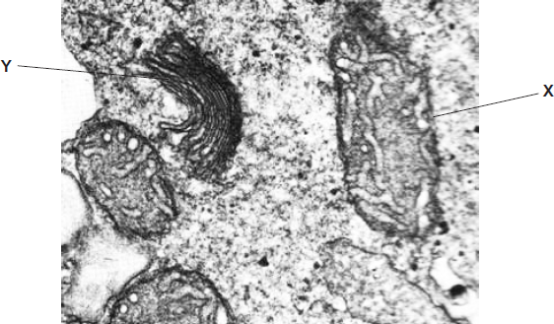

(a)     (i)      Organelle **X** is a mitochondrion.

What is the function of this organelle?

______________________________________________________________

______________________________________________________________

**(1)**

(ii)     Name organelle **Y.**

______________________________________________________________

**(1)**

(b)     This photograph was taken using a transmission electron microscope. The structure of the organelles visible in the photograph could not have been seen using an optical(light) microscope. Explain why.

___________________________________________________________________

___________________________________________________________________

___________________________________________________________________

___________________________________________________________________

___________________________________________________________________

**(2)**

**(Total 4 marks)**

**Q2.**

(a)     **Figure 1** shows part of the blood circulation in a mammal.

**Figure 1**

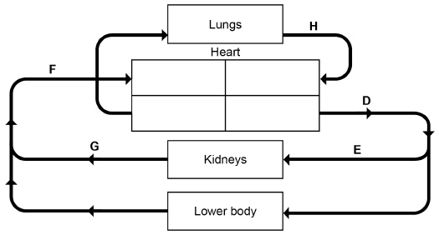

Use **Figure 1** to give the letter that represents each of these blood vessels.

|  |  |
| --- | --- |
| Aorta |  |
| Renal vein |  |
| Vena cava |  |

**(3)**

(b)     Name the blood vessels that carry blood to the heart **muscle**.

___________________________________________________________________

**(1)**

(c)     **Figure 2** shows a photograph of part of a mitochondrion from a mouse liver cell taken using a transmission electron microscope at × 62 800 magnification.

**Figure 2**

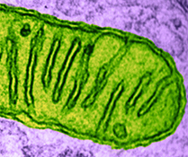

Produce a scientific drawing of the mitochondrion in **Figure 2** in the box below.

Label the following parts of the mitochondrion on your drawing.

•        Matrix

•        Crista



**(4)**

**(Total 8 marks)**

**Q3.**

(a)     Structures **A** to **E** are parts of a plant cell.

**A**     Cell Wall

**B**     Chloroplast

**C**     Nucleus

**D**     Mitochondrion

**E**     Golgi apparatus

Complete the table by putting the correct letter, **A**, **B**, **C**, **D** or **E** in the box next to each statement.

|  |  |
| --- | --- |
| **Statement** | **Letter** |
| Has stacked membranes arranged in parallel and contains DNA. |  |
| Is made of polysaccharide. |  |
| Is an organelle and is **not** surrounded by two membranes. |  |

**(3)**

(b)     Human breast milk is produced and secreted by gland cells. These gland cells have adaptations that include many mitochondria and many Golgi vesicles. The milk contains a high concentration of protein.

Explain the role of these cell adaptations in the production and secretion of breast milk.

___________________________________________________________________

___________________________________________________________________

___________________________________________________________________

___________________________________________________________________

___________________________________________________________________

___________________________________________________________________

___________________________________________________________________

___________________________________________________________________

**(2)**

**(Total 5 marks)**

**Q4.**

The diagram shows a cholera bacterium. It has been magnified 50 000 times.

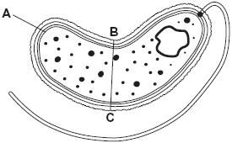

(a)     Name **A**.

___________________________________________________________________

**(1)**

(b)     Name **two** structures present in an epithelial cell from the small intestine that are **not** present in a cholera bacterium.

1. _________________________________________________________________

2. _________________________________________________________________

**(2)**

(c)     Cholera bacteria can be viewed using a transmission electron microscope (TEM) or a scanning electron microscope (SEM).

(i)      Give **one** advantage of using a TEM rather than a SEM.

______________________________________________________________

______________________________________________________________

**(1)**

(ii)     Give **one** advantage of using a SEM rather than a TEM.

______________________________________________________________

______________________________________________________________

______________________________________________________________

**(1)**

(d)     Calculate the actual width of the cholera bacterium between points **B** and **C**.  
Give your answer in micrometres and show your working.

____________________ µm

**(2)**

**(Total 7 marks)**

**Q5.**

An amoeba is a single-celled, eukaryotic organism. Scientists used a transmission electron microscope to study an amoeba. The diagram shows its structure.

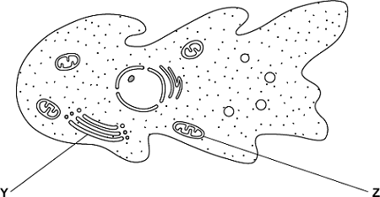

(a)     (i)      Name organelle **Y**.

______________________________________________________________

**(1)**

(ii)     Name **two** other structures in the diagram which show that the amoeba is a eukaryotic cell.

1. ____________________________________________________________

2. ____________________________________________________________

**(2)**

(b)     What is the function of organelle **Z**?

___________________________________________________________________

___________________________________________________________________

**(1)**

(c)     The scientists used a transmission electron microscope to study the structure of the amoeba. Explain why.

___________________________________________________________________

___________________________________________________________________

___________________________________________________________________

___________________________________________________________________

**(2)**

**(Total 6 marks)**

**Q6.**

Bacteriophages are viruses that kill bacteria.

The diagram below shows drawings of a bacteriophage and a bacterium.

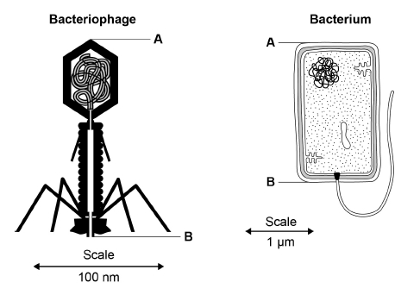

(a)     Using the diagram and your own knowledge, put a tick (✔) in the box next to the **only** correct statement about the structures of the bacteriophage and the bacterium

|  |  |
| --- | --- |
| Both have ribosomes. |  |
| Both have a cell-surface membrane. |  |
| The bacteriophage has a capsid and the bacterium has a cell-surface membrane. |  |
| The bacteriophage has a cell wall and the bacterium has a capsid. |  |

**(1)**

(b)     Using the scales in the diagram above, calculate how many times longer the bacterium is than the bacteriophage.

Use the distance between the points labelled **A** and **B** on each drawing in your calculations. Show your working.

The bacterium is ____________________ times longer

**(2)**

**(Total 3 marks)**

**Q7.**

The diagram shows a chloroplast as seen with an electron microscope.

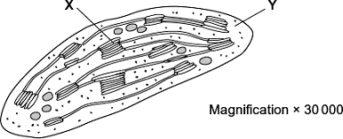

(a)     Name **X** and **Y**.

**X** _________________________________________________________________

**Y** _________________________________________________________________

**(2)**

(b)     Describe the function of a chloroplast.

___________________________________________________________________

___________________________________________________________________

___________________________________________________________________

___________________________________________________________________

___________________________________________________________________

**(2)**

(c)     Calculate the maximum length of this chloroplast in micrometres (μm). Show your working.

Answer ____________________ μm

**(2)**

**(Total 6 marks)**

**Q8.**

(a)     Describe how you would use cell fractionation techniques to obtain a sample of chloroplasts from leaf tissue. Do **not** include in your answer information about any solutions.

___________________________________________________________________

___________________________________________________________________

___________________________________________________________________

___________________________________________________________________

___________________________________________________________________

___________________________________________________________________

___________________________________________________________________

___________________________________________________________________

**(3)**

(b)     The table shows features of a mitochondrion and a chloroplast. Complete the table with ticks where a feature is present.

|  |  |  |
| --- | --- | --- |
| **Feature** | **Mitochondrion** | **Chloroplast** |
| Double outer membrane |  |  |
| Starch grains |  |  |
| Diffusion of oxygen into the organelle |  |  |

**(3)**

(c)     Give the function of a mitochondrion.

___________________________________________________________________

___________________________________________________________________

___________________________________________________________________

**(1)**

**(Total 7 marks)**

**Q9.**

(a)     Name the type of bond that joins amino acids together in a polypeptide.

___________________________________________________________________

**(1)**

The diagram shows a cell from the pancreas.

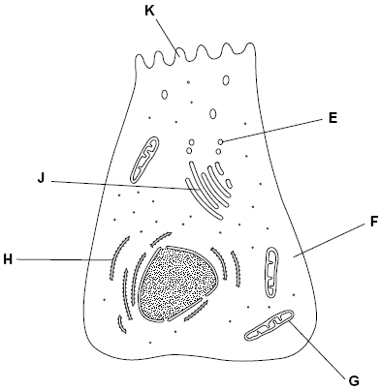

(b)     The cytoplasm at **F** contains amino acids. These amino acids are used to make proteins which are secreted from the cell.

Place the appropriate letters in the correct order to show the passage of an amino acid from the cytoplasm at **F** until it is secreted from the cell as a protein at **K**.

|  |  |  |  |  |
| --- | --- | --- | --- | --- |
| **F** |  |  |  | **K** |

**(2)**

(c)     There are lots of organelle **G** in this cell. Explain why.

___________________________________________________________________

___________________________________________________________________

___________________________________________________________________

___________________________________________________________________

**(2)**

(d)     A group of scientists homogenised pancreatic tissue before carrying out cell fractionation to isolate organelle **G**.

Explain why the scientists

(i)      homogenised the tissue

______________________________________________________________

______________________________________________________________

**(1)**

(ii)     filtered the resulting suspension

______________________________________________________________

______________________________________________________________

**(1)**

(iii)     kept the suspension ice cold during the process

______________________________________________________________

______________________________________________________________

**(1)**

(iv)    used isotonic solution during the process.

______________________________________________________________

______________________________________________________________

______________________________________________________________

______________________________________________________________

**(2)**

**(Total 10 marks)**