**Q1.**          Yeast is a single-celled eukaryotic organism. When yeast cells are grown, each cell forms a bud. This bud grows into a new cell. This allows yeast to multiply because the parent cell is still alive and the new cell has been formed.

Scientists grew yeast cells in a culture. They counted the number of cells present and measured the total concentration of DNA in the culture over a period of 6 hours. Their results are shown in the graph.

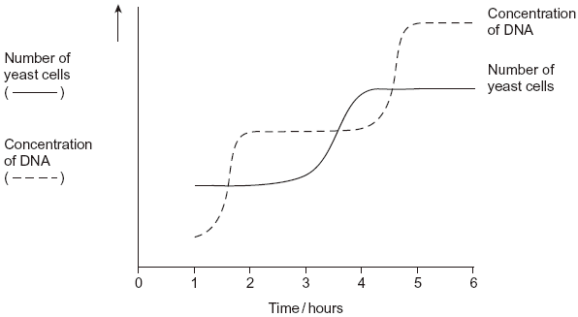

(a)     Use your knowledge of the cell cycle to explain the shape of the curve for the number of yeast cells

(i)      between 1 and 2 hours

.............................................................................................................

.............................................................................................................

**(1)**

(ii)     between 3 and 4 hours.

.............................................................................................................

.............................................................................................................

**(1)**

(b)     Use the curve for the concentration of DNA to find the length of a cell cycle in these yeast cells. Explain how you arrived at your answer.

Length of cell cycle ......................................................................................

Explanation ..................................................................................................

......................................................................................................................

......................................................................................................................

......................................................................................................................

**(3)**

**(Total 5 marks)**

**Q2.**A student investigated mitosis in the tissue from an onion root tip.

(a)     The student prepared a temporary mount of the onion tissue on a glass slide. She covered the tissue with a cover slip. She was then given the following instruction.

“Push down hard on the cover slip, but do not push the cover slip sideways.”

Explain why she was given this instruction.

........................................................................................................................

........................................................................................................................

........................................................................................................................

........................................................................................................................

The image below shows one cell the student saw in the onion tissue.

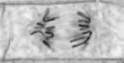

© Ed Reschke/Oxford Scientific/Getty Images

**(2)**

(b)     The student concluded that the cell in the image above was in the anaphase stage of mitosis.  
Was she correct? Give **two** reasons for your answer.

1 .....................................................................................................................

........................................................................................................................

2 .....................................................................................................................

........................................................................................................................

**(2)**

(c)     The student counted the number of cells she observed in each stage of mitosis.  
Of the 200 cells she counted, only six were in anaphase.

One cell cycle of onion root tissue takes 16 hours. Calculate how many minutes these cells spend in anaphase.

Show your working.

Answer = ................................... minutes

**(2)**

**(Total 6 marks)**

**Q3.**The figure below shows some cells from an onion root tip at different stages of the cell cycle.

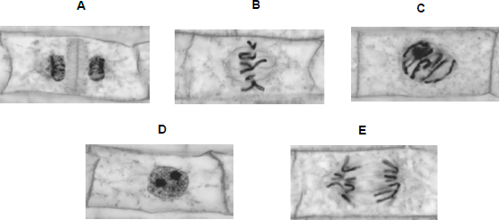

© Ed Reschke/Oxford Scientific/Getty Images

(a)     Place stages **A** to **E** in the correct order. Start with stage **D**.

**D**.............................................................................................................

**(1)**

To obtain these images, the onion root tip was cut off, stained and put on a microscope slide. A cover slip was placed on top. The root tip was then firmly squashed and viewed under an optical microscope.

(b)     Complete the table below to give **one** reason why each of these steps was necessary.

|  |  |  |
| --- | --- | --- |
|  | **Step** | **Reason** |
|  | Taking cells from the root tip |  |
|  | Firmly squashing the root tip |  |

**(2)**

**(Total 3 marks)**

**Q4.**          (a)     Mitosis is important in the life of an organism. Give **two** reasons why.

........................................................................................................................

........................................................................................................................

........................................................................................................................

........................................................................................................................

........................................................................................................................

**(2)**

A biologist used a microscope to investigate plant tissue where some of the cells were dividing by mitosis. She examined 200 cells and counted the number of cells in interphase and in each stage of mitosis.

The table shows some of the cells she saw, and the percentage of cells in interphase and in two stages of mitosis, **A** and **B**.

|  |  |  |
| --- | --- | --- |
| **Stage of cell cycle** | | **Percentage of cells** |
| Interphase |  | 90 |
| Stage **A** |  | 3 |
| Stage **B** |  | 1 |

         Images by Edmund Beecher Wilson [Public domain], via Wikimedia Commons

(b)     (i)      Explain why the biologist chose to examine 200 cells.

...............................................................................................................

...............................................................................................................

**(1)**

(ii)     Name Stage **A** and Stage **B**. Give the evidence from the photograph that you used to identify the stage.

Name of Stage **A** ...................................................................................

Evidence ...............................................................................................

...............................................................................................................

Name of Stage **B** ...................................................................................

Evidence ...............................................................................................

...............................................................................................................

**(4)**

(c)     In this tissue one complete cell cycle took 20 hours.  
Using information from the table, calculate the mean time for these cells to complete mitosis. Show your working.

  Answer ......................................

**(2)**

**(Total 9 marks)**

**Q5.**(a)     The diagram shows a stage of mitosis in an animal cell.

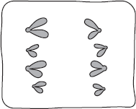

(i)      Name this stage.

...............................................................................................................

**(1)**

(ii)     Describe what happens during this stage that results in the production of two genetically identical cells.

...............................................................................................................

...............................................................................................................

...............................................................................................................

...............................................................................................................

...............................................................................................................

**(2)**

(b) A sample of epithelial tissue from the small intestine of an animal was analysed.

Some of the cells had 8.4 units of DNA, others had only 4.2 units.

(i)      Use your knowledge of the cell cycle to explain why some cells had 8.4 units of DNA and others had only 4.2 units.

...............................................................................................................

...............................................................................................................

...............................................................................................................

...............................................................................................................

...............................................................................................................

**(2)**

(ii) How many units of DNA would you expect to be present in a gamete formed in this animal as a

result of meiosis?



**(1)**

**(Total 6 marks)**

**Q6.**          (a)     Nucleus **A** and nucleus **B** come from the same organism. The diagram shows these nuclei immediately before division and the nuclei formed immediately after their division. The table gives information about some of the nuclei shown in the diagram.

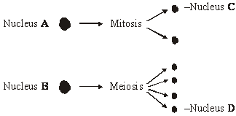

|  |  |  |
| --- | --- | --- |
| **Nucleus** | **Number of chromosomes** | **Mass of DNA / arbitrary units** |
| **A** | 8 | 600 |
| **B** | 8 | 600 |
| **C** |  |  |
| **D** |  |  |

          Complete the table for nuclei **C** and **D**.

**(2)**

(b)     A student investigated the process of meiosis by observing cells on a microscope slide. The cells on the slide had been stained.

(i)      Name an organ from which the cells may have been obtained.

.............................................................................................................

**(1)**

(ii)     Explain why a stain was used.

.............................................................................................................

**(1)**

**(Total 4 marks)**

**Q7.**     A student investigated the stages of mitosis in a garlic root. The root tip was placed on a microscope slide with a stain. A cover slip was placed on top and the root tip was firmly squashed.

(a)     Explain why

(i)      a root tip was used;

.............................................................................................................

**(1)**

(ii)     a stain was used;

.............................................................................................................

**(1)**

(iii)     the root tip was firmly squashed.

.............................................................................................................

**(1)**

(b)     The student examined the cells in the garlic root tip under the microscope, and obtained the following data.

|  |  |  |
| --- | --- | --- |
|  | **Stage** | **Number of cells** |
|  | Interphase | 872 |
|  | Prophase | 74 |
|  | Metaphase | 18 |
|  | Anaphase | 10 |
|  | Telophase | 8 |

(i)      Calculate the percentage of these cells in which the chromosomes are visible and would consist of a pair of chromatids joined together. Show your working.

   Answer .........................................

**(2)**

(ii)     A different set of results was obtained when the count was repeated on another occasion with a different garlic root tip. Give **two** reasons for the difference in results.

1 ..........................................................................................................

2 ..........................................................................................................

**(2)**

**(Total 7 marks)**

**Q8.**          The photograph shows cells from an onion root tip. The root tip has been squashed and stained to show the stages of mitosis.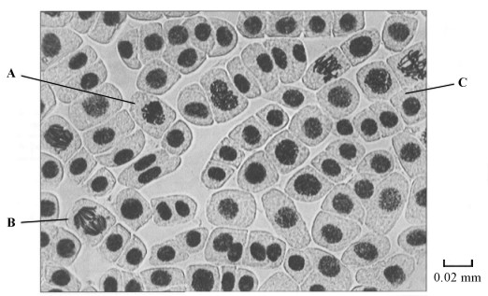

(a)     (i)      At what stage of mitosis is cell **A**?

.............................................................................................................

**(1)**

(ii)     What is the evidence that cell **B** is in anaphase?

.............................................................................................................

**(1)**

(iii)     Cell **C** is in interphase. Give **two** processes which occur during interphase that enable cell division to occur.

1 ..........................................................................................................

2 ..........................................................................................................

**(2)**

(b)     Explain how you would calculate the magnification of the photograph.

......................................................................................................................

**(1)**

(c)     The number of cells at each stage of mitosis was counted. The results are shown in the table.

|  |  |
| --- | --- |
| **Stage of mitosis** | **Number of cells** |
| Interphase | 123 |
| Prophase | 32 |
| Metaphase | 12 |
| Anaphase | 6 |
| Telophase | 27 |

One complete cell cycle takes 24 hours. The number of cells at each stage is proportional to the time spent at that stage. Calculate the length of time spent in metaphase. Show your working.

Answer ........................................................... hours

**(2)**

**(Total 7 marks)**