**Q1.**

The diagram shows part of a plasma membrane.

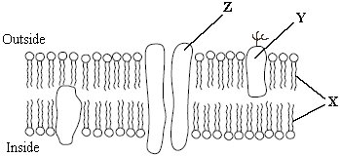

(a)     Describe **two** functions of the structure made from the parts labelled **X**.

1. _________________________________________________________________

___________________________________________________________________

2. _________________________________________________________________

___________________________________________________________________

**(2)**

(b)     Give **one** function of the molecule labelled **Y**.

___________________________________________________________________

___________________________________________________________________

**(1)**

(c)     The part labelled **Z** is involved in facilitated diffusion of substances across the membrane.

(i)      Give **one** similarity in the way in which active transport and facilitated diffusion transport substances across the membrane.

______________________________________________________________

______________________________________________________________

(ii)     Give **one** way in which active transport differs from facilitated diffusion.

______________________________________________________________

______________________________________________________________

**(2)**

(iii)     The graph shows the relationship between the concentration of a substance outside a cell and the rate of entry of this substance into the cell.

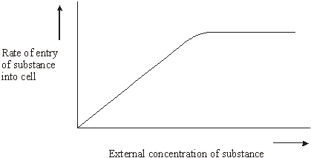

Explain the evidence from the graph that this substance is entering the cell by facilitated diffusion and not by simple diffusion.

_____________________________________________________________

______________________________________________________________

______________________________________________________________

**(2)**

**(Total 7 marks)**

**Q2.**

The diagram shows part of a cell surface membrane.

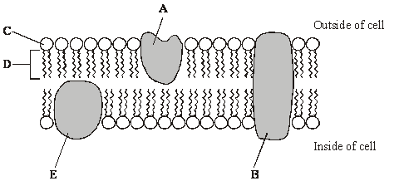

(a)     Complete the table by writing the letter from the diagram which refers to each part of the membrane.

|  |  |
| --- | --- |
| **Part of membrane** | **Letter** |
| Channel protein |  |
| Contains only the elements carbon and hydrogen |  |

**(2)**

(b)     Explain why the structure of a membrane is described as *fluid-mosaic*.

___________________________________________________________________

___________________________________________________________________

___________________________________________________________________

**(2)**

(c)     When pieces of carrot are placed in water, chloride ions are released from the cell vacuoles. Identical pieces of carrot were placed in water at different temperatures. The concentration of chloride ions in the water was measured after a set period of time. The graph shows the results.

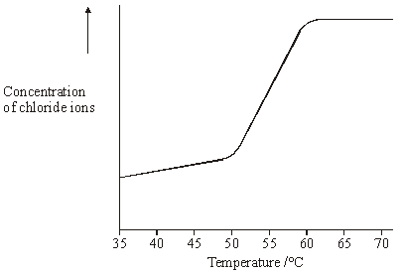

Describe and explain the shape of the curve.

___________________________________________________________________

___________________________________________________________________

___________________________________________________________________

___________________________________________________________________

___________________________________________________________________

**(3)**

**(Total 7 marks)**

**Q3.**

(a)     Explain how **three** features of a plasma membrane adapt it for its functions.

___________________________________________________________________

___________________________________________________________________

___________________________________________________________________

___________________________________________________________________

___________________________________________________________________

___________________________________________________________________

___________________________________________________________________

___________________________________________________________________

___________________________________________________________________

___________________________________________________________________

**(6)**

**(Total 6 marks)**

**Q4.**

Gorter and Grendel investigated the structure of the surface membrane of cells. They extracted the phospholipids from the surface membranes of red blood cells in 1 cm3 of blood and placed them in the apparatus shown in **Figure 1**.

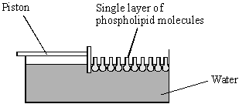

**Figure 1**

The piston was pushed across the surface of the water until the phospholipid molecules were tightly packed into a single layer. The area covered by the phospholipid molecules was measured. This area was compared with the estimated surface area of the red blood cells from which phospholipids were extracted.

Gorter and Grendel obtained the data shown in the table.

|  |  |
| --- | --- |
| Number of red blood cells per cm3 of blood | 4.74 × 109 |
| Estimated mean surface area of one red blood cell | 99.4 μm2 |
| Surface area of membrane phospholipids extracted from 1cm3 of blood | 0.92 m2 |

(a)     Explain what these data suggest about the arrangement of phospholipids in the surface membranes of red blood cells. Support your explanation with suitable calculations.

Show your working.

___________________________________________________________________

___________________________________________________________________

___________________________________________________________________

___________________________________________________________________

**(3)**

(b)     **Figure 2** shows a red blood cell and a white blood cell.

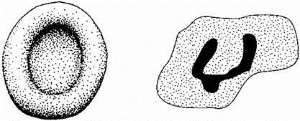

Red blood cell        White blood cell

Explain why red blood cells were used in this investigation rather than white blood cells.

___________________________________________________________________

___________________________________________________________________

___________________________________________________________________

___________________________________________________________________

**(2)**

**(Total 5 marks)**

**Q5.**

If red blood cells are placed in pure water, water enters the cells by osmosis and they burst. This is called haemolysis. As red blood cells burst they release pigment.

Scientists placed samples of red blood cells in different concentrations of sodium chloride solution for the same period of time. They used red blood cells from four different mammals: dog, guinea pig, rabbit and sheep.

If haemolysis had taken place, the solution turned red. The scientists measured the intensity of the red colour using a colorimeter. The more intense the red colour, the greater the amount of haemolysis.

The scientists calculated the percentage of red blood cells that were haemolysed in each sodium chloride solution.

The following figure shows the scientists’ results.

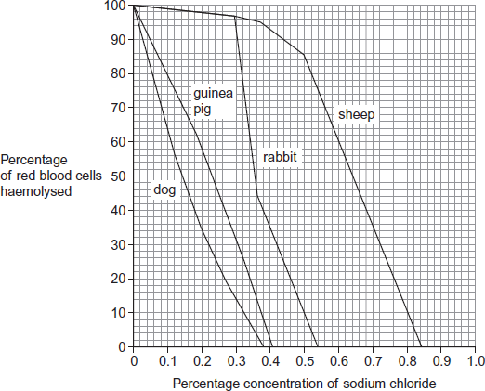

(a)     Use the figure to give **two** differences between the results for dog and sheep.

Difference 1 _________________________________________________________

___________________________________________________________________

Difference 2 _________________________________________________________

___________________________________________________________________

**(2)**

(b)     Calculate the difference in the percentage of haemolysed cells between sheep and rabbit at a sodium chloride concentration of 0.5%.

____________________

**(1)**

(c)     Explain the relationship between the depth of the red colour of the solution and how much haemolysis has taken place.

___________________________________________________________________

___________________________________________________________________

___________________________________________________________________

___________________________________________________________________

___________________________________________________________________

**(2)**

(d)     During treatment in a veterinary surgery, any of the mammals in the figure above may be given an infusion of sodium chloride solution directly into a vein. The concentration of sodium chloride solution used is 0.9%, rather than 0.5%, regardless of the species of mammal.

Explain the advantage to the vet of using this concentration.

___________________________________________________________________

___________________________________________________________________

___________________________________________________________________

___________________________________________________________________

**(2)**

**(Total 7 marks)**

**Q6.**

A scientist placed plant cells in solutions containing different concentrations of calcium ions. She measured the rate of uptake of calcium ions by plant cells.

The graph below shows her results.

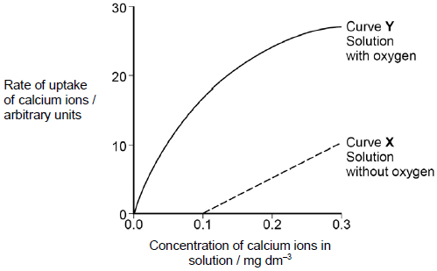

(a)     What can you conclude from the graph about the processes involved in the uptake of calcium ions by these plant cells?

Use evidence from the graph to support your answer.

___________________________________________________________________

___________________________________________________________________

___________________________________________________________________

___________________________________________________________________

___________________________________________________________________

___________________________________________________________________

___________________________________________________________________

___________________________________________________________________

___________________________________________________________________

___________________________________________________________________

___________________________________________________________________

**(5)**

(b)     Suggest **one** way in which the scientist could have ensured the solutions she used for curve **X** contained **no** oxygen.

___________________________________________________________________

___________________________________________________________________

___________________________________________________________________

**(1)**

**(Total 6 marks)**

**Q7.**

A group of students carried out an investigation to find the water potential of potato tissue.

The students were each given a potato and 50 cm3 of a 1.0 mol dm−3 solution of sucrose.

•        They used the 1.0 mol dm−3 solution of sucrose to make a series of different concentrations.

•        They cut and weighed discs of potato tissue and left them in the sucrose solutions for a set time.

•        They then removed the discs of potato tissue and reweighed them.

The table below shows how one student presented his processed results.

|  |  |
| --- | --- |
| **Concentration of sucrose solution / mol dm−3** | **Percentage change in mass of potato tissue** |
| 0.15 | +4.7 |
| 0.20 | +4.1 |
| 0.25 | +3.0 |
| 0.30 | +1.9 |
| 0.35 | −0.9 |
| 0.40 | −3.8 |

(a)     Explain why the data in the table above are described as **processed** results.

___________________________________________________________________

___________________________________________________________________

**(1)**

(b)     Describe how you would use a 1.0 mol dm−3 solution of sucrose to produce 30 cm3 of a 0.15 mol dm−3 solution of sucrose.

___________________________________________________________________

___________________________________________________________________

___________________________________________________________________

**(2)**

(c)     Explain the change in mass of potato tissue in the 0.40 mol dm−3 solution of sucrose.

___________________________________________________________________

___________________________________________________________________

___________________________________________________________________

___________________________________________________________________

**(2)**

(d)     Describe how you would use the student’s results in the table above to find the water potential of the potato tissue.

___________________________________________________________________

___________________________________________________________________

___________________________________________________________________

___________________________________________________________________

___________________________________________________________________

___________________________________________________________________

**(3)**

**(Total 8 marks)**

**Q8.**

A scientist investigated the uptake of sodium ions by animal tissue.  
To do this, he:

•        used two flasks, **F** and **G**

•        put equal masses of animal tissue into each flask

•        added equal volumes of a solution containing sodium ions to each flask

•        added to flask **F** a solution of a substance that prevents the formation of ATP by cells

•        measured the concentration of sodium ions **remaining** in the solution in each flask.

The graph below shows his results.

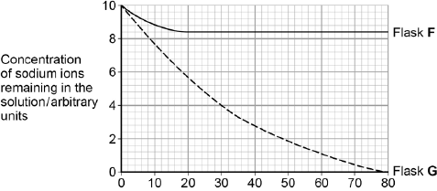  
                        Time / minutes

(a)     Calculate the rate of uptake of sodium ions by the tissue in flask **G** during the first 20 minutes of this investigation.

Answer = ____________________ arbitrary units per minute

**(1)**

(b)     The scientist concluded that the cells in flask **G** took up sodium ions by active transport. Explain how the information given supports this conclusion.

___________________________________________________________________

___________________________________________________________________

___________________________________________________________________

___________________________________________________________________

___________________________________________________________________

___________________________________________________________________

___________________________________________________________________

___________________________________________________________________

**(4)**

(c)     The curve for flask **F** levelled off after 20 minutes. Explain why.

___________________________________________________________________

___________________________________________________________________

___________________________________________________________________

___________________________________________________________________

___________________________________________________________________

**(2)**

**(Total 7 marks)**