**Q1.**

(a)     What is a pathogen?

___________________________________________________________________

**(1)**

(b)     When a pathogen enters the body it may be destroyed by phagocytosis.  
Describe how.

___________________________________________________________________

___________________________________________________________________

___________________________________________________________________

___________________________________________________________________

___________________________________________________________________

___________________________________________________________________

___________________________________________________________________

**(4)**

(c)     When a pathogen causes an infection, plasma cells secrete antibodies which destroy this pathogen.

Explain why these antibodies are only effective against a specific pathogen.

___________________________________________________________________

___________________________________________________________________

___________________________________________________________________

___________________________________________________________________

**(2)**

**(Total 7 marks)**

**Q2.**

(a)     Describe how phagocytosis of a virus leads to presentation of its antigens.

___________________________________________________________________

___________________________________________________________________

___________________________________________________________________

___________________________________________________________________

___________________________________________________________________

___________________________________________________________________

___________________________________________________________________

**(3)**

(b)     Describe how presentation of a virus antigen leads to the secretion of an antibody against this virus antigen.

___________________________________________________________________

___________________________________________________________________

___________________________________________________________________

___________________________________________________________________

___________________________________________________________________

___________________________________________________________________

___________________________________________________________________

___________________________________________________________________

**(3)**

(c)     Collagen is a protein produced by cells in joints, such as the knee.

Rheumatoid arthritis (RA) is an auto-immune disease. In an auto-immune disease, a person’s immune system attacks their own cells. RA causes pain, swelling and stiffness in the joints.

Scientists have found a virus that produces a protein very similar to human collagen.

Suggest how the immune response to this viral protein can result in the development of RA.

___________________________________________________________________

___________________________________________________________________

___________________________________________________________________

___________________________________________________________________

___________________________________________________________________

**(2)**

**(Total 8 marks)**

**Q3.**

In the early 1980s, before DNA analysis had been developed, scientists investigated the genetic variation of cheetahs living in captivity. They used skin grafts to do this. They carried out skin grafts on anaesthetised animals by

•        removing a small piece of skin from one animal. This animal was the recipient.

•        replacing the removed skin by a piece of skin taken from another animal. This animal was the donor.

•        attaching the new piece of skin with stitches.

A graft may be accepted by the recipient. It will be rejected if the recipient’s immune system recognises the antigens on the skin as foreign.

Scientists carried out skin grafts between cheetahs living in captivity and domestic cats.  
The table shows the data that they obtained.

|  |  |  |  |
| --- | --- | --- | --- |
| **Recipient of skin graft** | **Donor of skin graft** | **Relationship** | **Time taken for the graft to be rejected / days** |
| Domestic cat 1 | Domestic cat 2 | Unrelated | 13 |
| Cheetah 1 | Domestic cat 3 | Unrelated | 12 |
| Cheetah 1 | Cheetah 2 | Sisters | No rejection after 52 days |
| Cheetah 3 | Cheetah 4 | Unrelated | 49 |
| Cheetah 5 | Cheetah 6 | Unrelated | No rejection after 78 days |
| Cheetah 7 | Cheetah 8 | Unrelated | No rejection after 41 days |
| Cheetah 9 | Cheetah 10 | Unrelated | No rejection after 24 days |
| Cheetah 11 | Cheetah 12 | Unrelated | No rejection after 14 days |
| Cheetah 13 | Cheetah 14 | Unrelated | No rejection after 44 days |

The scientists also grafted skin from one area to another on the same animal. These grafts were not rejected.

(a)     (i)      The scientists grafted skin from a domestic cat to a cheetah. Suggest why.

______________________________________________________________

______________________________________________________________

**(1)**

(ii)     They also grafted skin from one area to another on the same animal. Explain why.

______________________________________________________________

______________________________________________________________

**(1)**

(b)     (i)      Give **three** conclusions that you can make from the data in the table above about the time taken for rejection.

1. ____________________________________________________________

______________________________________________________________

2. ____________________________________________________________

______________________________________________________________

3. ____________________________________________________________

______________________________________________________________

**(3)**

(ii)     Give **one** reason why these conclusions may **not** be reliable.

______________________________________________________________

______________________________________________________________

**(1)**

(iii)    There are proteins on the skin of cheetahs that act as antigens. What do the data in the table suggest about these cheetah antigens?

______________________________________________________________

______________________________________________________________

**(1)**

(iv)    Antigens are proteins. Explain why a knowledge of antigens can show that animals are genetically similar.

______________________________________________________________

______________________________________________________________

______________________________________________________________

______________________________________________________________

**(2)**

**(Total 9 marks)**

**Q4.**

(a)     What is an antigen?

___________________________________________________________________

___________________________________________________________________

___________________________________________________________________

**(2)**

(b)     Describe how B-lymphocytes respond when they are stimulated by antigens.

___________________________________________________________________

___________________________________________________________________

___________________________________________________________________

___________________________________________________________________

___________________________________________________________________

___________________________________________________________________

___________________________________________________________________

___________________________________________________________________

**(4)**

(c)     The diagram shows some components of a human immunodeficiency virus (HIV).

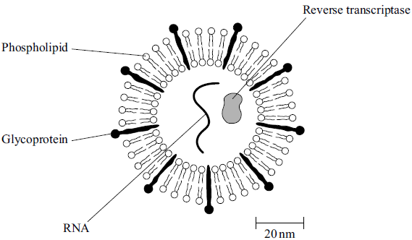

(i)      Suggest which labelled component of the virus is most likely to act as an antigen. Give a reason for your answer.

Component ____________________________________________________

Reason _______________________________________________________

______________________________________________________________

**(1)**

(ii)     A cell that HIV infects is 15 µm in diameter. Calculate how many times larger in diameter this cell is than an HIV particle. Show your working.

Answer ____________________ times larger

**(2)**

**(Total 9 marks)**

**Q5.**

Nicotine is the addictive substance in tobacco. When nicotine reaches the brain, it binds to a specific protein. This causes the release of chemicals that give a feeling of reward to the smoker. This reward is part of the reason why people find it difficult to stop smoking.

Scientists have developed a vaccine against nicotine to help people stop smoking.  
They set up an investigation, which involved a large number of volunteers. Once a month for 5 months, one group of volunteers was given the vaccine and the other group was given a placebo.

At regular intervals, the scientists measured the concentration of antibodies to nicotine in the blood of each group of volunteers. They also calculated the percentage of volunteers who had stopped smoking from months 2 to 6 of the investigation.

(a)     (i)      In this investigation, neither the volunteers nor the scientists knew if a particular volunteer was receiving the vaccine or a placebo.

Suggest **two** reasons why this made the scientists’ results more reliable.

1. ____________________________________________________________

______________________________________________________________

2. ____________________________________________________________

______________________________________________________________

**(2)**

(ii)     The scientists measured the concentration of nicotine in the blood of two volunteers who smoked the same number of cigarettes per day.

Suggest **two** reasons why the concentration of nicotine in the blood of these smokers might be different.

1. ____________________________________________________________

______________________________________________________________

2. ____________________________________________________________

______________________________________________________________

**(2)**

(b)     (i)      Suggest how this vaccine could help people to stop smoking.

______________________________________________________________

______________________________________________________________

______________________________________________________________

______________________________________________________________

______________________________________________________________

**(3)**

(ii)     Some people have suggested that this vaccine should **not** be given free to smokers on the National Health Service (NHS). Evaluate this suggestion.

______________________________________________________________

______________________________________________________________

______________________________________________________________

______________________________________________________________

______________________________________________________________

**(3)**

The scientists measured the concentration of antibodies to nicotine in the blood of the volunteers for 12 months after the first vaccination. As a result of these measurements, they divided the volunteers who received the nicotine vaccine into three groups:

•        high antibody responders

•        medium antibody responders

•        low antibody responders.

The figure below shows their results.

The scientists also recorded the number of volunteers who had stopped smoking from months 2 to 6 of the investigation.

The table below shows these results.

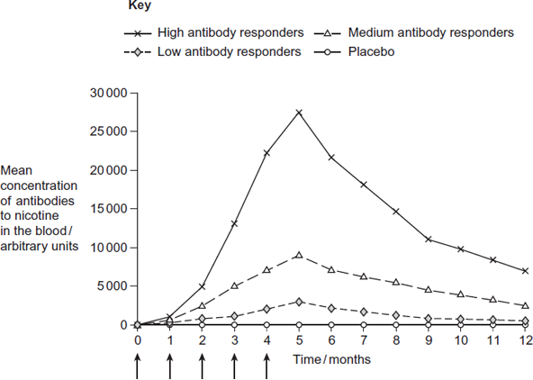  
Month when vaccine or placebo was given

|  |  |
| --- | --- |
| **Group** | **Percentage of volunteers who had stopped smoking from months 2 to 6 of the investigation** |
| High antibody responders | 56.6 |
| Low antibody responders | 38.1 |
| Medium antibody responders | 32.1 |
| Placebo | 31.3 |

(c)     A journalist reported that this vaccine is a major breakthrough in helping people to stop smoking. Do these data support this statement? Explain your answer.

___________________________________________________________________

___________________________________________________________________

___________________________________________________________________

___________________________________________________________________

___________________________________________________________________

___________________________________________________________________

___________________________________________________________________

___________________________________________________________________

___________________________________________________________________

___________________________________________________________________

**(5)**

**(Total 15 marks)**

**Q6.**

An antigen called PSA is present in the blood of men in the early stages of prostate cancer.

There is a blood test for PSA. The test uses monoclonal antibodies to PSA. The stages in the test are shown in the diagram.

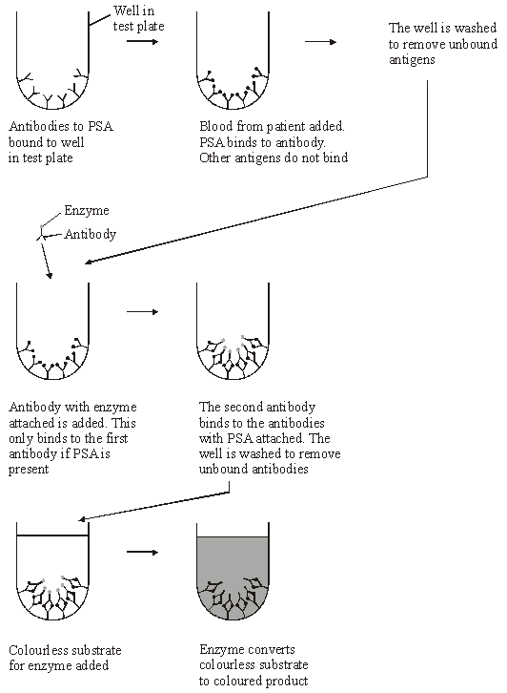

(a)     (i)      What is an antigen?

______________________________________________________________

______________________________________________________________

______________________________________________________________

______________________________________________________________

**(2)**

(ii)     What is a *monoclonal* antibody?

______________________________________________________________

______________________________________________________________

______________________________________________________________

______________________________________________________________

**(2)**

(b)     (i)      Explain why this test detects prostate cancer, but not any other disease.

______________________________________________________________

______________________________________________________________

______________________________________________________________

______________________________________________________________

**(2)**

(ii)     Explain why there will not be a colour change if the blood sample does not contain PSA.

______________________________________________________________

______________________________________________________________

______________________________________________________________

______________________________________________________________

**(2)**

**(Total 8 marks)**