3.3.2 Gas Exchange Question Pack 2016

**Q1.**          (a)     Flatworms are small animals that live in water. They have no specialised gas exchange or circulatory systems.  
The drawing shows one type of flatworm.

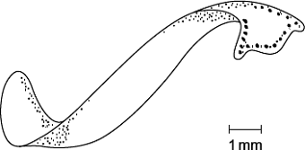

(i)      Name the process by which oxygen reaches the cells inside the body of this flatworm.

...............................................................................................................

**(1)**

(ii)     The body of a flatworm is adapted for efficient gas exchange between the water and the cells inside the body.  
Using the diagram, explain how **two** features of the flatworm’s body allow efficient gas exchange.

1 ............................................................................................................

...............................................................................................................

2 ............................................................................................................

...............................................................................................................

**(2)**

**(Total 3 marks)**

**Q2.**(a)     Describe and explain how the countercurrent system leads to efficient gas exchange across the gills of a fish.

........................................................................................................................

........................................................................................................................

........................................................................................................................

........................................................................................................................

........................................................................................................................

........................................................................................................................

*(Extra space)* .................................................................................................

........................................................................................................................

........................................................................................................................

**(3)**

(b)     Amoebic gill disease (AGD) is caused by a parasite that lives on the gills of some species of fish. The disease causes the lamellae to become thicker and to fuse together.

AGD reduces the efficiency of gas exchange in fish. Give **two** reasons why.

1 .....................................................................................................................

........................................................................................................................

2 .....................................................................................................................

........................................................................................................................

**(2)**

(c)     The table below shows some features of gas exchange of a fish at rest.

|  |  |  |
| --- | --- | --- |
|  | Volume of oxygen absorbed by the gills from each dm3 of water / cm3 | 7 |
|  | Mass of fish / kg | 0.4 |
|  | Oxygen required by fish / cm3 kg–1 hour–1 | 90 |

(i)      Calculate the volume of water that would have to pass over the gills each hour to supply the oxygen required by the fish. Show your working.

.......................................................... dm3

**(2)**

(ii)     The volume of water passing over the gills increases if the temperature of the water increases. Suggest why.

...............................................................................................................

...............................................................................................................

...............................................................................................................

**(1)**

**(Total 8 marks)**

**Q3.** Large insects contract muscles associated with the abdomen to force air in and out of the spiracles. This is known as ‘abdominal pumping’. The table shows the mean rate of abdominal pumping of an insect before and during flight.

|  |  |  |
| --- | --- | --- |
|  | **Stage of flight** | **Mean rate of abdominal pumping / dm 3 of air kg −1 hour −1** |
|  | Before | 42 |
|  | During | 186 |

(a)     Calculate the percentage increase in the rate of abdominal pumping before and during flight. Show your working.

Answer ..................................... %

**(2)**

(b)     Abdominal pumping increases the efficiency of gas exchange between the tracheoles and muscle tissue of the insect. Explain why.

........................................................................................................................

........................................................................................................................

........................................................................................................................

........................................................................................................................

........................................................................................................................

**(2)**

(c)     Abdominal pumping is an adaptation not found in many small insects. These small insects obtain sufficient oxygen by diffusion.

Explain how their small size enables gas exchange to be efficient without the need for abdominal pumping.

........................................................................................................................

........................................................................................................................

........................................................................................................................

**(1)**

The graph shows the concentration of oxygen inside the tracheoles of an insect when at rest. It also shows when the spiracles are fully open.

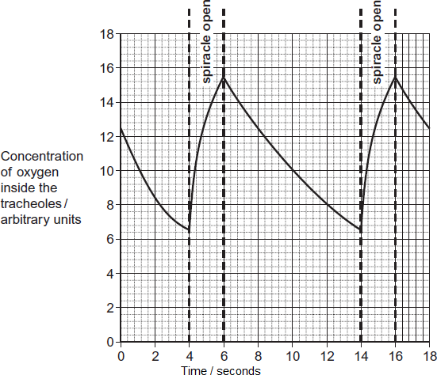

(d)     Use the graph to calculate the frequency of spiracle opening. Show your working.

Frequency ..................................... times per minute

**(2)**

(e)     The insect opens its spiracles at a lower frequency in very dry conditions. Suggest **one** advantage of this.

........................................................................................................................

........................................................................................................................

........................................................................................................................

**(1)**

(f)     The ends of tracheoles connect directly with the insect’s muscle tissue and are filled with water. When flying, water is absorbed into the muscle tissue. Removal of water from the tracheoles increases the rate of diffusion of oxygen between the tracheoles and muscle tissue. Suggest **one** reason why.

........................................................................................................................

........................................................................................................................

........................................................................................................................

**(1)**

**(Total 9 marks)**

**Q4.**Scientists used fossil leaves from one species of pine tree to investigate whether changes in the concentration of carbon dioxide in the air over long periods of time had led to changes in the number of stomata in the leaves.

Their method is outlined below.

•        They selected sites of different ages.

•        They collected between 11 and 24 fossil leaves from each site.

•        They found the mean number of stomata per mm2 on the leaves from each site.

•        They estimated the age of each sample by dating organic remains around the leaves at each site.

They compared results from the fossil leaves with leaves from the same species of pine tree growing today.

They knew the concentration of carbon dioxide in the air at different times in the past.

Their results are shown in the table.

|  |  |  |  |
| --- | --- | --- | --- |
|  | **Age of sample  / years** | **Concentration of  carbon dioxide in the  air / %** | **Mean number of stomata  per mm2  (± standard deviation)** |
|  | present day | 0.0350 | 92 (±2) |
|  | 5000 | 0.0270 | 87 (±4) |
|  | 10 000 | 0.0250 | 95 (±2) |
|  | 15 000 | 0.0205 | 108 (±6) |
|  | 20 000 | 0.0195 | 115 (±4) |
|  | 25 000 | 0.0188 | 118 (±6) |
|  | 30 000 | 0.0190 | 130 (±6) |

(a)     The concentration of carbon dioxide in the air has changed with time. Use the data to describe how.

........................................................................................................................

........................................................................................................................

........................................................................................................................

........................................................................................................................

........................................................................................................................

**(2)**

(b)     The scientists calculated the mean number of stomata per mm2 and the standard deviation.

What does the standard deviation show?

........................................................................................................................

........................................................................................................................

........................................................................................................................

........................................................................................................................

........................................................................................................................

**(2)**

(c)     The scientists found the age of the fossil leaves by dating the organic remains around them.  
Would this have affected the accuracy of their data? Explain your answer.

........................................................................................................................

........................................................................................................................

........................................................................................................................

**(1)**

(d)     30 000 years ago the mean number of stomata per mm2 on the lower epidermis of pine tree leaves was much higher than it is today. This would have enabled the plant to grow faster when the carbon dioxide concentration of the air was low.

Explain why.

........................................................................................................................

........................................................................................................................

........................................................................................................................

**(1)**

(e)     A student who saw these results concluded that as the carbon dioxide concentration of the air had increased the number of stomata per mm2 in leaves had decreased.  
Do the results support this conclusion?

........................................................................................................................

........................................................................................................................

........................................................................................................................

........................................................................................................................

........................................................................................................................

........................................................................................................................

(Extra space) .................................................................................................

........................................................................................................................

........................................................................................................................

**(3)**

(f)      The leaves of plants that grow in dry areas usually have a low number of stomata per mm2. Use your knowledge of leaf structure to suggest **three** other adaptations that the leaves might have that enable the plants to grow well in dry conditions.

1 .....................................................................................................................

2 .....................................................................................................................

3 .....................................................................................................................

**(3)**

**(Total 12 marks)**

**Q5.**          The drawing shows part of the lower leaf epidermis of sorghum.

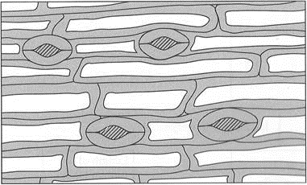



(a)     Calculate the number of stomata per mm2 of the leaf surface. Show your working.

Answer ....................................... stomata per mm2

**(2)**

(b)     Sorghum has few stomata per mm2 of leaf surface area. Explain how this is an adaptation to the conditions in which sorghum grows.

......................................................................................................................

......................................................................................................................

......................................................................................................................

......................................................................................................................

......................................................................................................................

......................................................................................................................

**(3)**

**(Total 5 marks)**