Name: ………………………………………………….

**Q1.**(a)    The table shows three statements about some biological molecules. Complete the table with a tick in each box if the statement is true for haemoglobin, cellulose or starch.

|  |  |  |  |  |
| --- | --- | --- | --- | --- |
|  | **Statement** | **Haemoglobin** | **Cellulose** | **Starch** |
|  | Has a quaternary structure |  |  |  |
|  | Formed by condensation reactions |  |  |  |
|  | Contains nitrogen |  |  |  |

**(3)**

The graph shows oxygen dissociation curves for the haemoglobin of a mother and her fetus.

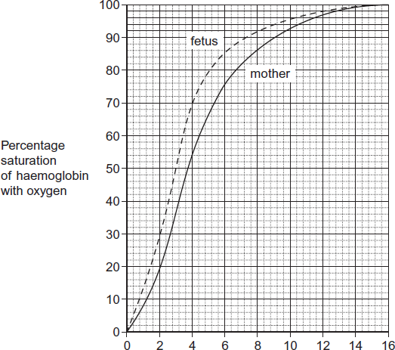

Partial pressure of oxygen (pO2) / kPa

(b)     What is the difference in percentage saturation between the haemoglobin of the mother and her fetus at a partial pressure of oxygen (pO2) of 4 kPa?



**(1)**

(c)     The oxygen dissociation curve of the fetus is to the left of that for its mother. Explain the advantage of this for the fetus.

........................................................................................................................

........................................................................................................................

........................................................................................................................

........................................................................................................................

........................................................................................................................

**(2)**

**(Total 6 marks)**

**Q2.**          The diagram shows a molecule of haemoglobin.

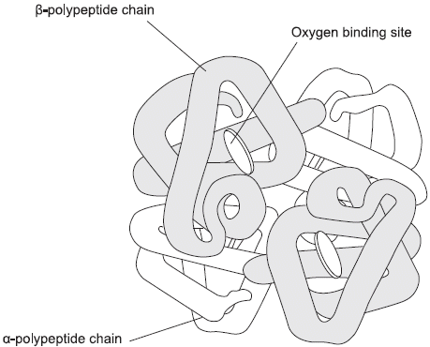

(a)     What is the evidence from the diagram that haemoglobin has a quaternary structure?

......................................................................................................................

......................................................................................................................

**(1)**

(b)     The haemoglobin in one organism may have a different chemical structure from the haemoglobin in another organism. Describe how.

......................................................................................................................

......................................................................................................................

**(1)**

(c)     The graph shows oxygen dissociation curves for horse haemoglobin and for llama haemoglobin. Horses are adapted to live at sea level and llamas are adapted to live in high mountains.

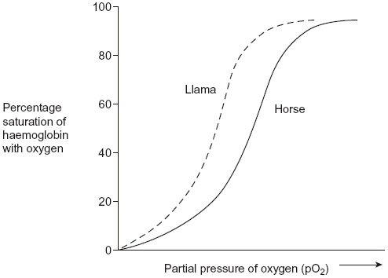

Use the graph to explain why llamas are better adapted to live in high mountains than horses.

......................................................................................................................

......................................................................................................................

......................................................................................................................

......................................................................................................................

......................................................................................................................

......................................................................................................................

**(3)**

**(Total 5 marks)**

**Q3.**(a)     (i)      The human heart has four chambers.  
In which **one** of the four chambers of the human heart does pressure reach the highest value?

...............................................................................................................

**(1)**

(ii)     Explain how the structure of this chamber causes this high pressure.

...............................................................................................................

...............................................................................................................

...............................................................................................................

**(1)**

The table shows the volume of blood in a man's right ventricle at different times during one cardiac cycle.

|  |  |  |
| --- | --- | --- |
|  | **Time / s** | **Volume of blood / cm3** |
|  | 0.0 | 125 |
|  | 0.1 | 148 |
|  | 0.2 | 103 |
|  | 0.3 | 70 |
|  | 0.4 | 56 |
|  | 0.5 | 55 |
|  | 0.6 | 98 |
|  | 0.7 | 125 |

(b)     Use information from the table to complete the table below to show whether the valves are **open** or **closed** at each of the times shown. Write open or closed in the appropriate boxes.

|  |  |  |  |
| --- | --- | --- | --- |
|  | **Time / s** | **Valve between right atrium and right ventricle** | **Valve between right ventricle and pulmonary artery** |
|  | 0.2 |  |  |
|  | 0.6 |  |  |

**(2)  
(Total 4 marks)**

**Q4.**The figure below shows recordings made from the heart of a dog.

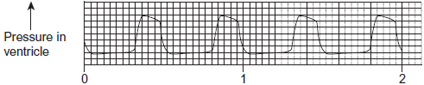  
                        Time / seconds

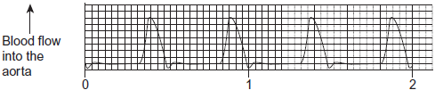  
                        Time / seconds

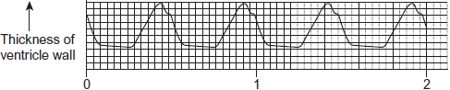  
                        Time / seconds

(a)     Use information from the figure to explain how the pressure in the dog’s ventricle is related to blood flow into the aorta.

........................................................................................................................

........................................................................................................................

........................................................................................................................

........................................................................................................................

*(Extra space)* .................................................................................................

........................................................................................................................

**(2)**

(b)     Use information from the figure to explain how the pressure in the dog’s ventricle is related to the thickness of the ventricle wall.

........................................................................................................................

........................................................................................................................

........................................................................................................................

*(Extra space)* .................................................................................................

........................................................................................................................

**(2)**

(c)     Use the figure to calculate the heart rate of the dog in beats per minute.  
Show your working.

Heart rate ........................................... beats per minute

**(2)**

**(Total 6 marks)**

**Q5.**          The graph shows changes in pressure in different parts of the heart during a period of one second.

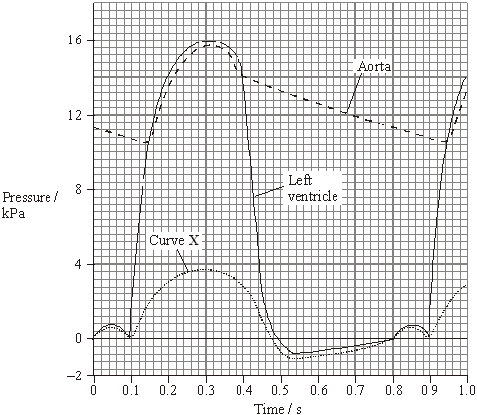

(a)     (i)      At what time do the semilunar valves close?

.............................................................................................................

**(1)**

(ii)     Use the graph to calculate the heart rate in beats per minute.

Show your working.

Answer ............................. beats per minute

**(1)**

(iii)     Use the graph to calculate the total time that blood flows out of the left side of the heart during one minute when beating at this rate. Show your working.

Answer ........................... seconds

**(1)**

(b)     What does curve **X** represent? Explain your answer.

**X** = ...............................................................................................................

Explanation ..................................................................................................

......................................................................................................................

**(2)**

(c)     The volume of blood pumped out of the left ventricle during one cardiac cycle is called the stroke volume.

The volume of blood pumped out of the left ventricle in one minute is called the cardiac output. It is calculated using the equation

Cardiac output = stroke volume × heart rate

After several months of training, an athlete had the same cardiac output but a lower resting heart rate than before. Explain this change.

......................................................................................................................

......................................................................................................................

......................................................................................................................

**(2)**

**(Total 7 marks)**

**Q6.**          Scientists compared the results of three investigations, **A**, **B** and **C**. These investigations were into the effect of drinking different amounts of alcohol on the risk of developing heart disease.

The graph shows the results of these investigations.

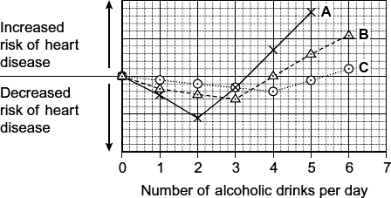

(a)     Describe the relationship between increasing the number of alcoholic drinks per day and the risk of heart disease in investigation **A**.

........................................................................................................................

........................................................................................................................

........................................................................................................................

........................................................................................................................

........................................................................................................................

**(2)**

(b)     All the volunteers who took part in investigation **C** were aged between 40 and 50 years old. Explain how choosing volunteers of a similar age improved this investigation.

........................................................................................................................

........................................................................................................................

........................................................................................................................

**(1)**

(c)     A newspaper headline used the information in the graph to claim ‘Alcohol is good for you.’ Evaluate this claim.

........................................................................................................................

........................................................................................................................

........................................................................................................................

........................................................................................................................

........................................................................................................................

........................................................................................................................

*(Extra space)* .................................................................................................

........................................................................................................................

........................................................................................................................

**(3)**

**(Total 6 marks)**

**Q7.**          The diagram shows vessels in a small piece of tissue from a mammal. The chart shows the hydrostatic pressure of the blood as it flows through the capillary.

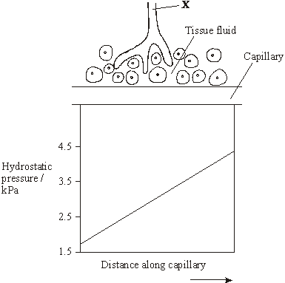

(a)     Name the fluid contained in vessel **X**. ........................................................................

**(1)**

(b)     Draw an arrow on the capillary to show the direction of the flow of blood. Describe the evidence from the chart to support your answer.

......................................................................................................................

......................................................................................................................

**(1)**

(c)     Describe and explain how water is exchanged between the blood and tissue fluid as blood flows along the capillary.

......................................................................................................................

......................................................................................................................

......................................................................................................................

......................................................................................................................

......................................................................................................................

......................................................................................................................

......................................................................................................................

......................................................................................................................

**(4)  
 (Total 6 marks)**

**Q8.**          The diagram shows a cross-section of a blood vessel.

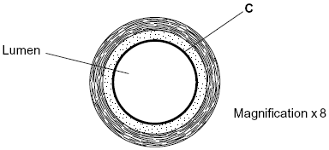

(a)     Name layer **C**.

......................................................................................................................

**(1)**

(b)     Calculate the actual diameter of the lumen of this blood vessel in millimetres. Show your working.

Answer ............................................. mm

**(2)**

(c)     The aorta has many elastic fibres in its wall. An arteriole has many muscle fibres in its wall.

(i)      Explain the importance of elastic fibres in the wall of the aorta.

.............................................................................................................

.............................................................................................................

.............................................................................................................

.............................................................................................................

**(2)**

(ii)     Explain the importance of muscle fibres in the wall of an arteriole.

.............................................................................................................

.............................................................................................................

.............................................................................................................

.............................................................................................................

**(2)**

(d)     The graph shows the rate of blood flow in different blood vessels. It also shows the total cross-sectional area of these blood vessels.

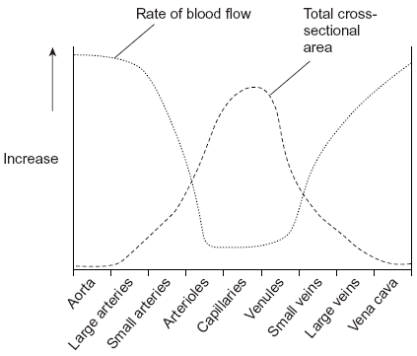

(i)      The rate of blood flow decreases from the aorta to the capillaries. Use information from the graph to explain why.

.............................................................................................................

.............................................................................................................

.............................................................................................................

**(1)**

(ii)     Efficient exchange of substances in the capillaries is linked to the rate of blood flow. Explain how.

.............................................................................................................

.............................................................................................................

.............................................................................................................

**(1)**

**(Total 9 marks)**

**Q9.**(a)     (i)      An arteriole is described as an organ. Explain why.

...............................................................................................................

...............................................................................................................

...............................................................................................................

**(1)**

(b)     (i)      A capillary has a thin wall. This leads to rapid exchange of substances between the blood and tissue fluid. Explain why.

...............................................................................................................

...............................................................................................................

...............................................................................................................

**(1)**

(ii)     Blood flow in capillaries is slow. Give the advantage of this.

...............................................................................................................

...............................................................................................................

...............................................................................................................

**(1)**

(c)     Kwashiorkor is a disease caused by a lack of protein in the blood. This leads to a swollen abdomen due to a build up of tissue fluid.

Explain why a lack of protein in the blood causes a build up of tissue fluid.

........................................................................................................................

........................................................................................................................

........................................................................................................................

........................................................................................................................

........................................................................................................................

........................................................................................................................

*(Extra space)*..................................................................................................

........................................................................................................................

........................................................................................................................

**(3)**

**(Total 6 marks)**