Name: ………………………………………………………………

**Q1.**          (a)     Scientists measured the rate of water flow and the pressure in the xylem in a small branch. Their results are shown in the graph.

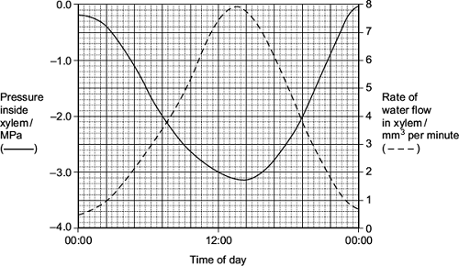

(i)      Use your knowledge of transpiration to explain the changes in the rate of flow in the xylem shown in the graph.

...............................................................................................................

...............................................................................................................

...............................................................................................................

...............................................................................................................

...............................................................................................................

...............................................................................................................

*(Extra space)* ........................................................................................

...............................................................................................................

...............................................................................................................

**(3)**

(ii)     Explain why the values for the pressure in the xylem are negative.

...............................................................................................................

...............................................................................................................

...............................................................................................................

**(1)**

**(Total 4 marks)**

**Q2.**          (a)     Students measured the rate of transpiration of a plant growing in a pot under different environmental conditions. Their results are shown in the table.

|  |  |  |
| --- | --- | --- |
|  | **Conditions** | **Transpiration rate / g h–1** |
|  | **A**    Still air 15° | 1.2 |
|  | **B**    Moving air 15° | 1.7 |
|  | **C**    Still air 25° | 2.3 |

During transpiration, water diffuses from cells to the air surrounding a leaf.

(i)      Suggest an explanation for the difference in transpiration rate between conditions **A** and **B**.

.............................................................................................................

.............................................................................................................

.............................................................................................................

.............................................................................................................

.............................................................................................................

**(2)**

(ii)     Suggest an explanation for the difference in transpiration rate between conditions **A** and **C**.

.............................................................................................................

.............................................................................................................

.............................................................................................................

.............................................................................................................

.............................................................................................................

**(2)**

(b)     Scientists investigated the rate of water movement through the xylem of a twig from a tree over 24 hours. The graph shows their results. It also shows the light intensity for the same period of time.

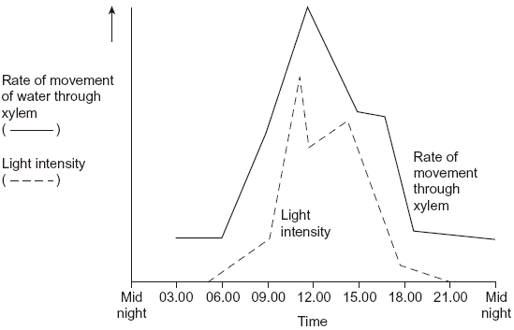

(i)      Describe the relationship between the rate of water movement through the xylem and the light intensity.

.............................................................................................................

.............................................................................................................

**(1)**

(ii)     Explain the change in the rate of water movement through the xylem between 06.00 and 12.00 hours.

.............................................................................................................

.............................................................................................................

.............................................................................................................

.............................................................................................................

**(2)**

(iii)     The scientists also measured the diameter of the trunk of the tree on which the twig had been growing. The diameter was less at 12.00 than it was at 03.00 hours.

Explain why the diameter was less at 12.00 hours.

.............................................................................................................

.............................................................................................................

.............................................................................................................

.............................................................................................................

**(2)**

**(Total 9 marks)**

**Q3.**(a)     Describe the mass flow hypothesis for the mechanism of translocation in plants.

........................................................................................................................

........................................................................................................................

........................................................................................................................

........................................................................................................................

........................................................................................................................

........................................................................................................................

........................................................................................................................

........................................................................................................................

*(Extra space)* ................................................................................................

........................................................................................................................

**(4)**

Scientists measured translocation in the phloem of trees. They used carbon dioxide labelled with radioactive 14C.

They put a large, clear plastic bag over the leaves and branches of each tree and added 14CO2. The main trunk of the tree was not in the plastic bag.

At regular intervals after adding the 14CO2 to the bag, the scientists measured the amount of 14CO2 released from the top and bottom of the main trunk of the tree. On the surface of the trunk of these trees, there are pores for gas exchange.

The following figure shows the scientists’ results.

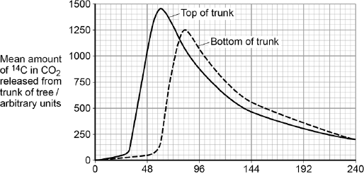  
                               Time after 14C labelled CO2 given / hours

(b)     Name the process that produced the 14CO2 released from the trunk.

........................................................................................................................

**(1)**

(c)     How long did it take the 14C label to get from the top of the trunk to the bottom of the trunk? Explain how you reached your answer.

........................................................................................................................

........................................................................................................................

........................................................................................................................

........................................................................................................................

**(2)**

(d)     What other information is required in order to calculate the mean rate of movement of the 14C down the trunk?

........................................................................................................................

........................................................................................................................

**(1)**

**(Total 8 marks)**

**Q4.**A student investigated the rate of transpiration from a leafy shoot. She used a potometer to measure the rate of water uptake by the shoot. The diagram shows the potometer used by the student.

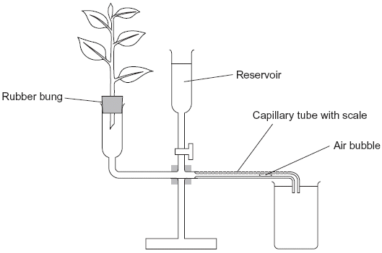

(a)     Give **one** environmental factor that the student should have kept constant during this investigation.

......................................................................................................................

**(1)**

(b)     The student cut the shoot and put it into the potometer under water. Explain why.

......................................................................................................................

......................................................................................................................

**(1)**

(c)     The student wanted to calculate the rate of water uptake by the shoot in cm3 per minute. What measurements did she need to make?

......................................................................................................................

......................................................................................................................

......................................................................................................................

......................................................................................................................

**(2)**

(d)     The student assumed that water uptake was equivalent to the rate of transpiration.

Give **two** reasons why this might **not** be a valid assumption.

1 ...................................................................................................................

......................................................................................................................

2 ...................................................................................................................

......................................................................................................................

**(2)**

(e)     The student measured the rate of water uptake three times.

(i)      Suggest how the reservoir allows repeat measurements to be made.

.............................................................................................................

.............................................................................................................

**(1)**

(ii)     Suggest why she made repeat measurements.

.............................................................................................................

.............................................................................................................

**(1)**

**(Total 8 marks)**

**Q5.**          (a)     Describe how water is moved through a plant according to the *cohesion-tension* hypothesis.

......................................................................................................................

......................................................................................................................

......................................................................................................................

......................................................................................................................

......................................................................................................................

......................................................................................................................

......................................................................................................................

......................................................................................................................

**(4)**

(b)     The mass of water lost from a plant was investigated. The same plant was used in every treatment and the plant was subjected to identical environmental conditions. In some treatments, the leaves were coated with a type of grease. This grease provides a waterproof barrier. The results of the investigation are given in the table.

|  |  |
| --- | --- |
| **Treatment** | **Mass lost in 5 days / g** |
| No grease applied | 10.0 |
| Grease applied only to the upper surface of every leaf | 8.7 |
| Grease applied to both surfaces of every leaf | 0.1 |

(i)      What is the advantage of using the same plant in every treatment?

.............................................................................................................

.............................................................................................................

**(1)**

(ii)     Why was it important to keep the environmental conditions constant?

.............................................................................................................

.............................................................................................................

**(1)**

(iii)     What is the evidence that the grease provides a waterproof barrier?

.............................................................................................................

.............................................................................................................

**(1)**

(c)     (i)      Calculate the mass of water lost in 5 days through the upper surface of the leaves.

Answer ................................................................

**(1)**

(ii)     Use your knowledge of leaf structure to explain why less water is lost through the upper surface of leaves than is lost through the lower surface.

.............................................................................................................

.............................................................................................................

.............................................................................................................

.............................................................................................................

**(2)**

**(Total 10 marks)**