**3.3.3 Digestion and Absorption AQA**

**Specification**

* During digestion, large biological molecules are hydrolysed to smaller molecules that can be absorbed across cell membranes.
* Digestion in mammals of:
  + Carbohydrates by amylases and membrane-bound disaccharidases
  + Lipids by lipase, including the action of bile salts
  + Proteins by endopeptidases, exopeptidases and membrane-bound dipeptidases.
* Mechanisms for the absorption of the products of digestion by cells lining the ileum of mammals, to include:
  + Co-transport mechanisms for the absorption of amino acids and of monosaccharides
  + The role of micelles in the absorption of lipids.

**Previous GCSE Knowledge**

* The hierarchical organisation of cells into tissues, organs and organ systems, exemplified by the stomach and digestive system
* The role of amylase, protease and lipase enzyme in the digestion of large insoluble food molecules, and their sites of production.
* The role of Bile in emulsifying fats and neutralising acid from the stomach, and the site of its production and storage
* Diffusion in the movement of molecules from a region of high to low concentration

**Preparatory work**

Read the following article found in resources on GOL ‘The Anatomy of Digestion’ and answer the following questions.

1. What is the process of digestion?
2. What is the function of teeth?
3. What type of digestion begins in the mouth?
4. What is the enzyme secreted by the salivary glands?
5. What connects the stomach to the mouth?
6. What is found in gastric juice?
7. Why do your teeth dissolve when you vomit?
8. What protects the stomach from being digested?
9. What are the two functions of the small intestine?
10. What does bile do?
11. Where does the majority of water absorption take place?

**Nutrition**

**Nutrition** is the process by which organisms obtain **energy** to maintain life functions and **matter** to create and maintain structure. These are obtained from nutrients. Use the internet to look up the different types of nutrition and fill in the table below.

|  |  |  |  |
| --- | --- | --- | --- |
| *Type of Nutrition* | | Explanation | Example |
| Autotrophs  (use simple inorganic molecules to make complex organic compounds) | Photo-  synthesis | These use simple inorganic materials (eg CO2 and O2.) to manufacture complex organic compounds such as sugars using energy from sunlight (absorbed by pigments such as chlorophyll) | Green plants  Algae  Some bacteria |
| Chemo-  synthesis | These use the energy derived from special methods of respiration to synthesise organic food. | Some bacteria |
| Heterotrophs  (obtain organic carbon by eating other heterotrophs or autotrophs) | Holozoic feeders |  |  |
| Saprophytes (saprobionts) | These feed on dead/decaying material organic compounds. They secrete digestive enzymes onto their  food, the food is externally digested and the soluble products absorbed | Some fungi  Most bacteria  () |
| Parasites | These live on or in other living organisms, their **hosts**, and obtain nourishment at the expense of the host. These digest the hosts cells and absorb the products | Examples across all kingdoms  tapeworm |
| Mutualism  (symbiotic) | Close association between two species where both be  . In lichens the fungal hyphae store water and algal cells provide sugars from photosynthesis. | Lichens (algae and fungi) |

**Human Nutrition**

Use the following link to answer questions on Human nutrition.

<http://leavingbio.net/human%20nutrition/human%20nutrition.htm>

What are the 5 stages of nutrition?

Using the following words please complete the following paragraph

Egestion, digested, excretion, absorption, assimilation, ingestion, and egestion.

Do not confuse _____________ elimination of material from a body cavity, with ___________ - elimination of waste material produced from within the body's cells.

In order to accomplish its functions the digestive system begins with the mouth where food enters. This process is called _____________. In this process food is placed into the alimentary canal.

After the food enters the alimentary canal it must be ______________**.** This is the breakdown of complex food into their simple soluble absorbable subunits.

They must be broken down so that they can be absorbed into the bloodstream and then taken to the body cells. This process is called ______________Through absorption the products of digestion enter into the blood or lymph.

After the food is absorbed the nutrients are brought to the body cells. Here the process of ______________ converts the absorbed nutrients into complex molecules for growth, repair and defence.

Finally the waste products which remain behind must be excluded from the body. This is done by the process of __________________.

**Major parts of the digestive system**

In **simple organisms**, feeding on only one type of food, the gut is undifferentiated.

In **more advanced organisms**, with a varied diet, the gut is divided into various parts along its length and each part is specialised to carry out particular functions.

In humans the site of ingestion/digestion/absorption is the gut (alimentary canal), which is a long tube that extends from the mouth to the anus.

Please label the following diagram. Refer to GoL articles and resources. It consists of the buccal cavity, tongue, oesophagus, stomach, duodenum, ileum, colon, rectum, anus and associated organs; salivary glands, liver and pancreas

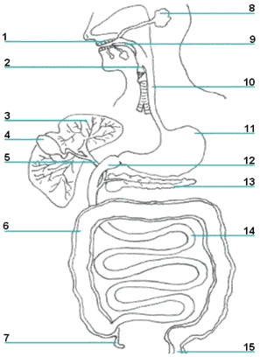

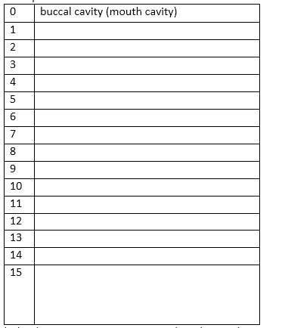

**The major organs and glands**

A gland is an organ in the human or animal body which secretes particular chemical substances for use in the body or for discharge into the surroundings.

Watch the following clip on the organs involved in digestion.

<https://www.youtube.com/watch?v=Q-n_Q0qKXzg#t=30>

Some glands are found in the wall of the gut with the digestive secretions passing directly into the gut cavity eg **gastric glands** and **Brunner’s glands (duodenum)**.

Other glands are found outside the gut with the secretions passing along **ducts** into the gut cavity eg **salivary glands, liver** and **pancreas**

**Digestion**

In humans as with many organisms digestion takes place in two stages:

Write short notes on these two different forms of digestion **p19 old AS book**:

1. Physical breakdown
2. Chemical digestion.

There are different types of digestive enzymes, three of which are particularly important: Fill in the table describing the function of the three different types enzymes used in digestion. (p19 Old AQA text book):-

|  |  |
| --- | --- |
| **Enzyme** | **Function** |
|  |  |
|  |  |
|  |  |

This table shows the function of each organ in the digestive system. Using the internet and your AQA textbook fill in the blanks.

The following words need to be used

Egestion, amylase, neutralise pH, microvilli, goblet cells, endopeptidase peristalsis, glycerol , hydrochloric acid, pancreatic enzymes, mucus, bile, villi, active transport, lacteal.

|  |  |  |
| --- | --- | --- |
| **Structure** | **Function** | **Adaptations** |
| Mouth | Initial mechanical and chemical breakdown of food | * Mechanical digestion due to food being chewed using the teeth * Saliva (pH 6.5-7.5) is important for **lubricating** the food before it is swallowed. Saliva contains ___________which breaks down starch to maltose. |
| Oesophagus | Move food to stomach  peristalsis | * Many mucus secreting _____________to **lubricate** food to aid movement * Circular/longitudinal muscles contract behind food to move food towards stomach – called _____________ |
| Stomach | To store and digest food, especially proteins | * The stomach is a muscular sac that produces enzymes * **Gastric glands** secrete **gastric juice** containing: * _________________ e.g. **Pepsin**, which hydrolyses **peptide** bonds to form shorter polypeptides * __________________________ (ph 2) – provides **optimum pH** for endopeptidases and **kills bacteria** * And an **alkaline** ______________**is secreted** to prevent the mucosa from being ‘self digested’ by acid and endopeptidases |
| Duodenum  (small intestine) | Neutralise acid from stomach. Site of bile and pancreatic ducts to secrete juices for digestion | * Glands secrete **mucus**, also **alkaline juice** (pH 8) to neutralise acid from stomach to give optimum pH for ______________________(endopeptidases, amylase and lipase) * **Bile** (produced in the liver and stored in the gall bladder) **neutralises** __________and provides **bile salts** to emulsifying the lipids |
| Ileum  (small intestine) | To absorb digested food    (Epithelial cells showing **microvilli)** | * Long muscular tube * Enzymes secreted by cells at the tips of the villi complete digestion (eg maltase, exopeptidases and dipeptidase) * Very **long folded** tube to **increase surface area** * Also mucosa forms finger like ____________ * Epithelial cells of villi have ___________ * **Glucose** and **amino acids** areabsorbed by ____________ * **One cell thick** provides a **short diffusion pathway** * **Blood capillaries** inside villi transport **glucose** and **amino acids** to the **liver** via the **hepatic portal vein** * **Fatty acids** and ______________pass into the __________(inside villi), through the **lymphatic system** to the blood stream opening at the **thoracic duct** |
| Colon  (large intestine) | To absorbed water and other soluble nutrients | * Most of the water absorbed is from the secretions of the many digestive glands |
| Rectum | Stores faeces until removed via the anus | * Final section of the intestines * This where _______________ occurs |

**This table shows Chemical digestion of the three different food types .**

|  |  |  |
| --- | --- | --- |
|  | | |
| **1. Carbohydrates (Starch)** | | |
|  | | |
| * **amylase** in saliva from **salivary glands** in mouth * **amylase** in **pancreatic juice** acts in the duodenum * **maltase** secreted by **cells at the tips of the villi in the ileum** complete digestion * **sucrase hydrolyses sucrose into glucose and fructose** * **lactase hydrolyses lactose into glucose and galactose** | | |
|  | | |
| **2. Protein** – digestion takes part in two stages by enzymes called peptidases | | |
|  | | |
| **Endopeptidases** hydrolyse peptide bonds along the length of the protein to provide more ‘**free ends**’ for **exopeptidases** to act on.  **Exopeptidases** hydrolyse the peptide bonds on the terminal amino acids  **Dipeptidase** will finally hydrolyse the bond between the two amino acids of a dipeptides into amino acids. They are **membrane bound and found on cell surface membrane of epithelial cells lining the ileum** |  | |
|  | | |
| **3. Lipids** (These are NOT polymers!) | | |
|  | | * **Bile** (not an enzyme) **emulsifies** large fat droplets to small droplets called **micelles (4-6nm)** * To **increase surface area** for **pancreatic** **lipase** action * The lipid is hydrolysed into **3** **fatty acids** and **glycerol or two fatty acids and a monoglyceride.** |
| Bile is produced by the liver and it **neutralises** acidic contents in the duodenum that come from the stomach | | |
|  | | |

Read through the previous table thoroughly and answer the following questions (you may need to link to previous topics):-

1. How do enzymes work?
2. What are the enzymes that break down starch to glucose?
3. How would you test for the presence of:-
   1. Starch
   2. Reducing sugar?
4. How does an endopeptidase work?
5. How does an exopeptidase work?
6. What organ produces lipase and what does lipase break down?
7. What is a micelle? (link back to cell membranes)

**Carbohydrate digestion flow chart**

Annotate these flow charts with where the enzymes are produced, where they are found in the digestive tract and their optimum pH.

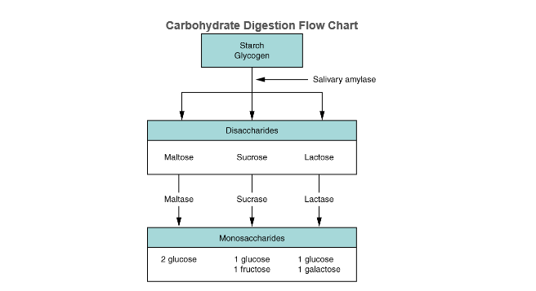

And pancreatic amylase

**Protein digestion flow chart**

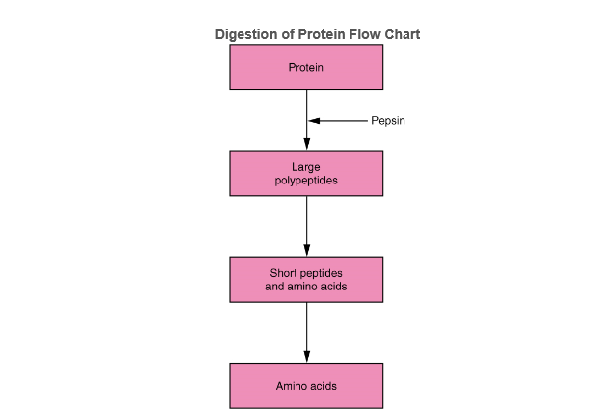

Endopeptidase (Trypsin) /exopeptidase produced by pancreas optimum pH ?

**Digestion of fatty acids**

Bile is a yellow-green liquid that is produced in the liver and stored in the gall bladder.Bile enters the duodenum through the **bile duct** where it neutralises the pH of the partially digested food that has come from the stomach. Bile contains bile salts which play a key role in the digestion of fatty acids. Bile salts are amphiphile compounds i.e. have one end that is hydrophillic and one end that is hydrophobic and act like a surfactant, emulsifying the lipids.

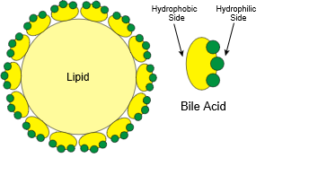

Bile salts aggregate around droplets of lipids to form **micelles** with the hydrphobic sides towards the fat and hydrophillic side facing outwards. This prevents fat droplets re aggregating together. Leaving a larger surface area for the action of pancreatic lipase.

Which previous topic has mentioned micelles?

**Summary of the enzymes involved in Digestion**

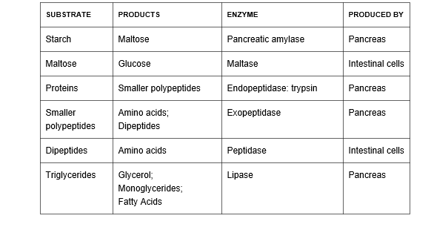

**Absorption**

The Ileum is where digestion ends and absorption starts. The following diagram is a cross section through the ileum



Please write Ficks law in the box below.

**Ficks Law**

Using Ficks law and the diagram above describe how the ileum is adapted to absorption (p63-64 in old AQA AS book) using the following headings to guide you.

Surface area

Short diffusion pathway

Diffusion gradient

The Villi contain lymphatic capillaries known as **lacteals** that transport lipids.

**Absorption of amino acids and monosaccharides**

Digestion of proteins produces amino acids while the digestion of carbohydrates produces monosaccharides such as fructose, glucose and galactose. The method of absorbing these products are the same namely **diffusion** and **co-transport**. Glucose and amino acids are absorbed by co transport into the epithelial cells lining the ileum while facilitated diffusion moves glucose and amino acids from the ileum epithelial cell to the blood. The blood maintains a concentration gradient.

Write a definition of diffusion

Write a definition of Co Transport

Using the information you learnt in Topic 3 Transport across cell membranes fill in the dark grey boxes in the diagram. Please state whether the concentration of amino acid/glucose is high or low (p64 old AS AQA textbook).

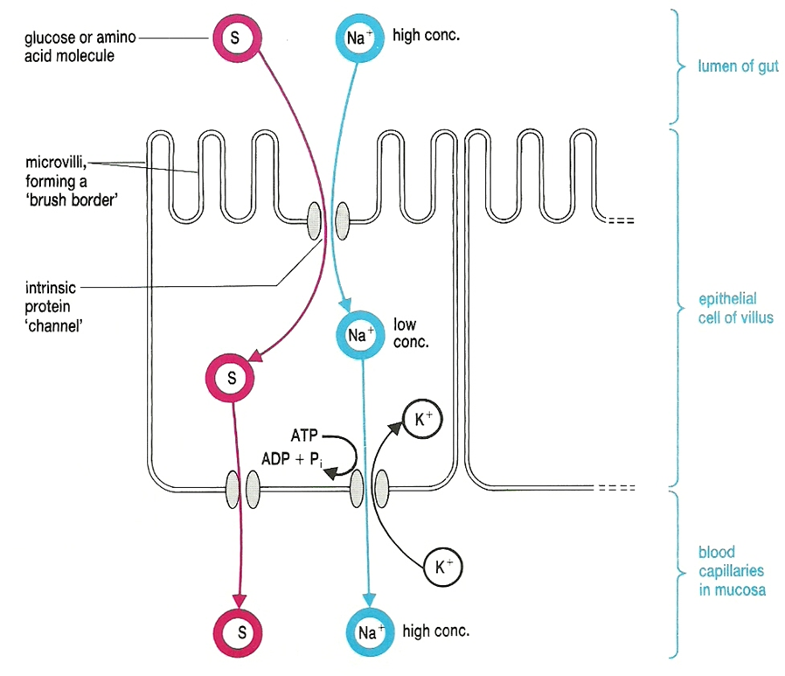

**Absorption of triglycerides (lipids)**

What is a triglyceride? Draw a picture below.

What is a monoglyceride? Draw a picture below.

A diagram to show the lymphatic system (in green). Lipids are transported into the lacteals found at the centre of the villi in the ileum. They enter the blood stream via the thoracic duct.

[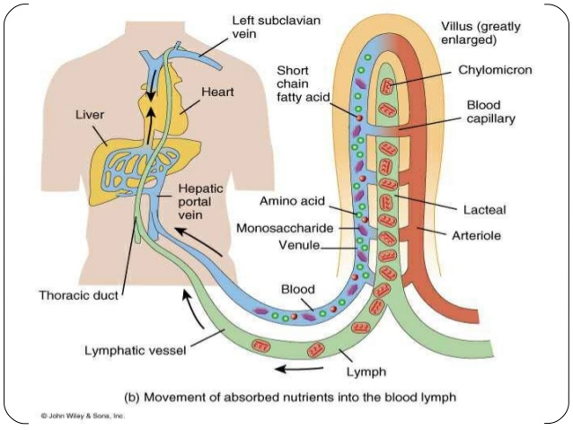](http://www.google.co.uk/url?sa=i&rct=j&q=&esrc=s&frm=1&source=images&cd=&cad=rja&uact=8&ved=0ahUKEwiH0dri7urKAhVGUhQKHQGyBTUQjRwIBw&url=http://www.slideshare.net/asrulicerole/the-lymphatic-system-08&psig=AFQjCNFviAWmVd7ejVuIgGGQKqkYrs6l6A&ust=1455113513972532)

Using your AQA textbook fill in the missing gaps using the following words.

**Monoglyceride, micelle, chylomicrons, lacteal, exocytosis, thoracic duct, and diffuse**

Triglycerides once digested to _____________ and fatty acids by pancreatic lipase remain in association with the bile salts. The structures formed are called ___________.

Once the micelle comes into contact with the epithelial cell lining the ileum they break down and release the non-polar monoglycerides and fatty acids which_____________across the cell-surface membrane into the epithelial cells.

They are then transported to the endoplasmic reticulum where they are recombined to form triglycerides. In the endoplasmic reticulum and Golgi apparatus the triglycerides associate with cholesterol and lipoproteins which become surrounded by a protein coat to form structures called **chylomicrons.** The chylomicrons are water soluble lipoproteins and are too big to pass into blood capillaries but can enter the large pores of the lacteals. Thus the chylomicrons move out of epithelial cell by exocytosis and enter the lymphatic capillaries called l**acteals.** They are then transported in the lymphatic vessels which eventually empty through the thoracic duct and into circulatory system.

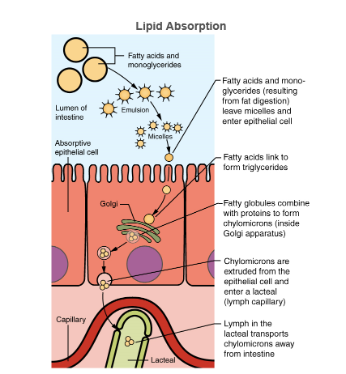

Unlike amino acids and simple sugars, lipids are transformed as they are absorbed through epithelial cells.

**Summary of Absorption**

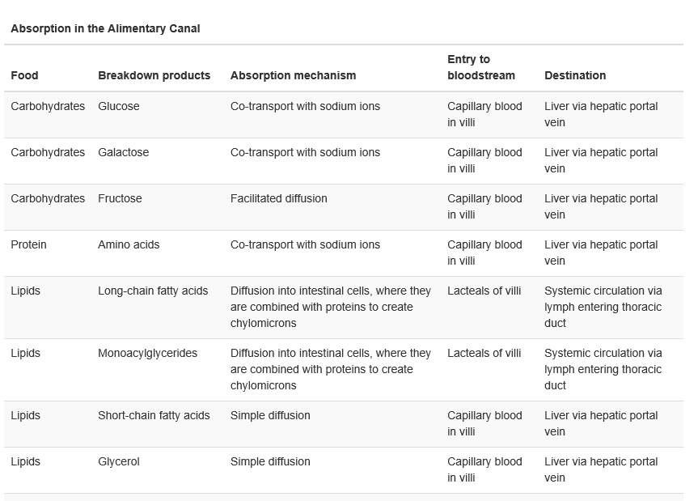

**Common diseases of the digestive system**

Please do some research on the following diseases:-

1. Lactose Intolerance
2. Coeliac Disease

Add a paragraph on each disease to the end of your booklet.

Answer the following questions using precise and concise language. Remember to use diagrams and reference.

* Who is at risk?
* What are the causes?
* What are the symptoms?
* What are the effects on the digestive system?

Please complete the summary table on the next page.

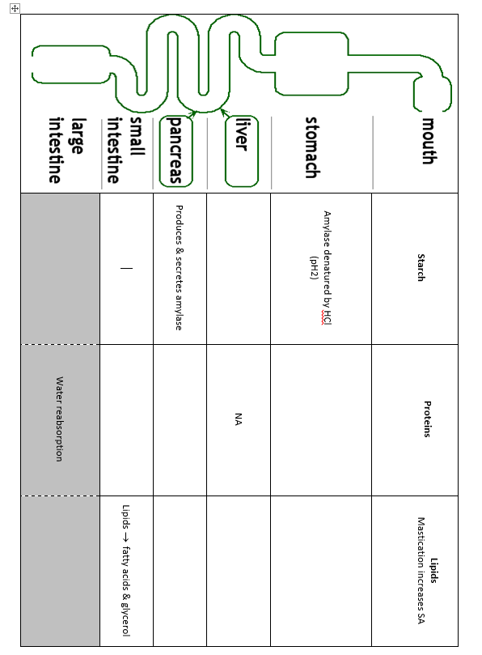

**Digestion Experiment**

Visking tubing is commonly used to model gut digestion because it is semi permeable. The tubing is soaked and a knot is tied at one end. It is then placed into a boiling tube containing water as shown in the diagram below.

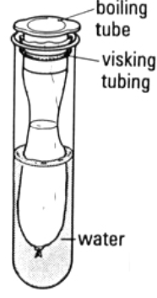

Watch the demonstration:

<http://sciencedemo.org/2014/01/modelling-digestion-using-visking-tubing/>

**Experiment**

In another experiment three model guts were set up labelled 1, 2 and 3. In each model gut rice was added to the visking tubing. Then:-

1. 5 cm3 of water was added to model gut 1.
2. 5 cm3 of amylase was added to model gut 2.
3. 5 cm3 of boiled amylase was added to model gut 3.

All the boiling tubes containing the model guts were placed in a water bath at 37ºC. The model guts were left for at least 15 minutes. After 15 minutes, a teat pipette was used to remove some of the water surrounding the model guts in the boiling tubes and then each solution was tested for starch and glucose.

How do you test for starch?

…………………………………………………………………………………………………………………………………………………………………………………………………..

How do you test for glucose?

………………………………………………………………………………………………………………………………………………………………………………………………………………………………………………………………………………………………………

What do you think your results would show for:-

1. Model Gut 1

..............................................................................................................................................................................................................................................................................

2. Model Gut 2

..............................................................................................................................................................................................................................................................................

3. Model Gut 3

..............................................................................................................................................................................................................................................................................

Please answer the following questions:

1. What does the Visking tubing of the model gut represent?
2. What does the water in the boiling tube, outside the model gut, represent?
3. How is this model different from the situation in a real gut?
4. Use the diagram to explain what is happening in each of the 3 model guts.

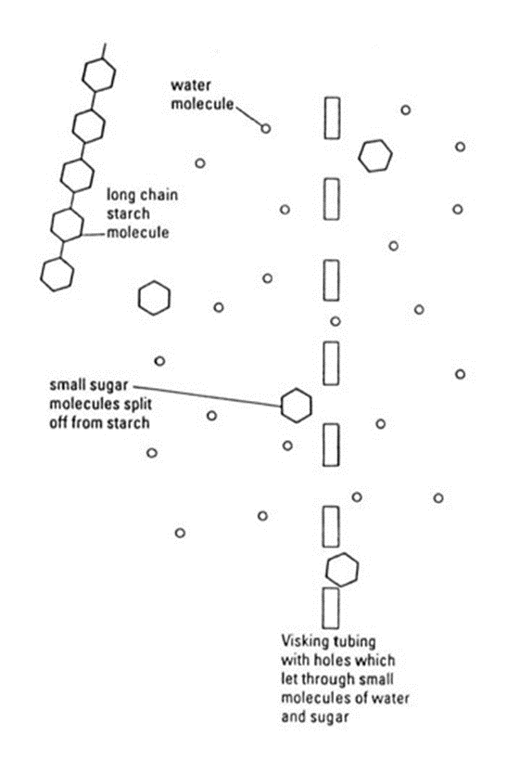

1. Why does the body need enzymes to digest food?
2. What would be the result with boiled amylase? Try to explain this.
3. How could you adapt this experiment to test for protein digestion?

**Exam Questions**

A student investigated the effect of chewing on the digestion of starch in cooked wheat.

He devised a laboratory model of starch digestion in the human gut. This is the method he used.

1.      Volunteers chewed cooked wheat for a set time. The wheat had been cooked in boiling water.

2.      This chewed wheat was mixed with water, hydrochloric acid and a protein-digesting enzyme and left at 37 °C for 30 minutes.

3.      A buffer was then added to bring the pH to 6.0 and pancreatic amylase was added. This mixture was then left at 37 °C for 120 minutes.

4.      Samples of the mixture were removed at 0, 10, 20, 40, 60 and 120 minutes, and the concentration of reducing sugar in each sample was measured.

5.      Control experiments were carried out using cooked wheat that had been chopped up in a blender, not chewed.

(a)     What reducing sugar, or sugars, would you expect to be produced during chewing?  
Give a reason for your answer.

.......................................................................................................................

.......................................................................................................................

.......................................................................................................................

.........................................................................................................

**(2)**

(b)     In this model of digestion in the human gut, what other enzyme is required for the complete digestion of starch?

.......................................................................................................................

**(1)**

(c)     What was the purpose of step 2, in which samples were mixed with water, hydrochloric acid and pepsin?

.......................................................................................................................

.......................................................................................................................

**(1)**

(d)     In the control experiments, cooked wheat was chopped up to copy the effect of chewing.

Suggest a more appropriate control experiment. Explain your suggestion.

.......................................................................................................................

.......................................................................................................................

.......................................................................................................................

.......................................................................................................................

**(2)**

(e)     The figure below shows the student’s results.

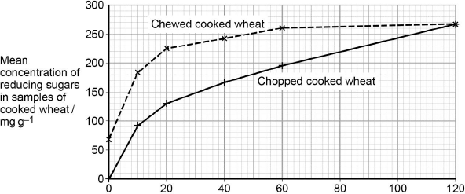  
                               Incubation time / minutes

Explain what these results suggest about the effect of chewing on the digestion of starch in wheat.

.......................................................................................................................

.......................................................................................................................

.......................................................................................................................

.......................................................................................................................

.......................................................................................................................

.......................................................................................................................

**(3)**

**(Total 9 marks)**

**Q2.**Some people have a medical condition called pancreatitis. This can lead to their pancreatic duct becoming blocked. As a result, a high concentration of amylase is found in their blood.

At 12-hour intervals, a doctor measured the concentration of amylase in the blood of a person suffering from a blocked pancreatic duct. He also measured the concentration of amylase in the blood of a healthy person.

The figure below shows his results.

|  |  |  |  |
| --- | --- | --- | --- |
|  |  | **Concentration of amylase in the blood / arbitrary units** | |
|  | **Time / hours** | **Person with blocked pancreatic duct** | **Healthy person** |
|  | 0 | 1800 | 800 |
|  | 12 | 2200 | 750 |
|  | 24 | 2500 | 700 |
|  | 36 | 2000 | 750 |
|  | 48 | 1400 | 800 |

(a)     (i)      The changes in concentration of amylase in the blood of a person with a blocked pancreatic duct are different from those of a healthy person during the period shown in the figure above.

Describe **two** of these differences.

1 ............................................................................................................

..............................................................................................................

..............................................................................................................

2 ............................................................................................................

..............................................................................................................

..............................................................................................................

**(2)**

(ii)     In a person with a blocked pancreatic duct, starch digestion is affected.  
Explain how.

..............................................................................................................

..............................................................................................................

..............................................................................................................

..............................................................................................................

..............................................................................................................

**(2)**

(b)     Healthy people have amylase in their blood. This does not cause any harmful effects in the body.  
Explain why.

.......................................................................................................................

.......................................................................................................................

.......................................................................................................................

.......................................................................................................................

.......................................................................................................................

**(2)**

(c)     Pancreatitis can lead to the release of protein-digesting enzymes into the blood. This is harmful to the body.  
Suggest **one** reason why.

.......................................................................................................................

.......................................................................................................................

.......................................................................................................................

.......................................................................................................................

.......................................................................................................................

**(2)**

**(Total 8 marks)**

**Q3.**          Read the following passage.

Gluten is a protein found in wheat. When gluten is digested in the small intestine,  
the products include peptides. Peptides are short chains of amino acids. These  
peptides cannot be absorbed by facilitated diffusion and leave the gut in faeces

Some people have coeliac disease. The epithelial cells of people with coeliac disease do not absorb the products of digestion very well. In these people, some of the peptides from gluten can pass between the epithelial cells lining the small intestine and enter the intestine wall. Here, the peptides cause an immune response that leads to the destruction of microvilli on the epithelial cells.

Scientists have identified a drug which might help people with coeliac disease.  
It reduces the movement of peptides between epithelial cells. They have carried out trials of the drug with patients with coeliac disease.

Use the information in the passage and your own knowledge to answer the following questions.

(a)     Name the type of chemical reaction which produces amino acids from proteins.

.......................................................................................................................

**(1)**

(b)     The peptides released when gluten is digested cannot be absorbed by facilitated diffusion (lines 2 – 3). Suggest why.

.......................................................................................................................

.......................................................................................................................

.......................................................................................................................

.......................................................................................................................

.......................................................................................................................

.......................................................................................................................

*(Extra space)* .................................................................................................

.......................................................................................................................

.......................................................................................................................

**(3)**

(c)     The epithelial cells of people with coeliac disease do not absorb the products of digestion very well (lines 4 – 5). Explain why.

.......................................................................................................................

.......................................................................................................................

.......................................................................................................................

.......................................................................................................................

.......................................................................................................................

.......................................................................................................................

*(Extra space)* .................................................................................................

.......................................................................................................................

.......................................................................................................................

**(3)**

(d)     Explain why the peptides cause an immune response (lines 7 – 8).

.......................................................................................................................

.......................................................................................................................

.......................................................................................................................

**(1)**

(e)     Scientists have carried out trials of a drug to treat coeliac disease (lines 10 – 11).  
Suggest **two** factors that should be considered before the drug can be used on patients with the disease.

1 .....................................................................................................................

.......................................................................................................................

2 .....................................................................................................................

.......................................................................................................................

**(2)**

**(Total 10 marks)**

**Q4.**   The diagram shows one method by which amino acids are absorbed from the small intestine into the blood. They are co-transported into the epithelial cell with sodium ions (Na+) at point **X** on the diagram. Normally, the concentration of sodium ions inside the epithelial cell is low.

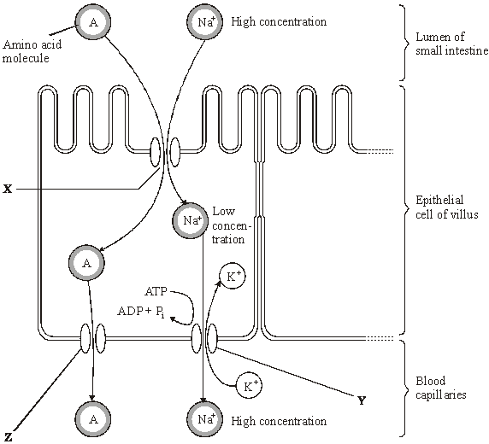

*Source*: adapted from M. ROWLAND,  
*Biology (University of Bath Science 16-19)* (Nelson Thornes) 1992.

Dinitrophenol (DNP) prevents ATP production. When treated with DNP, the sodium-potassium pump at **Y** no longer works. As a result, the concentration of sodium ions in the cell rises and amino acid absorption stops.

(i)      Explain why pump **Y** will **not** work in the presence of DNP.

......................................................................................................................

......................................................................................................................

......................................................................................................................

......................................................................................................................

**(2)**

(ii)      Explain why sodium ions and amino acids are **not** absorbed from the lumen of the small intestine in the presence of DNP.

......................................................................................................................

......................................................................................................................

......................................................................................................................

......................................................................................................................

**(2)**

(iii)     By what mechanism would amino acids leave the epithelial cell at point **Z**?

......................................................................................................................

**(1)**

**(Total 5 marks)**

**Q5.**          The diagram shows part of the gut wall of an animal.

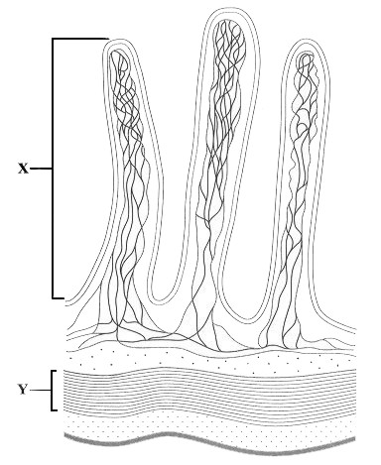

(a)     (i)      Name the structure labelled **X**.

.............................................................................................................

**(1)**

(ii)     Describe the function of the layer labelled **Y**.

.............................................................................................................

.............................................................................................................

.............................................................................................................

.............................................................................................................

**(2)**

(b)     Describe and explain how **two** features shown in the diagram increase the rate of absorption of digested food.

Feature 1

Description

......................................................................................................................

......................................................................................................................

Explanation

......................................................................................................................

......................................................................................................................

Feature 2

Description

......................................................................................................................

......................................................................................................................

Explanation

......................................................................................................................

......................................................................................................................

**(4)**

**(Total 7 marks)**

**Q6.**(a)     Describe the role of the enzymes of the digestive system in the complete breakdown of starch.

......................................................................................................................

......................................................................................................................

......................................................................................................................

......................................................................................................................

......................................................................................................................

......................................................................................................................

......................................................................................................................

......................................................................................................................

......................................................................................................................

......................................................................................................................

**(5)**

(b)     Describe the processes involved in the absorption of the products of starch digestion.

......................................................................................................................

......................................................................................................................

......................................................................................................................

......................................................................................................................

......................................................................................................................

......................................................................................................................

......................................................................................................................

......................................................................................................................

......................................................................................................................

......................................................................................................................

**(5)**

**(Total 10 marks)**

## 

**Q7.**Scientists investigated the effect of lipase and a 3% bile salts solution on the digestion of triglycerides. The graph below shows their results.

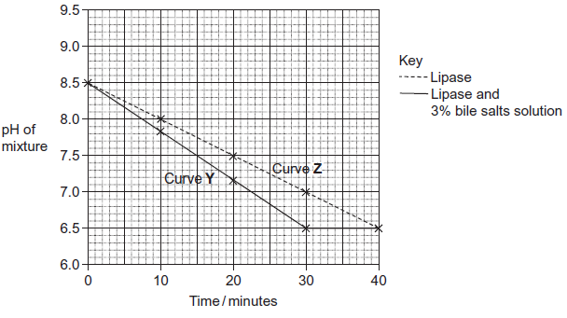

The scientists also incubated triglycerides with different concentrations of bile salts. After 30 minutes they measured the diameter of the triglyceride droplets. They used the results to calculate the mean radius of the droplets at each concentration. The table below shows their results.

|  |  |  |  |  |  |  |  |
| --- | --- | --- | --- | --- | --- | --- | --- |
|  | Concentration of bile salts /% | 0 | 1 | 2 | 3 | 4 | 5 |
|  | Mean radius of triglyceride droplet / μm | 6 | 5 | 4 | 3 | 2 | 1 |

(a)     Describe how you would use a microscope to find the mean diameter of triglyceride droplets on a slide.

.......................................................................................................................

.......................................................................................................................

.......................................................................................................................

..................................................................................................................

.......................................................................................................................

.......................................................................................................................

*(Extra space)* ..................................................................................................

.......................................................................................................................

.......................................................................................................................

**(3)**

(b)     (i)      The ratio of mean radius of triglyceride droplets in bile salts at a concentration of 0% to the mean radius in bile salts at a concentration of 3% is 2 : 1.

What is the ratio of their surface areas? Show your working.

You can calculate the surface area of a droplet from the formula

A = 4*π*r2

Where  A = surface area  
    r = radius  
   *π* = 3.14

**(2)**

(ii)     Use the data in the table to explain the difference between curves **Y** and **Z** in the graph.

..............................................................................................................

..............................................................................................................

..............................................................................................................

..............................................................................................................

..............................................................................................................

..............................................................................................................

*(Extra space)* ........................................................................................

..............................................................................................................

..............................................................................................................

**(3)**

**(Total 8 marks)**