**Name:……………………….. Date: …………………….**

* + - 1. **Mass Transport in Animals – Booklet 2**

**Tissue Fluid Formation**

**Objectives:**

**To understand the importance of capillary beds as exchange surfaces.**

**To explain how hydrostatic pressure causes tissue fluid formation.**

**To understand the importance of return of tissue fluid to the circulatory system.**

**The Blood Vessel System**

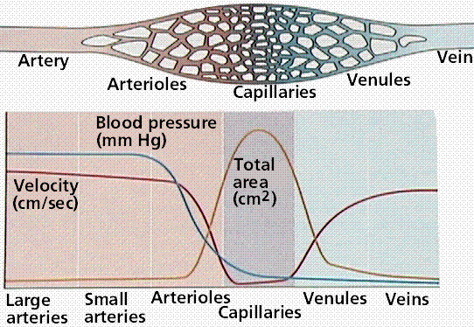

**Questions:**

Describe the changes in blood pressure as blood moves from arteries to veins

…………………………………………………………………………………………………………………………………………………………………………………………………………………………………………………………………………………………………………………………………………………………………………………………………………………………………………………………………………

……………………………………………………………………………………………………………………………………………………………………………………………………………………………………

Describe the changes in the speed of transport as blood moves from arteries to veins

……………………………………………………………………………………………………………………………………………………………………………………………………………………………………

……………………………………………………………………………………………………………………………………………………………………………………………………………………………………

……………………………………………………………………………………………………………………………………………………………………………………………………………………………………

Where is the total surface area the highest?

……………………………………………………………………………………………………………………………………………………………………………………………………………………………………

Explain the changes you have described

……………………………………………………………………………………………………………………………………………………………………………………………………………………………………

……………………………………………………………………………………………………………………………………………………………………………………………………………………………………

……………………………………………………………………………………………………………………………………………………………………………………………………………………………………

……………………………………………………………………………………………………………………………………………………………………………………………………………………………………

……………………………………………………………………………………………………………………………………………………………………………………………………………………………………

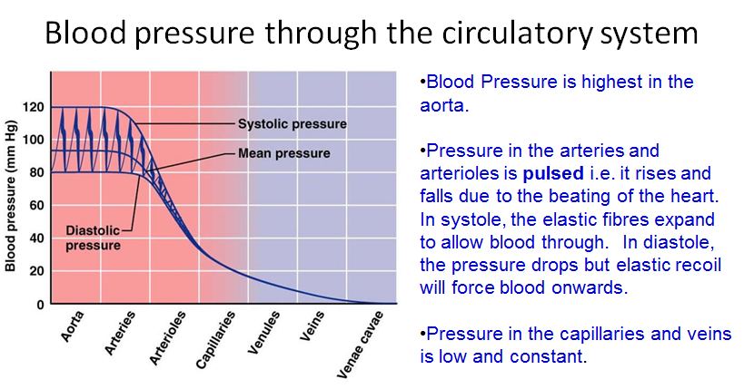

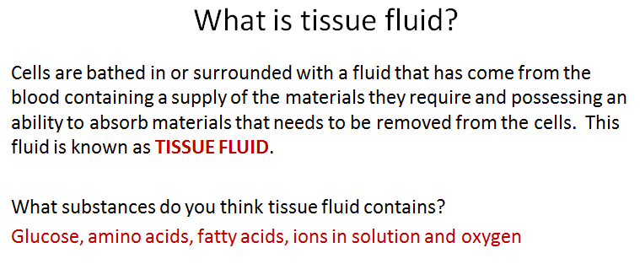

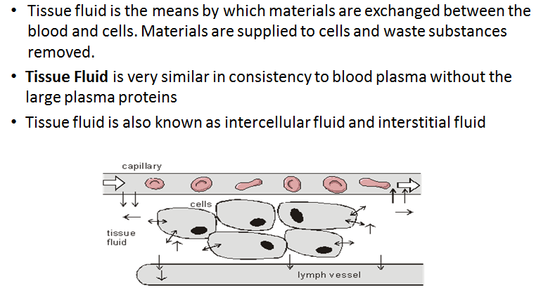

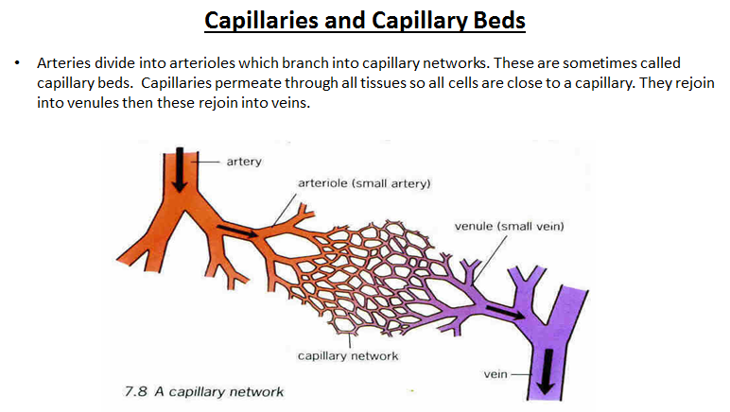

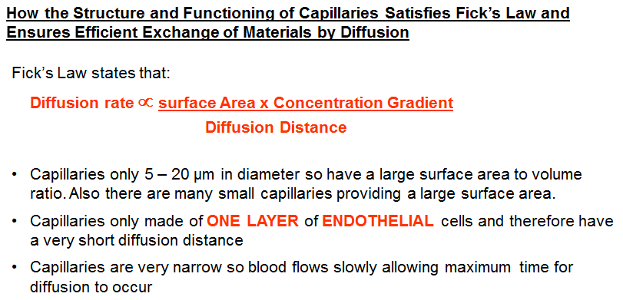

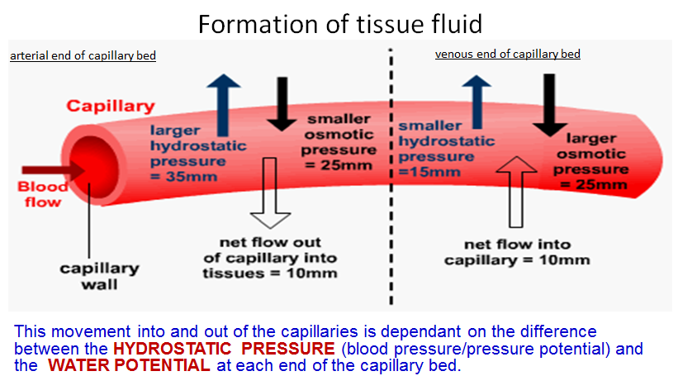

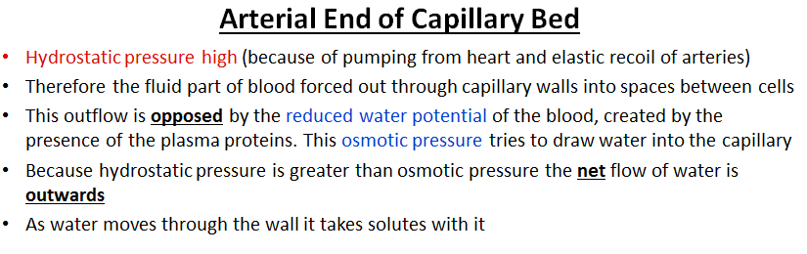

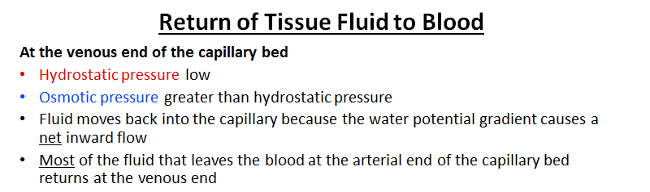

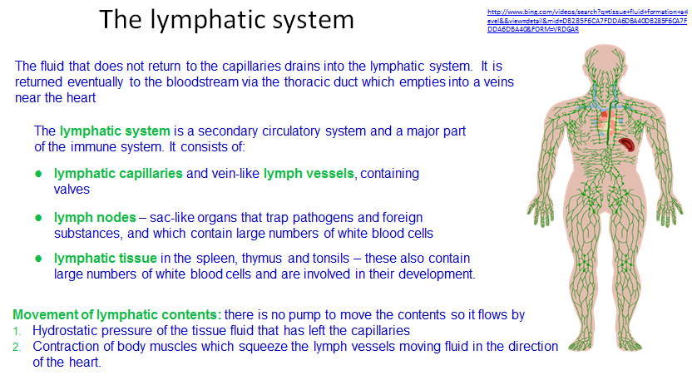

**Summary Questions**

1. State **one** advantage of having:
   1. Thick elastic tissue in the walls of the arteries

……………………………………………………………………………………………………………………………………………………………………………………………………………………

* 1. Relatively thick muscle walls in arterioles

……………………………………………………………………………………………………………………………………………………………………………………………………………………

* 1. Valves in veins

……………………………………………………………………………………………………………………………………………………………………………………………………………………

* 1. Only a lining layer in capillaries

……………………………………………………………………………………………………………………………………………………………………………………………………………………

|  |  |
| --- | --- |
| **Blood Vessel** | **Mean Wall Thickness/mm** |
| A | 1.000 |
| B | 000.1 |
| C | 2.000 |
| D | 0.500 |
| E | 0.030 |

1. Table 1 shows the mean wall thickness of different blood vessels in a mammal. Suggest the letter that is most likely to refer to **a.** the aorta, **b)** a capillary, **c)** a vein, **d)** an arteriole and **e)** the renal artery.

a

b

c

d

e

1. State what forces tissue fluid out of the blood plasma in capillaries and into the surrounding tissues.

……………………………………………………………………………………………………………………………………………………………………………………………………………………………..

1. List the **two** routes by which tissue fluid returns to the blood stream.

………………………………………………………………………………………………………………………………………………………………………………………………………………………………

**Risk factors associated with cardiovascular disease**

**Objectives:**

**To analyse the risks factors that could lead to cardiovascular diseases.**

**To evaluate conflicting evidence associated with risk factors affecting CVD**

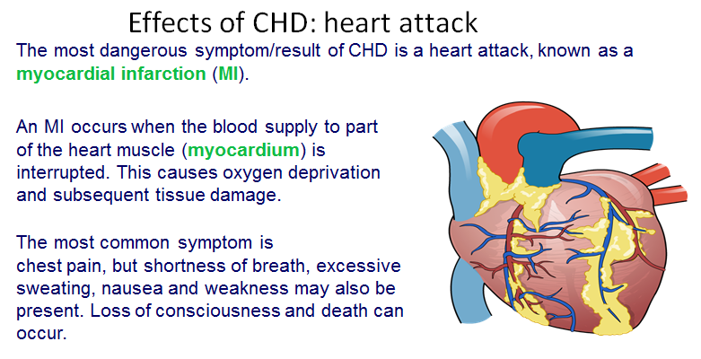

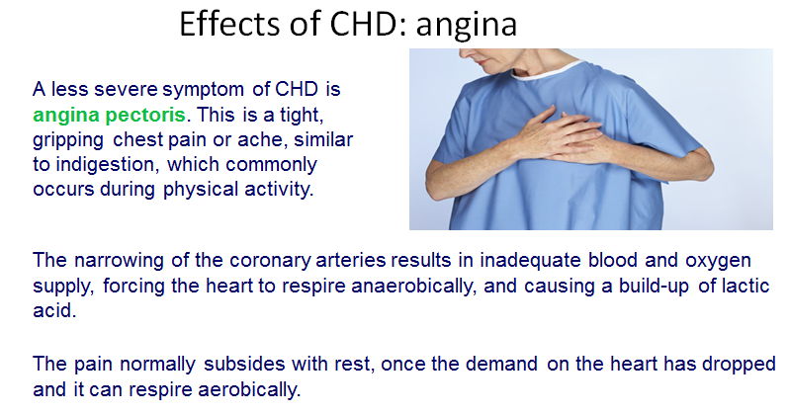

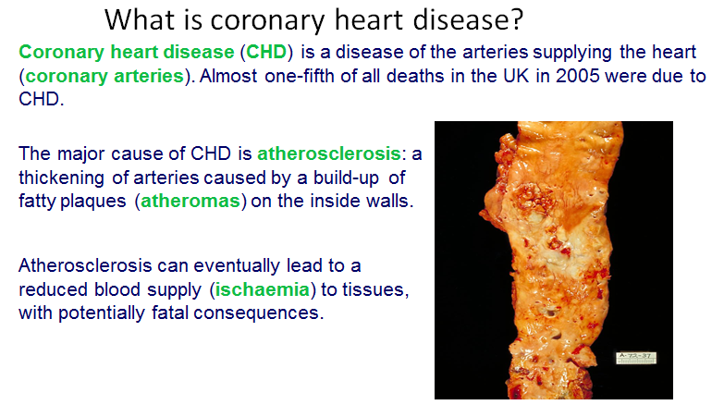

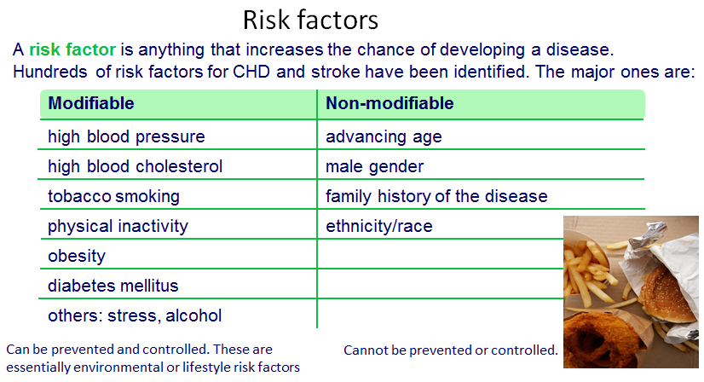

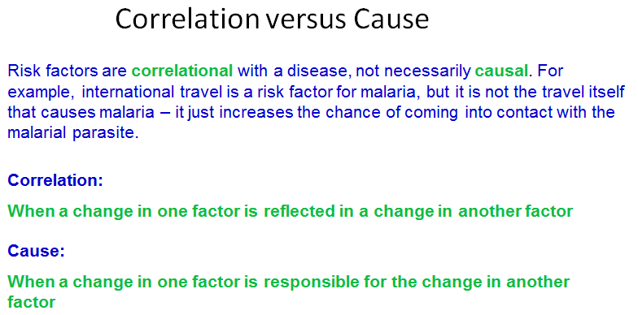

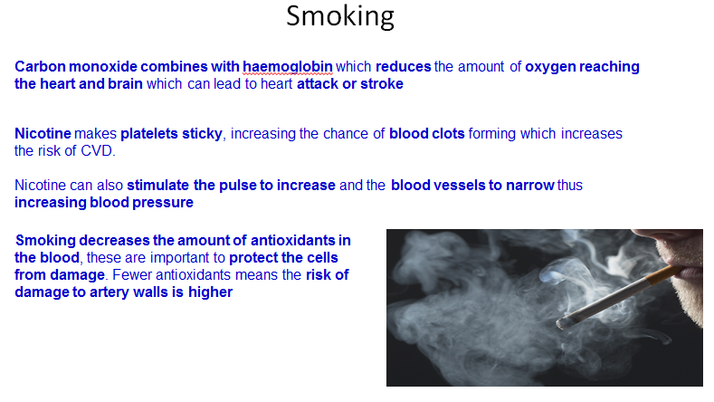

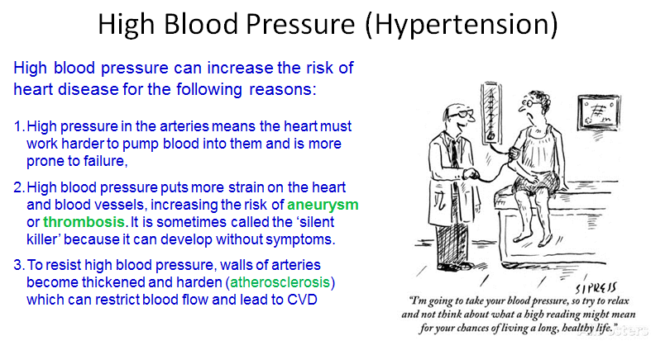

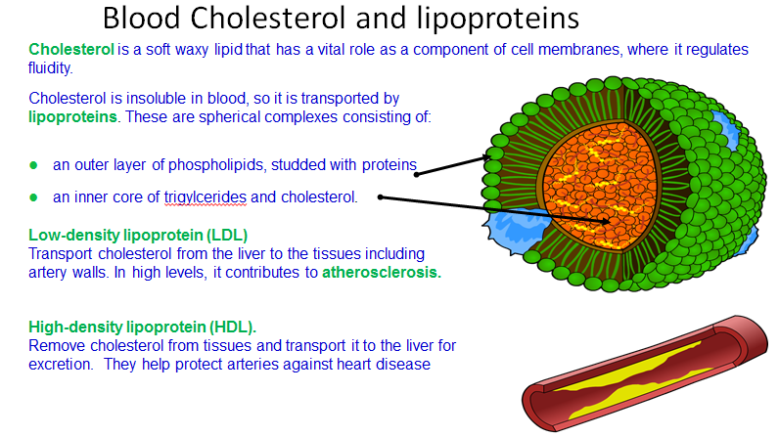

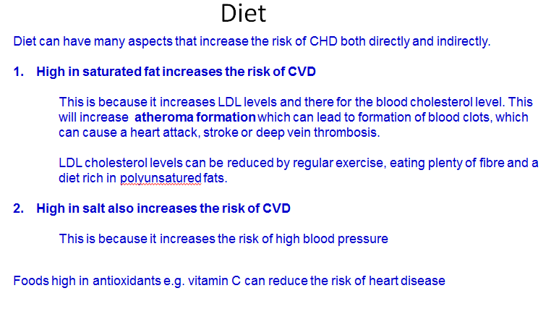

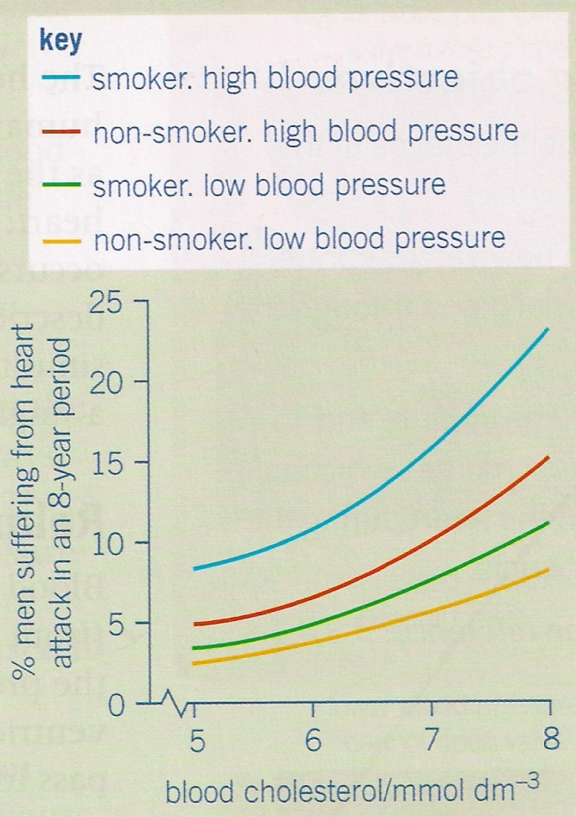**Question: Evaluating Risk**

1. A smoker with high blood pressure wishes to reduce his risk of heart attack. If he could only alter one factor, would he be better giving up smoking or reducing his blood pressure? Explain your answer.

................................................................................

................................................................................ ................................................................................

................................................................................

................................................................................

................................................................................

................................................................................

................................................................................

................................................................................

................................................................................

................................................................................

................................................................................

1. A non-smoker with high blood pressure has a blood cholesterol level of 5mmdol-3. Over a period of 3 years this concentration increases to 8mmoldm-3. Calculate how many times greater his risk of heart disease is. Show your working.

..................................................................................................................................................................................................................................................................

..................................................................................................................................................................................................................................................................

..................................................................................................................................................................................................................................................................

..................................................................................................................................................................................................................................................................

1. Two non-smoking men with low blood pressure both have a blood cholesterol level of 5mmdm-3. One of them starts to smoke and the blood cholesterol level of the other increases to 7 mmdm-3. State which man is now at the greater risk from heart disease. Explain your answer.

..................................................................................................................................................................................................................................................................

..................................................................................................................................................................................................................................................................

..................................................................................................................................................................................................................................................................

..................................................................................................................................................................................................................................................................

**Investigation: Does caffeine affect the heart rate of *Daphnia* (water fleas)**

**Background information**

**Caffeine**

Plants produce caffeine as an insecticide. Cocoa in South America, coffee in Africa and tea in Asia have all been used for hundreds of years to produce ‘pick me up’ drinks containing caffeine. These days, caffeine is also used as a flavour enhancer in a wide range of cola and other soft drinks. In addition, it has medicinal uses in aspirin preparations and is found in weight-loss drugs and as a stimulant in students’ exam-time favourites like Pro-plus and Red Bull.

In humans, caffeine acts as a stimulant drug, causing increased amounts of stimulatory neurotransmitters to be released. At high levels of consumption caffeine has been linked to restlessness, insomnia and anxiety, causing raised stress and blood pressure. This can lead to heart and circulation problems.

**Hypothesis:** ………………………………………………………………………………………………………………………………………………………………………………………………………………………………………………………………………………………………………

**Risk Assessment**

* **Heating due to the microscope lamp:** When working with organisms under a microscope, the effects of heating due to the microscope lamp itself can be significant. Turning the lamp on only when observing the Daphnia will help.
* Observe normal, good laboratory hygiene practices when completing the practical.
* Although they are simple organisms that may not 'suffer' in the same way as higher animals, they still deserve respect. Animals should be returned promptly to the holding tank after being examined.

**Equipment**

● Culture of *Daphnia* (water fleas)

● Cavity slides

● Dropping pipettes

● Distilled water

● Caffeine tablets

● Cotton wool

● Standard glassware (beakers, measuring cylinders, etc.)

● Stopclock

● Paper towels or filter paper

● Microscope

**Dependent variable:**

**Independent variable.**

**Control variables:**

**Preparation**

**a** Take a small piece of cotton wool, tease it out and place it in the middle of a small Petri dish.

**b** Select a large *Daphnia* and use a pipette to transfer it onto the cotton wool fibres.

**c** Immediately add pond water to the Petri dish until the animal is just covered by the water.

**d** Place the Petri dish on the stage of a microscope and observe the animal under low power. The beating heart is located on the dorsal side just above the gut and in front of the brood pouch (see diagram). Make sure that you are counting the heart beats, and not the flapping of the gills or movements of the gut. The heart must be observed with transmitted light if it is to be properly visible.

**e** Use a stopwatch to time 15 seconds, and count the number of heart beats in 4 periods of 20 seconds. The heartbeat of *Daphnia* is very rapid, so count the beats by tapping a pencil on the bench for each heart beat while your partner counts the taps.

**f** At the end of the investigation, return the *Daphnia* to the stock culture.

Take a large *Daphnia* from the stock culture and record its heart beat at room temperature in pond water (as in step **e**).

**l** Add one drop of 1% ethanol to 5 cm3 of pond water in a beaker. Mix well. Draw the pond water off the *Daphnia* with a pipette and replace it with 2 or 3 cm3 of the water containing ethanol (**Note 3**). Record the rate of heart beat again.

**m** Repeat step **l** using 10% ethanol in place of 1%.

**n** Repeat with other chemicals such as acetylcholine, L-adrenaline (epinephrine), caffeine or aspirin (**Note 4**).

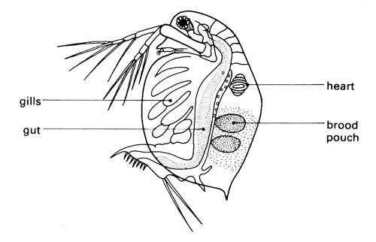

**Results**

Put your results into the table below. There will be considerable variation in the data gathered. Add the class results to the table then calculate mean results.

|  |  |  |
| --- | --- | --- |
| Treatment | Number of beats per 15 seconds | Mean number of beats |
|  |  |  |
|  |  |  |

Analysis

Write a conclusion and evaluation for your results. You must include the following:

* Identify any pattern or trend in the results – quote data that shows any pattern
* Explain any pattern or trends using biological knowledge
* Identify if your results support your hypothesis or not.
* Explain where there may have been errors in this experiment and suggest alternative methods to combat these errors.

Risk Factors and Cardiovascular Disease.

A calculated risk

Study the graph that shows the effect of three risk factors on the chance of heart attack in American men. Answer the questions below:

1. A smoker with high blood pressure wished to reduce his risk of heart attack. If he could only alter one factor, would he be better giving up smoking or reducing his blood pressure? Explain your answer

..................................................................................................................................................................................................................................................................................................................................................................................................................................................................................................................................................................................................................................................................................................................................................................................................................................................................

1. A non-smoker with high blood pressure has a blood cholesterol level of 5mmol dm-3. Over a period of 3 years this concentration increases to 8mmol dm-3. Calculate how many times greater his risk of heart disease is. Show your working

..................................................................................................................................................................................................................................................................................................................................................................................................................................................................................................................................................................................................................................................................................................................................................................................................................................................................

1. Two non-=smoking men with low blood pressure both have a blood cholesterol level of 5mmol dm-3. One of them starts to smoke and the blood cholesterol level of the other increases to 7mmol dm-3. State which man is now at the greater risk from heart disease. Explain your answer.

..................................................................................................................................................................................................................................................................................................................................................................................................................................................................................................................................................................................................................................................................................................................................................................................................................................................................

**Haemoglobin and oxygen dissociation curves**

**Objectives:**

* **To describe the structure and function of haemoglobins and explain the differences between haemoglobins in different organisms including the properties of haemoglobins in relation to the ecology of the organism.**
* **To explain what loading and unloading of oxygen is in relation to the oxyhaemoglobin dissociation curve.**
* **To explain the effect of carbon dioxide on the concentration on the dissociation of oxyhaemoglobin.**

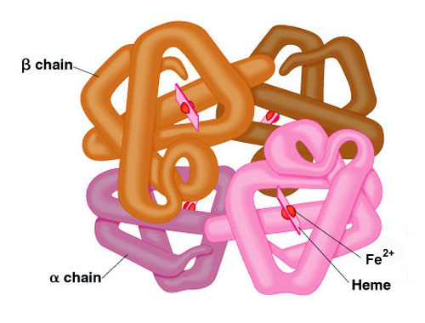

In the next part of the booklet you will find information about haemoglobin and oxygen dissociation curves, together with an assortment of questions on the topic.

Using the information in this booklet, presentation from Godalming online (used in your lessons) and your text book pages 150-155 (Pg 161-167 New Text Book) answer the questions in the following pages.

When you have finished go to page 162 in your text book and answer questions 1, 2 and 3

**Haemoglobin and Oxygen Dissociation Curves**

Haemoglobin is a protein that carries oxygen around the body.

Different species have different forms of haemoglobin, depending on where each species lives, and within a species there may be more than one version of the molecule.

Haemoglobin is found in all vertebrates as well as earthworms, starfish, some insects, some plants and even some bacteria. The red colour of haemoglobin comes from its iron content. Lobsters use a different oxygen carrying pigment called hemocyanin which uses copper instead of iron which gives them a blue colour, turning red when boiled as the copper oxidises.

Haemoglobin is a quaternary protein made of 4 polypeptide chains, each chain containing iron. The molecule has a high affinity for oxygen (this means it likes to combine with oxygen molecules), and each molecule can carry 4 oxygen molecules:

Hb + 4O2 = HbO8

Haemoglobin + oxygen = oxyhaemoglobin

This is a reversible reaction. Oxyhaemoglobin is formed in the lungs, then when oxygen dissociates (leaves) haemoglobin in the body tissues it turns back to haemoglobin.

Partial Pressure of O2: The partial pressure of oxygen (pO2) is a measure of oxygen concentration. pO2 will be high in the lungs, and lower in body tissues such as muscle.

Haemoglobin's affinity for oxygen depends on the pO2. Oxygen combines with haemoglobin to for oxyhaemoglobin where there's a high pO2, and oxyhaemoglobin breaks down to haemoglobin and oxygen where there's a lower pO2.

This means haemoglobin picks up oxygen in the lungs (high pO2) and delivers oxygen to respiring tissues where pO2 is lower as cells use up oxygen.

**QUESTIONS**

1. Haemoglobin is a protein with a quaternary structure. Explain what this means.

………………………………………………………………………………………………………………………………………………………………………………………………………………………………………………………………………………………………………………………………………………………

2. How many oxygen molecules can each molecule carry?

…………………………………………………………………………………………………………………

3. Where in the body would you find a lower partial pressure of oxygen?

…………………………………………………………………………………………………………………

4. The blood system carries the red cells through the pulmonary vein, to the heart and out through arteries and arterioles to the tissues where oxygen is finally unloaded. Explain why the haemoglobin does not unload its oxygen until it reaches the capillaries in the tissues.

………………………………………………………………………………………………………………………………………………………………………………………………………………………………………………………………………………………………………………………………………………………

………………………………………………………………………………………………………………………………………………………………………………………………………………………………………………………………………………………………………………………………………………………

**Oxygen Dissociation Curves**

These show how saturated with oxygen the haemoglobin is at any given pO2.

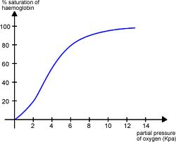

The graph is S-shaped because when haemoglobin combines with the first oxygen molecule it changes shape in a way that makes it easier for other oxygen molecules to join. However, as the molecule adds more oxygen to it (becomes more saturated) it then gets harder for more oxygen molecules to join. This means the curve has a steep part in the middle, where it's easy for oxygen to combine, and shallow parts at each end where it's harder for oxygen to combine.

When the curve is steep a small change in pO2 causes a big change in the amount of O2 carried.

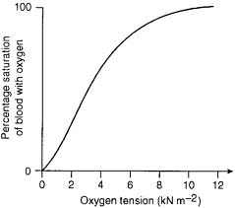

**Question**

The graph on the previous page shows the oxygen dissociation curve for human Hb. On the graph sketch the curves you would expect for an earthworm (lives in low oxygen environment). Explain the position of your curve.

**The Effect of Carbon Dioxide**

To complicate matters the CO2 concentration also affect how haemoglobin functions!

Haemoglobin gives up its oxygen more readily at high partial pressure of CO2 (pCO2). This enables more oxygen to get to cells that are respiring at a high rate.

When cells respire they produce CO2, therefore increasing pCO2

This increases the rate of oxygen dissociation and the dissociation curves 'shift' to the right.

This means the saturation of blood with O2 at a given pO2 is lower because more oxygen is being released.

We call this the Bohr effect.

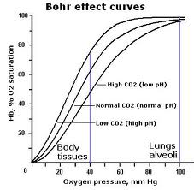

**QUESTION:**

You can see from the above graph there is also a reference to pH.

Explain this in terms of how CO2 levels affect the pH of the blood.

………………………………………………………………………………………………………………………………………………………………………………………………………………………………………………………………………………………………………………………………………………………

………………………………………………………………………………………………………………………………………………………………………………………………………………………………………………………………………………………………………………………………………………………

**Foetal Haemoglobin:**

Foetal haemoglobin has a higher affinity for oxygen than maternal haemoglobin, so the oxygen dissociation curve for foetal haemoglobin is to the left of the maternal one. This means maternal haemoglobin will dissociate itself in the placenta and the foetal haemoglobin will load with oxygen.

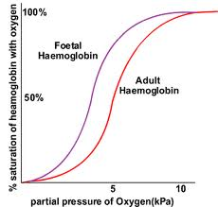

**QUESTION**

**Explain why it is essential for the survival of the foetus that the foetal curve is to the left of the maternal curve.**

………………………………………………………………………………………………………………………………………………………………………………………………………………………………………………………………………………………………………………………………………………………

………………………………………………………………………………………………………………………………………………………………………………………………………………………………………………………………………………………………………………………………………………………

**.........and other species:**

Organisms that live in low oxygen environments have haemoglobin with a higher affinity for O2 than human haemoglobin. The dissociation curve is to the left of ours.

Organisms that are very active (high respiration rate) have a high oxygen demand and haemoglobin with a lower affinity for oxygen than human haemoglobin. Their curve lies to the right of ours.

Now, sketch an oxygen dissociation curve and draw lines to represent the following:

Human Hb llama Hb lugworm Hb hawk Hb

*Hint: you first need to consider O2 concentration and respiratory needs of each animal and its environment.*

**Finally.....**

Describe how the transport and unloading of oxygen occurs in humans. Include in your answer a description of the mechanism of the Bohr effect. (this answer carries 6 marks)

………………………………………………………………………………………………………………………………………………………………………………………………………………………………………………………………………………………………………………………………………………………

………………………………………………………………………………………………………………………………………………………………………………………………………………………………………………………………………………………………………………………………………………………

………………………………………………………………………………………………………………………………………………………………………………………………………………………………………………………………………………………………………………………………………………………

Now work through the questions from your text book.

( page 162 questions 1, 2 and 3)