Name: ………………………………..

**3.3.4.1 Mass Transport in Plants**

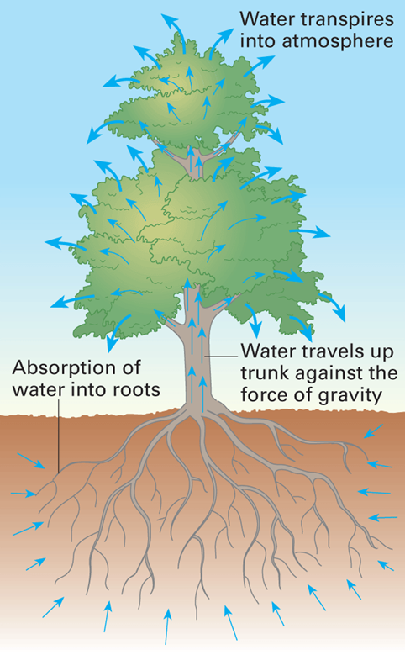**Specification Content**

Xylem as the tissue that transports water in the stem and leaves of plants. The cohesion-tension theory of water transport in the xylem.

Phloem as the tissue that transports organic substances in plants. The mass flow hypothesis for the mechanism of translocation in plants. The use of tracers and ringing experiments to investigate transport in plants.

Students should be able to:

* recognise correlations and causal relationships
* Interpret evidence from tracer and ringing experiments and to evaluate the evidence for and against the mass flow hypothesis.

.

**What you should know from GCSE**

Structure of the leaf

Transpiration and factors affecting transpiration

**Synoptic topics linked to mass transport in plants:**

Transport across membranes

Properties of water

Gas exchange in plants

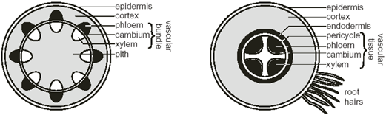

**References**

Make sure you spend time consolidating work done in lessons by reading back through your booklet and reading text books and other references linked to this topic

**Transport of water in plants**

**Objectives:**

**To know the structure of a xylem vessel and how this enables transport of water in a plant.**

**To explain in terms of water potential and osmosis how water moves through the leaf.**

**To explain in terms of the properties of water, how water moves up the xylem (cohesion-tension theory).**

Diffusion is too slow to supply the needs of multicellular plants so a mass flow system is needed but unlike animals there is no pump. Plants have evolved two distinct systems of tubes:

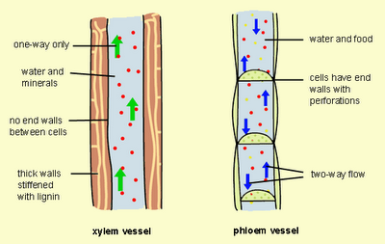

**xylem** to transport ­­­­­­­­­­­­­____________________________________

**phloem** to transport ___________________________________

Transport of Water

Vast amounts of water pass through plants. A large tree can use water at a rate of 1 dm³ min-1. Only 1% of this water is used by the plant cells for photosynthesis and turgor, and the remaining 99% evaporates from the leaves and is lost to the atmosphere. This evaporation from leaves is called transpiration. 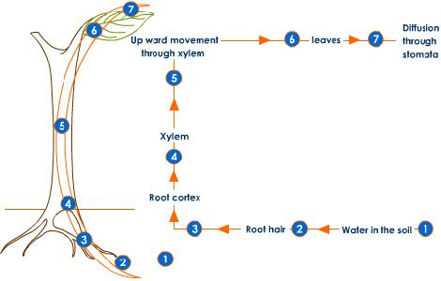

The movement of water through a plant can be split into sections:

* + Movement of water out through the stomata
  + Movement of water across the cells of a leaf
  + Movement of water up the stem in the xylem
  + (Movement of water into the roots)

**Movement of water out through the stomata**

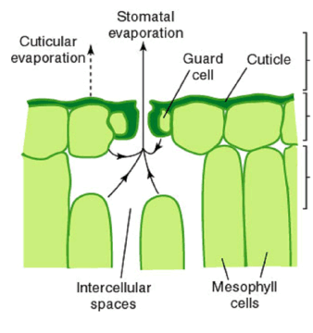

* Water will evaporate out of the stomata if the humidity of the atmosphere is lower than that of the air spaces next to the stomata
* As a result there is a water potential gradient from the air spaces through the stomata to the air.
* Water vapour diffuses out of the air spaces into the air (if stomata are open)
* The water that is lost is replaced with water that diffuses from the cell walls of the surrounding mesophyll cells.
* The rate of transpiration is controlled changing the size of the stomata.

Movement of water out through stomata

**Diffuses changing Walls**

**lower mesophyll cells evaporates**

Water will _________ out of stomata if the humidity of the atmosphere is ___________ than that of the air spaces next to the stomata. The water that is lost is replaced with water that _______________________ from the cell walls of the surrounding ______________________ __________. Rate of transpiration can be controlled by ____________ the size of the stomata.

(Remember what we covered in unit 3.3.2 gas exchange to explain how guard cells open and close stomata)

**Movement of water across the cells of a leaf**

* Water is lost from mesophyll cells by evaporation from their cell walls into air spaces.
* This is replaced by water coming from xylem either via cell walls or cytoplasm.

Cytoplasmic route

* + Mesophyll cells lose water but evaporation due to heat from the sun
  + The cells now have a lower water potential so water enters via osmosis from neighbouring cells
  + The loss of water from the cells lowers their water potential
  + They in turn take water from neighbouring cells by osmosis.

This water potential gradient pulls water from the xylem across the leaf mesophyll and into the atmosphere

**Movement of water from the xylem and across the cells of a leaf.**

The main force that pulls water up a stem is evaporation of water from the leaves –called transpiration.

Water can move into the air spaces of a leaf by either the apoplastic or symplastic pathways.

Put the following alphabetically arranged statements in order showing how water moves into air spaces from the cytoplasmic route pathway.

|  |  |
| --- | --- |
| A = | These cells now have a lower water potential and so water enters by osmosis from neighbouring cells |
| B = | They, in turn, take in water from their neighbours by osmosis. |
| C = | Mesophyll cells lose water to the air spaces. |
| D = | The loss of water from these neighbouring cells lowers their water potential. |

This means that water is **PULLED** from the xylem, across the leaf mesophyll, and finally out into the atmosphere.

**Movement of water up the stem in the xylem**

**Structure of Xylem Vessels**

Xylem is composed of dead cells that are joined together to form long narrow tubes.

The walls of the tubes become thickened with lignin to allow them to withstand the strong pressures that occur in water transport.

As lignin is impermeable materials cannot pass into xylem cells and so the protoplasm dies leaving a hollow tube.

Xylem is found in the root, the stem and the leaves. Its distribution gives valuable mechanical support.

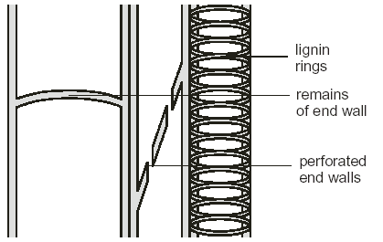In the stem it is located in peripheral vascular bundles for flexible support, in the leaves the arrangement of vascular tissues are in the midrib and veins and in the roots the central arrangement helps to anchor the plant

**Cohesion-Tension Theory**

Water moves up the xylem because of Cohesion-Tension theory.

Put the following alphabetical statements that explain the cohesion – tension theory in order.

|  |  |
| --- | --- |
| A= | Water is hence pulled up the xylem as a result of transpiration. This is known as transpirational pull. |
| B = | As water evaporates from the mesophyll cells in the leaf into the air spaces beneath the stomata, more molecules of water are drawn up behind it as a result of this cohesion. |
| C = | Water forms a continuous, unbroken pathway across the mesophyll cells and down the xylem. |
| D = | Transpiration pull puts the xylem under tension, i.e. there is an upwards force, hence the name cohesion-tension theory. |
| E = | Water molecules are polar and so form hydrogen bonds between the hydrogen atom of one molecule of water and an oxygen atom of another molecule of water. The water molecules are attracted to each other. This is known as cohesion. |
| F = | Water evaporates from leaves as a result of transpiration. |
| G = | Water molecules stick to the inside of the xylem vessel. This is known as adhesion |

Describe three pieces of evidence that support the cohesion – tension theory.



**Movement of water into the roots**

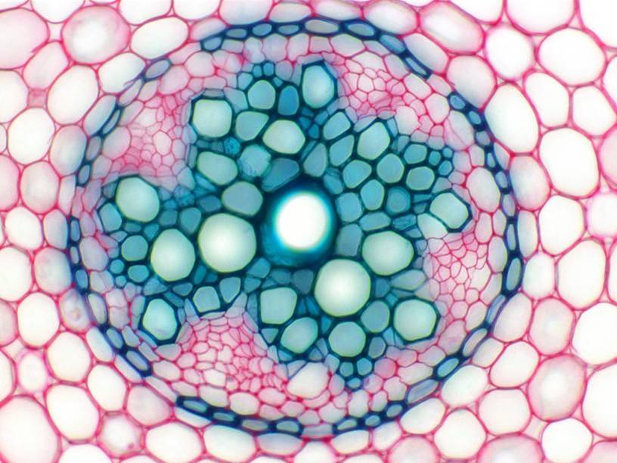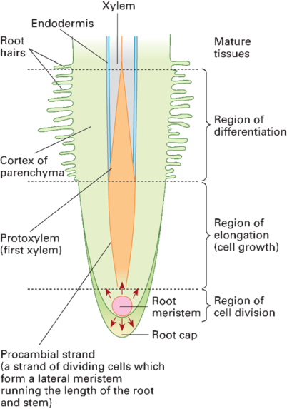

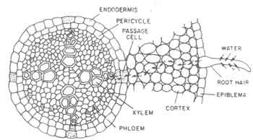

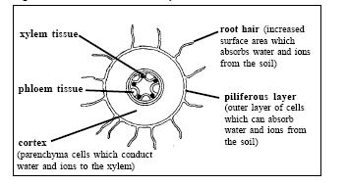

Plants must absorb enough water to replace transpiration losses.

Root systems have evolved to maximise the ability to absorb water from the soil water.

Water absorption occurs mainly by root hairs which are cellular extensions of epidermal cells

**Water can travel through cells in various ways. 2 are outlined below**

1. **The cell wall pathway (apoplast route)- ......................................................................................**
2. **The cytoplasmic pathway (symplast route) - .............................................................................**

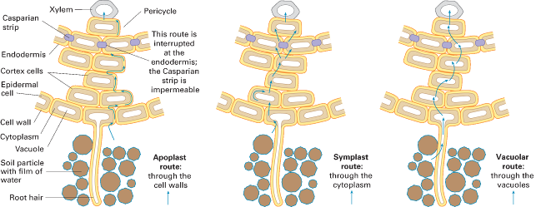

**Independent to work to consolidate the theories for the movement of water in plants.**

Look at the website

<http://www.tutorvista.com/content/biology/biology-iv/plant-water-relations/ascent-sap-theories.php>

**Read through the information on physical theories and answer the following questions.**

1. Which process do both the porous pot and plant carry out?

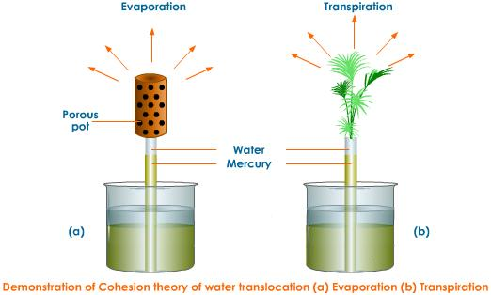

1. What happens to the water potential of the cell sap when water is evaporated from the cell?
2. What is the force that exists between water molecules?
3. What is the force that exists between the walls of xylem vessels and water?
4. By what term is the narrow thread of water in a xylem vessel known as?
5. When transpiration pull lifts the water in the xylem what is said to develop?
6. What pressure develops in the xylem vessels?
7. A break in a water column would prevent water from reaching the top of a plant why do you think there are pits in the xylem vessels?

**Summary of movement of water up a stem**

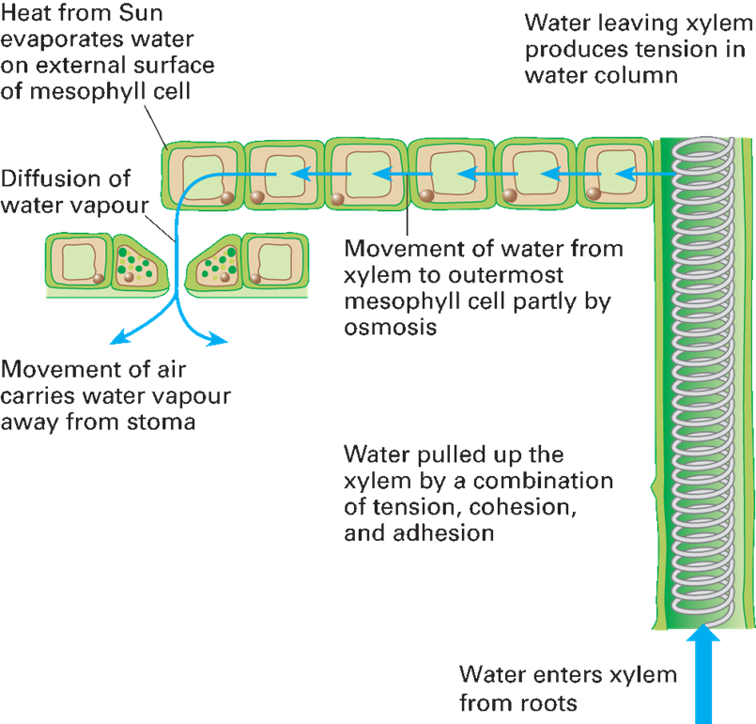

**Investigating transpiration**

**Objectives:**

To set up a potometer in order to measure the rate of transpiration.

To analyse the rate of transpiration of a plant in different environmental conditions and to calculate the volume of water taken up by the plants.

**The Potometer – used for measuring the rate of transpiration**

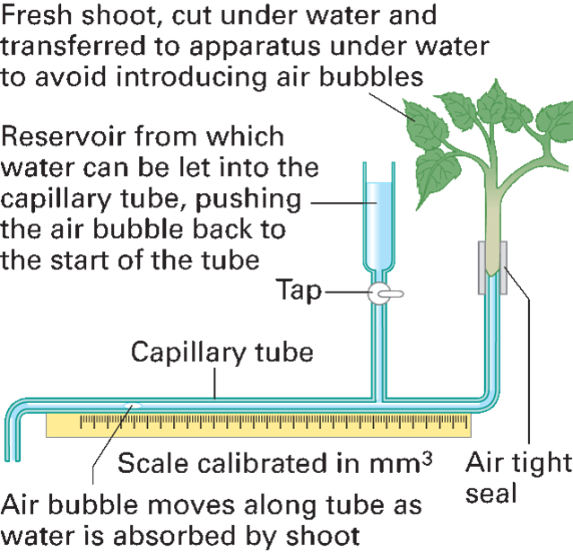

What is the purpose of the reservoir?

Why is the plant put under water for cutting and fitting into the potometer tubing?

How could this apparatus be used to measure the transpiration rate in mm³ min‾1?

Consolidation work – Questions on Pg. 199 of AQA Biology text book, (Pg. 186 new text book)

**Transport of organic substances in the phloem.**

**Objectives:**

To describe the mass flow mechanism for the transport of organic substances in the phloem.

To describe the use of ringing and tracer experiments to investigate transport in plants

To explain the evidence that translocation or organic molecules occurs in the phloem.

Sugar transport in plants

**Structure and function of Phloem**

* The phloem contains a very concentrated solution of dissolved solutes, mainly **sucrose**, but also other sugars, amino acids, and other metabolites. This solution is called the sap, and the transport of solutes in the phloem is called **translocation**, which occurs by **Mass Flow**, the bulk movement of substances through the phloem vessels.

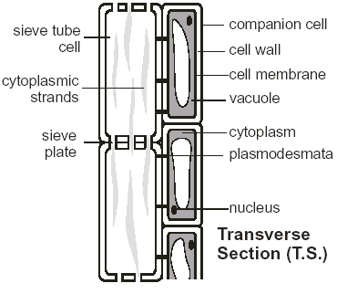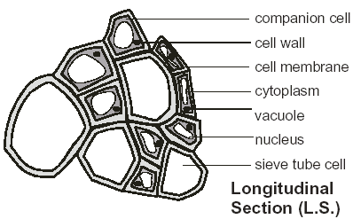

## What is Phloem tissue?

sieve tubes sieve plates elongated living nucleus plasmodesmata

pores companion cells mitochondria

Phloem is a ________________________ tissue consisting of several types of cell. The main ones are ___________________ ____________ and __________________________ __________. The sieve tubes are _____________________ and their ends are perforated with

________________. These areas are called _____________ ____________. Cytoplasmic filaments containing phloem protein extend from one sieve cell to the next through the sieve plates. The sieve tubes do not possess a _________________. Each sieve tube is connected to a companion cell by numerous ____________________________. Companion cells have many

______________________ used for active transport of sucrose into the phloem.

**Mass flow theory**

* The rate of movement in the phloem is too fast to be explained by diffusion. Therefore there must be another mechanism to explain this.
* Currently **mass flow theory** is the favoured theory to explain this. It has 3 stages:
  1. Transfer of sucrose into sieve elements from photosynthesising tissues
  2. Mass flow of sucrose through sieve tube elements
  3. Transfer of sucrose from the sieve tube elements into storage of other sink cells

**Transfer of sucrose into sieve elements from photosynthesising tissue**

* Sucrose is made from the products of photosynthesis in cells with chloroplasts
* Sucrose moves down a concentration gradient by facilitated diffusion into companion cells
* H+ ions are actively transported from companion cells into spaces within cell walls using ATP
* These H+ ions then diffuse down a concentration gradient through carrier proteins into the sieve tube
* Sucrose molecules are transported along with the H+ ions in a process called co-transport. The protein carriers are called co-transport proteins.

**Mass flow of sucrose through sieve tube elements**

Unlike the water in the xylem, the contents of the phloem can move both up or down a plant stem, often simultaneously (but not in the same sieve tube). The Mass Flow theory tries to explain how this is possible:

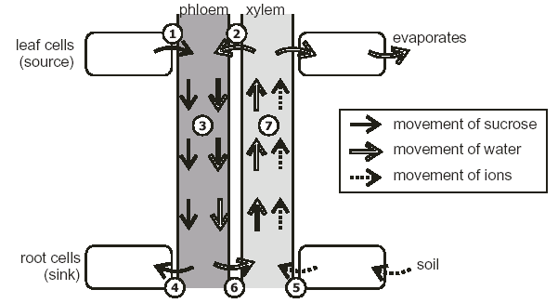

Areas in a plant where sucrose is loaded into the phloem are called a **source**. This is an active process. Areas where sucrose is removed from the phloem is called a **sink**.

An example of a source:

An example of a sink:

**Transfer of sucrose into sieve elements from photosynthesising tissue**

1. Sucrose is made from the products of photosynthesis in cells with chloroplasts
2. Sucrose moves down a concentration gradient by facilitated diffusion into companion cells
3. H+ ions are actively transported from companion cells into spaces within cell walls using ATP
4. These H+ ions then diffuse down a concentration gradient through carrier proteins into the sieve tube
5. Sucrose molecules are transported along with the H+ ions in a process called co-transport. The protein carriers are called co-transport proteins.

**Major steps in mass flow theory**

1. Active transport of …………….. (sucrose) at the source into sieve tubes (as previous slide)
2. Causes the water potential of sieve tube to become …………………………….
3. Xylem has much …………….. water potential so water follows by osmosis creating a high ……………………….
4. At sink cells, sucrose is either …………….. (respiration) or converted to ……………..
5. These cells have …………….. content so sucrose is ………………………… into them from sieve tubes …………….. the water potential.
6. Due to low water potential, water moves into these sink cells by osmosis
7. Hydrostatic pressure in this part of sieve tubes is ……………..
8. This leaves ……………..hydrostatic pressure in source area of phloem and …………….. at sink area
9. There is a ………………………of sucrose down the hydrostatic gradient in the sieve tubes (phloem)

#### Translocation experiments

Evidence for this theory was first obtained from ringing experiments.

**Ringing experiments**

* + Since the phloem vessels are outside the xylem vessels, they can be selectively removed by cutting a ring in a stem just deep enough to cut the phloem but not the xylem.

Describe what happens in this experiment. How does this support the theory that sugars are transported in the phloem

**Method:**

........................................................................................................................................................................................................................................................................................................................

**Results:**

........................................................................................................................................................................................................................................................................................................................

**Conclusions:**

........................................................................................................................................................................................................................................................................................................................

........................................................................................................................................................................................................................................................................................................................

**Using Radioactive tracers**

* Radioactive isotopes can be used trace precisely where different compounds are being transported from and to, as well as measuring the rate of transport. The radioactivity can be traced using photographic film (an autoradiograph). This techniques can be used to trace sugars, ions or even water.
* In a typical experiment a plant is grown in the lab and one leaf is exposed for a short time to carbon dioxide containing the radioactive isotope 14C. This 14CO2 will be taken up by photosynthesis and the 14C incorporated into glucose and then sucrose.



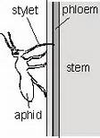The mass flow hypothesis suggests there is a passive flow of sucrose from source to sink

**Additional Evidence**

1. When phloem is cut, a solution of organic molecules flows out.
2. Aphids have needle like mouthparts which penetrate the phloem. They can extract contents of sieve tubes. These contents show daily variations in the sucrose content of leaves that are mirrored a little later by identical changes in the sucrose content of the phloem

**Table showing the evidence for and against mass flow theory.**

|  |  |
| --- | --- |
| **Evidence supporting mass flow theory** | **Evidence questioning mass flow theory** |
| There is pressure within sieve tubes, as shown by say being released when they are cut | The function of sieve plates in unclear, as they would seem to hinder mass flow (suggestions are they may have a structural function helping to prevent bursting) |
| The concentration of sucrose is higher in leaves (source) | Not all solute move at the same speed – they should do so if movement is by mass flow |
| Downward flow in the phloem occurs in daylight, but ceases when leaves are shaded, or at night | Sucrose is delivered at more of less the same rate to all regions, rather than going more quickly to the ones with the lowest sucrose concentration, which the mass flow theory suggests |
| Increases in sucrose levels in the leaf are followed by similar increases in sucrose levels in the phloem a little later |  |
| Metabolic poisons are/or lack of oxygen inhibit translocation of sucrose in the phloem |  |
| Companion cells possess many mitochondria and readily produce ATP |  |