**Staining of root tip meristems to see mitosis**

**Learning objectives**

1. To develop practical skills **d, e, f** and begin to demonstrate **competencies 1a, 3a and 4a**
2. To prepare stained squashes of cells from plant root tips
3. To set up and use an optical microscope to identify the stages of mitosis in these stained squashes.
4. To calculation of a mitotic index

During cell division chromosomes condense and, provided they are suitable stained, become visible under a light microscope. Various stains are available, which react with either the DNA or protein in the chromosomes.

The two stains most commonly used are *toluidine blue* and *orcein*, both of which are low hazard. Toluidine blue is used in a simple and low hazard aqueous solution, whereas corrosive carboxylic acids (acetic or proprionic) are required for the orcein stain to adhere to the chromosomes.

Even though its use is more hazardous, orcein is often used in preference to toluidine blue, because the stain produces greater definition of chromosome structure. This can be seen below.

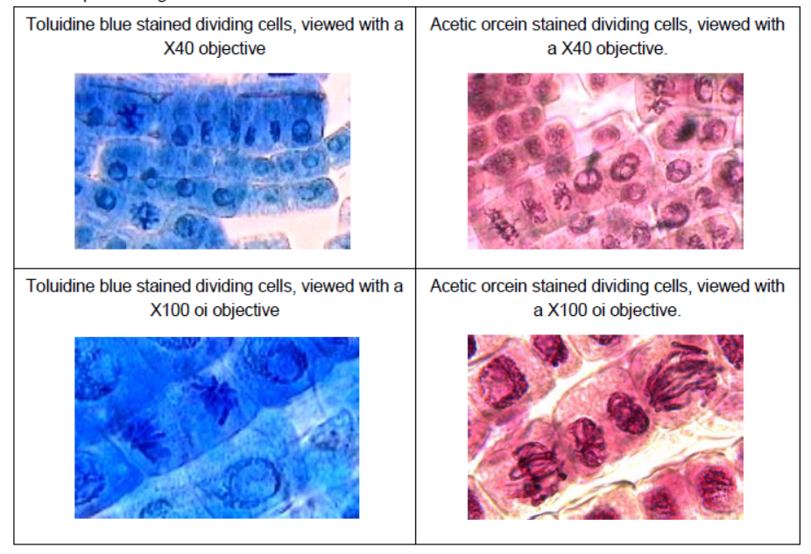

**Growing the roots**

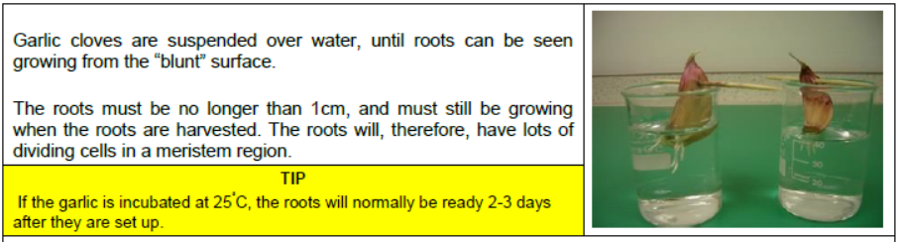The meristem cells need to be actively dividing when the roots are harvested for staining. Fixing the roots in Farmer’s solution is not necessary if the roots have been growing for the correct time period when they are harvested for staining.

**You are provided with the following:**

|  |  |
| --- | --- |
| * garlic clove which has been growing for 3 days | * a small bottle (universal bottle) |
| * a small bottle containing hydrochloric acid (1M) | * scissors |
| * a stoppered bottle containing acetic/proprionic orcein stain | * forceps |
| * mounted needle | * microscope slide and cover slip |
| * filter paper/paper towels | * microscope and light source |
| * distilled water |  |

You are required to prepare a microscope slide of the meristem tissue from a garlic clove. You will add a stain to the material which allows you to see the chromosomes. You will look at the slide under the microscope to identify any cells showing stages of mitosis. You will then calculate the mitotic index.

**Treatment of the plant root cell walls with acid**

1. Fill a small bottle (e.g. a universal bottle) with 1M hydrochloric acid, and place it in a thermostatically controlled water bath set **at 55°C.** Leave the bottle for 15 minutes, so that the acid warms to the temperature of the water bath (this will have been done for you).
2. 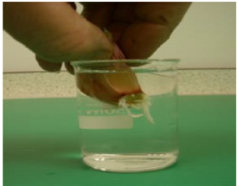Place a garlic clove in the bottle, so that the roots are submerged in the 55°C hydrochloric acid. (The hydrochloric acid breaks down the calcium pectate between the roots allowing the stain to penetrate.) Leave the roots in the acid for 5 minutes.
3. When the garlic clove has been in the 55°C hydrochloric acid for 5 minutes, take it out and replace the lid on the hydrochloric acid bottle and return to water bath. Rinse the roots thoroughly in tap water.
4. This can be done by either by rinsing under the tap, or as shown here by immersing the roots in a beaker of water.

**Staining the root tip cells**

1. 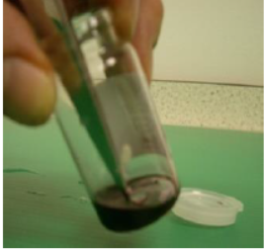Use a pair of sharp scissors on the garlic clove to cut off the root tips (5-10 mm at the pointed end) so they fall, or can be placed, in the vial of acetic orcein.
2. Use the scissors to make sure that the root tips are immersed in the stain. Then place the lid on the vial.
3. Place the acetic orcein vial in the 55oC waterbath for 5 minutes.

**TIP :** Placing the vial in a shallow layer of water in a large beaker in the water bath means that the vial stays upright.

1. After the root tips have been in the stain for 5 minutes, use forceps to take them out of the vial, and place them on a microscope slide.

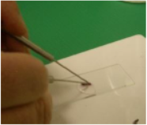**Squashing the stained root tip**

1. Add a drop of water to the root tip on the slide
2. Tease the root tip with needles, to spread out the cells.
3. Place a cover slip over the root tip.

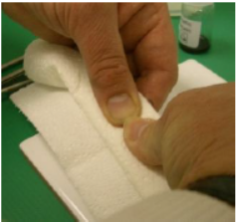

1. Wrap the slide in several layers of a thick paper towel
2. Use your thumbs to gently press on the slide and cover slip through the paper towel.

1. 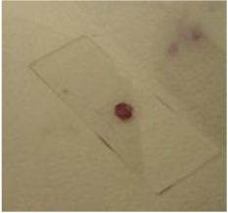You should be just able to feel the glass through the towel.
2. The finished root tip squash

**Viewing the stained meristem cells under the microscope**

1. Place the slide onto the stage of the microscope, and view the slide.
2. With the x10 objective lens in place, find some meristem cells (inside the black oval in this picture) , and place them in the centre of the field of view

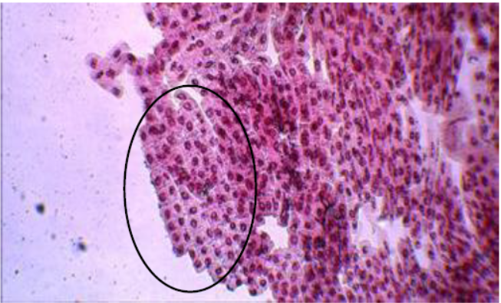

**TIP:** Meristem cells are small and square, have no obvious vacuoles and are usually found in rows. The nucleus will be in the middle of the cell.

1. With the x40 objective in place, find the meristem cells looking for threadlike chromosomes

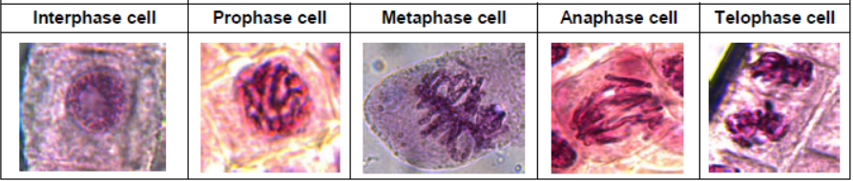

1. Produce scientific drawings of cells at each stage of mitosis you observe. Annotate your drawings.
2. Calculate the mitotic index.

Mitotic index = Number of cells in stages of mitosis (ie not interphase) ÷ total number of cells

Risk Assessment

For this practical you must perform a risk assessment. It provides a useful opportunity to:

* + identify any significant hazards associated with the practical activity
  + suggest appropriate and reasonable measures required to reduce risk to an acceptable level

|  |  |  |
| --- | --- | --- |
| Hazard | Risk associated with Hazard | Method to reduce risk |
| 1. |  |  |
| 2. |  |  |
| 3. |  |  |

|  |  |
| --- | --- |
| Competencies demonstrated | |
| 1. Follows written procedures | a. Correctly follows instructions to carry out experimental techniques or procedures. |
| 3. Safely uses a range of practical equipment and materials | a. Identifies hazards and assesses risks associated with these hazards, making safety adjustments as necessary, when carrying out experimental techniques and procedures in the lab or field. |
| 4. Makes and records observations | a. Makes accurate observations relevant to the experimental or investigative procedure. |
|  | Apparatus and techniques |
| AT d | use of light microscope at high power and low power, including use of a graticule |
| AT e | produce scientific drawing from observation with annotations |
| AT f | use qualitative reagents to identify biological molecules |