**Investigation into the effect of a named variable on the permeability of cell-surface membranes**

**Learning objectives**

* To develop practical skills a, b, c, l and begin to demonstrate competencies 2b, 4b and 5b.
* To use a colorimeter to measure absorbance of light through different known concentrations of beetroot extract.
* To plot a graph of concentration of extract against absorbance.
* To use the graph to read concentration of extract for unknown samples.

**The effect of detergent concentration on the leakage of pigment from beetroot cells**

**Introduction**

Beetroot contains high concentrations of betalin. This is a purple pigment found inside the vacuoles of the cells. The pigment cannot move across undamaged plasma membranes. You will investigate the effect of detergent concentration on the amount of pigment leaking through beetroot plasma membranes.

In **Part 1** of the investigation, you will produce a set of standards and use a colorimeter to measure the absorbance of light through these. You will then plot a graph of concentration of extract against absorbance. In **Part 2** you will use the graph to read the concentration of extract produced when beetroot discs have been soaked in different concentrations of detergent.

**Method**

You are provided with:

* a bottle of stock solution of beetroot extract.
* five concentrations of detergent labelled 100%, 80%, 60%, 40%, 20%
* 10 discs cut from a beetroot stored in a beaker of water
* graduated pipettes or syringes
* test tubes
* bungs to fit some of the test tubes
* thermometer
* large beaker to use as a water bath
* stopwatch
* test-tube rack
* small beaker of water
* permanent marker pen
* sieve

**You should read these instructions carefully before you start work.**

**Part 1(a) Making the colour standards.**

1. Use the extract and water to prepare a series of six test tubes containing 5 cm3 of different concentrations of extract. The concentrations should be equally spaced and cover a range from pure water (0%) to pure extract (100%). These will be your colour standards.
2. Label these standards 0%, 20%, 40%, 60%, 80%, 100%.
3. Complete **Table 1** to show how you made the colour standards in **Part 1** of the investigation and the concentration of extract in each tube.

**Table 1**

|  |  |  |  |  |  |  |
| --- | --- | --- | --- | --- | --- | --- |
| Volume of beetroot  extract / cm3 |  |  |  |  |  |  |
| Volume of water / cm3 |  |  |  |  |  |  |
| Concentration of extract / % | 0 |  |  |  |  | 100 |
| Absorbance reading from colorimeter |  |  |  |  |  |  |

**Part 1(b) Using a colorimeter**

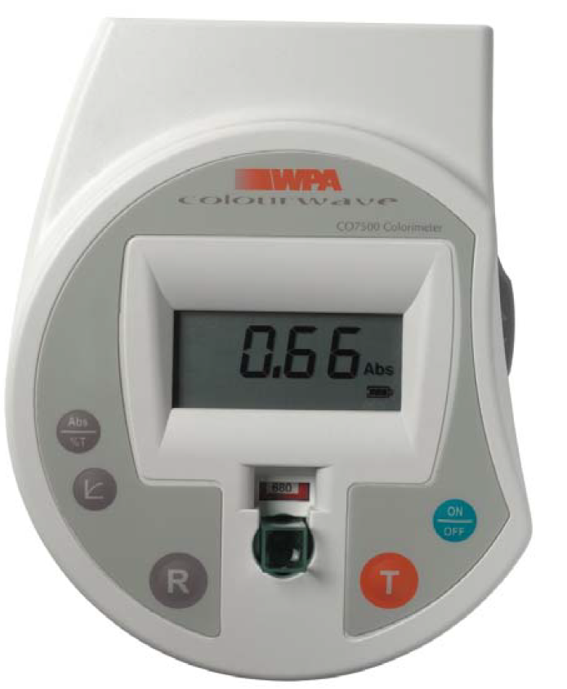

1. Switch the colorimeter on by pressing the on/off button.
2. Ensure the wavelength is set to 550.
3. Select Abs mode on display using the Abs/%T button.
4. Place a test tube containing only water in to the cuvette compartment of the colorimeter.

This is your reference sample.

1. Press and release the ‘R’ button to calibrate the colorimeter. The display will show 0.00Abs
2. Replace the reference test tube with the first of your colour standards.
3. Press and release the ‘T’ button.
4. The result is displayed in absorbance units (Abs)
5. Complete **Table 1 with** the absorbance reading of each of your standards.
6. Plot a graph of concentration of extract against absorbance. **(This can be completed at the end of the practical lesson)**

**Part 2 The Investigation**

1. With a second set of test tubes add 2 cm3 of 100% detergent to a test tube and put a bung in the tube.
2. Label the tube with the detergent concentration.
3. Repeat steps 14 and 15 with detergent concentrations of 80%, 60%, 40% and 20%.
4. Put the tubes of detergent in a 30 °C water bath until the temperature of the detergent reaches 30°C.
5. Remove the discs of beetroot from the beaker using a sieve.
6. Blot the 10 discs of beetroot with a paper towel to remove excess water.
7. Gently put two discs of beetroot in each of the five tubes. Replace the bungs as soon as possible after doing so.
8. Leave the tubes in the water bath for 5 minutes. Shake the tubes gently once every minute. Then remove the tubes from the water bath.
9. Immediately pour each solution into a clean test tube, being careful to label the tubes appropriately. Throw the beetroot discs away.
10. Measure the absorbance of each of your solutions with the colorimeter. Use the graph to read concentration of extract for each sample. Record your results in a suitable table.
11. **Write a paragraph to explain what you can conclude from this experiment. How did the concentration of detergent affect the absorbance readings and therefore the permeability of the cell membrane? Research other variables which would affect the permeability of cell-surface membranes. Cite your sources of information.**

|  |  |
| --- | --- |
| Competencies demonstrated | |
| 2. Applies investigative approaches and methods when using instruments and equipment | b. Carries out techniques or procedures methodically, in sequence and in combination, identifying practical issues and making adjustments when necessary. |
| 4. Makes and records observations | b. Obtains accurate, precise and sufficient data for experimental and investigative procedures and records this methodically using appropriate units and conventions. |
| 5. Researches, references and reports | b. Cites sources of information demonstrating that research has taken place, supporting planning and conclusions. |
|  | Apparatus and techniques |
| ATa | a. use appropriate apparatus to record a range of quantitative measurements |
| AT b | use appropriate instrumentation to record quantitative measurements |
| AT c | use laboratory glassware apparatus for a variety of experimental techniques |
| AT l | use ICT such as computer modelling, or data logger to collect data, or use software to process data |