**Use of chromatography to investigate the pigments isolated from leaves of different plants.**

**Learning objectives**

* To develop practical skills b and g to demonstrate competencies 1a, 2b and 5a.
* To carry out thin layer chromatography to separate photosynthetic pigments contained in two different type of leaves
* Calculate Rf values and compare to known values to identify different photosynthetic pigments

**Introduction**

The pigments in leaves absorb light energy and convert it to chemical energy. This energy is transferred to and trapped inside chemicals such as glucose and starch.

Several different pigments are involved in the absorption of light, the main one being chlorophyll a. This experiment shows how these pigments can be extracted from plants and then separated.

Chromatography is a method used to separate chemically similar substances. Once the separation is complete, a chromatogram is formed.

The distance that a pigment travels over the thin layer plate depends on two factors:

* 1. the solubility of that pigment in each of the chemicals in the solvent. The more soluble a pigment the greater the distance it will travel.
  2. the adsorption of the pigment to the thin layer plate. The more strongly a pigment is adsorbed to the silica of the plate the more slowly it will travel.

**Method**

**Materials required by each student/group:**

* 2 glass slides
* Either a piece of spider leaf with parallel veins or a piece of grass, approx 2x6cm
* 1 dropping bottle propanone/acetone
* 1 small watch glass or Fuji can lid
* 1 stirring rod
* gloves
* eye protection

**Materials to be shared**

* hair dryer

**Extraction of pigments**

1. Lay the piece of leaf on a slide.
2. Using a second slide gently scrape along the piece of leaf several times so that a dark green mush is formed at one end of the slide. (Keep the moving slide almost horizontal to the slide on the bench as this will reduce the chances of shredding the leaf.)
3. Add 5-6 drops of propanone to the green mush. Mix with a glass rod until the propanone is dark green.
4. Tilt the slide and allow the green extract to drip into the watch glass/film can lid.
5. Repeat steps 3 and 4 until you have about 20 drops of dark green extract.

WARNING: PROPANONE IS HIGHLY FLAMMABLE

1. Using a hair dryer remove all water and propanone from the extract in the watch glass by evaporation (2-3 minutes). The removal of all water is necessary to obtain good separation of the pigments.
2. Allow watch glass to cool to approximately 40oC. (so if just feels warm when you hold it)

CARE: TOO STRONG AN AIR CURRENT WILL BLOW THE MIXTURE AWAY

**Separation of the leaf pigments**

**Equipment and materials**

**Materials required by each student/group:**

* a TLC plate 66mm x 12mm
* a small glass bottle
* a rubber stopper for bottle with a slit about 3mm deep along its narrow end
* a capillary tube
* pencil
* ruler

**Materials to be shared**

* chromatography solvent (2 petroleum ether : 1 propanone)

WARNING: THIS SOLVENT IS HIGHLY FLAMMABLE

**Instructions**

1. With a pencil mark a line across the TLC strip 10mm from one end. Mark a pencil dot in the middle of this line
2. Now measure 45mm from this line and draw another pencil line across the TLC.
3. Add 2-3 drops of propanone to the dry plant pigments in the watch glass and mix with the capillary tube.
4. Use the capillary tube to transfer tiny amounts of plant extract to the pencil dot on the TLC strip. Repeat this many times until a dark green spot is formed. (You may need to add the odd drop of propanone to the watch glass/film can lid during this procedure).
5. Ensure the TLC strip is completely dry by placing it in a stream of hot air from the hair dryer for about 30 seconds.
6. Remove the stopper from the bottle and attach the TLC strip (with the pigment dot furthest from the stopper). Quickly return the stopper with attached TLC strip back inside the bottle making sure that:

* 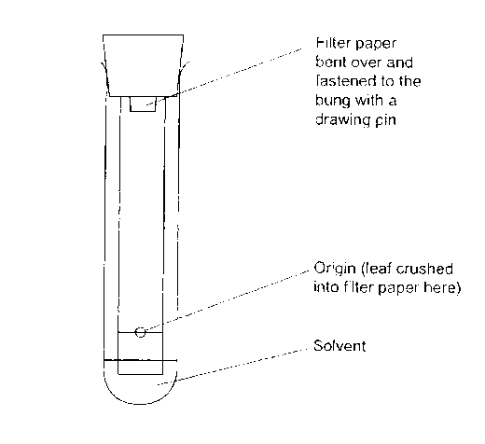the bottle is sitting upright and not at an angle
* the green spot is above the solvent
* the TLC strip is not touching the sides of the glass tube

1. Watch the solvent move up the strip causing the leaf pigments to separate. Do not move the bottle as the solvent is running.
2. When the solvent reaches the second pencil line remove the TLC strip and immediately using a pencil mark the top end of any pigments visible.
3. Calculate the Rf value for each pigment using the formula:

Rf = distance run by pigment (distance from pencil dot to top end of pigment)

distance run by solvent (should be distance between the two pencil lines)

13. Identify the principal pigments using the table of Rf values below.

|  |  |  |
| --- | --- | --- |
| **Pigment colour** | **Pigment** | **Rf value** |
| orange yellow | carotene | 0.96 |
| grey | a breakdown product | 0.70 |
| blue green | chlorophyll a | 0.58 |
| green | chlorophyll b | 0.48 |
| deep yellow | xanthophyll | 0.44 |

**Other points to consider**

The Rf value of pigments will vary if different solvents or chromatography material is used. Even very small changes in the composition of the solvent will result in different Rf values. The solvent must also be fresh as different rates of evaporation of the components will change its composition.

You will probably notice the presence of other photosynthetic pigments on your chromatogram. Remember their existence when you are trying to explain differences between the ABSORPTION SPECTRA of the pigments in the table and the ACTION SPECTRUM of the plant.

|  |  |
| --- | --- |
|  | Apparatus and techniques |
| AT b | use appropriate instrumentation to record quantitative measurements, such as a colorimeter or potometer |
| AT g | separate biological compounds using thin layer/paper chromatography or electrophoresis |
| 1. Follows written procedures | a. Correctly follows instructions to carry out experimental techniques or procedures. |
| 2. Applies investigative approaches and methods when using instruments and equipment | b. Carries out techniques or procedures methodically, in sequence and in combination, identifying practical issues and making adjustments when necessary. |
| 5. Researches, references and reports | a. Uses appropriate software and/or tools to process data, carry out research and report findings. |