**3.3.3 Digestion and Absorption AQA**

**Specification**

* During digestion, large biological molecules are hydrolysed to smaller molecules that can be absorbed across cell membranes.
* Digestion in mammals of:
  + Carbohydrates by amylases and membrane-bound disaccharidases
  + Lipids by lipase, including the action of bile salts
  + Proteins by endopeptidases, exopeptidases and membrane-bound dipeptidases.
* Mechanisms for the absorption of the products of digestion by cells lining the ileum of mammals, to include:
  + Co-transport mechanisms for the absorption of amino acids and of monosaccharides
  + The role of micelles in the absorption of lipids.

**Previous GCSE Knowledge**

* The hierarchical organisation of cells into tissues, organs and organ systems, exemplified by the stomach and digestive system
* The role of amylase, protease and lipase enzyme in the digestion of large insoluble food molecules, and their sites of production.
* The role of Bile in emulsifying fats and neutralising acid from the stomach, and the site of its production and storage
* Diffusion in the movement of molecules from a region of high to low concentration

**Preparatory work**

Read the following article found in resources on GoL ‘The anatomy of Digestion’ and answer the following questions.

1. What is the process of digestions?

It is the breakdown of macromolecules into smaller soluble units which can pass into the blood

1. What is the function teeth?

Increases the surface area of food to increase the rate of enzyme action

1. What digestion begins in the mouth?

Carbohydrate digestion

1. What is the enzyme secreted by the salivary glands?

amylase

1. What connects the stomach to the mouth?

oesophagus

1. What is found in gastric juice?

Hydrochloric acid and pepsin

1. Why do your teeth dissolve when you vomit?

Hydrochloric acid from your stomach dissolves the enamel on your teeth

1. What protects the stomach from being digested?

Mucus coats the wall of the stomach providing a physical barrier between the wall and the gastric juices

1. What are the two functions of the small intestine?

Ensures that digestion is complete

Absorbs all the soluble products into the blood to be taken to the liver for processing

1. What does Bile do?

Neutralises the acidic contents of the stomach acid and raises the pH of contents of the small intestine

1. Where does the majority of water absorption take place?

Large intestine

**Nutrition**

<http://leavingbio.net/human%20nutrition/human%20nutrition.htm>

**Nutrition** is the process by which organisms obtain **energy** to maintain life functions and **matter** to create and maintain structure. These are obtained from nutrients.

|  |  |  |  |
| --- | --- | --- | --- |
| *Type of Nutrition* | | Explanation | Example |
| Autotrophs  (use simple inorganic molecules to make complex organic compounds) | Photo-  synthesis | These use simple inorganic materials (eg CO2 and O2.) to manufacture complex organic compounds such as sugars using energy from sunlight (absorbed by pigments such as chlorophyll) | Some bacteria and plants |
| Chemo-  synthesis | These use the energy derived from special methods of respiration to synthesise organic food. | Some bacteria |
| Heterotrophs  (obtain organic carbon by eating other heterotrophs or autotrophs) | Holozoic feeders | Internalization and internal processing of organic liquid or solid food particles. | Protozoans, and most animals. |
| Saprophytes (saprobionts) | These feed on dead/decaying material organic compounds. They secrete digestive enzymes onto their  food, the food is externally digested and the soluble products absorbed | Some fungi  Most bacteria  () |
| Parasites | These live on or in other living organisms, their **hosts**, and obtain nourishment at the expense of the host. These digest the hosts cells and absorb the products | Examples across all kingdoms  tapeworm |
| Mutualism  (symbiotic) | Close association between two species where both be  . In lichens the fungal hyphae store water and algal cells provide sugars from photosynthesis. | Lichens (algae and fungi) |

**Human Nutrition**

The five stages of human nutrition are:

1. **Ingestion**
2. **Digestion**
3. **Absorption**
4. **Assimilation**
5. **Egestion**

Do not confuse egestion - elimination of material from a body cavity, with excretion - elimination of waste material produced from within the body's cells.

In order to accomplish its functions the digestive system begins with the mouth where food enters. This process is called **ingestion**. In this process food is placed into the alimentary canal.

After the food enters the alimentary canal it must be **digested.** This is the breakdown of complex food into their simple soluble absorbable subunits.

They must be broken down so that they can be absorbed into the bloodstream and then taken to the body cells. This process is called **absorption**. Through absorption the products of digestion enter into the blood or lymph.

After the food is absorbed the nutrients are brought to the body cells. Here the process of **assimilation** converts the absorbed nutrients into complex molecules for growth, repair and defence.

Finally the waste products which remain behind must be excluded from the body. This is done by the process of **egestion**.

**Major parts of the digestive system**

In **simple organisms**, feeding on only one type of food, the gut is undifferentiated.

In **more advanced organisms**, with a varied diet, the gut is divided into various parts along its length and each part is specialised to carry out particular functions.

In humans the site of ingestion/digestion/absorption is the gut (alimentary canal), which is a long tube that extends from the mouth to the anus.

Please label the following diagram. Refer to GoL articles and resources. It consists of the buccal cavity, tongue, oesophagus, stomach, duodenum, ileum, colon, rectum, anus and associated organs; salivary glands, liver and pancreas

www.lessontutor.com/jm_digestive.html

|  |  |  |
| --- | --- | --- |
| **Print ready worksheet picture of the organs and accessory structures of the digestive system**  **www.lessontutor.com/jm_digestive.html** | **0** | **buccal cavity (mouth cavity)** |
| 1 | teeth |
| 2 | epiglottis |
| 3 | liver |
| 4 | gall bladder |
| 5 | bile duct |
| 6 | large intestine (colon) |
| 7 | appendix |
| 8 | salivary gland |
| 9 | tongue |
| 10 | oesophagus |
| 11 | stomach |
| 12 | duodenum (small intestine) |
| 13 | pancreas |
| 14 | ileum (small intestine) |
| 15 | Rectum |

**The major organs and glands**

A gland is an organ in the human or animal body which secretes particular chemical substances for use in the body or for discharge into the surroundings

<https://www.youtube.com/watch?v=Q-n_Q0qKXzg#t=30>

**Digestion**

In humans as with many organisms digestion takes place in two stages:

Write short notes on these two different forms of digestion **p19 old AS book**:

1. Physical breakdown

If food is large it is broken down into smaller pieces by teeth. It makes it possible to ingest the food but it also supplies a large surface area for chemical digestion. Food is also churned by muscles in the stomach wall which also helps to break up the food

1. Chemical digestion

Chemical digestion hydrolyses large, insoluble molecules into smaller soluble ones. It is carried out by enzymes. All digestive enzymes function by hydrolysis which splits up molecules by adding water to the chemical bonds that hold them together (Think and link). Enzymes are specific so more than one enzyme is required hydrolyse a large molecule.

There are different types of digestive enzymes, three of which are particularly important:

These are:-

|  |  |
| --- | --- |
| **Enzyme** | **Function** |
| Carbohydrases | Hydrolyse carbohydrates ultimately to monosaccharides |
| lipases | Hydrolyse lipids (fats and olis) into glycerol and fatty acids |
| Proteases | Hydrolyse proteins ultimately to amino acids |

|  |  |  |
| --- | --- | --- |
| **Structure** | **Function** | **Adaptations** |
| Mouth | Initial mechanical and chemical breakdown of food | * Mechanical digestion due to food being chewed using the teeth * Saliva (pH 6.5-7.5) is important for **lubricating** the food before it is swallowed. Saliva contains **amylase** which breaks down starch to maltose. |
| Oesophagus | Move food to stomach  peristalsis | * Many mucus secreting **goblet cells** to **lubricate** food to aid movement * Circular/longitudinal muscles contract behind food to move food towards stomach – called **peristalsis** |
| Stomach | To store and digest food, especially proteins | * The stomach is a muscular sac that produces enzymes * **Gastric glands** secrete **gastric juice** containing: * **Endopeptidase** e.g. **Pepsin**, which hydrolyses **peptide** bonds to form shorter polypeptides * **Hydrochloric acid** (ph 2) – provides **optimum pH** for endopeptidases and **kills bacteria** * And an **alkaline mucus is secreted** to prevent the mucosa from being ‘self digested’ by acid and endopeptidases |
| Duodenum  (small intestine) | Neutralise acid from stomach. Site of bile and pancreatic ducts to secrete juices for digestion | * Glands secrete **mucus**, also **alkaline juice** (pH 8) to neutralise acid from stomach to give optimum pH for **pancreatic enzymes** (endopeptidases, amylase and lipase) * **Bile** (produced in the liver and stored in the gall bladder) **neutralises pH** and provides **bile salts** to emulsifying the lipids |
| Ileum  (small intestine) | To absorb digested food    (Epithelial cells showing **microvilli)** | * Long muscular tube * Enzymes secreted by cells at the tips of the villi complete digestion (eg maltase, exopeptidases and dipeptidase) * Very **long folded** tube to **increase surface area** * Also mucosa forms finger like **villi** * Epithelial cells of villi have **microvilli** * **Glucose** and **amino acids** areabsorbed by **active transport** * **One cell thick** provides a **short diffusion pathway** * **Blood capillaries** inside villi transport **glucose** and **amino acids** to the **liver** via the **hepatic portal vein** * **Fatty acids** and **glycerol** pass into the **lacteal** (inside villi), through the **lymphatic system** to the blood stream opening at the **thoracic duct** |
| Colon  (large intestine) | To absorbed water and other soluble nutrients | * Most of the water absorbed is from the secretions of the many digestive glands |
| Rectum | Stores faeces until removed via the anus | * Final section of the intestines * Egestion |

**Chemical digestion-Three different food types that have to be digested.**

|  |  |  |
| --- | --- | --- |
|  | | |
| **1. Carbohydrates (Starch)** | | |
|  | | |
| * **amylase** in saliva from **salivary glands** in mouth * **amylase** in **pancreatic juice** acts in the duodenum * **maltase** secreted by **cells at the tips of the villi in the ileum** complete digestion * **sucrase hydrolyses sucrose into glucose and fructose** * **lactase hydrolyses lactose into glucose and galactose** | | |
|  | | |
| **2. Protein** – digestion takes part in two stages by enzymes called peptidases | | |
|  | | |
| **Endopeptidases** hydrolyse peptide bonds along the length of the protein to provide more ‘**free ends**’ for **exopeptidases** to act on.  **Exopeptidases** hydrolyse the peptide bonds on the terminal amino acids  **Dipeptidase** will finally hydrolyse the bond between the two amino acids of a dipeptides into amino acids. They are **membrane bound and found on cell surface membrane of epithelial cells lining the ileum** |  | |
|  | | |
| **3. Lipids** (These are NOT polymers!) | | |
|  | | * **Bile** (not an enzyme) **emulsifies** large fat droplets to small droplets called **micelles (4-6nm)** * To **increase surface area** for **pancreatic** **lipase** action * The lipid is hydrolysed into **3** **fatty acids** and **glycerol or two fatty acids and a monoglyceride.** |
| Bile is produced by the liver and it **neutralises** acidic contents in the duodenum that come from the stomach | | |
|  | | |

Read through the previous table and answer the following questions (you may need to link and think) :-

1. How do enzymes work?

Enzymes are biological catalysts that reduce the activation energy of a reaction. They are globular proteins with a specific tertiary structure. The part of the enzyme that acts as a catalyst is called the active site which is complimentary to the substrate it catalyses.

1. What are the enzymes that breakdown starch to glucose?

Amylase and maltase

1. How would you test for the presence of
   1. Starch?

To approximately 2 cm³ of test solution add two drops of iodine/potassium iodide solution. A blue-black colour indicates the presence of starch

* 1. Reducing sugar

To approximately 2 cm³ of test solution add an equal quantity of Benedict’s reagent. Shake, and heat for a few minutes at 95°C in a water bath. A red precipitate indicates the presence of a reducing sugar.

1. How does an endopeptiase work?

Endopeptidases beak peptide links (the bonds which hold amino acids together) in the middle of polypeptide chains

1. How does an exopeptidase work?

Exopeptidases break the peptide links of the amino acids at the ends of the chains.

1. What organ produces Lipase and what does Lipase break down?

Pancreas and lipase break down lipids

1. What is a micelle (link back to membranes)

Micelles are lipid molecules that arrange themselves in a spherical form in aqueous solutions. The formation of a micelle is a response to the amphipathic nature of fatty acids, meaning that they contain both hydrophilic regions (polar head groups) as well as hydrophobic regions (the long hydrophobic chain).

**Carbohydrate digestion flow chart**

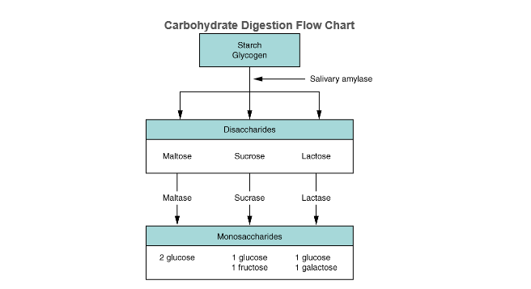

Maltase found on the brush border (microvilli) of the epithelial cells in the ileum.

And pancreatic amylase

**Protein digestion flow chart**

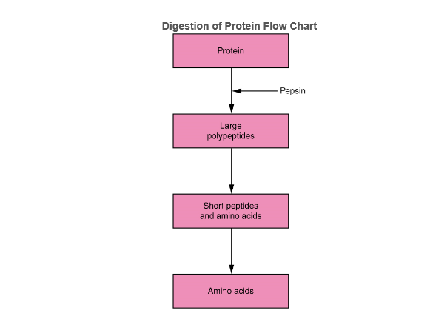

Pepsin is an Endopeptidase produced by stomach

Endopeptidase (Trypsin) /exopeptidase produced by pancreas

Dipeptidase found on brush border (microvilli) of ileum

**Digestion of fatty acids**

Bile salts are produced by the liver and stored in the gall bladder. Bile salts are secreted into the duodenum to neutraluse the acidity of the food bolus coming from the stomach. Bile salts also play a key role in digestion of fatty acids. Bile salts are amphiphile compounds i.e. have one end that is hydrophillic and one end that is hydrophobic and act like a surfactant, emulsifying the lipids.

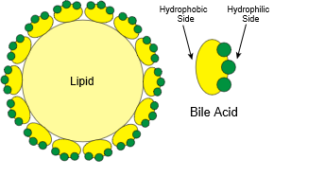

Bile salts aggregate around droplets of lipids to form **micelles** with the hydrphobic sides towards the fat and hydrophillic side facing outwards. This prevents fat droplets re aggregating together. Leaving a larger surface area for the action of pancreatic lipase.

**Summary of the enzymes involved in Digestion**

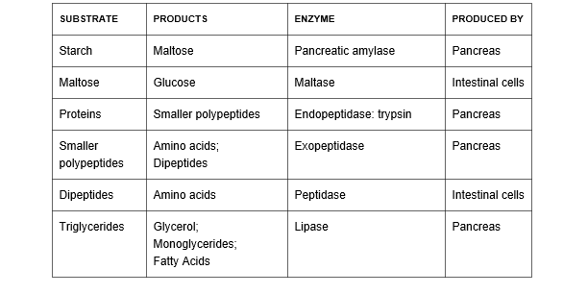

**Absorption**

The ileum is where digestion ends and absorption starts. The following diagram is a cross section through the ileum.



Please write Ficks law in the box below

**Ficks Law**

Rate of diffusion (ROD) = Surface area x diffusion gradient (SAD)

Thickness of exchange surface (TOES)

Using Fick’s law and the diagram above describe how the ileum is adapted to absorption (p63-64 in old AQA AS book) using the following headings to guide you.

Surface area

Villi and microvilli increase the surface area for diffusion

Short diffusion pathway

Villi are very thin walled thus reducing the distance over which diffusion takes place

Diffusion gradient

* Contain **muscle** so are able to **move**. This **maintains diffusion gradient** as the movement mixes the contents of the ileum therefore as products of digestion are absorbed from the food, new fresh material will replace it.
* They are well supplied with **blood vessels** so that the blood can **maintain a diffusion gradient** by moving away absorbed molecules.

**Absorption of amino acids and monosaccharides**

Digestion of proteins produces amino acids while the digestion of carbohydrates produces monosaccharides such as fructose, glucose and galactose. The method of absorbing these products are the same namely **diffusion** and **co-transport**. Glucose and amino acids are absorbed by co transport into the epithelial cells lining the ileum while facilitated diffusion moves glucose and amino acids from the ileum epithelial cell to the blood. The blood maintains a concentration gradient.

Write a definition of diffusion

The movement of molecules or ions from a region of where they are in high concentration to a region where their concentration is lower

Write a definition of Co transport

A process where two substances are simultaneously transported across a membrane in the same direction by one carrier protein.

Using the information you learnt in Topic 3.2 Transport across cell membranes please fill in the gaps in the diagram. Please state whether the concentration of amino acid/glucose is high or low (p64 old AS AQA textbook)

Low conc

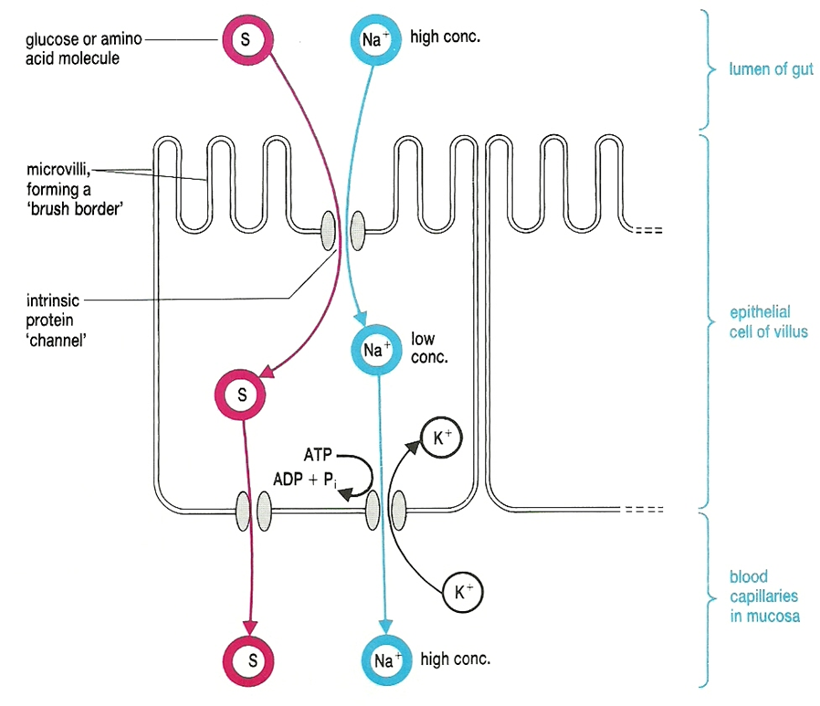

Low conc

High

conc

**Absorption of triglycerides**

What is a triglyceride? Draw a picture below

[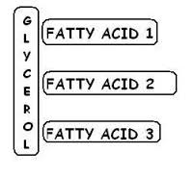](https://www.google.co.uk/imgres?imgurl=http://www.fattyacidshub.com/img/depiction-of-a-triglyceride.jpg&imgrefurl=http://www.fattyacidshub.com/fish-oil/fish-oil-for-triglycerides/&h=232&w=252&tbnid=yTwrgx1VGWnngM:&docid=9iVQfTCO0JJHRM&hl=en&ei=HWzMVpOFHsjTU53ZgagM&tbm=isch&ved=0ahUKEwjTh9Tli47LAhXI6RQKHZ1sAMUQMwhiKCUwJQ)

What is a monoglyceride? Draw a picture below.

[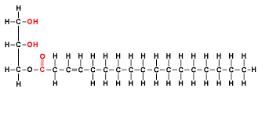](https://www.google.co.uk/imgres?imgurl=http://kimwootae.com.ne.kr/apbiology/monoglyceride.gif&imgrefurl=http://kimwootae.com.ne.kr/apbiology/chap2.htm&h=300&w=700&tbnid=BiphulggpdybbM:&docid=pQAKpqh5vvq4JM&hl=en&ei=ZGzMVre-FcKGU--eqpAD&tbm=isch&ved=0ahUKEwi3gLmHjI7LAhVCwxQKHW-PCjIQMwg9KBgwGA)

A diagram to show the lymphatic system (in green). Lipids are transported into the lacteals found at the centre of the villi in the ileum. They enter the blood stream via the thoracic duct.

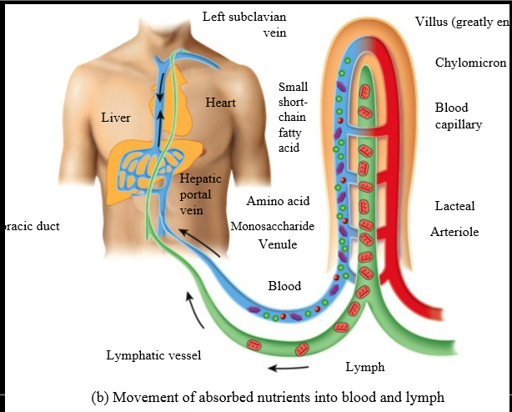

Use your AQA textbook to fill in the missing gaps using the following words.

**Monoglyceride, micelle , chylomicrons, lacteal, exocytosis, diffuse, lacteal, thoracic duct.**

Triglycerides once digested to **monoglycerides** and fatty acids by pancreatic lipase remain in association with the bile salts. The structures formed are called **micelles.**

Once the micelle comes into contact with the epithelial cell lining the ileum they break down and release the non-polar monoglycerides and fatty acids which **diffuse** across the cell-surface membrane into the epithelial cells.

They are then transported to the endoplasmic reticulum where they are recombined to form triglycerides. In the endoplasmic reticulum and Golgi apparatus the triglycerides associate with cholesterol and lipoproteins which become surrounded by a protein coat to form structures called **chylomicrons.** The chylomicrons are water soluble lipoproteins and are too big to pass into blood capillaries but can enter the large pores of the lacteals. Thus the chylomicrons move out of epithelial cell by **exocytosis** and enter the lymphatic capillaries called **lacteals.** They are then transported in the lymphatic vessels which eventually empty through the **thoracic duct** and into circulatory system.

<https://www.youtube.com/watch?v=G_7EchSkkc0>

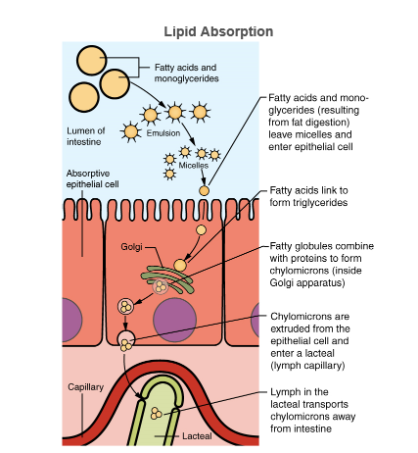

Unlike amino acids and simple sugars, lipids are transformed as they are absorbed through epithelial cells.

**S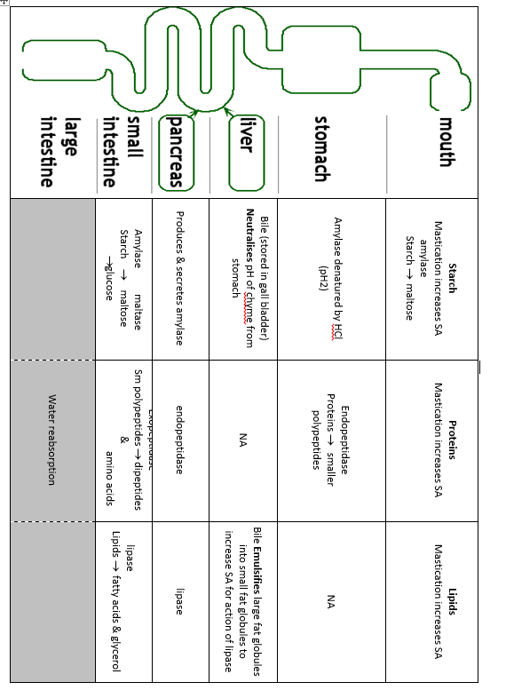ummary of Absorption**

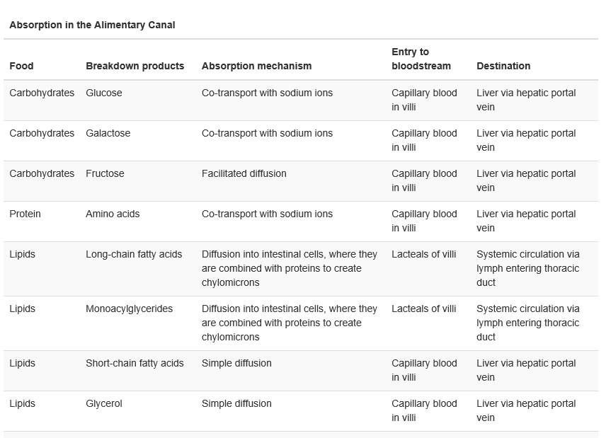

Please complete the summary table on the next page.

**Digestion Experiment**

Visking tubing is commonly used to model gut digestion because it is semi permeable. The tubing is soaked and a knot is tied at one end. It is then placed into a boiling tube containing water as shown in the diagram below.

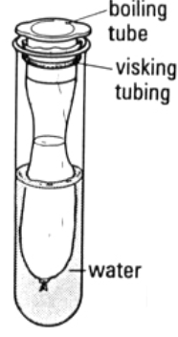

Watch the demonstration:

<http://sciencedemo.org/2014/01/modelling-digestion-using-visking-tubing/>

**Experiment**

In another experiment three model guts were set up labelled 1, 2 and 3. In each model gut rice was added to the visking tubing. Then:-

1. 5 cm3 of water was added to model gut 1.
2. 5 cm3 of amylase was added to model gut 2.
3. 5 cm3 of boiled amylase was added to model gut 3.

All the boiling tubes containing the model guts were placed in a water bath at 37ºC. The model guts were left for at least 15 minutes. After 15 minutes, a teat pipette was used to remove some of the water surrounding the model guts in the boiling tubes and then each solution was tested for starch and glucose.

How do you test for starch?

Iodine test

How do you test for glucose?

Reducing sugar test

What do you think your results would show for:-

1. Model Gut 1

There is no starch outside the Visking tubing, but starch on the inside. It looks like starch cannot get through the Visking membrane

2. Model Gut 2

There would be starch and reducing sugars on the inside and reducing sugars would be detected on the outside of the visking tubing. Glucose can move through the visking tubing

3. Model Gut 3

.There is no starch outside the Visking tubing, but starch on the inside.

Please answer the following questions:

1. What does the Visking tubing of the model gut represent?

The Visking tubing of the model gut represents the wall of the small intestine.

1. What does the water in the boiling tube, outside the model gut, represent?

The water in the boiling tube outside the model gut represents blood in the blood vessels around the intestine.

1. How is this model different from the situation in a real gut?

In a real gut, food is moving through the tube, blood is circulating around the blood vessels and carrying away the absorbed food chemicals, the gut lining is folded into villi and microvilli, there are mechanisms that can actively absorb some food chemicals, there is a more complicated mixture of food and enzymes in the intestine, the pH of the gut contents is controlled by gut secretions.

1. Use the diagram to explain what is happening in each of the 3 model guts.

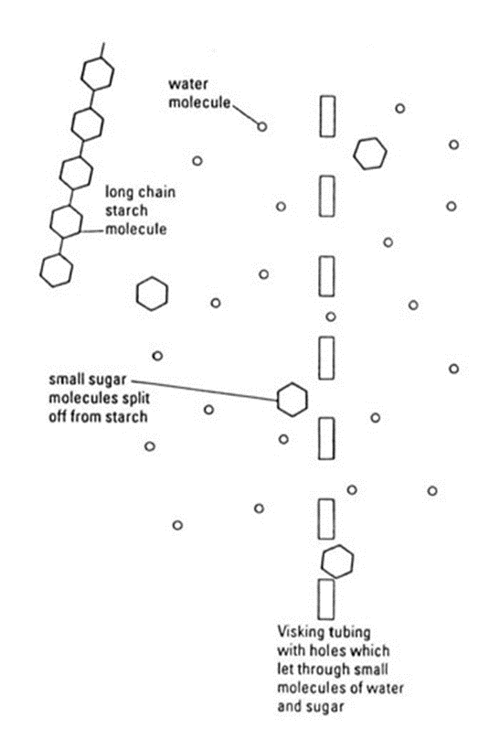

Model 1- the starch is not broken down and the starch molecules are too large to move thr ouigh the holes in the visking tubing

Model 2-amaylase breaks down the starch into glucose molecules which are small enough to pass through the visking tubing

Model 3-The amylase is denatured and can not break down the starch molecules which are too large to pass through the holes in the visking tubing

1. Why does the body need enzymes to digest food?

The body needs enzymes to digest food because large polymer food molecules are too large to pass through the gut wall. Chemical digestion without catalysts is too slow to be useful. Specifically, we need glucose (and other sugars) as a ready source of energy in our bloodstream.

1. What would be the result with boiled amylase? Try to explain this.

The boiled amylase has had no effect on the starch in the rice because it is has been denatured by the high temperature. This means the protein molecule has lost its shape and can no longer work as a catalyst for breaking down starch to sugar.

1. How could you adapt this experiment to test for protein digestion?

Would use albumin (protein) instead of rice and the enzyme trypsin instead of amylase.

**Mark scheme**

**M1.**(a)     1.      Maltose;

2.      Salivary amylase breaks down starch;

**2**

(b)     Maltase;

**1**

(c)     (Mimics / reproduces) effect of stomach;

**1**

(d)     1.      Add boiled saliva;

2.      Everything same as experiment but salivary amylase denatured;

**2**

(e)     1.      Some starch already digested when chewing / in mouth;

2.      Faster digestion of chewed starch;

3.      Same amount of digestion without chewing at end;

*Accept use of values from graph*

**3**

**[9]**

**M2.**(a)     (i)      For person with pancreatitis / blocked pancreatic duct:

1.      At 0 h / start higher than healthy person / higher than healthy person throughout;

2.      Rises then falls whereas healthy person falls then rises;

3.      At 48 h / end, below the starting value whereas healthy person is the same (as at start);

*Differences required for all points*

**2 max**

(ii)     1.      Little / less / no amylase can enter small intestine;

*Accept gut or intestine but reject wrong locations e.g. stomach*

2.      Little / less / no starch digested (in intestine);

**2**

(b)     1.      Amylase is specific (to starch);

2.      No starch in human blood / cells / tissues / starch only in plants;

**2**

(c)     1.      Could digest own body / own proteins;

*e.g. ‘could digest carrier proteins in body cells’ would score 2 marks*

*e.g. ‘could digest antibodies in blood’ would also score 2 marks*

2.      Example of protein digested e.g. membrane protein, antibody, named protein in blood;

*Do not credit unsuitable example such as muscle proteins*

**2**

**[8]**

**M3.**          (a)     Hydrolysis (reaction);

*Accept phonetic spelling*

**1**

(b)     1.      Too big / wrong shape;

*Wrong charge - neutral*

*Accept insoluble*

2.      To fit / bind / pass through (membrane / into cell / through carrier / channel protein);

3.      Carrier / channel protein;

*Accept carrier / channel protein not present*

**3**

(c)     1.      Villi / microvilli damaged / destroyed;

2.      Reduced surface area;

*Accept fewer channel / carrier proteins*

3.      For (facilitated) diffusion / active transport;

*Must be in correct context*

**3**

(d)     Foreign / (act as) antigen / non-self;

*Reject foreign cells*

**1**

(e)     1.      Dose to be given;

*Accept: interaction with other drugs*

2.      No (serious) side effects;

3.      How effective;

4.      Cost of drug;

**2 max**

**[10]**

**M4.**          (i)      Lack of ATP;  
Pump = active transport / requires energy / ATP provides energy /   
transport is up  
concentration gradient;

**2**

(ii)      Concentration of Na+ inside cell no longer less than concentration in  
gut lumen / no longer a concentration gradient;  
No (facilitated) diffusion of NA+ ions possible / amino acid absorption  
requires diffusion of Na+ ions into cell;

**2**

(iii)     Diffusion / facilitated diffusion;

**1**

**[5]**

**M5.**          (a)     (i)      villus; (*reject microvilli*)

**1**

(ii)     contracts / peristalsis;  
moves / pushes / forces food through gut;

**2**

(b)     many / projecting villi (X) (*no double penalty for microvilli*);  
large surface area (for absorption);  
large / good blood supply / many capillaries / blood vessels;  
maintains concentration gradients / efficient removal of digested products;  
thin outer layer / blood vessels near to surface;  
short diffusion pathway;

**4 max**

**[7]**

**M6.**(a)     Amylase;

(Starch) to maltose:

Maltase;

Maltose to glucose;

Hydrolysis;

(Of) glycosidic bond;

***Q*** *Do not penalise incorrect site for digestion or incorrect site of enzyme production.*

**5 max**

(b)     Glucose moves in with sodium (into epithelial cell);

Via (carrier / channel) protein / symport;

Sodium removed (from epithelial cell) by active transport / sodium- potassium pump;

Into blood;

Maintaining low concentration of sodium (in epithelial cell) / maintaining sodium concentration gradient (between lumen and epithelial cell);

Glucose moves into blood;

By (facilitated) diffusion;

***Q*** *Only allow diffusion mark in context of movement of glucose into the blood.*

**5 max**

**[10]**

**M7.**(a)     Measure with eyepiece graticule / scale;  
Calibrate with stage micrometer / scale on slide / object of known size;   
Repeats and calculate the mean;  
***OR***Use a ruler to estimate the field diameter under microscope;  
How many droplets go across the field;  
Repeats and calculate mean;

*Accept references to radius*

**3**

(b)     Two mark for correct answer of 4 : 1;;  
One mark for incorrect answer but working shows that candidate has clearly attempted to compare values of r2 / 62 and 32 / 36 and 9;

*Idea of comparing ratios  
A ratio of 1 : 4 should gain 1 mark*

**2**

(c)     Small droplets have a larger surface area to volume ratio;

More surface for lipase (to act), leading to faster digestion of triglycerides;

Fatty acids are produced more quickly so pH will drop more quickly in curve **Y** / with bile salts / less fatty acids in curve **Z** / without bile salts so pH drop more slowly;

**3**

**[8]**