3.4.1 DNA, Genes and Chromosomes and 3.4.2 DNA and Protein Synthesis

Preparatory Work

1. Think and Link

Knowledge of the following topics all feed into 3.4.1 and 3.4.2.

3.1.4.1 Protein structure
3.1.5.1 Structure of DNA and RNA
3.1.5.2 DNA replication
3.2.1 Structure of eukaryotic cells
3.2.2 Structure of prokaryotic cells

In the space below produce a simple memory map linking all 5 topics using the following vocabulary to help you. You can use diagrams to annotate the words or further words if you want to. Use a separate sheet of paper if you want more space.

amino acids, monomer, condensation, polypeptide, polymer, peptide bond, functional protein, secondary, tertiary, quaternary structure, H bonds, ionic bonds, disulphide bridges, DNA, RNA, mRNA, tRNA, rRNA, nucleotide, phosphodiester bond, polynucleotide chain, single strand, double strand, complementary base pairing, semi conservative replication, DNA helicase, DNA polymerase, membrane bound organelles (nucleus, Golgi, RER) smaller ribosomes, circular DNA, plasmids, capsule, flagella

2. Read the article: What is a chromosome? (Biological sciences review September 2011) and answer the following questions on file paper. Staple your answers to the back of the booklet.

- What is the difference in the way that prokaryotic and eukaryotic DNA is arranged and stored?
- In non dividing eukaryotic cells the chromosomes are unravelled and genetically active. What is their appearance at the beginning of mitosis?
- What is the length of the total DNA in a newly divided human cell?
- How many base pairs would this accommodate?
- What is ‘junk’ DNA now called?
- What is the non coding DNA thought to be needed for?
- What analogy is given to describe the first stage of DNA packaging in humans?
- What analogy is given to demonstrate the amazing feat of shortening and supercoiling chromatin into a chromosome?
- Do all species have the same number of chromosomes? Provide evidence for your answer.
- Human DNA is arranged in 23 pairs of chromosomes (homologous pairs, one from mum and one from dad, each carrying the same genes but not necessarily the same alleles of the genes). How many base pairs of DNA are there in our largest pair of chromosomes (pair1)? And our smallest pair (pair 21)?
- Why is chromosome pair 1 medically important?


3.4.1 Specification

Highlight the new vocabulary. Use it to make a glossary of terms (you can find the definitions at the back of most good A level text books).

- In prokaryotic cells, DNA molecules are short, circular and not associated with proteins.
- In the nucleus of eukaryotic cells, DNA molecules are very long, linear and associated with proteins, called histones. Together a DNA molecule and its associated proteins form a chromosome.
- The mitochondria and chloroplasts of eukaryotic cells also contain DNA which, like the DNA of prokaryotes, is short, circular and not associated with protein
- A gene occupies a fixed position, called a locus, on a particular DNA molecule.
- A gene is a base sequence of DNA that codes for:
- the amino acid sequence of a polypeptide
- functional RNA (including ribosomal RNA and tRNAs).
- A sequence of three DNA bases, called a triplet, codes for a specific amino acid. The genetic code is universal, non-overlapping and degenerate.
- In eukaryotes, much of the nuclear DNA does not code for polypeptides. There are, for example, non-coding multiple repeats of base sequences between genes. Even within a gene only some sequences, called exons, code for amino acid sequences. Within the gene, these exons are separated by one or more non-coding sequences, called introns.

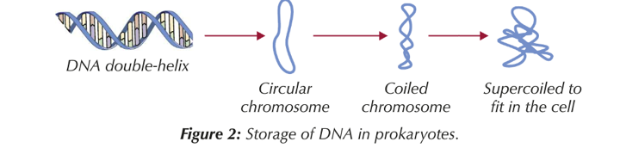
DNA storage in Eukaryotes and Prokaryotes
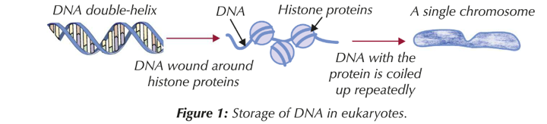

In the space below produce a table to compare and contrast prokaryotic and eukaryotic DNA

Feature | Eukaryotic | Prokaryotic
Location
Length
Shape
Histones

Evaluate this Statement


Stated in a text book “The bacterial chromosome is found within the cytoplasm of the cell”
Mitochondria and Chloroplasts
How does the DNA in mitochondria and chloroplasts resemble prokaryotic DNA?

——————————————————————

——————————————————————

What does this suggest about the origin of these eukaryotic organelles?

——————————————————————

——————————————————————

——————————————————————

What’s the name of this theory?

——————————————————————

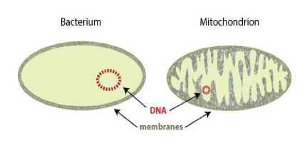

Eukaryotic DNA is stored in the form of chromosomes

What is a gene?

———————————————————————-

———————————————————————-

What is an allele?

———————————————————————-

———————————————————————-

What is a locus?

———————————————————————-

———————————————————————

What does homologous pair of chromosomes mean?

———————————————————————-

———————————————————————-

———————————————————————
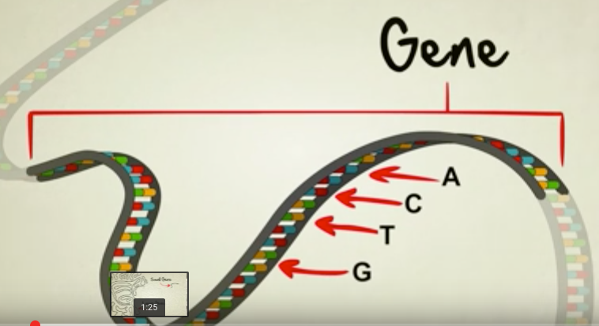

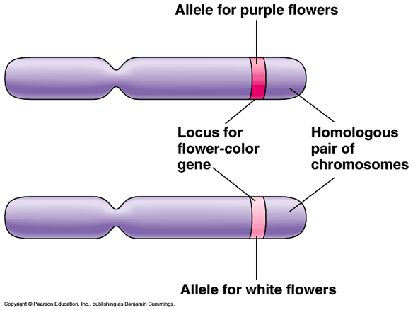
Watch the following 5 minute video, What is a gene? : https://www.youtube.com/watch?v=5MQdXjRPHmQ by Stated clearly and answer the questions that follow:

What do genes code for?

What letters provide the basic code?

Can genes vary in size?

What determines the size and shape of a protein?

Humans and chimps share 96% of their genetic code. What percentage of genes does a fruit fly have in common with a human?

How is DNA used to make proteins?

Watch this introductory video to protein synthesis that also recaps on DNA structure.
Known as “The Central Dogma of Biology”:

DNA contains genes (sequences of bases) that provide the instructions for the order of amino acids, which fold to create a protein. The shape and function of the protein determines the characteristics of the cell. It provides the molecular blueprint for living organisms.
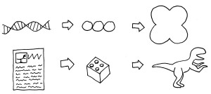
https://www.youtube.com/watch?v=zwibgNGe4aY

In simple terms, what are the three stages of protein synthesis?

1.

2.

3.

The Genetic Code
The genetic code is known as a triplet code. Why is this?

—————————————————————————

What other word is used for ‘triplet’?

—————————————————————————

What does each triplet code for? _____________________

Why wouldn’t a doublet code work?

—————————————————————————

—————————————————————————

How many amino acids would a triplet code, code for?

————————————————————————-----

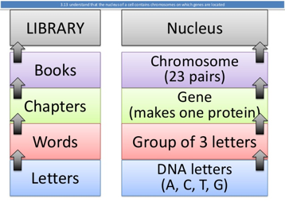

If a polypeptide is made up of 24 amino acids, what is the minimum number of bases that the gene coding for it must have had?

Explain why the genetic code is described as:

1. Degenerate
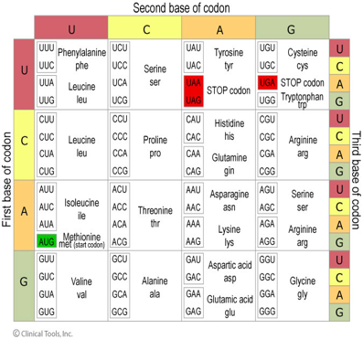
Most amino acids are coded for by

————————————————————

triplet. A triplet is always read in the same direction along the DNA.

Start and stop codes operate, rather like capital letters and full stops in sentences.

What are the three stop codons?

————————————————————

What is the start codon that codes for the amino acid methionine?

————————————————————

2. Non overlapping

Show below how TACGCTCCGCTGTAC would be read.

How could it be read if the code was an overlapping code?

3. Universal (providing indirect evidence for the process of evolution)

With a few minor exceptions each triplet codes for the same amino acid in all organisms.

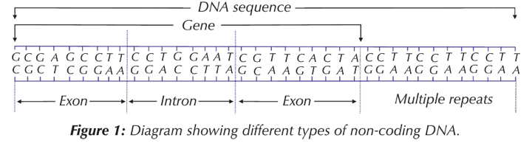
Eukaryotic DNA

- Much of the DNA ———— ———— code for polypeptides.

- Between genes there are non coding regions of —————— ———————- repeats.

- Coding regions are called ————————-

- Non coding sequences are called ————————-

- Some genes code for RNA (ribosomal and transfer RNA).

- Introns are thought to be remnants of sequences earlier in evolution and needed for gene regulation. They are no longer considered to be ‘junk’ sequences; damage to non coding regions can cause cell death.

Do bacteria have introns in their DNA? ————————————————————

Exam Question
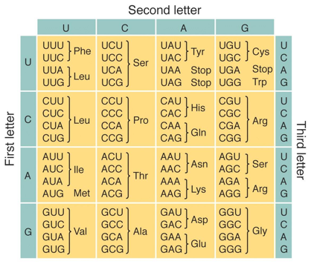
1.List the two amino acids that have only one codon and state what it is in each case

————————————————————————-

2. Name the amino acids that have each of the following codons: CUC, AAA, GAU

————————————————————————-

3. For each of the following base sequences on the DNA molecule, deduce the sequences of amino acids in the order they would occur in the resulting polypeptide.

- ATGCGTTAAGGCAGT ————————————

b) GCTAAGTTTCCAGAT ————————————-

One gene/one polypeptide hypothesis

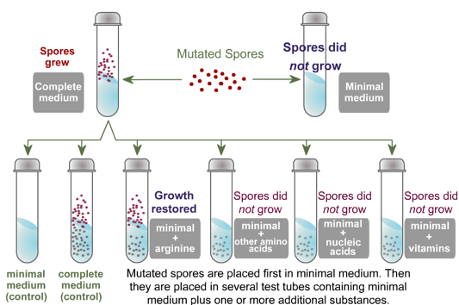
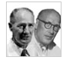

https://www.dnalc.org/view/16360-animation-16-one-gene-makes-one-protein-.html


Follow the hyperlink and read through the work of Beadle and Tatum, who won a Nobel prize in 1958 for their research demonstrating the ‘one gene one protein’ hypothesis using Neurospora crass - red bread mould. Why was the theory later changed to ‘one gene one polypeptide’? Write short notes below to describe the research using the diagram above to help you.
What is the genome and the proteome?

Genome:

Proteome:

DNA and RNA Revision Exercise
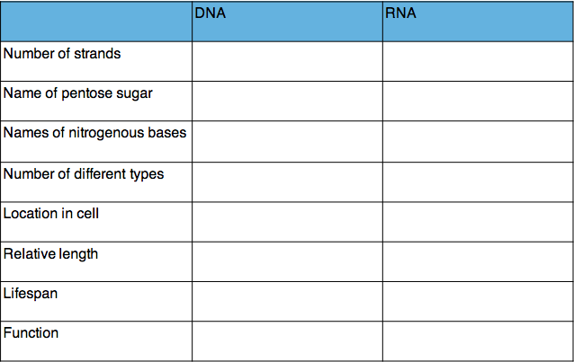

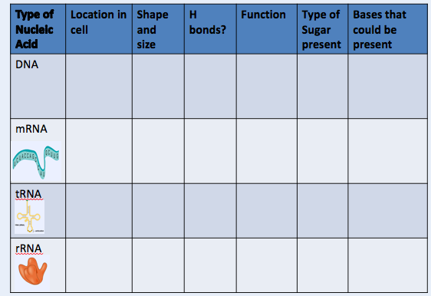
Nucleic Acids involved in protein synthesis
Protein Synthesis

Basic process:

- DNA provides instructions in the form of a long sequence of bases

- DNA ——————- leave the nucleus

- A complementary section of DNA is made in the form of ——— mRNA, a process called transcription.

- Pre RNA is ———————— to form ———————-

- mRNA is used as a template to which —————————— —————- molecules attach and the amino acids they carry are linked to form a polypeptide – a process called translation.

Bakery Analogy - describe below

Protein Synthesis Lab

In small groups follow the instructions to make a protein using the various sheets supplied.
10 Sheets:

- DNA template strand (pale orange)
- RNA polymerase picture
- mRNA nucleotides x 4 (blue = cytosine, yellow = uracil, green = guanine, pink = adenine)
- tRNA (pale yellow)
- 5” tail = mauve
- Amino acid codes (white)
- mRNA codons (white)

Use the molecules you build to answer the summary questions. at the end

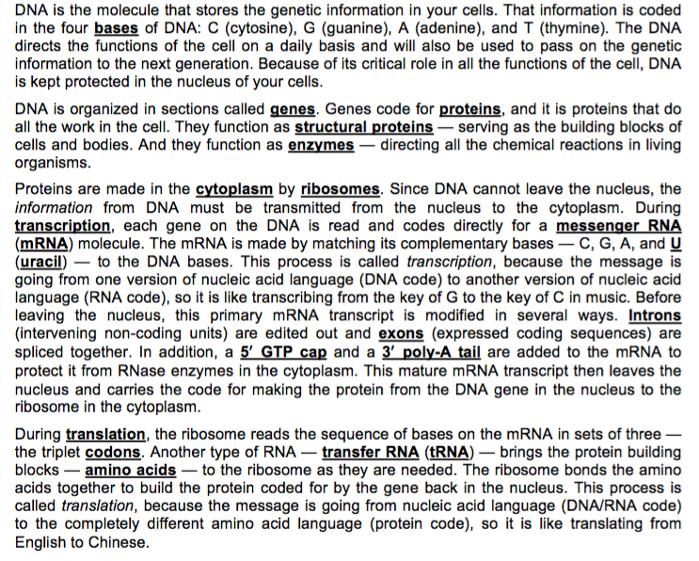
Introduction to lab
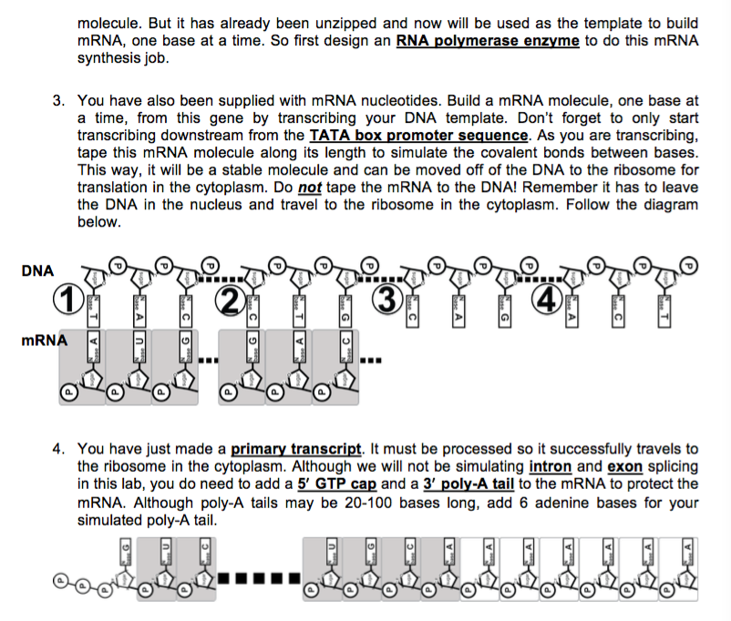
Instructions
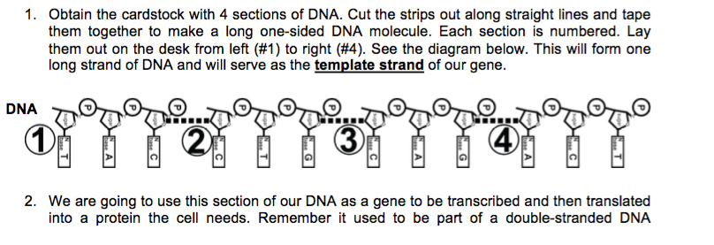

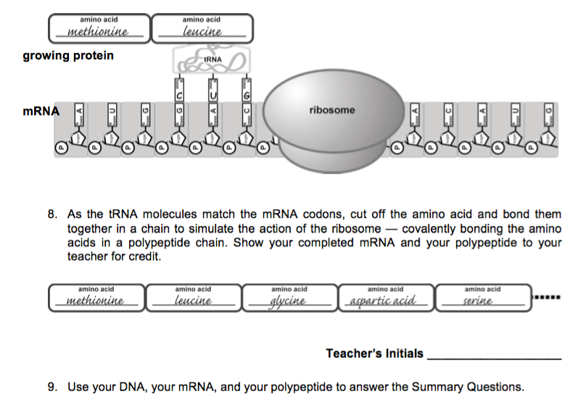
Summary questions are on the next page
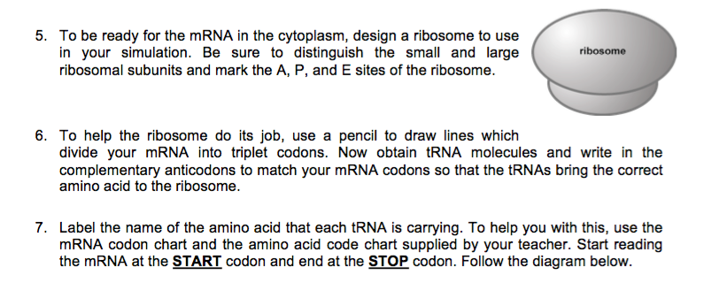

Please note: The protein synthesis lab involved information not covered by the AQA specification (GTP, poly A tail, TATA box promoter sequence and the specific sites on ribosomes).

There are however details that were not covered by the lab that you need to know for your exams.

Transcription

- The enzyme DNA helicase acts on a specific region of the DNA breaking the H bonds and exposing the nucleotide bases.

- The enzyme RNA polymerase binds to the DNA and as it moves along the strand it picks up free nucleotides from the nucleoplasm.

- The nucleotide bases on one of the two DNA strands known as the template strand pair with their complementary nucleotide bases (T with A, C with G, A with U)

- When RNA polymerase reaches a stop triplet then it detaches and the pre mRNA is then complete.

- In the nucleus pre-mRNA is ——————- to remove introns that do not code for amino acids.

- This process does not take place in prokaryotic cells, as most of them do not have introns.

mRNA carries the DNA code out of the nucleus through the ———————- ——————. It then finds a free floating ribosome in the cytoplasm for the next stage of the process

Comparing Transcription and DNA replication

Can you think of 3 similarities and 4 differences?

Similarities | Differences
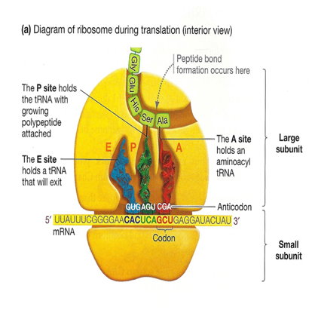
Translation
Takes place on ribosomes. Each ribosome has 2 subunits

The larger subunit has 3 sites for the attachment of tRNA. The A site = acceptor site for tRNA, E site = exit site for tRNA, P site holds the growing polypeptide chain.

The smaller subunit holds the —————-.

The ribosome becomes attached to the starting codon (AUG) at one end of the mRNA molecule

Label the anticodon on the diagram of the tRNA molecule. What bases make up the anticodon?

————————————————————-

Why is it called an anticodon?

——————————————————————

—————————————————————-

The incoming tRNA takes the amino acid to the ribosome where the anti codon will bind with the codon on the mRNA.

What complementary bases would the mRNA have that would allow the anticodon and codon to combine in this tRNA molecule? (bottom diagram may be helpful)

—————————————————————-

Look back at page 8. What amino acid does this represent?

——————————————————————

A ribosomal enzyme catalyses the formation of a peptide bond between two amino acids

using ———— . Label the peptide bond.

The first tRNA leaves the ribosome leaving an attachment site vacant. The ribosome now moves one codon along the mRNA strand.

Polysome System

Up to 50 ribosomes can pass immediately behind the first, so that many poly peptides can be assembled simultaneously.

Assembling the protein

Sometimes a single polypeptide chain is a functional protein. It is coiled or folded

producing what structure? ——————————— or —————————————-

That structure is then further folded to form what structure? ——————————

What bonds are formed? —————————————————————————-

What type of protein will be made if more than one polypeptide chain is brought together and bonded?

———————————————————————————————-

What organelle is used to modify the protein if necessary? —————————————

How was the genetic code cracked?

https://www.dnalc.org/view/15882-breaking-the-code.html

Visit the website above and follow the interactive description of the work of Nirenberg and Matthael who made synthetic mRNA and used this to make polypeptides.

Questions may be asked on experimental work asking you to interpret data.

Consolidation Activity

Transcribe and translate a gene: http://learn.genetics.utah.edu/content/molecules/transcribe/

Consolidation Videos

Interactive website http://www.wiley.com/college/boyer/0470003790/animations/translation/translation.htm

Crash course http://www.youtube.com/watch?v=itsb2SqR-R0

