Name: ………………………………..

**3.4.5, 3.4.5 & 3.4.7**

**Species, Taxonomy & Biodiversity Independent Study**

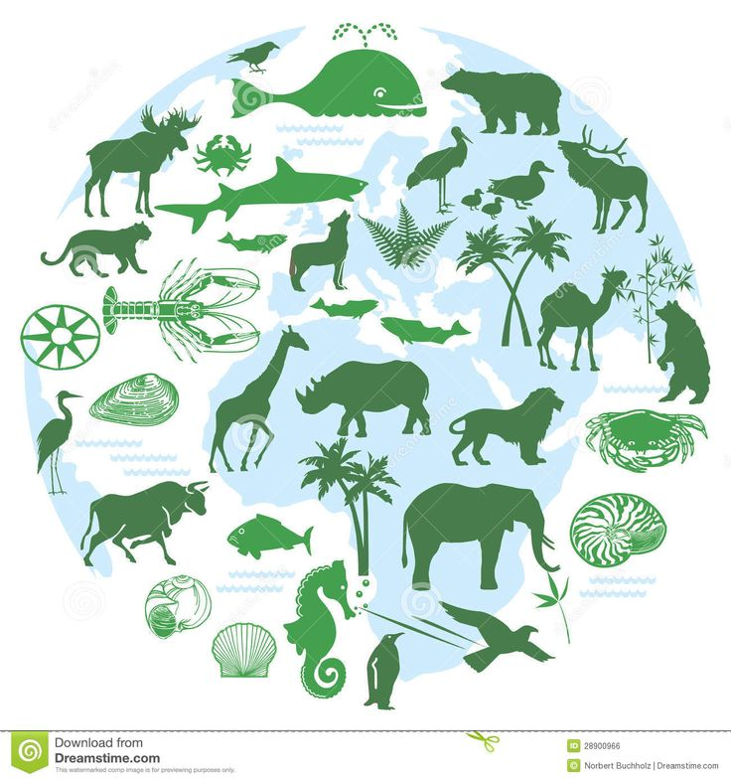

**You are expected to work through this booklet independently and complete all sections.**

**3 sections of the course will be covered:**

1. **Species and taxonomy**
2. **Biodiversity within a community**
3. **Investigating diversity**

**Specification Content**

**Species and Taxonomy**

* Two organisms belong to the same species if they are able to produce fertile offspring. Courtship behaviour as a necessary precursor to successful mating. The role of courtship in species recognition.
* A phylogenetic classification system attempts to arrange species into groups based on their evolutionary origins and relationships. It uses a hierarchy in which smaller groups are placed within larger groups, with no overlap between groups. Each group is called a taxon (plural taxa).
* One hierarchy comprises the taxa: domain, kingdom, phylum, class, order, family, genus and species.
* Each species is universally identified by a binomial consisting of the name of its genus and species, e.g., Homo sapiens.
* Recall of different taxonomic systems, such as the three domain or five kingdom systems, will not be required.
* **Students should be able to** appreciate that advances in immunology and genome sequencing help to clarify evolutionary relationships between organisms.

**Biodiversity within a community**

* Biodiversity can relate to a range of habitats, from a small local habitat to the Earth.
* Species richness is a measure of the number of different species in a community.
* An index of diversity describes the relationship between the number of species in a community and the number of individuals in each species.
* Calculation of an index of diversity (d) from the formula d = N (N −1)

∑n( n−1)

* Where N = total number of organisms of all species and n = total number of organisms of each species.
* Farming techniques reduce biodiversity. The balance between conservation and farming

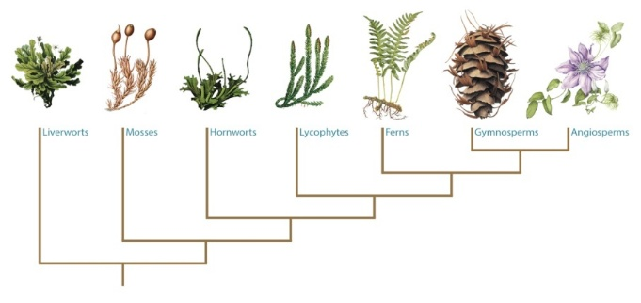**Quantitative investigations of diversity**

Quantitative investigations of variation within a species involve:

• collecting data from random samples

• calculating a mean value of the collected data and the standard deviation of that mean

• interpreting mean values and their standard deviations.

Students will not be required to calculate standard deviations in written papers.

**Species and Taxonomy**

**Read through all of these references and watch all videos. Using the information you have read complete the booklet.**

1. Watch the following videos

[Domain theory video](https://www.bing.com/videos/search?q=species+and+taxonomy+domain+theory&&view=detail&mid=E96A0B9CE2500A15879DE96A0B9CE2500A15879D&FORM=VRDGAR) (Mr. Anderson Biology – the 3 domains of life)

<https://www.bing.com/videos/search?q=species+and+taxonomy+domain+theory&&view=detail&mid=E96A0B9CE2500A15879DE96A0B9CE2500A15879D&FORM=VRDGAR>

[Phylogentics](https://www.bing.com/videos/search?q=Mr.+Anderson+Biology&&view=detail&mid=5BF1CAF17164025387285BF1CAF1716402538728&FORM=VRDGAR) (Mr. Anderson Biology – phylogenetics) <https://www.bing.com/videos/search?q=Mr.+Anderson+Biology&&view=detail&mid=5BF1CAF17164025387285BF1CAF1716402538728&FORM=VRDGAR>

1. Godalming online power point Species and Taxonomy
2. Text book AS Biology (old) Pgs. 204-207, 213-214 (new) Pgs. 237-242
3. Bio factsheet no 91 Taxonomy and Classification (Godalming online)

**Activity: The Next Bug Thing**

Purpose

• To provide practice in reading and analysing extended text.

• To introduce binomial nomenclature and taxonomy.

Beetle mania

Many of the scientists who work on cataloguing biodiversity are specialists in one group

of organisms. Much of their work goes on hidden behind the scenes in museums and research institutes around the world. Get an idea of the scale of biodiversity and the challenge faced by the biologists researching just one group by reading the extract of the article ‘The next bug thing’ (found on Godalming online articles and resources folder). This is about two beetle taxonomists, Martin Brendell and Peter Hammond, who work at the Natural History Museum in London.

Look up any words that you are unfamiliar with before answering the following questions based on the text.

Questions

Q1 What does Martin Brendell mean when he says that the beetle found in the Kalahari is probably an ‘unrecorded species’?

…………………………………………………………………………………………………………………………………………………

…………………………………………………………………………………………………………………………………………………

Q2 How many species of beetle have been ‘described’ by scientists so far and what does this term mean?

…………………………………………………………………………………………………………………………………………………

Q3 Using Peter Hammond’s lowest estimate of total number of beetle species, calculate what percentage of the estimated total number of beetle species have been described so far.

…………………………………………………………………………………………………………………………………………………

…………………………………………………………………………………………………………………………………………………

Q4 Describe the characteristic features that all beetles have in common.

…………………………………………………………………………………………………………………………………………………

…………………………………………………………………………………………………………………………………………………

Q5 How many scientific names does each beetle species have? State one example.

…………………………………………………………………………………………………………………………………………………

Q6 Who devised the system of naming used by all biologists today?

…………………………………………………………………………………………………………………………………………………

Q7 What are holotypes?

…………………………………………………………………………………………………………………………………………………

…………………………………………………………………………………………………………………………………………………

Q8 Why do you think that the process of describing and naming organisms is actually one of the constraints in cataloguing global biodiversity?

…………………………………………………………………………………………………………………………………………………

…………………………………………………………………………………………………………………………………………………

…………………………………………………………………………………………………………………………………………………

**Species and Taxonomy** (Pgs. 204-207 old text book, Pgs. 237-242 new text book)

Estimates for the total number of species on Earth vary from 10 to 100 million. Classification is the organising of living organisms into groups based on similarities and differences. There are a few classification systems in use.

Using your text book (Pg. 204 old book Pg.237 new book), write the definition of a species below.

**Definition of species**

**Binomial system of naming species**

[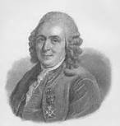](https://www.bing.com/images/search?q=carl+linnaeus&view=detailv2&&id=E3E0A7D3BD1349DD09EF9E2AD839B844708212A9&selectedIndex=23&ccid=Tm8JdUO1&simid=607994209853902260&thid=OIP.M4e6f097543b5611da593f50a9885d5c1o2)

Carl Linnaeous devised a common system to name organisms called the **binomial system.**

1. Based on Latin or Greek names
2. First name is the genus name
3. Second name is the specific name.

E.g. *Homo sapiens*

Capital letter Lowercase letter

Printed in italics

(underlined if handwritten)

**Courtship behaviour**

The behavior of members of the same species is more alike than that of members of different species. Physical and biochemical features of a species and the ability to display a behaviour is genetically determined. It influences the chances of survival and so courtship and mating is essential.

Courtship behaviours have the purpose is to make breeding more successful because it allow;

* Recognition of members of your own species is possible – to produce fertile offspring
* Identify a mate that is capable of breeding – both partners need to be sexually mature
* Form a pair bond – lead to successful mating
* Synchronise mating – so that it takes place when there is a max probability of the sperm meeting the egg
* Become able to breed but bring a member of the opposite sex into physiological state that allows breeding to occur.

Females of many species undergo a cycle of sexual activity in which they can only conceive in a short time. Courtship behaviour is used by males to determine if the female is receptive. If she responds courtship continues but if not he ceases to court her, turning his attention elsewhere.

Courtship can be used in classification as it is species specific. Species with similar rituals suggests they are more closely related to each other.

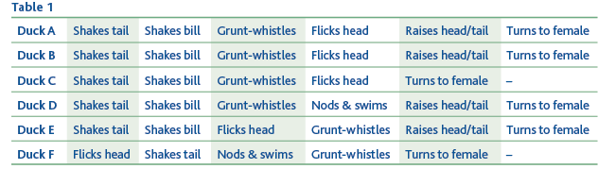

Duck A and B are same species as they have the same ritual, duck C is only a closely related species as it is only missing one element of the ritual. F displays quite a different sequence of behaviour and so is a more distant relative of A.

**Grouping species together – the principles of classification**

Grouping of organisms = classification

Theory and practice of biological classification = taxonomy

There are 2 main forms of biological classification. Research the 2 ways and complete the table below. (Pg. 205 old book, Pg. 239 new book or power point presentation ‘Species and Taxonomy’).

|  |  |
| --- | --- |
| **Artificial Classification** | **Natural/Phylogenetic Classification** |
|  |  |
|  |  |
|  |  |
|  |  |

**Organising the groups of species – taxonomy**

Each group within phylogenetic biological classification is called a taxon (plural taxa). Taxonomy is the study of these groups and their positions in a hierarchical order. They are based on evolutionary line of descent. A **domain** is the highest taxonomic rank. There are 3 **Bacteria, Archaea** and **Eukarya.**

In your old text book Domains are not mentioned so you need to use the power point presentation ‘Species and Taxonomy’ or <http://www.ucmp.berkeley.edu/alllife/threedomains.html>)

**Complete the notes below describing the main features of the 3 domains**

**Bacteria**

* ...............................................................................................................................................................
* ...............................................................................................................................................................
* ...............................................................................................................................................................
* ...............................................................................................................................................................
* ...............................................................................................................................................................

**Archaea**

* ...............................................................................................................................................................
* ...............................................................................................................................................................
* ...............................................................................................................................................................
* ...............................................................................................................................................................

**Eukarya**

* ...............................................................................................................................................................
* ...............................................................................................................................................................
* ...............................................................................................................................................................
* ...............................................................................................................................................................

The Eukarya are divided into 4 **Kingdoms**:

**Protoctista, Fungi, Plantae** and **Animalia**

Each kingdom is organised into groups called **phyla** which are in turn divided into **classes**, then **orders, families, genera** and lastly **species**.

Hierarchy is defined as groups within groups with no overlap between the groups.

Meaning the largest group is the

Kingdom (animal, plant)

Within this the animal kingdom there is the phylum, vertebrates and invertebrate,

Within the vertebrates there are classes, fish, mammals, reptiles, amphibians.

Within the mammals there are orders

This is further divided in to family

Genus and species

Use a pneumonic to remember the taxonomic grouping

Dreadful🡪 domain (eukarya)

King🡪 kingdom (animal, plant, fungi, protest, moneran)

Phillip 🡪Phylum (chordate, arthropod, mollusc,

Came 🡪Class (mammal, bird, reptile)

Over 🡪Order (carnivore, primate, rodents)

From 🡪Family (Canidae: dogs, Felidae: cats, hominidae)

Germany 🡪Genus (Acinonyx: cheetah Panthera: lion, tiger)

Swimming 🡪 Species (Panthera leo (lion), Panthera tigris (tiger)

The cheetah, *Acinonyx jubatus*, and other cat species belong to the family Felidae. Using your understanding of taxonomic grouping, complete the table below.

[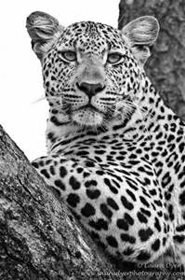](http://www.bing.com/images/search?q=cheetah+black+and+white&view=detailv2&&id=0C04D921EDEE03E5066941D102CD3F8CB85C6636&selectedIndex=5&ccid=Izn9At5l&simid=608039852473454576&thid=OIP.M2339fd02de6550f60ca5c8d6e53eb064H0)

|  |  |
| --- | --- |
| Domainain |  |
| Kingdom | Animalia |
|  | Chordata |
|  | Mammalia |
|  | Carnivora |
| Family | Felidae |
| Genus |  |
|  |  |

Using your text books (Pg. 206 old book, Pg. 241 new book) to make notes on phylogeny. Make sure you explain what phylogeny means and how phylogenetic trees can explain relationships between species. Use the trees below to help you write your notes.

**Phylogenetics**

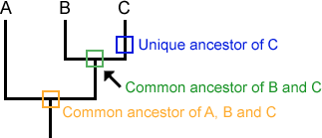

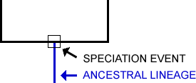

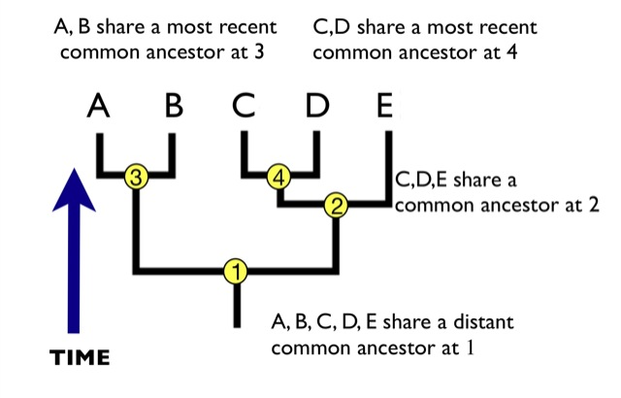

Look at the phylogenetic tree (on the next page) showing the members of the Hominidae family (great apes and humans). You can see that they evolved from a common ancestor. First orangutans diverged from the common ancestor, followed by gorillas and then humans closely followed by bonobos and chimp.

Humans and chimps are closely related as they diverged recently. You can see their branches are close together. Humans and orangutans are distantly related, diverged longer ago.

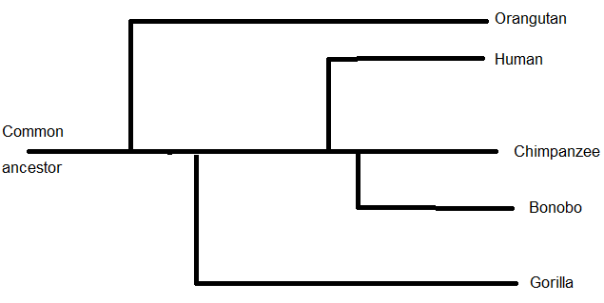

Phylogenetic tree of the Hominidae family

**Classification can have problems:**

* Inability to observe reproductive behaviour of living species, of extinct species and of those that reproduce asexually.
* Because of some of the limitations of observable features, behaviour scientists will use molecular techniques to determine the relationship between organisms. **(Techniques to compare genetic diversity and immunological comparisons to investigate variations will be covered in class).**

**Diversity within a community**

1. Text book AS Biology (old) Pgs. 226-230 (new) Pgs. 243-249
2. Bio factsheet no 34 Species Diversity (Godalming online)

**Previous knowledge – use the internet to complete these definitions**

Habitat ......................................................................................................................................

..............................................................................................................................................................

Population ......................................................................................................................................

..............................................................................................................................................................

Species ......................................................................................................................................

..............................................................................................................................................................

Community ......................................................................................................................................

..............................................................................................................................................................

Pesticides ......................................................................................................................................

..............................................................................................................................................................

Herbicide ......................................................................................................................................

..............................................................................................................................................................

Insecticide ......................................................................................................................................

..............................................................................................................................................................

Fungicide ......................................................................................................................................

..............................................................................................................................................................

Biodiversity is a general term used to describe variety in the living world. It refers to the number and variety of living organisms in a particular area and has 3 components:

1. **Species diversity** – number of different species and number of different individuals of each species within any one **community**
2. **Genetic diversity** – the variety of genes possessed by the individuals that make up a population of a species
3. **Ecosystem diversity** – the range of different **habitats** from a small local habitat to the entire Earth.

Species richness is a measure of the number of different species in a community at a given time.

**Measuring Diversity** (Pgs. 229–228 old book, Pgs. 243-245 new book)

An index of diversity describes the relationship between the number of species in a community and the number of individuals in each species.

Species diversity can give an indication of the complexity, quality and stability of a habitat but does not take account of organisms present in low/high numbers.

To get a true picture of biodiversity we need to know

**Species richness:** number of different types of species,

**Species abundance**: number of each population

To get accurate estimations of these figures we need to sample the population in such a way to avoid bias (use random sampling methods, this will also allow statistical analysis of data) and to ensure that the sample is representative (large samples)

The Simplon Diversity Index can be used to calculate the biological diversity in a habitat. It is useful as it measures the number of individuals and the number of species taking account of those present in low numbers

Calculation of an index of diversity (*d*) from the formula



d = index of diversity

*N* = total number of organisms of all species

*n* = total number of organisms of each species.

∑ = the sum of

Data from different habitats may appear to have the same number of species but the proportions may differ indicating a very different level of biodiversity. The diversity index is used to measure the species diversity.

**Worked Example**

The table below shows the number and type of species found in 2 different habitats within the same ecosystem.

|  |  |  |
| --- | --- | --- |
| **Species found** | **Numbers found in habitat X** | **Numbers found in habitat Y** |
| A | 10 | 3 |
| B | 10 | 5 |
| C | 10 | 2 |
| D | 10 | 36 |
| E | 10 | 4 |
| No. of species (n) | 5 | 5 |
| Total no. of organisms (N) | 50 | 50 |

Use the index to calculate the species diversity of the 2 habitats in the table above

You must first calculate n(n-1) for each species in each habitat.

Than you can calculate ∑n(n-1)

|  |  |  |  |  |
| --- | --- | --- | --- | --- |
| **Species** | **Numbers (n) found in habitat X** | **n(n-1)** | **Numbers (n) found in habitat Y** | **n(n-1)** |
| A | 10 | 10(9) = 90 | 3 | 3(2) = 6 |
| B | 10 | 10(9) = 90 | 5 | 5(4) = 20 |
| C | 10 | 10(9) = 90 | 2 | 2(1) = 2 |
| D | 10 | 10(9) = 90 | 36 | 36(35) = 1260 |
| E | 10 | 10(9) = 90 | 4 | 4(3) = 12 |
|  | ∑n(n-1) | 450 | ∑n(n-1) | 1300 |

You can now calculate species diversity index for each habitat using the equation above.

Habitat X: d = 50 (49) = 2450 = 5.44

450 450

Habitat Y d = 50 (49) = 2450 = 1.88

1300 1300

The **higher** the value of d, the **greater** the species diversity. So in the case above, although the total number of organisms of each species and total number of individuals are the same in both habitats, the species diversity of habitat X is much greater.

**Question**

Calculate the index of diversity for the following data samples and comment on which population has a greater species diversity

Population A Population B

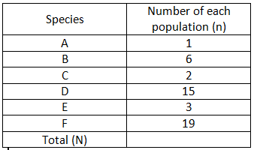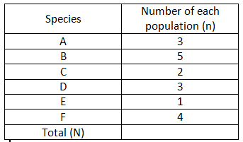

Number of organisms

Number of organisms

**Question answer - show all your working.**

**Species diversity and ecosystems** (Pgs. 227-228 old book, Pg. 245 new book)

Biodiversity reflects how well an ecosystem is likely to function. The higher the diversity index the more stable an ecosystem is and the less it is affected by change. If there was a drought at least 1 species would be able to tolerate the drought. In extreme environments the diversity index is usually low

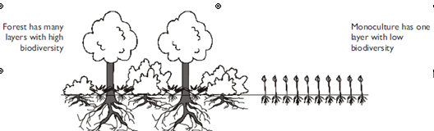

Forests have a high biodiversity because a mature forest has many different species of plants in several layers; each adapted to their own conditions of light and nutrient availability. The different plants have different animals (primary consumers) feeding on them and living in them; and the different primary consumers have different secondary consumers feeding on them. So forests contain complex food webs with high diversity.

By contrast, a field of crops has a very low diversity (especially as many farms grow monocultures) with very few plants (often just the crop and a few weeds) and so few animals. Use of pesticides (herbicide and insecticide) will reduce biodiversity further. Use of fertilisers can lead to leaching (liquid draining off farmland into waterways) and eutrophication (water becomes lifeless except for bacteria that can survive anaerobic conditions) in ponds and lakes which kills living organisms

Deforestation therefore reduces biodiversity.

**Species diversity and human activities.**

Agriculture has a large impact on species diversity. It has led to a reduction in biodiversity.

**Read the AQA text book Pg. 229 (Old book) or Pg. 246 (New book) and use information to annotate below.**

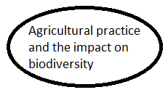

**Balance between conservation and farming**.

Due to an ever increasing population, agriculture has changed in order to produce enough food. Improved genetic varieties (through selective breeding and genetic modification) of plant and animal species, greater use of chemical fertilisers and pesticides, greater use of biotechnology and changes in farm practices have led to larger farms and conversion of natural communities into farmland. These changes have large ecological effects and ultimately a reduction in species diversity.

**Research:** use the internet to research the following topics and make notes on them.

[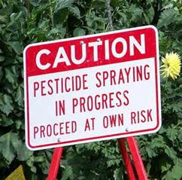](https://www.bing.com/images/search?q=pesticides&view=detailv2&&id=32FCCB6A6FDFE57EE7AF96031BA4E96E99A28151&selectedIndex=3&ccid=FxX6Zxdu&simid=608047647830837252&thid=OIP.M1715fa67176ee6258cc931b985c2914do0)

1. Farm practices that remove habitats and reduce species diversity

[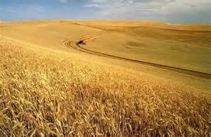](https://www.bing.com/images/search?q=monocultures&view=detailv2&&id=1D12C6204D60CA188AC7BED90D4AAEFF0516BF5E&selectedIndex=4&ccid=l1nPM2gh&simid=608001859187442694&thid=OIP.M9759cf336821758bd0eff64d698b1d0ao0)

**2.** Management/conservation techniques that can increase species and habitat diversity which have been taken away by intensive food production.

[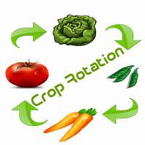](https://www.bing.com/images/search?q=crop+rotation&view=detailv2&&id=548D016BC6BA2DECA75E106F38C8C45498C58E98&selectedIndex=33&ccid=2G/H%2bcsb&simid=608040024265854469&thid=OIP.Md86fc7f9cb1b37a841659dbcfa1405d3H0)

[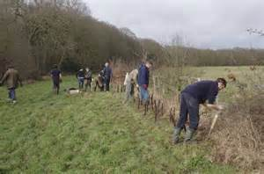](https://www.bing.com/images/search?q=planting+hedgerows+farmers&view=detailv2&&id=059150E98B34C50900809B44369BB946CA8236A0&selectedIndex=1&ccid=ptmFiLv2&simid=608019837915170505&thid=OIP.Ma6d98588bbf6a92f7d19a2813e8d425co0)

**Quantitative investigations of variation**

1. Text book AS Biology (old) Pgs. 124-127 (new) Pgs. 253-256

**Interspecific variation** = variation between different species

**Intraspecific variation** = variation between individuals of the same species

**Ways of measuring variation in a population or community– Random Sampling**

This involves taking measurements of individuals from a population and should be representative of the population as a whole. Read about how random sampling is done and complete the sections below.

Investigations of living things **may not be** representative due to:

* **Sampling bias**  ............................................................................................................................

...............................................................................................................................................................................................................................................................................................................................

* **Chance** ............................................................................................................................

................................................................................................................................................................................................................................................................................................................................

Describe how to estimate the number of daisies growing in a field

**Random Sampling** – outline how you could sample a meadow using a quadrat to illuminate human involvement that could cause bias

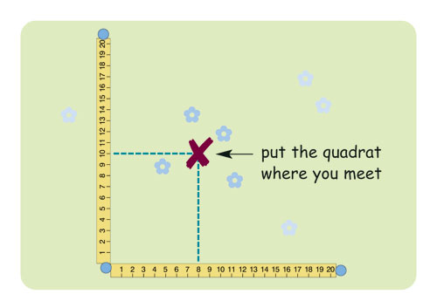

List the ways in which the sampling process can minimize the effects of chance

1. ................................................................................................................................................................................................................................................................................................................................................................................................................................................................................................
2. ................................................................................................................................................................................................................................................................................................................................................................................................................................................................................................

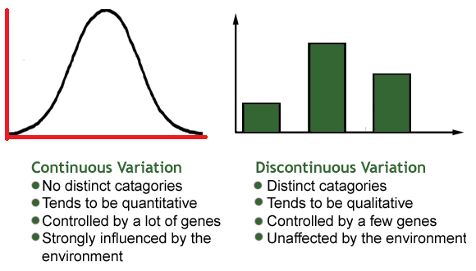**Types of variation.**

Variation is the result of either genetic differences or environmental factors or a combination of both.

**The normal distribution**

Bell-shaped curve that shows continuous variation. It can be skewed to one side.

Mean, mode and median are associated with normal distributions

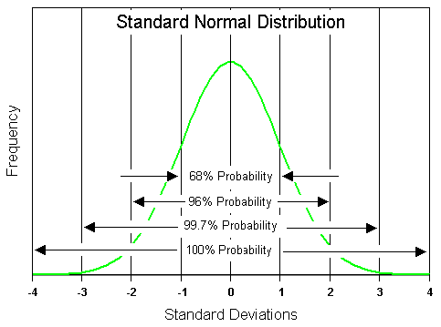

**Mean**

Calculated by the sum of all sampled values divided by the number of values themselves.

**Mode**

The single value that occurs the most in a data set.

**Median**

The central or middle value in a set of values. You need to arrange the values in ascending order to calculate this.

**Standard Deviation**

[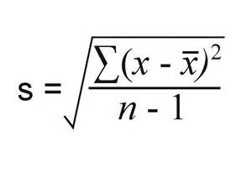](https://www.bing.com/images/search?q=standard+deviation&view=detailv2&&id=78963231044AC72965DFA9A3A17E0C70CB4347A3&selectedIndex=10&ccid=qO6xHONw&simid=608033659125632400&thid=OIP.Ma8eeb11ce370810d2b3da4af67966397o0)

The formula for standard deviation is:

Where ∑ = sum of

X = measured value (from sample)

X = mean value

n = total number of values in the sample

**Normal distribution and Standard deviation and mean**

Mean = measurement of the height of the curve – it does not say anything about the range of values just the average value.

Standard deviation is measure of the width of the curve and shows the range of values either side of the mean Therefore this shows the spread of the results around the mean

Furthermore, the standard deviation can be used in statistical analysis to look for **significant differences.**

From a sample of data

68% of the data values will lie 1 standard deviation either side of the mean

99% of the data values will lie within 2 standard deviations of the mean

**Worked Example**

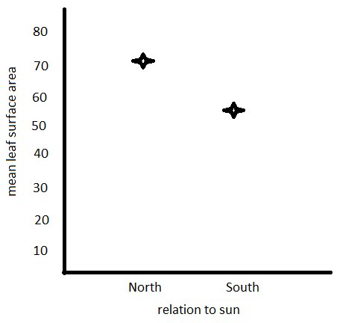**A hypothesis was made about leaves on a plant; south facing leaves are smaller than north facing leave.**

**Results obtained:**

Mean surface area of south facing leaves 50mm2

Mean surface area of north facing leaves 70mm2

On this basis you would probably accept that the hypothesis was correct.

However, what happens when we add in the SD, the spread of the results around the mean

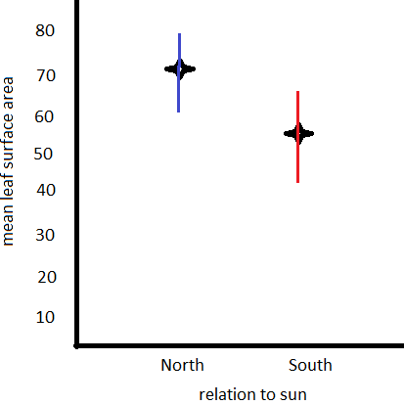

**Standard deviations were calculated:**

South leaves =50mm2 ± 14

North leaves = 70mm2 ± 17

We can see there is an overlap in standard deviations

The maximum size of south leaves was 64mm2, and the minimum size of north leaves was 53 mm2, so sometimes south leaves are bigger than north leaves so the difference in length may not be a significant difference all the time.

**Question**

A Sri Lankan scientist investigated the effect of human disturbance on the organisms living on a rocky seashore. He chose three areas for the study. These areas had different amounts of human disturbance.

The scientist measured human disturbance by walking from one end of the beach to the other. He recorded the number of people he encountered. **Figure 1** shows his results.

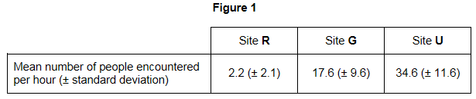

What conclusions can you draw about the number of people visiting Site **R** compared with the number of people visiting the other two sites? Give evidence from **Figure 1** to support your answer. (2) ……………………………..…………………………………………………………….

……………………………………………………………………………………………………………………………………………………………………………………………………………………

**Exam Questions**

**Q1.**(a)     What is a *species?*

........................................................................................................................

........................................................................................................................

........................................................................................................................

**(2)**

(b)     Scientists investigated the diversity of plants in a small area within a forest. The table shows their results.

|  |  |  |
| --- | --- | --- |
|  | **Plant species** | **Number of individuals** |
|  | Himalayan raspberry | 20 |
|  | Heartwing sorrel | 15 |
|  | Shala tree | 9 |
|  | Tussock grass | 10 |
|  | Red cedar | 4 |
|  | Asan tree | 6 |
|  | Spanish needle | 8 |
|  | Feverfew | 8 |

The index of diversity can be calculated by the formula



where

*d* = index of diversity  
*N* = total number of organisms of all species  
*n* = total number of organisms of each species

(i)      Use the formula to calculate the index of diversity of plants in the forest. Show your working.

 Answer .....................................

**(2)**

(ii)     The forest was cleared to make more land available for agriculture.

After the forest was cleared the species diversity of insects in the area decreased. Explain why.

...............................................................................................................

...............................................................................................................

...............................................................................................................

...............................................................................................................

...............................................................................................................

...............................................................................................................

(Extra space).........................................................................................

...............................................................................................................

...............................................................................................................

**(3)**

**(Total 7 marks)**

**Q2.**There are over 200 species of catfish. All catfish evolved from a common ancestor.  
The diagram shows how some species of catfish are classified. This diagram is based on the evolutionary links between these species.

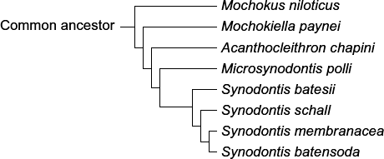

(a)     (i)      Which species of catfish is most closely related to *Synodontis membranacea*?

...............................................................................................................

**(1)**

(ii)     Which species of catfish is most distantly related to *Synodontis membranacea*?

...............................................................................................................

**(1)**

(b)     How many different genera are shown in this diagram?



**(1)**

(c)     (i)      A scientist carried out breeding experiments with catfish from different populations.  
Describe how the results could show that the catfish belong to the same species.

...............................................................................................................

...............................................................................................................

...............................................................................................................

**(1)**

(ii)     The variety of colours displayed by catfish is important in courtship. Give **two** ways in which courtship increases the probability of successful mating.

1 ............................................................................................................

...............................................................................................................

2 ............................................................................................................

...............................................................................................................

**(2)**

**(Total 6 marks)**

**Q3.**          Hummingbirds belong to the order Apodiformes. One genus in this order is *Topaza*.

(a)     (i)      Name **one** other taxonomic group to which all members of the Apodiformes belong.

...............................................................................................................

**(1)**

(ii)     Name the taxonomic group between order and genus.

...............................................................................................................

**(1)**

The crimson topaz and the fiery topaz are hummingbirds.

Biologists investigated whether the crimson topaz and the fiery topaz are different species of hummingbird, or different forms of the same species.

They caught large numbers of each type of hummingbird. For each bird they

•        recorded its sex

•        recorded its mass

•        recorded the colour of its throat feathers

•        took a sample of a blood protein.

The table shows some of their results.

|  |  |  |  |  |  |
| --- | --- | --- | --- | --- | --- |
|  |  | **Crimson topaz** | | **Fiery topaz** | |
|  |  | **Male** | **Female** | **Male** | **Female** |
|  | Mean mass / g (± standard deviation) | 13.6 (±1.9) | 10.8 (±1.3) | 14.2 (±1.6) | 11.6 (±0.63) |
|  | Colour of throat feathers | Green | Grey edges | Yellowish green | No grey edges |

(b)     Explain how the standard deviation helps in the interpretation of these data.

........................................................................................................................

........................................................................................................................

........................................................................................................................

........................................................................................................................

........................................................................................................................

**(2)**

(c)     The biologists analysed the amino acid sequences of the blood protein samples from these hummingbirds.

Explain how these sequences could provide evidence as to whether the crimson topaz and the fiery topaz are different species.

........................................................................................................................

........................................................................................................................

........................................................................................................................

........................................................................................................................

........................................................................................................................

**(2)**

**(Total 6 marks)**

**Q4.**The following figure shows how some animals with hooves are classified.

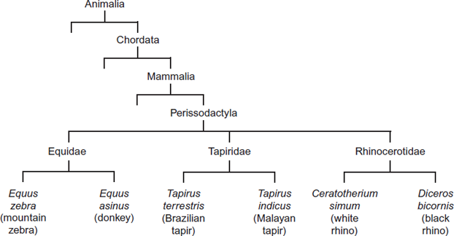

(a)     This type of classification can be described as a phylogenetic hierarchy.

(i)      What is meant by a **hierarchy**?

...............................................................................................................

...............................................................................................................

...............................................................................................................

*(Extra space)* ........................................................................................

...............................................................................................................

**(2)**

(ii)     How many different families are shown in the figure?



**(1)**

(iii)    To which phylum does the white rhino belong?

...............................................................................................................

**(1)**

(b)     (i)      Explain the role of independent segregation in meiosis.

...............................................................................................................

...............................................................................................................

...............................................................................................................  **(2)**

(ii)     A zedonk is the offspring produced from breeding a mountain zebra with a donkey.

•        The body cells of a mountain zebra contain 32 chromosomes.

•        The body cells of a donkey contain 62 chromosomes.

Use this information to suggest why zedonks are usually infertile.

...............................................................................................................

...............................................................................................................

...............................................................................................................

...............................................................................................................

**(2)**

**(Total 8 marks)**

**Q5.**          Scientists investigated the species of insects found in a wood and in a nearby wheat field. The scientists collected insects by placing traps at sites chosen at random both in the wood and in the wheat field.

The table shows the data collected in the wood and in the wheat field.

|  |  |  |
| --- | --- | --- |
| **Species of insect** | **Number of organisms of each species** | |
| **Wood** | **Wheat field** |
| Bird-cherry oat aphid | 0 | 216 |
| Beech aphid | 563 | 0 |
| Large white butterfly | 20 | 0 |
| Lacewing | 12 | 3 |
| 7-spot ladybird | 36 | 0 |
| 2-spot ladybird | 9 | 1 |
| Total number of organisms of all species | 640 | 220 |

(a)     The scientists collected insects at sites chosen at random. Explain the importance of the sites being chosen at random.

........................................................................................................................

........................................................................................................................

........................................................................................................................

**(1)**

(b)     (i)      Use the formula



to calculate the index of diversity for the insects caught in the wood, where

*d* = index of diversity *N* = total number of organisms of all species *n* = total number of organisms of each species

Show your working.

                               Answer ...................................................................

**(2)**

(ii)     Without carrying out any further calculations, estimate whether the index of diversity for the wheat field would be higher or lower than the index of diversity for the wood.

Explain how you arrived at your answer.

...............................................................................................................

...............................................................................................................

...............................................................................................................

...............................................................................................................

**(2)**

(c)     A journalist concluded that this investigation showed that farming reduces species diversity.  
Evaluate this conclusion.

........................................................................................................................

........................................................................................................................

........................................................................................................................

........................................................................................................................

**(2)**

(d)     Farmers were offered grants by the government to plant hedges around their fields.  
Explain the effect planting hedges could have on the index of diversity for animals.

........................................................................................................................

........................................................................................................................

........................................................................................................................

........................................................................................................................

**(Total 9 marks) (2)**

**Q6.**(a)     What **two** measurements are needed to calculate an index of diversity?

1 .....................................................................................................................

2 .....................................................................................................................

**(2)**

(b)     A herbicide is a chemical used to kill weeds. Ecologists investigated the effect of a herbicide on crop yield and the diversity of insects. They sprayed different fields with the same volume of different concentrations of the herbicide. At harvest, the ecologists determined the mean crop yield and the mean index of diversity of insects for fields that had received the same concentration of the herbicide.

The figure below shows their results.

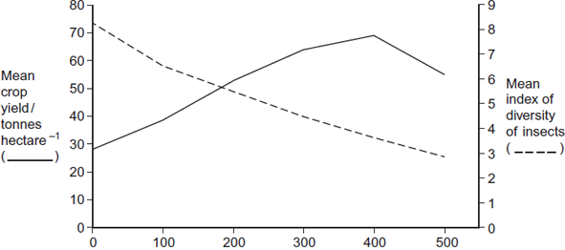  
Concentration of herbicide sprayed on field / mg dm−3

(i)      Some fields acted as controls. They were sprayed with a solution that did not contain the herbicide. Explain the purpose of these control fields.

...............................................................................................................

...............................................................................................................

...............................................................................................................

**(1)**

(ii)     Suggest an explanation for the relationship between the concentration of herbicide and the mean crop yield.

...............................................................................................................

...............................................................................................................

...............................................................................................................

...............................................................................................................

**(2)**

(iii)     Explain the relationship between the concentration of herbicide and the mean index of diversity of insects.

...............................................................................................................

...............................................................................................................

...............................................................................................................

...............................................................................................................

...............................................................................................................

...............................................................................................................

*(Extra space)* ........................................................................................

...............................................................................................................

...............................................................................................................

**(3)**

**(Total 8 marks)**