**Answer Booklet**

**3.4.5, 3.4.5 & 3.4.7**

**Species, Taxonomy & Biodiversity Independent Study**

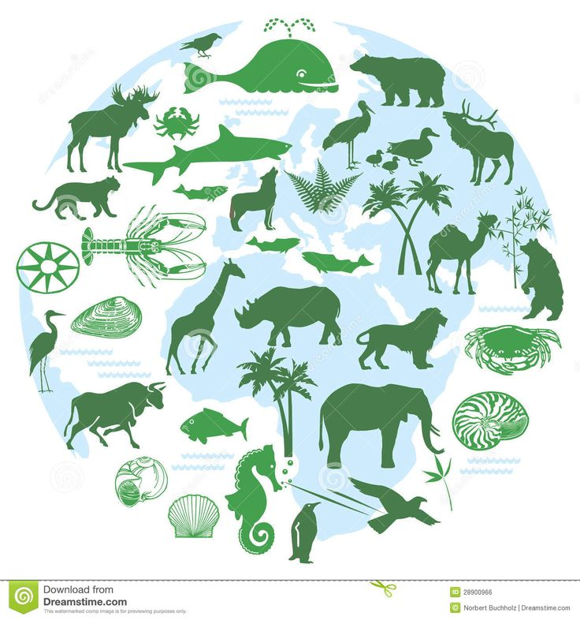

**You are expected to work through this booklet independently and complete all sections.**

**3 sections of the course will be covered:**

1. **Species and taxonomy**
2. **Biodiversity within a community**
3. **Investigating diversity**

**Specification Content**

**Species and Taxonomy**

* Two organisms belong to the same species if they are able to produce fertile offspring. Courtship behaviour as a necessary precursor to successful mating. The role of courtship in species recognition.
* A phylogenetic classification system attempts to arrange species into groups based on their evolutionary origins and relationships. It uses a hierarchy in which smaller groups are placed within larger groups, with no overlap between groups. Each group is called a taxon (plural taxa).
* One hierarchy comprises the taxa: domain, kingdom, phylum, class, order, family, genus and species.
* Each species is universally identified by a binomial consisting of the name of its genus and species, e.g., Homo sapiens.
* Recall of different taxonomic systems, such as the three domain or five kingdom systems, will not be required.
* **Students should be able to** appreciate that advances in immunology and genome sequencing help to clarify evolutionary relationships between organisms.

**Biodiversity within a community**

* Biodiversity can relate to a range of habitats, from a small local habitat to the Earth.
* Species richness is a measure of the number of different species in a community.
* An index of diversity describes the relationship between the number of species in a community and the number of individuals in each species.
* Calculation of an index of diversity (d) from the formula d = N (N −1)

∑n( n−1)

* Where N = total number of organisms of all species and n = total number of organisms of each species.
* Farming techniques reduce biodiversity. The balance between conservation and farming

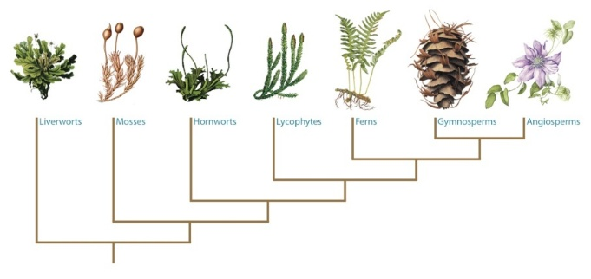**Quantitative investigations of diversity**

Quantitative investigations of variation within a species involve:

• collecting data from random samples

• calculating a mean value of the collected data and the standard deviation of that mean

• interpreting mean values and their standard deviations.

Students will not be required to calculate standard deviations in written papers.

**Species and Taxonomy**

**Read through all of these references and watch all videos. Using the information you have read complete the booklet.**

1. Watch the following videos

[Domain theory video](https://www.bing.com/videos/search?q=species+and+taxonomy+domain+theory&&view=detail&mid=E96A0B9CE2500A15879DE96A0B9CE2500A15879D&FORM=VRDGAR) (Mr. Anderson Biology – the 3 domains of life)

<https://www.bing.com/videos/search?q=species+and+taxonomy+domain+theory&&view=detail&mid=E96A0B9CE2500A15879DE96A0B9CE2500A15879D&FORM=VRDGAR>

[Phylogentics](https://www.bing.com/videos/search?q=Mr.+Anderson+Biology&&view=detail&mid=5BF1CAF17164025387285BF1CAF1716402538728&FORM=VRDGAR) (Mr. Anderson Biology – phylogenetics) <https://www.bing.com/videos/search?q=Mr.+Anderson+Biology&&view=detail&mid=5BF1CAF17164025387285BF1CAF1716402538728&FORM=VRDGAR>

1. Godalming online power point Species and Taxonomy
2. Text book AS Biology (old) Pgs. 204-207, 213-214 (new) Pgs. 237-242
3. Bio factsheet no 91 Taxonomy and Classification (Godalming online)

**Activity: The Next Bug Thing**

Purpose

• To provide practice in reading and analysing extended text.

• To introduce binomial nomenclature and taxonomy.

Beetle mania

Many of the scientists who work on cataloguing biodiversity are specialists in one group

of organisms. Much of their work goes on hidden behind the scenes in museums and research institutes around the world. Get an idea of the scale of biodiversity and the challenge faced by the biologists researching just one group by reading the extract of the article ‘The next bug thing’ (found on Godalming online articles and resources folder). This is about two beetle taxonomists, Martin Brendell and Peter Hammond, who work at the Natural History Museum in London.

Look up any words that you are unfamiliar with before answering the following questions based on the text.

Questions

Q1 What does Martin Brendell mean when he says that the beetle found in the Kalahari is probably an ‘unrecorded species’?

**A species that has not been named/formally described.**

Q2 How many species of beetle have been ‘described’ by scientists so far and what does this term mean?

**450 000 named and had the characteristics that distinguish them from other species written down and published in the academic literature**.

Q3 Using Peter Hammond’s lowest estimate of total number of beetle species, calculate what percentage of the estimated total number of beetle species have been described so far.

**450 000/1 000 000 x 100 = 45%**

Q4 Describe the characteristic features that all beetles have in common.

**Exoskeleton, biting mandibles, six legs, hard wing covers and four distinct life stages.**

Q5 How many scientific names does each beetle species have? State one example.

**Two, for example Blaps gigantean, Pogonus rodolphi.**

Q6 Who devised the system of naming used by all biologists today?

**Carl von Linné (the Latin version of his name is Carolus Linnaeus).**

Q7 What are holotypes?

**The original specimens that were used to describe the species and against which other potential members of the same species are compared.**

Q8 Why do you think that the process of describing and naming organisms is actually one of the constraints in cataloguing global biodiversity?

**It takes a great deal of time to make sure that no one else has already identified and named the organism. Detailed drawings, measurements and observations are needed**.

**Species and Taxonomy** (Pgs. 204-207 old text book, Pgs. 237-242 new text book)

Estimates for the total number of species on Earth vary from 10 to 100 million. Classification is the organising of living organisms into groups based on similarities and differences. There are a few classification systems in use.

Using your text book (Pg. 204 old book Pg.237 new book), write the definition of a species below.

**Definition of species**

**Can breed together in their natural environment to produce fertile offspring.**

**Are similar in appearance (morphology), behaviour and biochemistry, and have the same ecological niche**

**Binomial system of naming species**

[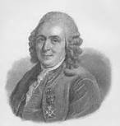](https://www.bing.com/images/search?q=carl+linnaeus&view=detailv2&&id=E3E0A7D3BD1349DD09EF9E2AD839B844708212A9&selectedIndex=23&ccid=Tm8JdUO1&simid=607994209853902260&thid=OIP.M4e6f097543b5611da593f50a9885d5c1o2)

Carl Linnaeous devised a common system to name organisms called the **binomial system.**

1. Based on Latin or Greek names
2. First name is the genus name
3. Second name is the specific name.

E.g. *Homo sapiens*

Capital letter Lowercase letter

Printed in italics

(underlined if handwritten)

**Courtship behaviour**

The behavior of members of the same species is more alike than that of members of different species. Physical and biochemical features of a species and the ability to display a behaviour is genetically determined. It influences the chances of survival and so courtship and mating is essential.

Courtship behaviours have the purpose is to make breeding more successful because it allow;

* Recognition of members of your own species is possible – to produce fertile offspring
* Identify a mate that is capable of breeding – both partners need to be sexually mature
* Form a pair bond – lead to successful mating
* Synchronise mating – so that it takes place when there is a max probability of the sperm meeting the egg
* Become able to breed but bring a member of the opposite sex into physiological state that allows breeding to occur.

Females of many species undergo a cycle of sexual activity in which they can only conceive in a short time. Courtship behaviour is used by males to determine if the female is receptive. If she responds courtship continues but if not he ceases to court her, turning his attention elsewhere.

Courtship can be used in classification as it is species specific. Species with similar rituals suggests they are more closely related to each other.

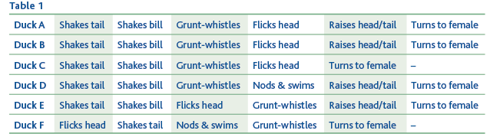

Duck A and B are same species as they have the same ritual, duck C is only a closely related species as it is only missing one element of the ritual. F displays quite a different sequence of behaviour and so is a more distant relative of A.

**Grouping species together – the principles of classification**

Grouping of organisms = classification

Theory and practice of biological classification = taxonomy

There are 2 main forms of biological classification. Research the 2 ways and complete the table below. (Pg. 205 old book, Pg. 239 new book or power point presentation ‘Species and Taxonomy’).

|  |  |
| --- | --- |
| **Artificial Classification** | **Natural/Phylogenetic Classification** |
| **Grouped according to simple, observable  differences e.g. colour, size, no. of legs** | **Based on evolutionary relationships** |
| **Analogous Characteristics = the same  function with different evolutionary  origins e.g. wings in butterflies & birds** | **Species classified into groups using shared  features derived from ancestors** |
|  | **Groups are arranged into a hierarchy - i.e.  groups into larger groups with no overlap** |
|  | **Based on homologous characteristics (same  origin, different function**  **e.g. wing of bat, arm of human** |

**Organising the groups of species – taxonomy**

Each group within phylogenetic biological classification is called a taxon (plural taxa). Taxonomy is the study of these groups and their positions in a hierarchical order. They are based on evolutionary line of descent. A **domain** is the highest taxonomic rank. There are 3 **Bacteria, Archaea** and **Eukarya.**

In your old text book Domains are not mentioned so you need to use the power point presentation ‘Species and Taxonomy’ or <http://www.ucmp.berkeley.edu/alllife/threedomains.html>)

**Complete the notes below describing the main features of the 3 domains**

**Bacteria**

* **The absence of membrane-bounded organelles e.g. nuclei, mitochondria**
* **Unicellular, although cells may occur in chains or clusters**
* **Ribosomes are smaller (70s) than eukaryotic cells**
* **Cell walls present and made of murein (never chitin or cellulose)**
* **Single loop of naked DNA make up of nucleic acids but no histones**

**Archaea**

* **their genes and protein synthesis are more similar to eukaryotes**
* **their membranes contain fatty acid chains attached to glycerol by ether linkages**
* **there is no murein in their cell walls**
* **they have a more complex form of RNA polymerase.**

**Eukarya**

* **their cells have membrane-bounded organelles e.g. mitochondria or chloroplasts**
* **they have membranes containing fatty acid chains attached to glycerol by wester linkages**
* **not all possess cells with cell walls but if they do it contains no murein**
* **ribosomes are larger (80s) than in Bacteria or Archaea.**

The Eukarya are divided into 4 **Kingdoms**:

**Protoctista, Fungi, Plantae** and **Animalia**

Each kingdom is organised into groups called **phyla** which are in turn divided into **classes**, then **orders, families, genera** and lastly **species**.

Hierarchy is defined as groups within groups with no overlap between the groups.

Meaning the largest group is the

Kingdom (animal, plant)

Within this the animal kingdom there is the phylum, vertebrates and invertebrate,

Within the vertebrates there are classes, fish, mammals, reptiles, amphibians.

Within the mammals there are orders

This is further divided in to family

Genus and species

Use a pneumonic to remember the taxonomic grouping

Dreadful🡪 domain (eukarya)

King🡪 kingdom (animal, plant, fungi, protest, moneran)

Phillip 🡪Phylum (chordate, arthropod, mollusc,

Came 🡪Class (mammal, bird, reptile)

Over 🡪Order (carnivore, primate, rodents)

From 🡪Family (Canidae: dogs, Felidae: cats, hominidae)

Germany 🡪Genus (Acinonyx: cheetah Panthera: lion, tiger)

Swimming 🡪 Species (Panthera leo (lion), Panthera tigris (tiger)

The cheetah, *Acinonyx jubatus*, and other cat species belong to the family Felidae. Using your understanding of taxonomic grouping, complete the table below.

[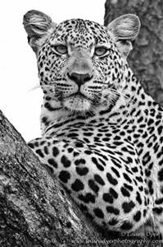](http://www.bing.com/images/search?q=cheetah+black+and+white&view=detailv2&&id=0C04D921EDEE03E5066941D102CD3F8CB85C6636&selectedIndex=5&ccid=Izn9At5l&simid=608039852473454576&thid=OIP.M2339fd02de6550f60ca5c8d6e53eb064H0)

|  |  |
| --- | --- |
| Domainain |  |
| Kingdom | Animalia |
| **Phyllum** | Chordata |
| **Class** | Mammalia |
| **Order** | Carnivora |
| Family | Felidae |
| Genus | ***Acinonyx*** |
| **Species** | ***jubatus*** |

Using your text books (Pg. 206 old book, Pg. 241 new book) to make notes on phylogeny. Make sure you explain what phylogeny means and how phylogenetic trees can explain relationships between species. Use the trees below to help you write your notes.

**Phylogenetics**

**Hierarchical order of taxonomic ranks bases on supposed evolutionary line of descent of the group members. Phylogeny reflects the evolutionary branch that led up to the grouping. Phylogenetic relationships of different species are usually represented by a tree-like diagram called a phylogenetic tree. The oldest species is at the base of the tree while the most recent ones are represented by the ends of the branches.**

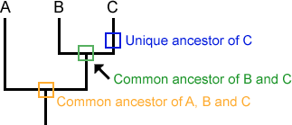

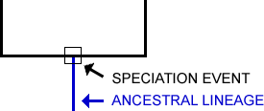

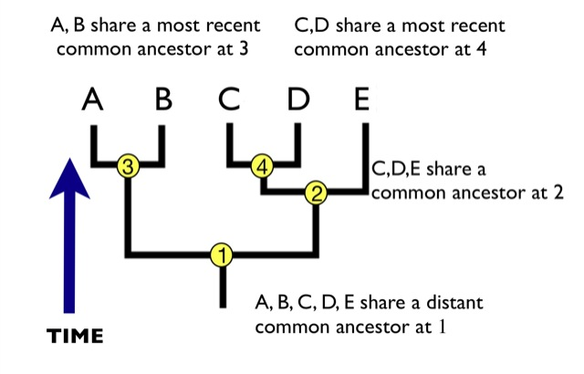

Look at the phylogenetic tree (on the next page) showing the members of the Hominidae family (great apes and humans). You can see that they evolved from a common ancestor. First orangutans diverged from the common ancestor, followed by gorillas and then humans closely followed by bonobos and chimp.

Humans and chimps are closely related as they diverged recently. You can see their branches are close together. Humans and orangutans are distantly related, diverged longer ago.

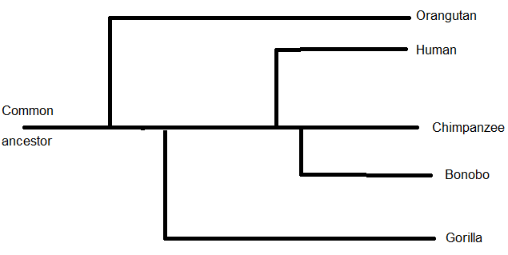

Phylogenetic tree of the Hominidae family

**Classification can have problems:**

* Inability to observe reproductive behaviour of living species, of extinct species and of those that reproduce asexually.
* Because of some of the limitations of observable features, behaviour scientists will use molecular techniques to determine the relationship between organisms. **(Techniques to compare genetic diversity and immunological comparisons to investigate variations will be covered in class).**

**Diversity within a community**

1. Text book AS Biology (old) Pgs. 226-230 (new) Pgs. 243-249
2. Bio factsheet no 34 Species Diversity (Godalming online)

**Previous knowledge – use the internet to complete these definitions**

Habitat **The place where an organism normally lives and which is characterised byu physical conditions and the types of other organisms present**

Population **A group of individuals of the same species that occupy the same habitat at the same time.**

Species **A group of similar organisms that can breed together to produce fertile offspring**.

Community **All the living organisms present in an ecosystem at a given time**.

Pesticides **A substance used for destroying insects or other organisms harmful to cultivated plants or to animals**

Herbicide **A substance that is toxic to plants, used to destroy unwanted vegetation**

Insecticide **A substance used for killing insects**

Fungicide **A chemical that destroys fungi.**

Biodiversity is a general term used to describe variety in the living world. It refers to the number and variety of living organisms in a particular area and has 3 components:

1. **Species diversity** – number of different species and number of different individuals of each species within any one **community**
2. **Genetic diversity** – the variety of genes possessed by the individuals that make up a population of a species
3. **Ecosystem diversity** – the range of different **habitats** from a small local habitat to the entire Earth.

Species richness is a measure of the number of different species in a community at a given time.

**Measuring Diversity** (Pgs. 229–228 old book, Pgs. 243-245 new book)

An index of diversity describes the relationship between the number of species in a community and the number of individuals in each species.

Species diversity can give an indication of the complexity, quality and stability of a habitat but does not take account of organisms present in low/high numbers.

To get a true picture of biodiversity we need to know

**Species richness:** number of different types of species,

**Species abundance**: number of each population

To get accurate estimations of these figures we need to sample the population in such a way to avoid bias (use random sampling methods, this will also allow statistical analysis of data) and to ensure that the sample is representative (large samples)

The Simplon Diversity Index can be used to calculate the biological diversity in a habitat. It is useful as it measures the number of individuals and the number of species taking account of those present in low numbers

Calculation of an index of diversity (*d*) from the formula



d = index of diversity

*N* = total number of organisms of all species

*n* = total number of organisms of each species.

∑ = the sum of

Data from different habitats may appear to have the same number of species but the proportions may differ indicating a very different level of biodiversity. The diversity index is used to measure the species diversity.

**Worked Example**

The table below shows the number and type of species found in 2 different habitats within the same ecosystem.

|  |  |  |
| --- | --- | --- |
| **Species found** | **Numbers found in habitat X** | **Numbers found in habitat Y** |
| A | 10 | 3 |
| B | 10 | 5 |
| C | 10 | 2 |
| D | 10 | 36 |
| E | 10 | 4 |
| No. of species (n) | 5 | 5 |
| Total no. of organisms (N) | 50 | 50 |

Use the index to calculate the species diversity of the 2 habitats in the table above

You must first calculate n(n-1) for each species in each habitat.

Than you can calculate ∑n(n-1)

|  |  |  |  |  |
| --- | --- | --- | --- | --- |
| **Species** | **Numbers (n) found in habitat X** | **n(n-1)** | **Numbers (n) found in habitat Y** | **n(n-1)** |
| A | 10 | 10(9) = 90 | 3 | 3(2) = 6 |
| B | 10 | 10(9) = 90 | 5 | 5(4) = 20 |
| C | 10 | 10(9) = 90 | 2 | 2(1) = 2 |
| D | 10 | 10(9) = 90 | 36 | 36(35) = 1260 |
| E | 10 | 10(9) = 90 | 4 | 4(3) = 12 |
|  | ∑n(n-1) | 450 | ∑n(n-1) | 1300 |

You can now calculate species diversity index for each habitat using the equation above.

Habitat X: d = 50 (49) = 2450 = 5.44

450 450

Habitat Y d = 50 (49) = 2450 = 1.88

1300 1300

The **higher** the value of d, the **greater** the species diversity. So in the case above, although the total number of organisms of each species and total number of individuals are the same in both habitats, the species diversity of habitat X is much greater.

**Question**

Calculate the index of diversity for the following data samples and comment on which population has a greater species diversity

Population A Population B

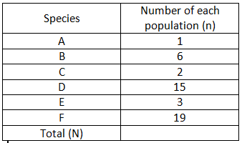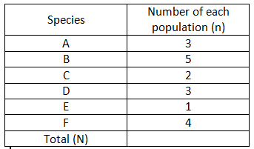

Number of organisms

Number of organisms

Question answer - show all your working.

|  |  |  |  |  |
| --- | --- | --- | --- | --- |
| Species | Numbers (n) found in population A | n(n-1) | Numbers (n) found in population B | n(n-1) |
| A | 1 | 1(0) = 0 | 3 | 3(2) = 6 |
| B | 6 | 6(5) = 30 | 5 | 5(4) = 20 |
| C | 2 | 2(1) = 2 | 2 | 2(1) = 2 |
| D | 15 | 15(14) = 210 | 3 | 3(2) = 6 |
| E | 3 | 3(2) = 6 | 1 | 1(0) = 0 |
| F | 19 | 19(18) = 342 | 4 | 4(3) = 12 |
| Total | 46 (N) | 590 ∑n(n-1) | 18 (N) | 46 ∑n(n-1) |



**For population A d = 46(45) = 2070 = 3.70**

**590 590**

**For Population B d = 18(17) = 306 = 6.65**

**46 46**

**From the calculations – population B show more species diversity than A.**

**Species diversity and ecosystems** (Pgs. 227-228 old book, Pg. 245 new book)

Biodiversity reflects how well an ecosystem is likely to function. The higher the diversity index the more stable an ecosystem is and the less it is affected by change. If there was a drought at least 1 species would be able to tolerate the drought. In extreme environments the diversity index is usually low

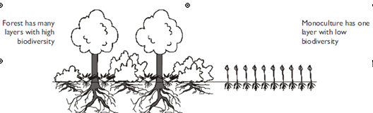

Forests have a high biodiversity because a mature forest has many different species of plants in several layers; each adapted to their own conditions of light and nutrient availability. The different plants have different animals (primary consumers) feeding on them and living in them; and the different primary consumers have different secondary consumers feeding on them. So forests contain complex food webs with high diversity.

By contrast, a field of crops has a very low diversity (especially as many farms grow monocultures) with very few plants (often just the crop and a few weeds) and so few animals. Use of pesticides (herbicide and insecticide) will reduce biodiversity further. Use of fertilisers can lead to leaching (liquid draining off farmland into waterways) and eutrophication (water becomes lifeless except for bacteria that can survive anaerobic conditions) in ponds and lakes which kills living organisms

Deforestation therefore reduces biodiversity.

**Species diversity and human activities.**

Agriculture has a large impact on species diversity. It has led to a reduction in biodiversity.

**Read the AQA text book Pg. 229 (Old book) or Pg. 246 (New book) and use information to annotate below.**

**Natural ecosystems – complex communities, lots individuals and lots species = high index of diversity**

**Agricultural ecosystems – controlled by humans, species chosen by farmers to have particular qualities to increase productivity. This leads to less species and genetic variety of alleles is reduced.**

**For productivity – need large population of a farmers chosen species.**

**Any area can only support a certain amount of biomass. This leads to competition.**

**Native species will compete for minerals, light, ions, water and food – many do not survive.**

**If native species do out-compete farmers chosen species, pesticides may be used to remove them.**

**This leads to massive reduction in diversity and index of diversity goes down.**

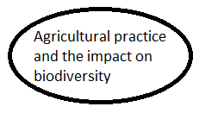

**Balance between conservation and farming**.

Due to an ever increasing population, agriculture has changed in order to produce enough food. Improved genetic varieties (through selective breeding and genetic modification) of plant and animal species, greater use of chemical fertilisers and pesticides, greater use of biotechnology and changes in farm practices have led to larger farms and conversion of natural communities into farmland. These changes have large ecological effects and ultimately a reduction in species diversity.

**Research:** use the internet to research the following topics and make notes on them.

[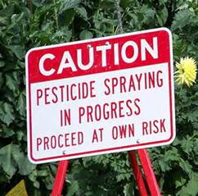](https://www.bing.com/images/search?q=pesticides&view=detailv2&&id=32FCCB6A6FDFE57EE7AF96031BA4E96E99A28151&selectedIndex=3&ccid=FxX6Zxdu&simid=608047647830837252&thid=OIP.M1715fa67176ee6258cc931b985c2914do0)

1. Farm practices that remove habitats and reduce species diversity

* **Removal of hedgerows and grubbing out (digging up) woodland**
* **Monocultures e.g. natural meadows replaced by cereal crops**
* **Filling in ponds and draining marsh and other wetland**
* **Over-grazing of land, e.g. upland areas by sheep thereby preventing**

**regeneration of woodland**

**More indirect practices:**

* **Pesticide and inorganic fertiliser use**
* **Escape of effluent from silage stores and slurry tanks into water courses**
* **Absence of crop rotation and lack of intercropping or undersowing.**

[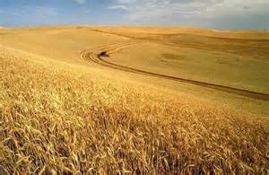](https://www.bing.com/images/search?q=monocultures&view=detailv2&&id=1D12C6204D60CA188AC7BED90D4AAEFF0516BF5E&selectedIndex=4&ccid=l1nPM2gh&simid=608001859187442694&thid=OIP.M9759cf336821758bd0eff64d698b1d0ao0)

**2.** Management/conservation techniques that can increase species and habitat diversity which have been taken away by intensive food production.

* **Maintain existing hedgerows at the most beneficial height and shape. A-shape provides better habitats than rectangular ones.**
* **Plant hedges instead of fences at field boundaries**
* **Maintain existing ponds and where possible create new ones**
* **Leave wet corners of fields rather than draining them.**
* **Plant native trees on land with a low species diversity rather than in species-rich areas.**
* **Reduce the use of pesticides – use biological control of GM organisms that are resistant to pests.**
* **Use organic rather than inorganic fertilisers**
* **Use crop rotation that includes nitrogen-fixing crops to improve soil fertility (instead or inorganic fertilisers)**
* **Use intercropping rather than herbicides to control weeds and other pests**
* **Create natural meadows and use hay rather than grass for silage.**
* **Leave cutting of verges and field edges until after flowering and when seeds have dispersed.**
* **Introduce conservation headlands – areas at the edges of fields where pesticides are used restrictively so that wild flowers and insects can breed**

[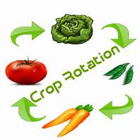](https://www.bing.com/images/search?q=crop+rotation&view=detailv2&&id=548D016BC6BA2DECA75E106F38C8C45498C58E98&selectedIndex=33&ccid=2G/H%2bcsb&simid=608040024265854469&thid=OIP.Md86fc7f9cb1b37a841659dbcfa1405d3H0)

[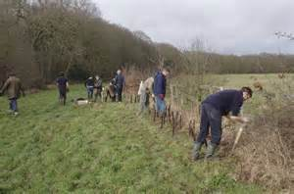](https://www.bing.com/images/search?q=planting+hedgerows+farmers&view=detailv2&&id=059150E98B34C50900809B44369BB946CA8236A0&selectedIndex=1&ccid=ptmFiLv2&simid=608019837915170505&thid=OIP.Ma6d98588bbf6a92f7d19a2813e8d425co0)

**Quantitative investigations of variation**

1. Text book AS Biology (old) Pgs. 124-127 (new) Pgs. 253-256

**Interspecific variation** = variation between different species

**Intraspecific variation** = variation between individuals of the same species

**Ways of measuring variation in a population or community– Random Sampling**

This involves taking measurements of individuals from a population and should be representative of the population as a whole. Read about how random sampling is done and complete the sections below.

Investigations of living things **may not be** representative due to:

* **Sampling bias**  **The selection process may be biased. The investigators may be making unrepresentative choices, either deliberately or unwittingly e.g. when sampling plants in a field they may just take samples from the areas which are not muddy/avoid nettles**
* **Chance Even if sampling bias is avoided, individuals may, by pure chance not be representative. E.g. if a sampling buttercups – in 50 plants they may be by chance the 50 tallest individuals in the populations**

Describe how to estimate the number of daisies growing in a field

1. **Divide the study area into a grid of numbered lines by using 2 long tapes at right angles**
2. **Use a random number generator, from a table or computer to obtain a series of co-ordinates**
3. **Take the sampe ar the intersection of each pair of coordinates.**

**Random Sampling** – outline how you could sample a meadow using a quadrat to illuminate human involvement that could cause bias

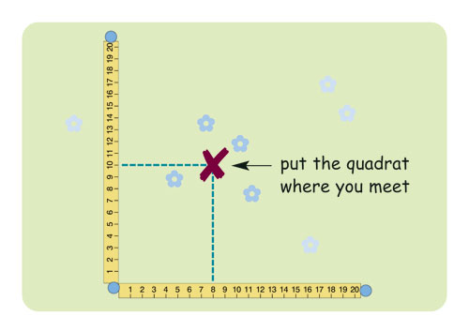

List the ways in which the sampling process can minimize the effects of chance

1. **Use a large sample size – the bigger the sample size, the smaller the probablitlity that chance will influence the results and the more reliable the data will be**
2. **Analyse the data collected – accepting that chance will play a part, data should be analysed using statistical tests to determine the extent to which chance may have influenced the data.**

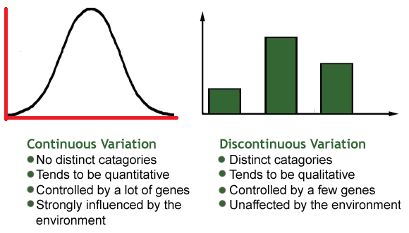**Types of variation.**

Variation is the result of either genetic differences or environmental factors or a combination of both.

**The normal distribution**

Bell-shaped curve that shows continuous variation. It can be skewed to one side.

Mean, mode and median are associated with normal distributions

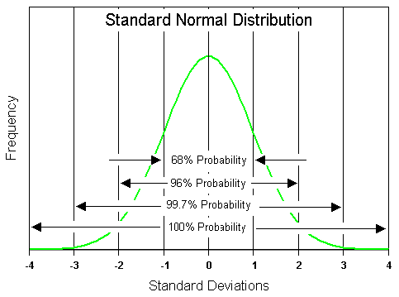

**Mean**

Calculated by the sum of all sampled values divided by the number of values themselves.

**Mode**

The single value that occurs the most in a data set.

**Median**

The central or middle value in a set of values. You need to arrange the values in ascending order to calculate this.

**Standard Deviation**

[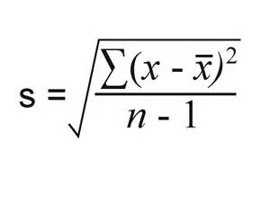](https://www.bing.com/images/search?q=standard+deviation&view=detailv2&&id=78963231044AC72965DFA9A3A17E0C70CB4347A3&selectedIndex=10&ccid=qO6xHONw&simid=608033659125632400&thid=OIP.Ma8eeb11ce370810d2b3da4af67966397o0)

The formula for standard deviation is:

Where ∑ = sum of

X = measured value (from sample)

X = mean value

n = total number of values in the sample

**Normal distribution and Standard deviation and mean**

Mean = measurement of the height of the curve – it does not say anything about the range of values just the average value.

Standard deviation is measure of the width of the curve and shows the range of values either side of the mean Therefore this shows the spread of the results around the mean

Furthermore, the standard deviation can be used in statistical analysis to look for **significant differences.**

From a sample of data

68% of the data values will lie 1 standard deviation either side of the mean

99% of the data values will lie within 2 standard deviations of the mean

**Worked Example**

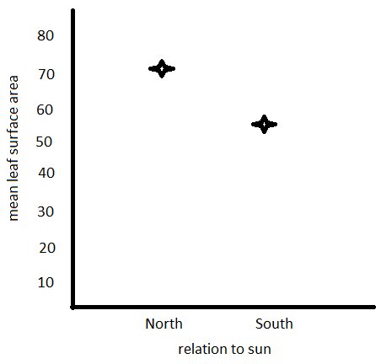**A hypothesis was made about leaves on a plant; south facing leaves are smaller than north facing leave.**

**Results obtained:**

Mean surface area of south facing leaves 50mm2

Mean surface area of north facing leaves 70mm2

On this basis you would probably accept that the hypothesis was correct.

However, what happens when we add in the SD, the spread of the results around the mean

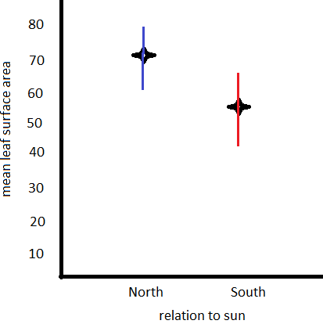

**Standard deviations were calculated:**

South leaves =50mm2 ± 14

North leaves = 70mm2 ± 17

We can see there is an overlap in standard deviations

The maximum size of south leaves was 64mm2, and the minimum size of north leaves was 53 mm2, so sometimes south leaves are bigger than north leaves so the difference in length may not be a significant difference all the time.

**Question**

A Sri Lankan scientist investigated the effect of human disturbance on the organisms living on a rocky seashore. He chose three areas for the study. These areas had different amounts of human disturbance.

The scientist measured human disturbance by walking from one end of the beach to the other. He recorded the number of people he encountered. **Figure 1** shows his results.

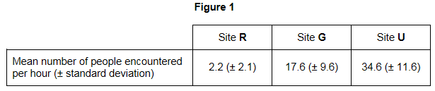

What conclusions can you draw about the number of people visiting Site **R** compared with the number of people visiting the other two sites? Give evidence from **Figure 1** to support your answer. (2) ……………………………..…………………………………………………………….

……………………………………………………………………………………………………………………………………………………………………………………………………………………

**Exam Questions – Mark Scheme**

**M1.**(a)     1.      Group of similar organisms / organisms with similar features / organisms with same genes / chromosomes;

*1. Accept: same number of chromosomes*

*1. Accept: smallest taxonomic group*

*1. Reject: genetically identical. Only allow 1 max if mentioned*

*1.* ***Q*** *Neutral: similar genes / chromosomes*

2.      Reproduce / produce offspring;

*2. Accept: breed / mate*

3.      That are fertile;

*3. Neutral: that are ‘viable’*

*‘Produce fertile offspring’ = 2 marks*

**2 max**

(b)     (i)      Correct answer of 6.97 to 7 = 2 marks;

One mark for 6320 as numerator or 906 as denominator;

**2**

(ii)     1.      Decrease in variety of plants / fewer plant species;

*1. Accept: reference to monoculture or description*

*1. Neutral: fewer plants*

2.      Fewer habitats / niches;

*2. Neutral: fewer homes / less shelter*

3.      Decrease in variety of food / fewer food sources;

*3. Neutral: less food*

*3. Accept: less variety of prey*

**3**

**[7]**

**M2.**(a)     (i)      *Synodontis batensoda / S. batensoda;*

*Ignore spellings*

**1**

(ii)     *Mochokus niloticus;*

*Ignore spellings*

**1**

(b)     5;

**1**

(c)     (i)      Fertile offspring produced;

*Allow suitable description of offspring being fertile.*

**1**

(ii)     1.      Attracts / recognises same species;

*Attracts mate of the same species = two marks.*

2.      Attracts / recognises mate / opposite sex;

3.      Indication of sexual maturity / fertility / synchronises mating;

*Allow 'ready to mate'.*

4.      Stimulates release of gametes;

5.      Form pair bond;

**2 max**

**[6]**

**M3.**         (a)     (i)     Kingdom / phylum / class;

*Accept Animalia / animal kingdom / Chordata / Chordates / Aves*

*Allow phonetic spelling*

**1**

(ii)     Family;

**1**

(b)     1.      Shows the spread of the data / how data varies;

*1. Reject range.*

*Accept varies from the mean*

2.      Overlap = no difference / due to chance / not significant;

*2. Allow converse*

**2**

(c)     1.      Different species would have different amino acid sequences;

*Accept more closely related = more similar sequence*

2.      Amino acid sequence is the result of DNA / alleles / base sequence;

*References to incorrect statements about coding negates second mark*

**2**

**[6]**

**M4.**(a)     (i)      1.      Groups within groups;

*Accept: idea of larger groups at the top* ***or*** *smaller groups at the bottom*

2.      No overlap (between groups);

**2**

(ii)     **3**;

**1**

(iii)    Chordata;

*Accept: if phonetically correct eg ‘Cordata’*

**1**

(b)     (i)      1.      (To provide) genetic variation;

*Genetic variation must be directly stated and not implied*

2.      (Allows) different combinations of maternal and paternal chromosomes / alleles;

*Accept: any allele of one gene can combine with any allele of another gene*

**2**

(ii)     1.      (Zedonk has) 47 / odd / uneven number of chromosomes;

*Accept: diploid number would be odd*

*Reject: if wrong number of chromosomes is given*

2.      Chromosomes cannot pair / are not homologous / chromosome number cannot be halved / meiosis cannot occur / sex cells / haploid cells are not produced;

*Accept: cannot have half a chromosome*

***Q*** *Reject: meiosis cannot occur* ***in*** *sex cells*

**2**

**[8]**

**M5.**          (a)     Removes bias;

**1**

(b)     (i)     1.      1.28 / 1.29 / 1.285 / 1.3

*1. Ignore more than 3dp*

2.      Answer incorrect but shows clear understanding of Σ

*2. Σ = 318250. Allow mark if denominator written out. Incorrect denominator but evidence of understanding gains mark*

**2**

(ii)     Diversity index would be lower (NO MARK)

*Assume wheat field if site unspecified*

1.      Fewer species / Beech aphid / Large white butterfly / 7-spot ladybird absent / only three species / species diversity lower / mostly one species / mostly bird-cherry aphid;

*1. Allow species richness in context of few species*

2.      Fewer plant species;

*2. Allow one type of food source if clearly plant*

**2**

(c)     For:

1.      Data support the claim / evidence supports claim;

*1. Ignore reference to correlation / causation*

Against:

2.      Only wheat field / only comparing with wood / one type of habitat / only insects considered;

**2 max**

(d)     1.      Greater variety of plants;

2.      Another habitat / more habitats / places to live / niches / another food source / more food types;

*2. Answers referring to ‘more food’ should not be credited. Allow  reference to either animal or plant as foods*

**2**

**[9]**

**M6.**(a)     1.      Number of (individuals of) each species;

*Accept: ‘population’ for ‘number’*

2.      Total number of individuals / number of species;

*Accept: ‘species richness’*

*MP2 allows for other types of diversity index*

**2**

(b)     (i)      (Shows) results are due to the herbicide / are not due to another factor / (to) compare the effect of using and not using the herbicide / shows the effect of adding the herbicide;

*Neutral: allows a comparison*

*Neutral: ensures results are due to the independent variable*

*Reject: ‘insecticide’*

*Accept: ‘pesticide’*

**1**

(ii)     1.      (More) weeds killed **so** more crops / plants survive / higher yield / less competition;

2.      High concentrations (of herbicide) harm / damage / kill / are toxic to crops / plants;

*Accept: ‘pesticide’*

*Neutral: ‘insecticide’*

*Accept: use of figures (eg 400+)*

**2**

(iii)    1.      Reduced plant diversity / fewer plant species / fewer varieties of plant;

*Accept: ‘weed’ for ‘plant’*

*Neutral: fewer plants*

*Accept: only one crop species remains*

2.      Fewer habitats / niches;

***Q*** *Neutral: fewer homes / shelters*

3.      Fewer food sources / varieties of food;

*Neutral: less food*

**3**

**[8]**

**E1.**This question was targeted at grade E. It is again surprising that all parts proved to be good discriminators.

(a)     Two-thirds of students gained full marks. This was usually for mentioning that organisms of the same species can produce fertile offspring. However, some students failed to gain the mark for replacing the word ‘fertile’ with ‘viable’.

(b)     (i)      Seventy percent of students correctly calculated the index of diversity within the range of 6.97 to 7. Of the other thirty percent, most gained one mark for calculating a correct numerator or denominator.

(ii)     Nearly all students gained at least one mark, typically for ‘fewer habitats’. Similarly, reference to pesticides or machinery decreasing species diversity was common. Compared with the previous series, it was pleasing to see a greater percentage of students refer to ‘less food sources’ or ‘less variety of food’, rather than simply ‘less food’. Relatively few students linked clearing the forest to a reduction in the number of plant species.

**E2.**(a)     (i)      Very few students failed to identify *Synodontis batensoda* as the species of catfish most closely related to *Synodontis membranacea*.

(ii)     Similarly, less than 4% of students failed to identify Mochokus niloticus as the species of catfish most distantly related to *Synodontis membranacea*.

(b)     This proved to be more demanding with over a third of students failing to determine that the number of different genera shown in the diagram was five.

(c)     (i)       The vast majority of students obtained this mark. Students who failed to gain credit often stated that 'viable offspring' would be produced without indicating that the offspring would be fertile.

(ii)     This question was very well answered with the majority of students gaining both marks. The importance of courtship in attracting the opposite sex, allowing species recognition and as an indicator of sexual maturity were common scoring points.

**E3.**         (a)      (i)      Almost all students gained this mark.

(ii)      Again, almost all gained this mark, with many writing a mnemonic of one form or another in the margin.

(b)     Most students gained the first mark for a simple definition of standard deviation in terms of the spread of the data. A few failed to gain the mark by using the word ‘range ’ as an alternative to ‘spread’. The interpretation of standard deviation in terms of overlap was less well understood, and very few students suggested that a low standard deviation was related to closely grouped and therefore reliable data.

(c)     The majority of low marks gained in this question resulted from students failing to respond to the question ‘ …these sequences (i.e. the amino acid sequences) could provide evidence … ’and going on to describe how different DNA base sequences would give different proteins. Although students seemed to appreciate that different species have different amino acid sequences in the same protein, few could link this to differences in the DNA base sequence. Students seemed unclear about the relationships between the DNA base sequences and the amino acid sequence, and the use of incorrect terminology made their answers even more opaque.

**E4.**Given that this question was targeted at grade E, it was surprising that parts (a)(i), (b)(i) and (b)(ii) proved to be good discriminators.

(a)    (i)      Half of students were aware that a hierarchy contains groups within groups, with no overlap. However, the ‘no overlap’ concept was often missed. Similarly, it was disappointing that nearly 30% of students failed to score, considering that a simple definition from the specification was required. Weaker responses often referred to the idea of ranking, dominance or importance.

(ii)     Most students gave the correct answer of **3**.

(iii)    Most students gave the correct answer of **Chordata**.

(b)    (i)      Just over half of students scored at least one mark. This was usually for relating independent segregation to genetic variation. Better responses showed an appreciation of how this is achieved. Typically, these referred to different combinations of maternal and paternal chromosomes, or the random arrangement of homologous chromosomes. Commonly seen responses that lacked the required precision included ‘provides variation’ and ‘allows different combinations of chromosomes’. A minority of students failed to score due to writing about crossing over. The role of independent segregation in producing haploid cells was rarely seen.

(ii)     One-third of students scored full marks. However, a number lost marks through a lack of precision; for example, ‘there would be the wrong number of chromosomes’ or ‘they are different species so the offspring would be infertile’. The most common misconceptions seen were that ‘the offspring would have 94 chromosomes’ and ‘meiosis would not be able to occur *in* the sex cells’.

**E5.**          (a)     This question was generally answered well, with the better students able to explain the importance of random collection in the context of the investigation rather than simply turning out the phrase ‘avoiding bias’.

(b)     (i)       Most students understood the summation process even though they made mistakes in another part of the calculation. A significant number of answers went up to 5 or 6 decimal places which, although not penalised, should be avoided. The mathematical requirements of the specification do state the ‘use of an appropriate number of significant figures’. A significant number of students use the space available as rough working rather than for setting out the logic by which they arrived at the answer. A tangled mass of numbers did not always allow the examiners to credit incorrect responses for an understanding of underlying principles.

(ii)     Most students made reasonable attempts at this section. Most correct references were to the reduction in species number and to the predominance of the bird-cherry aphid. Incorrect references were made to totals of all organisms and totals of all species. Weaker students assumed that the fewer organisms in total, the lower the biodiversity. Some wrote, incorrectly, about genetic diversity.

(c)      Instead of evaluating the conclusion given, a significant number of students wrote their own conclusions about the effects of farming on the environment and the mechanisms by which these were brought about. Answers were often vague and did not refer to the data provided.

(d)     Generally answered well; almost all students offered responses, often with good explanations relating to increasing variety of habitats and food sources.

**E6.**Parts (a), (b)(ii) and (b)(iii) proved to be good discriminators.

(a)     70% of students scored full marks. Those who scored one mark often gave both alternatives of the second mark point. Weaker responses often lacked clarity; for example, ‘number of individuals’ and ‘different species within a population’. Students who failed to score often thought that the ‘size of the area’ and ‘standard deviation values’ are needed to calculate an index of diversity. It should be noted that although the specification requires students to be able to calculate one specific index of diversity, the mark scheme was amended so that other types of index of diversity could be credited.

(b)    (i)      Most students were aware that the purpose of the control fields was to ensure that the results are due to the herbicide, or not due to another factor. Those who failed to score typically gave stock How Science Works responses, which could apply to any investigation. These usually referred to comparing groups or results, ensuring that the results were due to the independent variable, or simply that these fields acted as controls. Students should be reminded of the need to relate their answers to the specific investigation or context outlined.

(ii)     Half of students scored one mark and this was usually for appreciating that the herbicide killed more weeds, which led to less competition. However, the ability to explain the effect of high concentrations of herbicide, in terms of damage to the crop, proved to be a good discriminator. Unfortunately, many students did not read information in the introduction carefully enough. They thought that the herbicide killed insects, which meant that fewer crops were eaten. The weakest responses usually went no further than to describe the graph.

(iii)    Just under half of students scored at least two marks. This was usually for ‘fewer habitats’ and ‘fewer food sources’. It was only the best responses that referred to ‘fewer plant species’ being present. Similarly, the ability to express these ideas discriminated well. Weaker responses often referred to ‘less food’ and ‘less plants’, which were not credited. As mentioned in part (i), some students wrongly thought that the herbicide killed insects, which directly led to a decrease in their index of diversity.