Extra questions for revision

**Q1.**          Sucrose is a disaccharide. It is formed from two monosaccharides **P** and **Q**. The diagram shows the structure of molecules of sucrose and monosaccharide **P**.

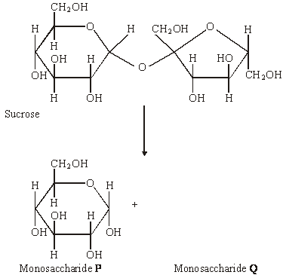

(a)     (i)      Name monosaccharide **Q**.

.............................................................................................................

**(1)**

(ii)     Draw the structure of a molecule of monosaccharide **Q** in the space above.

**(1)**

(b)     The enzyme sucrase catalyses the breakdown of sucrose into monosaccharides. What type of reaction is this breakdown?

......................................................................................................................

**(1)**

(c)     The diagram shows apparatus used in breaking down sucrose. The enzyme sucrase is fixed to inert beads. Sucrose solution is then passed through the column.

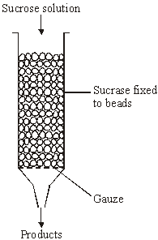

Describe a biochemical test to find out if the solution collected from the apparatus contains

(i)      the products;

.............................................................................................................

.............................................................................................................

.............................................................................................................

.............................................................................................................

**(2)**

(ii)     the enzyme.

.............................................................................................................

.............................................................................................................

.............................................................................................................

.............................................................................................................

**(2)**

**(Total 7 marks)**

**Q2.**          Cellulose is made from one type of monomer. The monomers are held together by bonds. The diagram shows parts of three cellulose molecules in a cell wall.

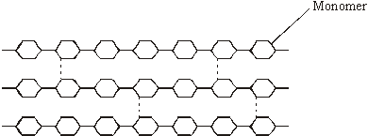

(a)     Name the monomer present in cellulose.

......................................................................................................................

**(1)**

(b)     Name the type of reaction that converts cellulose to its monomers.

......................................................................................................................

**(1)**

(c)     Cotton is a plant fibre used to make cloth. Explain how cellulose gives cotton its strength.

......................................................................................................................

......................................................................................................................

......................................................................................................................

......................................................................................................................

......................................................................................................................

......................................................................................................................

**(3)**

**(Total 5 marks)**

**Q3.**          Read the following passage.

Straw consists of three main organic substances – cellulose, hemicellulose and lignin.  
Cellulose molecules form chains which pack together into fibres. Hemicellulose is a small  
molecule formed mainly from five-carbon (pentose) sugar monomers. It acts as a cement  
holding cellulose fibres together. Like hemicellulose, lignin is a polymer, but it is not a

 5      carbohydrate. It covers the cellulose in the cell wall and supplies additional strength. In

addition to these three substances, there are small amounts of other biologically important  
polymers present.

 The other main component of straw is water. Water content is variable but may be determined  
         by heating a known mass of straw at between 80 and 90°C until it reaches a constant mass.

10     The loss in mass is the water content.

Since straw is plentiful, it is possible that it could be used for the production of a range of  
organic substances. The first step is the conversion of cellulose to glucose. It has been  
suggested that an enzyme could be used for this process. There is a difficulty here, however.  
The lignin which covers the cellulose protects the cellulose from enzyme attack.

          Use information from the passage and your own knowledge to answer the following questions.

(a)     (i)      Give **one** way in which the structure of a hemicellulose molecule is similar to the structure of a cellulose molecule.

.............................................................................................................

.............................................................................................................

**(1)**

(ii)     Complete the table to show **two** ways in which the structure of a hemicellulose molecule differs from the structure of a cellulose molecule.

|  |  |  |
| --- | --- | --- |
|  | **Hemicellulose** | **Cellulose** |
|  | ..........................................................  .......................................................... | ..........................................................  .......................................................... |
|  | ..........................................................  .......................................................... | ..........................................................  .......................................................... |

**(2)**

(b)     Name **one** biologically important polymer, other than those mentioned in the passage, which would be found in straw.

......................................................................................................................

**(1)**

(c)     Explain why the following steps were necessary in finding the water content of straw:

(i)      heating the straw *until it reaches constant mass* (line 9);

.............................................................................................................

.............................................................................................................

..............................................................................................

**(1)**

(ii)     not heating the straw above 90°C (line 9).

.............................................................................................................

.............................................................................................................

.............................................................................................................

.............................................................................................................

**(2)**

(d)     A covering of lignin protects cellulose from enzyme attack (line 14). Use your knowledge of the way in which enzymes work to explain why cellulose-digesting enzymes do not digest lignin.

......................................................................................................................

......................................................................................................................

......................................................................................................................

......................................................................................................................

**(2)**

(e)     Describe the structure of a cellulose molecule and explain how cellulose is adapted for its function in cells.

......................................................................................................................

......................................................................................................................

......................................................................................................................

......................................................................................................................

......................................................................................................................

......................................................................................................................

......................................................................................................................

......................................................................................................................

......................................................................................................................

......................................................................................................................

......................................................................................................................

......................................................................................................................

......................................................................................................................

......................................................................................................................

**(6)**

**(Total 15 marks)**

**Q4.**(a)    Name the monosaccharides of which the following disaccharides are composed.

(i)      Sucrose

monosaccharides.....................................and.......................................

**(1)**

(ii)     Lactose

monosaccharides.....................................and.......................................

**(1)**

(b)     Amylase and maltase are involved in the digestion of starch in the small intestine.

Complete the table by identifying where these enzymes are produced and the product of the reaction they catalyse.

|  |  |  |  |
| --- | --- | --- | --- |
|  | **Name of enzyme** | **Where the enzyme is produced** | **Product of the reaction catalysed by the enzyme** |
|  | Amylase |  |  |
|  | Maltase |  |  |

**(2)**

**(Total 4 marks)**

**Q5.**A student investigated the effect of chewing on the digestion of starch in cooked wheat.

He devised a laboratory model of starch digestion in the human gut. This is the method he used.

1.      Volunteers chewed cooked wheat for a set time. The wheat had been cooked in boiling water.

2.      This chewed wheat was mixed with water, hydrochloric acid and a protein-digesting enzyme and left at 37 °C for 30 minutes.

3.      A buffer was then added to bring the pH to 6.0 and pancreatic amylase was added. This mixture was then left at 37 °C for 120 minutes.

4.      Samples of the mixture were removed at 0, 10, 20, 40, 60 and 120 minutes, and the concentration of reducing sugar in each sample was measured.

5.      Control experiments were carried out using cooked wheat that had been chopped up in a blender, not chewed.

(a)     What reducing sugar, or sugars, would you expect to be produced during chewing?  
Give a reason for your answer.

........................................................................................................................

........................................................................................................................

........................................................................................................................

........................................................................................................................

**(2)**

(b)     In this model of digestion in the human gut, what other enzyme is required for the complete digestion of starch?

........................................................................................................................

**(1)**

(c)     What was the purpose of step 2, in which samples were mixed with water, hydrochloric acid and pepsin?

........................................................................................................................

........................................................................................................................

**(1)**

(d)     In the control experiments, cooked wheat was chopped up to copy the effect of chewing.

Suggest a more appropriate control experiment. Explain your suggestion.

........................................................................................................................

........................................................................................................................

........................................................................................................................

........................................................................................................................

**(2)**

(e)     The figure below shows the student’s results.

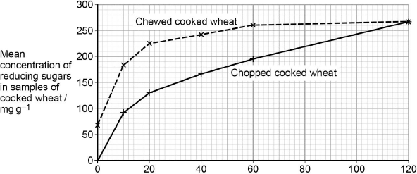  
                               Incubation time / minutes

Explain what these results suggest about the effect of chewing on the digestion of starch in wheat.

........................................................................................................................

........................................................................................................................

........................................................................................................................

........................................................................................................................

........................................................................................................................

........................................................................................................................

**(3)**

**(Total 9 marks)**

**Q6.**          (a)     **Figure 1** shows the structure of a molecule of glycerol and a molecule of fatty acid.

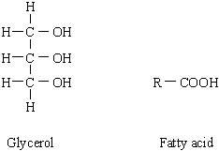

**Figure 1**

Draw a diagram to show the structure of a triglyceride molecule.

**(2)**

(b)     Explain why triglycerides are **not** considered to be polymers.

......................................................................................................................

......................................................................................................................

**(1)**

(c)     **Figure 2** shows two types of fat storage cell. Mammals living in cold conditions have more brown fat cells than mammals living in tropical conditions.

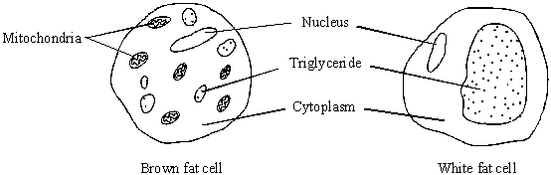

**Figure 2**

Using evidence from **Figure 2** to support your answer, suggest how the function of brown fat cells differs from that of white fat cells.

......................................................................................................................

......................................................................................................................

......................................................................................................................

......................................................................................................................

......................................................................................................................

......................................................................................................................

**(3)**

**(Total 6 marks)**

**Q7.**Omega-3 fatty acids are also found in fish. Scientists investigated the concentration of omega-3 fatty acids from wild-caught and farmed fish. Their results are shown in the figure below.

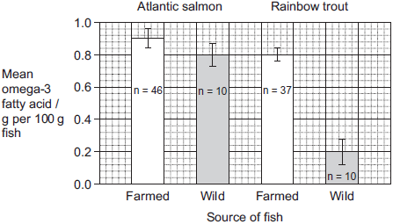

The bars show standard deviation; n is the sample size.

It is **not** possible to conclude from the data that the concentration of omega-3 fatty acids in the farmed salmon is higher than that of the wild salmon. Use the data to explain why.

.................................................................................................................................

.................................................................................................................................

.................................................................................................................................

.................................................................................................................................

**(Total 2 marks)**

**Q8.**          The diagrams show four types of linkage, **A** to **D**, which occur in biological molecules.

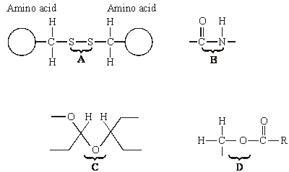

(a)     Name the chemical process involved in the formation of linkage **B**.

......................................................................................................................

**(1)**

(b)     Give the letter of the linkage which

(i)      occurs in a triglyceride molecule;

.............................................................................................................

**(1)**

(ii)     might be broken down by the enzyme amylase;

.............................................................................................................

**(1)**

(iii)     may occur in the tertiary, but not the primary structure of protein.

.............................................................................................................

**(1)**

(c)     Describe how a saturated fatty acid differs in molecular structure from an unsaturated fatty acid.

......................................................................................................................

......................................................................................................................

......................................................................................................................

......................................................................................................................

**(2)**

**(Total 6 marks)**

**Q9.**(a)     Describe how you would test a piece of food for the presence of lipid.

........................................................................................................................

........................................................................................................................

........................................................................................................................

**(2)**

The figure below shows a phospholipid.

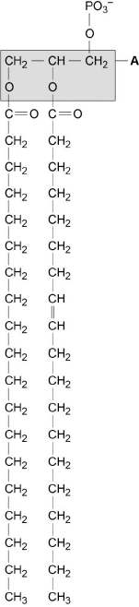  
**X**         **Y**

(b)     The part of the phospholipid labelled **A** is formed from a particular molecule. Name this molecule.

........................................................................................................................

**(1)**

(c)     Name the type of bond between **A** and fatty acid **X**.

........................................................................................................................

**(1)**

(d)     Which of the fatty acids, **X** or **Y**, in the figure above is unsaturated? Explain your answer.

........................................................................................................................

........................................................................................................................

........................................................................................................................

........................................................................................................................

**(1)**

Scientists investigated the percentages of different types of lipid in plasma membranes from different types of cell. The table shows some of their results.

|  |  |  |  |  |
| --- | --- | --- | --- | --- |
|  | **Type of lipid** | **Percentage of lipid in plasma membrane by mass** | | |
|  | **Cell lining ileum of mammal** | **Red blood cell of mammal** | **The bacterium *Escherichia coli*** |
|  | Cholesterol | 17 | 23 | 0 |
|  | Glycolipid | 7 | 3 | 0 |
|  | Phospholipid | 54 | 60 | 70 |
|  | Others | 22 | 14 | 30 |

(e)     The scientists expressed their results as **Percentage of lipid in plasma membrane by mass**. Explain how they would find these values.

........................................................................................................................

........................................................................................................................

........................................................................................................................

........................................................................................................................

**(2)**

Cholesterol increases the stability of plasma membranes. Cholesterol does this by making membranes less flexible.

(f)     Suggest **one** advantage of the different percentage of cholesterol in red blood cells compared with cells lining the ileum.

........................................................................................................................

........................................................................................................................

........................................................................................................................

**(1)**

(g)     *E. coli* has no cholesterol in its cell-surface membrane. Despite this, the cell maintains a constant shape. Explain why.

........................................................................................................................

........................................................................................................................

........................................................................................................................

........................................................................................................................

**(2)**

**(Total 10 marks)**

**M1.**          (a)     (i)      fructose;

**1**

(ii)     correctly drawn (OH group at bottom left);

**1**

(b)     hydrolysis;

**1**

(c)     (i)      heat with Benedict’s solution (*disqualify if HCl added*);  
orange / brown / brick red / green / yellow colour or precipitate;

**2**

(ii)     biuret test / NaOH + CuSO4;  
purple / violet / lilac / mauve;

**2**

**[7]**

**M2.**          (a)     glucose;

*(reject alpha glucose)*

**1**

(b)     hydrolysis;

*(accept catabolic)*

**1**

(c)     (long) straight / unbranched chains;  
(idea of more than 1) chains lie side by side / form (micro)fibrils;  
idea of H bonds holding chains together;

**3**

**[5]**

**M3.**          (a)     (i)      both are polymers / polysaccharides / built up from many sugar units / both contain glycosidic bonds / contain (C)arbon, (H)ydrogen and (O)xygen;

**1**

(ii)     hemicellulose shorter / smaller than cellulose / fewer carbons;  
hemicellulose from pentose / five-carbon sugars and cellulose from  
hexose / glucose / six-carbon sugars;

*(only credit answers which compare like with like.)*

**2**

(b)     protein / nucleic acid / enzyme / RNA / DNA / starch / amylose / amylopectin polypeptide;

**1**

(c)     (i)      to make sure that all the water has been lost;

**1**

(ii)     only water given off below 90 °C;  
(above 90°C) other substances straw burnt / oxidised / broken down; and lost as gas / produce loss in mass;

**2**

(d)     enzymes are specific;  
shape of lignin molecules will not fit active site (of enzyme);  
*OR*shape of active site (of enzyme);  
will not fit molecule;

**2 max**

(e)     1. made from β-glucose;  
2. joined by condensation / removing molecule of water / glycosidic bond;  
3. 1 : 4 link specified or described;  
4. “flipping over” of alternate molecules;  
5. hydrogen bonds linking chains / long straight chains;  
6. cellulose makes cell walls strong / cellulose fibres are strong;  
7. can resist turgor pressure / osmotic pressure / pulling forces;  
8. bond difficult to break;  
9. resists digestion / action of microorganisms / enzymes;

*(allow maximum of 4 marks for structural features)*

**6 max**

**[15]**

**M4.**(a)     (i)      Glucose and fructose;

*Ignore reference to alpha and beta*

*Either way around*

**1**

(ii)     Glucose and galactose;

*Ignore reference to alpha and beta*

*Either way around*

**1**

(b)     1.      (Amylase) pancreas, produces maltose;

*Place and product = 1 mark*

*(mark horizontally)*

2.      (Maltase) in / on epithelium (of small intestine), produces glucose;

*Ignore references to salivary glands or saliva*

*Accept wall / lining of small intestine*

*Ignore reference to cells alone*

*Ignore reference to ribosomes / rER*

**2**

**[4]**

**M5.**(a)     1.      Maltose;

2.      Salivary amylase breaks down starch;

**2**

(b)     Maltase;

**1**

(c)     (Mimics / reproduces) effect of stomach;

**1**

(d)     1.      Add boiled saliva;

2.      Everything same as experiment but salivary amylase denatured;

**2**

(e)     1.      Some starch already digested when chewing / in mouth;

2.      Faster digestion of chewed starch;

3.      Same amount of digestion without chewing at end;

*Accept use of values from graph*

**3**

**[9]**

**M6.**          (a)     3 fatty acids attached;   
ester bond correct;

*(H on glycerol component, O attached to carbon, R at other end)*

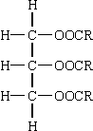

**2**

(b)     not made of monomers / many repeating units;

**1**

(c)     (many) mitochondria present in brown fat cells;   
mitochondria release heat / energy;(*ignore ATP*)  
white fat cells for fat storage / reduced fat storage in brown fat cells;

**3**

**[6]**

**M7.**Standard deviation shows there is overlap of the 2 data sets;  
Small sample of wild salmon so may not be representative of population;

**[2]**

**M8.**          (a)     (i)      condensation;

**1**

(b)     (i)      **D**;

**1**

(ii)     **C**;

**1**

(iii)     **A**;

**1**

(c)     absence of a double bond;  
in the (hydrocarbon) chain;  
unable to accept more hydrogen / saturated with hydrogen;

**2 max**

**[6]**

**M9.**(a)     1.      Dissolve in alcohol, then add water;

2.      White emulsion shows presence of lipid;

**2**

(b)     Glycerol;

**1**

(c)     Ester;

**1**

(d)     **Y** (no mark)

Contains double bond between (adjacent) carbon atoms in hydrocarbon chain;

**1**

(e)     1.      Divide mass of each lipid by total mass of all lipids (in that type of cell);

2.      Multiply answer by 100;

**2**

(f)     Red blood cells free in blood / not supported by other cells so cholesterol helps to maintain shape;

*Allow converse for cell from ileum – cell supported by others in endothelium so cholesterol has less effect on maintaining shape*

**1**

(g)     1.      Cell unable to change shape;

2.      (Because) cell has a cell wall;

3.      (Wall is) rigid / made of peptidoglycan / murein;

**2 max**

**[10]**