**Q1.**          During an action potential, the permeability of the cell-surface membrane of an axon changes. The graph shows changes in permeability of the membrane to sodium ions (Na+) and to potassium ions (K+) during a single action potential.

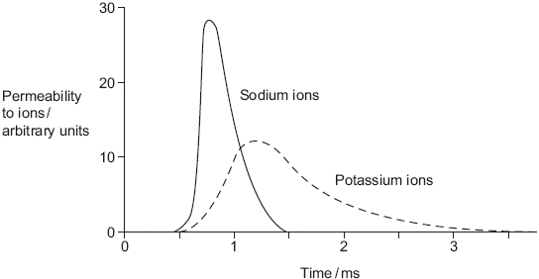

(a)     Explain the shape of the curve for sodium ions between 0.5 ms and 0.7ms.

......................................................................................................................

......................................................................................................................

......................................................................................................................

......................................................................................................................

......................................................................................................................

......................................................................................................................

**(3)**

(b)     During an action potential, the membrane potential rises to +40 mV and then falls. Use information from the graph to explain the fall in membrane potential.

......................................................................................................................

......................................................................................................................

......................................................................................................................

......................................................................................................................

......................................................................................................................

......................................................................................................................

**(3)**

(c)     After exercise, some ATP is used to re-establish the resting potential in axons. Explain how the resting potential is re-established.

......................................................................................................................

......................................................................................................................

......................................................................................................................

......................................................................................................................

**(2)**

**(Total 8 marks)**

**Q2.**          The diagram shows the change in the charge across the surface membrane of a non-myelinated axon when an action potential is produced.

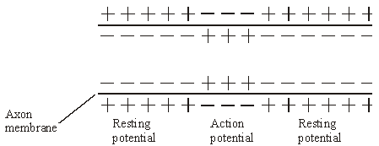

(a)     Describe how the change shown in the diagram occurs when an action potential is produced.

......................................................................................................................

......................................................................................................................

......................................................................................................................

......................................................................................................................

**(2)**

(b)     Explain what causes the conduction of impulses along a non-myelinated axon to be slower than along a myelinated axon.

......................................................................................................................

......................................................................................................................

......................................................................................................................

......................................................................................................................

......................................................................................................................

......................................................................................................................

**(3)**

**(Total 5 marks)**

**Q3.**          **Figure 1** shows changes in the membrane potential of a neurone during one action potential.

**Figure 1**

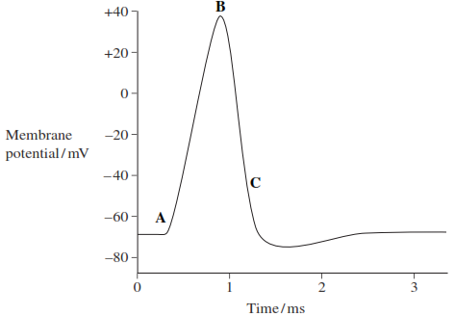

(a)     What happens in the membrane to cause the change in membrane potential at time **B**?

.......................................................................................................................

.......................................................................................................................

.......................................................................................................................

.......................................................................................................................

**(2)**

(b)     No further action potential can be produced between times **A** and **C**.

What is the name given to the period between times **A** and **C**?

.......................................................................................................................

**(1)**

(c)     **Figure 2** shows the force generated by a muscle when it was stimulated by different frequencies of nerve impulse.

**Figure 2**

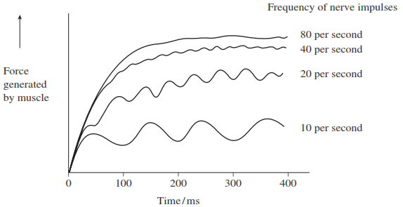

A taser is a device used by the police to arrest violent suspects. It fires electrical impulses very similar to action potentials into a suspect. The frequency of the impulses is between 15 and 20 per second.

(i)      Suggest the effect a taser has on a suspect’s muscles.

.............................................................................................................

.............................................................................................................

.............................................................................................................

.............................................................................................................

**(2)**

(ii)     Tasers with frequencies of between 40 and 80 per second are not used, because they are considered too dangerous. Suggest how they might be dangerous to a suspect.

.............................................................................................................

.............................................................................................................

.............................................................................................................

.............................................................................................................

**(2)**

**(Total 7 marks)**

**Q4.**A biologist investigated the stimulation of a Pacinian corpuscle in the skin of a fingertip.  
She used microelectrodes to measure the maximum membrane potential of a Pacinian corpuscle and its sensory neurone when different pressures were applied to the fingertip.

The figure below shows the Pacinian corpuscle, its sensory neurone and the position of the microelectrodes.

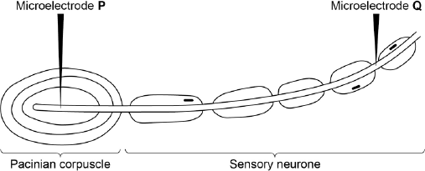

The table below shows some of the biologist’s results.

|  |  |  |  |
| --- | --- | --- | --- |
|  | **Pressure applied to the  fingertip** | **Membrane potential at P /  millivolts** | **Membrane potential at Q /  millivolts** |
|  | None | –70 | –70 |
|  | Light | –50 | –70 |
|  | Medium | +30 | +40 |
|  | Heavy | +40 | +40 |

(a)     Explain how the resting potential of –70 mV is maintained in the sensory neurone when no pressure is applied.

........................................................................................................................

........................................................................................................................

........................................................................................................................

........................................................................................................................

**(2)**

(b)     Explain how applying pressure to the Pacinian corpuscle produces the changes in membrane potential recorded by microelectrode **P**.

........................................................................................................................

........................................................................................................................

........................................................................................................................

........................................................................................................................

........................................................................................................................

........................................................................................................................

........................................................................................................................

........................................................................................................................

**(Extra space)** ................................................................................................

........................................................................................................................

........................................................................................................................

**(3)**

(c)     The membrane potential at **Q** was the same whether medium or heavy pressure was applied to the finger tip. Explain why.

........................................................................................................................

........................................................................................................................

........................................................................................................................

........................................................................................................................

**(2)**

(d)     Multiple sclerosis is a disease in which parts of the myelin sheaths surrounding neurones are destroyed. Explain how this results in slower responses to stimuli.

........................................................................................................................

........................................................................................................................

........................................................................................................................

........................................................................................................................

**(2)**

**(Total 9 marks)**

**M1.**          (a)     (Ion) channel proteins open, sodium in;

Changes membrane potential / makes inside of axon less  
negative / positive / depolarisation / reaches threshold;

More channels open / positive feedback;

*Accept other phrases for ion channel proteins providing that it is clear that it is something through which ions pass.  
Reject carrier.*

*First marking point relates to opening.  
Third point must relate to more (channels) opening.*

**3**

(b)     Potassium channels open;

Potassium out;

Sodium channels close;

*Do not penalise candidate who refers to sodium or potassium. Ions are mentioned in question.  
Reject pump*

**3**

(c)     Pump / active transport / transport against concentration gradient;

Of sodium from axon / sodium out / of potassium in;

*Do not penalise candidate who refers to sodium or potassium. Ions are mentioned in question*

**2**

**[8]**

**M2.**          (a)     sodium gates or channels open / increase in permeability of axon membrane to sodium ion;  
sodium ions enter axon;

**2**

(c)     non-myelinated – next section of membrane depolarised / whole  
membrane;  
myelinated – depolarisation / ion movement only at nodes;  
impulse jumps from node to node / saltatory conduction;

**3**

**[5]**

**M3.**          (a)     Potassium channels open (and K+ ions diffuse out);

*Accept references to sodium channels opening;*

Sodium channels close (and stops Na+ ions diffusion in);

*Leading to depolarisation;*

*Accept sodium pump (starts) to pump out sodium ions*

**2**

(b)     (Absolute) refractory (period);

**1**

(c)     (i)      Causes them to contract;

And relax;

Rapidly/twitch;

**2 max**

(ii)     Cause continuous muscle contraction;

*Accept a reasonable suggestion of harm ‒ linked  
to muscle contraction*

At high force;

Causing failure to breathe/heart stops pumping/  
damage to bones or joints;

**2 max**

**[7]**

**M4.**(a)     1.      Membrane more permeable to potassium ions and less permeable to sodium ions;

2.      Sodium ions actively transported / pumped out and potassium ions in.

**2**

(b)     1.      (Pressure causes) membrane / lamellae to become deformed / stretched;

2.      Sodium ion channels in membrane open and sodium ions move in;

3.      Greater pressure more channels open / sodium ions enter.

**3**

(c)     1.      Threshold has been reached;

2.      (Threshold or above) causes maximal response / all or nothing principle.

**2**

(d)     1.      Less / no saltatory conduction / action potential / impulse unable to ‘jump’ from node to node;

2.      More depolarisation over length / area of membranes.

**2**

**[9]**