**Extra questions for revision Proteins and Enzymes**

**Q1.**          (a)     Explain how the shape of an enzyme molecule is related to its function.

......................................................................................................................

......................................................................................................................

......................................................................................................................

......................................................................................................................

......................................................................................................................

......................................................................................................................

**(3)**

(b)     Bacteria produce enzymes which cause food to decay. Explain how vinegar, which is acidic, can prevent the action of bacterial enzymes in some preserved foods.

......................................................................................................................

......................................................................................................................

......................................................................................................................

......................................................................................................................

......................................................................................................................

......................................................................................................................

**(3)**

**(Total 6 marks)**

**Q2.**          The diagrams show four types of linkage, **A** to **D**, which occur in biological molecules.

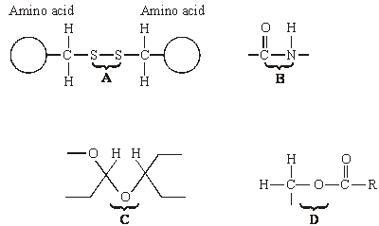

(a)     Name the chemical process involved in the formation of linkage **B**.

......................................................................................................................

**(1)**

(b)     Give the letter of the linkage which

(i)      occurs in a triglyceride molecule;

.............................................................................................................

**(1)**

(ii)     might be broken down by the enzyme amylase;

.............................................................................................................

**(1)**

(iii)     may occur in the tertiary, but not the primary structure of protein.

.............................................................................................................

**(1)**

(c)     Describe how a saturated fatty acid differs in molecular structure from an unsaturated fatty acid.

......................................................................................................................

......................................................................................................................

......................................................................................................................

......................................................................................................................

**(2)**

**(Total 6 marks)**

**Q3.**          In an investigation into carbohydrase activity, the contents from part of the gut of a small animal were collected. The contents were added to starch solution at pH 7 and kept in a water bath at 25°C. At one-minute intervals, samples were removed and added to different test tubes containing dilute iodine solution. The colour intensity of each sample was determined. The graph shows the results.

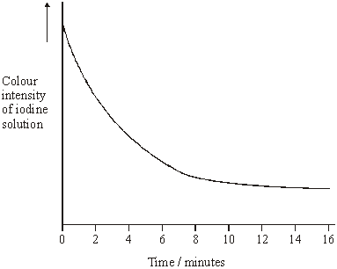

(a)     Explain the change in colour intensity.

......................................................................................................................

......................................................................................................................

......................................................................................................................

......................................................................................................................

**(2)**

(b)     Draw clearly labelled curves on the graph to show the expected result if the experiment was repeated

(i)      at 35 °C;

(ii)     at pH 2.

**(2)**

(c)     Explain how

(i)      raising the temperature to 35 °C affects carbohydrase activity;

.............................................................................................................

.............................................................................................................

.............................................................................................................

.............................................................................................................

.............................................................................................................

.............................................................................................................

.............................................................................................................

.............................................................................................................

(ii)     decreasing the pH affects carbohydrase activity.

.............................................................................................................

.............................................................................................................

.............................................................................................................

.............................................................................................................

.............................................................................................................

.............................................................................................................

.............................................................................................................

.............................................................................................................

.............................................................................................................

.............................................................................................................

**(7)**

**(Total 11 marks)**

**Q4.**          The diagram shows the structure of the amino acid serine.

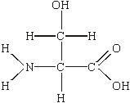

(a)     (i)      Draw a box on the diagram around the R group of serine and label the box with the letter **R**.

**(1)**

(ii)     Draw a circle around each of the parts of the serine molecule which would be removed when **two** other amino acid molecules join directly to it.

**(1)**

(b)     (i)      Which **two** substances are formed when two amino acid molecules join together?

1 ..........................................................................................................

2 ..........................................................................................................

**(1)**

(ii)     Name the type of bond formed between the joined pair of amino acid molecules.

.............................................................................................................

**(1)**

(c)     Explain how a change in the primary structure of a globular protein may result in a different three-dimensional structure.

......................................................................................................................

......................................................................................................................

......................................................................................................................

......................................................................................................................

......................................................................................................................

......................................................................................................................

**(3)**

**(Total 7 marks)**

**Q5.**          Ethylene glycol is a substance used in car anti-freeze. If it is accidentally swallowed it enters the liver cells where it is converted to poisonous oxalic acid. Ethanol inhibits the production of oxalic acid and can be used to treat patients who have swallowed anti-freeze.

In an investigation, the rate of reaction of an enzyme that makes oxalic acid was measured with and without ethanol present. The graph shows the results.

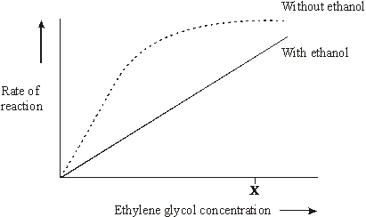

(i)      Increasing the concentration of ethylene glycol above **X** without ethanol present does not increase the rate of the reaction. Explain why.

......................................................................................................................

......................................................................................................................

......................................................................................................................

......................................................................................................................

**(2)**

(ii)      Use the information in the graph to explain how ethanol prevents oxalic acid production.

......................................................................................................................

......................................................................................................................

......................................................................................................................

......................................................................................................................

**(2)**

**(Total 4 marks)**

**Q6.**          (a)     Amylase is an enzyme which hydrolyses starch to maltose. Some amylase and starch were mixed and the mixture incubated at 37 °C until the reaction was complete.

(i)      Sketch a curve on the axes below to show the progress of this reaction.

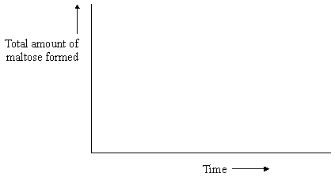

**(1)**

(ii)     Explain why the rate of the reaction decreases as the reaction progresses.

.............................................................................................................

.............................................................................................................

.............................................................................................................

**(2)**

The effect of temperature on the rate of reaction of an enzyme was investigated. A test tube containing the enzyme and a test tube containing the substrate were incubated separately at each of the temperatures being investigated. After 5 minutes, they were mixed and the rate of reaction was determined. The experiment was repeated but, this time, the enzyme and the substrate were left for 60 minutes before they were mixed. The results of the investigation are shown in the graph.

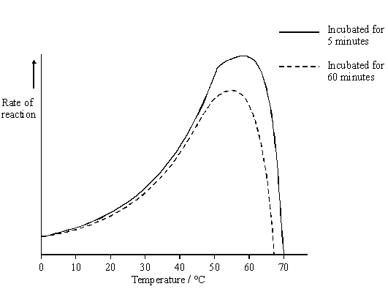

(b)     The enzyme solution used in this investigation was made by dissolving a known mass of enzyme in a buffer solution. Explain why a buffer solution was used.

......................................................................................................................

......................................................................................................................

**(1)**

(c)     (i)      Use the graph to describe how incubation time affects the rate of the reaction.

.............................................................................................................

.............................................................................................................

.............................................................................................................

.............................................................................................................

**(2)**

(ii)     The maximum rate of reaction with an incubation time of 60 minutes is less than the maximum rate of reaction with an incubation time of 5 minutes. Explain why.

.............................................................................................................

.............................................................................................................

.............................................................................................................

.............................................................................................................

.............................................................................................................

.............................................................................................................

**(3)**

(d)     Explain how inhibitors affect the rate of enzyme-controlled reactions.

......................................................................................................................

......................................................................................................................

......................................................................................................................

......................................................................................................................

......................................................................................................................

......................................................................................................................

......................................................................................................................

......................................................................................................................

......................................................................................................................

......................................................................................................................

......................................................................................................................

**(6)**

**(Total 15 marks)**

**Q7.**          Read the following passage.

Job’s Tears is a cereal plant which grows in the tropics. An unusual protein has been found in  
its grains. This protein is unusual because it has two functions. It acts as both an enzyme  
inhibitor and as an enzyme. As an inhibitor, the protein reduces the activity of starch-digesting  
enzymes. The protein acts as an enzyme by breaking down chitin, a polysaccharide found in

5     the walls of many fungi, to its monomers. Because of the resulting more negative water

potential in the cytoplasm of the fungus, this effectively leads to “death by osmosis” of any  
fungus attacking the grain.

Our knowledge of the relationship between protein structure and function has led to the  
development of the new technology of protein engineering. This involves changing the amino

10   acid sequence of a protein and altering its tertiary structure. Altering the tertiary structure

changes the protein’s properties. So far, we have been unable to produce a protein with more  
than one function such as that found in Job’s Tears. We have had success, though, in making  
some enzymes more stable and less prone to heat denaturation. We have done this by  
substituting amino acids and allowing the formation of additional chemical bonds.

Use information from the passage and your own knowledge to answer the following questions.

(a)     (i)      The protein found in Job’s Tears breaks down chitin (line 4). What type of chemical reaction is involved in breaking down chitin?

.............................................................................................................

**(1)**

(ii)     Breakdown of chitin leads to “death by osmosis” of fungi attacking the grain   
(lines 6 - 7). Explain how.

.............................................................................................................

.............................................................................................................

.............................................................................................................

.............................................................................................................

**(2)**

(iii)     This protein does not break down the cell walls of the Job’s Tears plant.  
Explain why.

.............................................................................................................

.............................................................................................................

**(1)**

(b)     Explain what is meant by the tertiary structure of a protein (line 10).

.............................................................................................................

.............................................................................................................

**(1)**

(c)     (i)      Explain how heating an enzyme leads to it being denatured.

.............................................................................................................

.............................................................................................................

.............................................................................................................

.............................................................................................................

**(2)**

(ii)     How can protein engineering make enzymes more stable and less prone to heat denaturation (line 13)?

.............................................................................................................

.............................................................................................................

.............................................................................................................

.............................................................................................................

**(2)**

(d)     Describe how the sequence of amino acids in part of the protein from Job’s Tears could enable this protein to act as an enzyme inhibitor.

......................................................................................................................

......................................................................................................................

......................................................................................................................

......................................................................................................................

......................................................................................................................

......................................................................................................................

......................................................................................................................

......................................................................................................................

......................................................................................................................

......................................................................................................................

......................................................................................................................

......................................................................................................................

**(6)**

**(Total 15 marks)**

**Q8.**          (a)     Describe how you would use a biochemical test to show that a solution contained protein.

......................................................................................................................

......................................................................................................................

......................................................................................................................

......................................................................................................................

**(2)**

The diagram shows the structure of two amino acid molecules, tyrosine and phenylalanine.

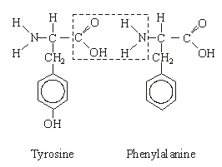

(b)     Copy from the diagram the R group in the phenylalanine molecule.

**(1)**

(c)     (i)      In the space below, draw the chemical bond formed when these two amino acids are joined by condensation. You need only draw the parts of the molecules shown in the box.

**(2)**

(ii)     Name this bond.

.............................................................................................................

**(1)**

(d)     Tyrosine can be made in the body by hydroxylating phenylalanine. Use the diagram to explain the meaning of *hydroxylating*.

......................................................................................................................

......................................................................................................................

**(1)**

**(Total 7 marks)**

**Q9.**          Catalase is an enzyme. It catalyses the breakdown of hydrogen peroxide in the reaction:

2H2O2    →    2H2O    +    O2

hydrogen         water      oxygen

peroxide

In an investigation, samples of different substances were added to hydrogen peroxide in a series of test tubes. The rate of reaction was measured by recording the rate at which bubbles of oxygen were produced. A scale going from 0 for no bubbles to 5 for the maximum rate of bubbling was used to measure this. The results are shown in the table.

|  |  |  |
| --- | --- | --- |
| **Tube** | **Substance added** | **Rate at which bubbles of oxygen were produced** |
| **A** | Piece of liver | 4 |
| **B** | Ground liver and sand | 5 |
| **C** | Sand | 0 |
| **D** | Piece of cooled, boiled liver | 0 |

(a)     Explain the difference between the rate at which bubbles were produced in.

(i)      tubes **A** and **B**;

..............................................................................................................

.............................................................................................................

.............................................................................................................

.............................................................................................................

**(2)**

(ii)     tubes **A** and **D**.

.............................................................................................................

.............................................................................................................

.............................................................................................................

.............................................................................................................

.............................................................................................................

.............................................................................................................

**(3)**

(b)     Explain the purpose of tube **C**.

......................................................................................................................

......................................................................................................................

**(1)**

(c)     The graph shows the energy changes which take place during the reaction in which hydrogen peroxide is converted to water and oxygen.

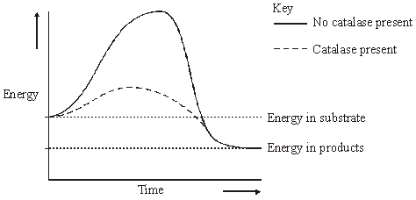

Use the graph to explain why

(i)      hydrogen peroxide breaks down at a lower temperature when catalase is present than when it is not present;

.............................................................................................................

.............................................................................................................

**(1)**

(ii)     test tubes **A** and **B** became warmer when the reaction was taking place.

.............................................................................................................

.............................................................................................................

.............................................................................................................

.............................................................................................................

**(2)**

**(Total 9 marks)**

**Q10.**          Some enymes digest protein. They hydrolyse the peptide bonds between amino acids. The extent to which a protein is digested is called the degree of hydrolysis (DH). The DH value may be calculated from the equation:



(a)     (i)      A protein molecule contains 151 amino acids. What is the total number of peptide bonds in this molecule?

.............................................................................................................

**(1)**

(ii)     A molecule of this protein is digested. The DH value of the digested protein is 18. Calculate the number of peptide bonds that have been hydrolysed.

Answer ......................................

**(1)**

(b)     What would be the DH value of a protein if it were completely hydrolysed to amino acids? Explain how you arrived at your answer.

DH value ......................................................................................................

Explanation ..................................................................................................

......................................................................................................................

......................................................................................................................

**(2)**

Enzymes **A** and **B** digest protein. The graph shows the effect of pH on the rates of reaction of these enzymes.

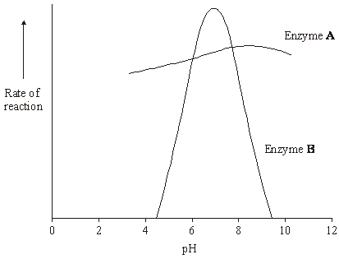

(c)     Pepsin is a protein-digesting enzyme found in the stomach. It has an optimum pH of 2 and is fully denatured at pH 6. Sketch a curve on the graph to show the effect of pH on the rate of reaction of pepsin.

**(1)**

(d)     Explain why the rate of reaction of enzyme **B** is low at pH 5.

......................................................................................................................

......................................................................................................................

......................................................................................................................

......................................................................................................................

......................................................................................................................

......................................................................................................................

**(3)**

(e)     Enzyme **A** is present in some washing powders used for cleaning clothes. Use the graph to suggest why enzyme **A** would be of more use in washing clothes than enzyme **B**.

......................................................................................................................

......................................................................................................................

......................................................................................................................

**(1)**

(f)      Use your knowledge of protein structure to explain why enzymes are specific and may be affected by non-competitive inhibitors.

......................................................................................................................

......................................................................................................................

......................................................................................................................

......................................................................................................................

......................................................................................................................

......................................................................................................................

......................................................................................................................

......................................................................................................................

......................................................................................................................

......................................................................................................................

......................................................................................................................

......................................................................................................................

......................................................................................................................

......................................................................................................................

**(6)**

**(Total 15 marks)**

**Q11.**          (a)     Sucrose, maltose and lactose are disaccharides.

(i)      Sucrase is an enzyme. It hydrolyses sucrose during digestion. Name the products of this reaction.

................................................... and ..................................................

**(2)**

(ii)     Sucrase does **not** hydrolyse lactose. Use your knowledge of the way in which enzymes work to explain why.

.............................................................................................................

.............................................................................................................

.............................................................................................................

.............................................................................................................

**(2)**

(b)     A woman was given a solution of sucrose to drink. Her blood glucose concentration was measured over the next 90 minutes. The results are shown on the graph.

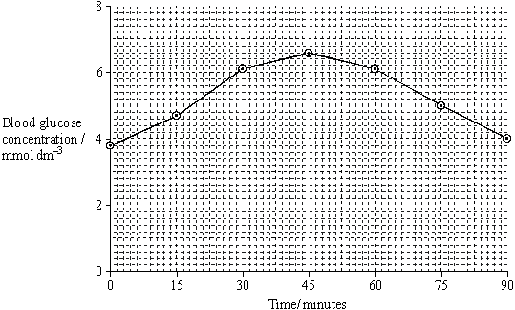

(i)      Describe how the woman’s blood glucose concentration changed in the period shown in the graph.

.............................................................................................................

.............................................................................................................

.............................................................................................................

.............................................................................................................

**(2)**

(ii)     Explain the results shown on the graph.

.............................................................................................................

.............................................................................................................

.............................................................................................................

.............................................................................................................

**(2)**

(iii)     This woman was lactose intolerant.

On the graph, sketch a curve to show what would happen to her blood glucose concentration if she had been given a solution of lactose to drink instead of a sucrose solution.

**(1)**

**(Total 9 marks)**

**Q12.**          The diagram represents an enzyme molecule and three other molecules that could combine with it.

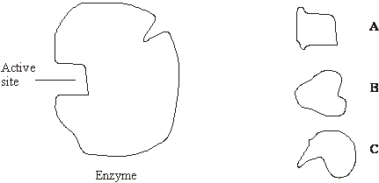

(a)     Which molecule is the substrate for the enzyme? Give a reason for your answer.

......................................................................................................................

......................................................................................................................

......................................................................................................................

**(1)**

(b)     Use the diagram to explain how a **non-competitive** inhibitor would decrease the rate of the reaction catalysed by this enzyme.

......................................................................................................................

......................................................................................................................

......................................................................................................................

......................................................................................................................

......................................................................................................................

......................................................................................................................

**(3)**

(c)     Lysozyme is an enzyme. A molecule of lysozyme is made up of 129 amino acid molecules joined together. In the formation of its active site, the two amino acids that are at positions 35 and 52 in the amino acid sequence need to be close together.

(i)      Name the bonds that join amino acids in the primary structure.

.............................................................................................................

**(1)**

(ii)     Suggest how the amino acids at positions 35 and 52 are held close together to form the active site.

.............................................................................................................

.............................................................................................................

.............................................................................................................

.............................................................................................................

**(2)**

**(Total 7 marks)**

**M1.**          (a)     specific 3D tertiary structure / shape;  
substrate complementary shape;

*(reject same shape)*

substrate (can bind) to active site / can fit into each active site;

**3**

(b)     (bacterial) active site / enzymes / proteins denatured /   
tertiary 3D structure disrupted / changed;  
(ionic) bonds broken;

*(reject peptide bonds)  
(ignore other bonds)*

no enzyme substrate complex formed / substrate no longer fits;

**3**

**[6]**

**M2.**          (a)     (i)      condensation;

**1**

(b)     (i)      **D**;

**1**

(ii)     **C**;

**1**

(iii)     **A**;

**1**

(c)     absence of a double bond;  
in the (hydrocarbon) chain;  
unable to accept more hydrogen / saturated with hydrogen;

**2 max**

**[6]**

**M3.**          (a)     colour results from starch-iodine reaction;  
decrease due to breakdown of starch by carbohydrase / enzyme;

**2**

(b)     (i)      curve drawn below curve on graph and starting at same point;

**1**

(ii)     curve drawn above curve on graph and starting at same point but  
finishing above;

*(allow curve or horizontal line)*

*(allow alternative curve for pH if explanation in (ii) is consistent)*

**1**

(c)     (i)      1. increase in temperature increases kinetic energy;  
2. increases collisions (between enzyme / active site and substrate) / increases formation of enzyme / substrate complexes;  
3. increases rate of breakdown of starch / rate of reaction / carbohydrase activity;

(ii)     4. (decrease in pH) increases H+ ions / protons which attach / attracted to amino acids;  
5. hydrogen / ionic bonds disrupted / broken which denatures enzyme / changes tertiary structure;  
6. changes shape / charge of active site so active site / enzyme unable to combine / fit with starch /  enzyme-substrate complex no longer able to form;  
7. decreases rate of breakdown of starch / rate of reaction / carbohydrase activity;

*(allow alternative explanation for pH if consistent with line   
drawn in (ii))*

**7**

**[11]**

**M4.**          (a)     (i)      box drawn around R group (i.e. CH2OH group)

*(allow circle if labelled R);*

**1**

(ii)     circle drawn around either of the Hs on NH2 group and circle drawn  
around the OH;

**1**

(b)     (i)      (di)peptide and water;

**1**

(ii)     peptide;

**1**

(c)     sequence of amino acids changes;  
tertiary structure changes / folds in a different way;  
bonds form in different places;  
(*Reject peptide bonds*)

**3**

**[7]**

**M5.**          (i)      active sites contain substrate / ethylene glycol;  
all active sites occupied / enzyme is limiting;

*(reject idea of active sites used up)*

**2**

(ii)      Ethanol is a similar shape to the substrate (ethylene glycol) /

complementary to active site;

*(reject “same shape”)*

ethanol is a competitive inhibitor / reduces enzyme-substrate complexes /   
prevents substrate (ethylene glycol) entering the active site;

*(reject “decreases rate of reaction”)*

**2**

**[4]**

**M6.**          (a)     (i)      Curve rising and levelling out;

**1**

(ii)     Substrate becomes limiting / falls / gets less;  
Fewer collisions / complexes formed;

**2**

(b)     To keep pH the same / optimum pH / so change in pH does not affect reaction;

**1**

(c)     (i)      For temperature up to 40 – 50 °C has no effect;  
Over temperature (of 40 – 50 °C) reduces rate of reaction;

*Note. Award one mark for general statement about the  
longer the incubation time, the slower the rate of reaction.*

**2**

(ii)     Bonds (holding tertiary structure) broken;  
More enzyme denatured / tertiary structure destroyed /   
active sites lose shape / no longer fit;  
Fewer enzyme-substrate complexes formed;

*Note. Award marks if clearly in the context of more denaturation. Allow credit here for converse relating to exposure for 5 minutes.*

**3**

(d)     Competitive  
2 Similarity of shape of inhibitor and substrate;  
3 Inhibitor can enter / bind with active site (of enzyme);

Non-competitive  
4 Affect / bind to enzyme other than at active site;  
5 Distorts shape of active site;

Inhibitors  
6 Prevent entry of / binding of substrate to active site;  
7 Therefore fewer / no enzyme-substrate complexes formed;

**6**

**[15]**

**M7.**          (a)     (i)      Hydrolysis;

**1**

(ii)     Water enters fungus (by osmosis) which increases pressure inside fungus;  
Cell wall no longer strong enough / present so cannot withstand this;

**2**

(iii)     Cell wall (of plant) not made of chitin / made of cellulose;  
Enzyme is specific to chitin / will not break down cellulose;

**1**

(b)     Way in which the whole protein / polypeptide is folded / shape adopted by whole protein molecule / further folding of 2° structure;

*Do not credit unqualified reference to three-dimensional shape.  
Reject third level / third sort.*

**1**

(c)     (i)      More (kinetic) energy;  
Bonds / specified bonds (holding tertiary structure) break;

**2**

(ii)     Change amino acids;  
Allowing formation of more hydrogen bonds / disulphide bridges;

**2**

(d)     1.      Sequence of amino acids gives shape;

2.      This is tertiary structure;

3.      Has similar shape to substrate;

4.      Fits / competes for active site;

5.      Fits at site other than active site;

6.      Distorting active site;

7.      Therefore substrate will not fit (active site);

**max 6**

**[15]**

**M8.**          (a)     (i)      Biuret / alkali + copper sulphate;  
Lilac / purple / mauve / violet;

*Do not give credit for blue or pink. Ignore references to heating.*

**2**

(b)     R group of phenylalanine copied accurately;

**1**

(c)     (i)      Bond shown linking carbon and nitrogen;  
OH and H removed, =O and –H remaining;

**2**

(ii)     Peptide bond;

**1**

(d)     Addition of hydroxyl / OH group;

*Candidate must distinguish clearly between hydroxylation and hydrolysis*

**1**

**[7]**

**M9.**          (a)     (i)      (Grinding) breaks open cells / increases surface area (of liver);  
Releases catalase / enzyme / more catalase / allows more hydrogen peroxide into liver;

**2**

(ii)     Heating causes bonds (maintaining tertiary structure) to break;  
Denatures / changes tertiary structure so active site changed;  
Substrate no longer fits / ES complex not formed;

**3**

(b)     (Control) to show that sand did not affect reaction (with ground liver);

**1**

(c)     (i)      Lower activation energy / less energy required to bring about reaction;

**1**

(ii)     Energy in products / water and oxygen less than energy in substrate / reactants / hydrogen peroxide;  
(Difference) given out as heat / exothermic;

**2**

**[9]**

**M10.**          (a)     (i)      150;

**1**

(ii)      27;

**1**

(b)     100;  
number of peptide bond hydrolysed = total number present / all peptide bonds have been hydrolysed;

*accept calculation showing same number top and bottom.*

**2**

(c)     curve rising to peak at pH 2 and falling to zero by pH 6;

**1**

(d)     (change in pH) leads to breaking of bonds holding tertiary structure / changes charge on amino acids;  
enzyme / protein / active site loses shape / denatured; substrate will not bind with / fit active site / fewer / no ES complexes formed;

**3**

(e)     more resistant to changes in pH and washing conditions variable / works in alkaline pH and washing powders alkaline;

*mark awarded for indicating aspect of effect of pH and advantage of this in terms of washing powder and conditions in wash.*

**1**

(f)      maximum of three marks for specificity, points 1 - 3. Can only be given credit in context of specificity

1       each enzyme / protein has specific primary structure / amino acid sequence;

2       folds in a particular way / has particular tertiary structure giving an active site with a unique structure;

3       shape of active site complementary to / will only fit that of substrate;   
maximum of three marks for inhibition, points 5 – 8

4       inhibitor fits at site on the enzyme other than active site;

5       distorts active site;

6       so substrate will no longer fit / form enzyme-substrate complex

**6**

**[15]**

**M11.**          (a)     (i)      Glucose;

Fructose;

*Any order.*

**2**

(ii)     Lactose has a different shape / structure;

Does not fit / bind to active site of enzyme / sucrase;

*Only allow a second mark if reference is made to the active site.  
Max 1 mark if active site is described as being on the substrate.*

**OR**

Active site of enzyme / sucrase has a specific shape / structure; Does not fit / bind to lactose;

*Do not accept same shape.*

**2**

(b)     (i)      Rose and fell;

Peak at 45 (minutes) / concentration of 6.6 (mmol dm–3);

**2**

(ii)     Glucose (produced by digestion) is absorbed / enters blood;

Decrease as used up / stored;

**2**

(iii)    Curve roughly parallel to the x-axis or falling, starting from approximately the same point;

**1**

**[9]**

**M12.**          (a)     **A** and structure(of **A**) is complementary to that of the active site;

**1**

(b)     idea that non-competitive inhibitor(**C**) binds at a site not the active  
site; binding causes a change in the shape of the active site;  
substrate is no longer able to bind to the active site;

**3**

(c)     (i)     peptide;

**1**

(ii)     idea that amino acid chain folds / tertiary structure;  
named bond holding tertiary structure e.g. ionic disulphide hydrogen;

*{reject peptide)*

**2**

**[7]**