**Q1.**         Answers should be written in continuous prose, where appropriate.

A large lake is surrounded by fields. These fields are separated from each other by hedges. One hundred years ago the lake was a habitat for many plants, invertebrates and fish. Today the lake has no fish and few plants or invertebrates.

Explain how increased use of inorganic fertilisers on the fields may have led to these changes.

................................................................................................................................

................................................................................................................................

................................................................................................................................

................................................................................................................................

................................................................................................................................

................................................................................................................................

................................................................................................................................

................................................................................................................................

................................................................................................................................

**(Total 5 marks)**

**Q2.**          (a)     Farmers who grow wheat sometimes leave a field fallow for a year by not growing a crop in it. The concentration of nitrate ions in the soil decreases when a field is left fallow.

(i)      When grass is grown in the field, fewer nitrate ions are lost than when the field is left with bare soil. Explain why.

.............................................................................................................

.............................................................................................................

**(1)**

(ii)     A crop of leguminous plants such as clover may be grown in the field and then ploughed in. Explain why less fertiliser would be needed for the wheat crop in the following year.

.............................................................................................................

.............................................................................................................

.............................................................................................................

.............................................................................................................

**(2)**

(b)     The table gives information about the yield and profitability of a wheat crop grown using different amounts of fertiliser.

|  |  |  |  |  |  |
| --- | --- | --- | --- | --- | --- |
| **Nitrogen fertiliser applied / kg ha–1** | **Grain yield / tonnes ha–1** | **Grain protein / %** | **Value added by using fertiliser / £ha–1** | **Cost of using fertiliser / £ha–1** | **Benefit : cost ratio** |
| 0 | 2.4 | 11.7 | – | – | – |
| 25 | 2.5 | 12.5 | 19 | 11 | 1.7 : 1.0 |
| 50 | 2.5 | 12.9 | 25 | 22 | 1.1 : 1.0 |
| 75 | 2.5 | 13.3 | 31 | 33 | 0.9 : 1.0 |
| 100 | 2.5 | 13.5 | 37 |  |  |

(i)      Describe the effects of increasing fertiliser application on the yield and protein content of the grain produced.

.............................................................................................................

.............................................................................................................

.............................................................................................................

.............................................................................................................

**(2)**

(ii)     Use the data in the table to estimate the benefit: cost ratio for a fertiliser application of 100 kg ha–1. Write your answer in the table.

**(1)**

**(Total 6 marks)**

**Q3.**          Pea plants are leguminous and have nodules on their roots which contain bacteria that are able to fix nitrogen. The diagram shows some of the processes involved in nitrogen fixation by these bacteria.

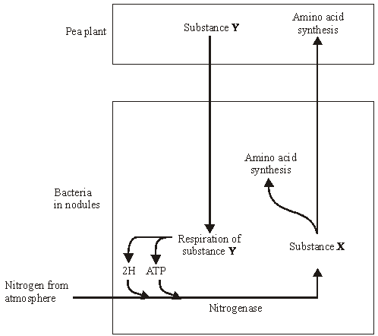

(a)     Name

(i)      substance **X**;

.............................................................................................................

**(1)**

(ii)     substance **Y**.

.............................................................................................................

**(1)**

**S**       (b)     Pea plants respire aerobically, producing ATP which can be used for amino acid synthesis. Describe the role of oxygen in aerobic respiration.

......................................................................................................................

......................................................................................................................

......................................................................................................................

......................................................................................................................

**(2)**

       (c)     The bacteria respire anaerobically. This produces hydrogen and ATP used in nitrogen fixation. The hydrogen comes from reduced NAD. Explain how the regeneration of NAD in this way allows ATP production to continue.

......................................................................................................................

......................................................................................................................

......................................................................................................................

......................................................................................................................

**(2)**

       (d)     The enzyme nitrogenase is specific to the reaction shown. Explain how **one** feature of the enzyme would contribute to this specificity.

          Feature

......................................................................................................................

          Explanation

......................................................................................................................

......................................................................................................................

......................................................................................................................

**(2)**

      (e)     Sodium ions act as a non-competitive inhibitor of the enzyme nitrogenase. Explain how the presence of a non-competitive inhibitor can alter the rate of the reaction catalysed by nitrogenase.

......................................................................................................................

......................................................................................................................

......................................................................................................................

......................................................................................................................

......................................................................................................................

......................................................................................................................

**(3)**

**(Total 11 marks)**

**Q4.**          Since 1965 there has been a steady rise in the phosphate concentration in the water of Lake Windermere. Scientists have monitored the phosphate concentration and plant biomass over a period of time. The results are shown in the graphs.

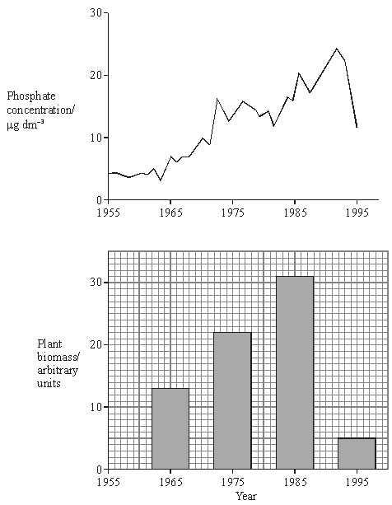

(a)     Suggest **one** source of the phosphate in the lake.

......................................................................................................................

......................................................................................................................

**(1)**

(b)     Calculate the percentage decrease in plant biomass between 1985 and 1995. Show your working.

Answer ............................................

**(2)**

(c)     From these graphs, a student concluded that changes in phosphate concentration caused changes in plant biomass. Explain why this conclusion may not be valid.

......................................................................................................................

......................................................................................................................

......................................................................................................................

......................................................................................................................

**(2)**

(d)     Between 1982 and 1992 the number of fish in the lake decreased. Explain how the change in phosphate concentration may have resulted in this decrease in the fish population.

......................................................................................................................

......................................................................................................................

......................................................................................................................

......................................................................................................................

......................................................................................................................

......................................................................................................................

......................................................................................................................

......................................................................................................................

......................................................................................................................

......................................................................................................................

......................................................................................................................

......................................................................................................................

**(6)**

**(Total 11 marks)**

**Q5.**         The diagram shows the energy flow through a freshwater ecosystem.All units are kJ m–2year–1.

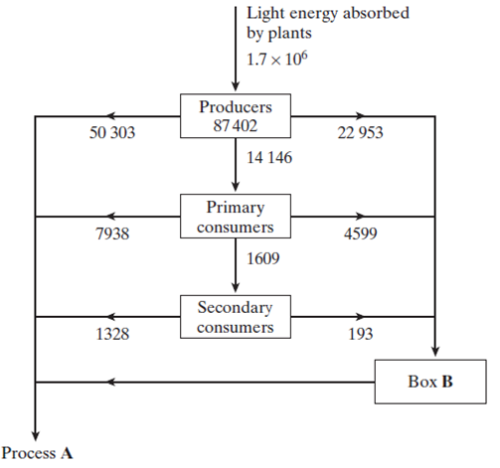

(a)     Name

(i)      process **A**;

.............................................................................................................

**(1)**

(ii)     the group of organisms represented by box **B**.

.............................................................................................................

**(1)**

(b)     Calculate the percentage efficiency with which light energy is transferred to energy in producers. Show your working.

Answer ........................................

**(2)**

       (c)     Describe the effect of light energy in the light-dependent reaction of photosynthesis.

......................................................................................................................

......................................................................................................................

......................................................................................................................

......................................................................................................................

**(2)**

       (d)     If a plant is kept in the dark it is still able to produce carbohydrates, as long as it is provided with two products of the light-dependent reaction of photosynthesis. Give the name of these products and explain their function in the light-independent reaction of photosynthesis.

Name ............................................................................................................

Function ........................................................................................................

......................................................................................................................

Name ............................................................................................................

Function ........................................................................................................

......................................................................................................................

**(4)**

**(Total 10 marks)**

**Q6.**          The diagram shows the flow of energy through a marine ecosystem.

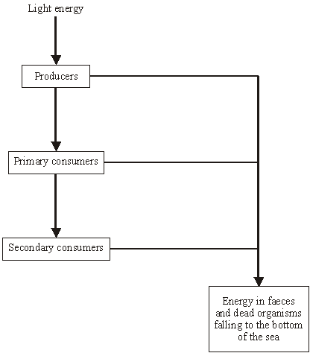

(a)     Give **one** reason why not all the light energy falling on the producers is used in photosynthesis.

......................................................................................................................

......................................................................................................................

**(1)**

(b)     The producers in this ecosystem are seaweeds, which have a large surface area to volume ratio. Give **two** advantages to seaweeds of having a large surface area to volume ratio.

1 ...................................................................................................................

......................................................................................................................

2 ...................................................................................................................

......................................................................................................................

**(2)**

       (c)     Some species of seaweed are submerged in water for most of the time. Explain how being under water might affect the rate of photosynthesis.

......................................................................................................................

......................................................................................................................

......................................................................................................................

......................................................................................................................

......................................................................................................................

......................................................................................................................

**(3)**

**(Total 6 marks)**

**Q7.**          The diagram shows a hedgerow and part of a field with a crop. The land is farmed in a way that conserves wildlife. The strip of bare ground next to the hedgerow is ploughed frequently to prevent any plants from growing. The first 6 m of the field, called the conservation headland, is sprayed with a selective herbicide to control some kinds of weeds. The rest of the field is sprayed with herbicide to kill all weeds.

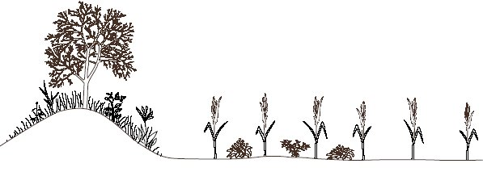

|  |  |  |  |  |
| --- | --- | --- | --- | --- |
|  |  |  |  |  |
|  |  |  |  |  |

Hedgerow                   Bare                  Conservation                            Crop

 ground                   headland

(2 m wide)              (6 m wide)

       (a)     Suggest **one** advantage of leaving a strip of bare ground between the hedgerow and the field.

......................................................................................................................

......................................................................................................................

**(1)**

(b)     Suggest the benefit of allowing some weeds to grow in the conservation headland.

......................................................................................................................

......................................................................................................................

......................................................................................................................

......................................................................................................................

**(2)**

       (c)     After harvesting the crop, the farmer digs the unwanted stems and roots into the soil. Explain how the nutrients contained in these plant parts become available for use by other organisms.

......................................................................................................................

......................................................................................................................

......................................................................................................................

......................................................................................................................

......................................................................................................................

......................................................................................................................

......................................................................................................................

......................................................................................................................

**(4)**

**(Total 7 marks)**

**M1.**         run off / leaching of nutrients / nitrates;  
leads to increased growth of algae / plants;  
competition for light / effect of competition;   
death of algae / plants;  
increases food supply / increases microorganisms / decomposers;  
respiration (of microorganisms) uses up oxygen / increases BOD;  
fish / animals die due to lack of oxygen;

**[5]**

**M2.**          (a)     (i)      presence of grass causes less nutrients / minerals / nitrates /   
ammonium ions to be leached;

*(do not allow references to less nitrogen)*

**1**

(ii)     clover contains nitrogen-fixing bacteria;

*(do not allow references to nitrifying bacteria)*

decomposition (of ploughed clover) introduces nitrates /   
ammonium ions into soil;

**2**

(b)     (i)      minimal effect / no significant effect on yield / small  
increase up to 25 kg ha–1;  
increase in protein content of grain with all fertiliser applications;

**2**

(ii)     (37 ÷ 44 =) 0.84 : 1.0

*(allow 0.8 : 1);*

**1**

**[6]**

**M3.**          (a)     (i)      ammonia / ammonium ions / compound;

**1**

(ii)     glucose;

**1**

(b)     final acceptor for hydrogen:  
to form water;

**2**

(c)     glycolysis can continue;  
NAD can accept more hydrogen;

**2**

(d)     secondary / tertiary structure;  
produces particular shape of active site;  
*or*(shape of) active site;  
complementary to shape of substrate;

**2**

(e)     sodium ions / non-competitive inhibitor binds to enzyme  
at a site other than active site;  
resulting in change of shape of active site / no longer complementary;  
substrate can no longer bind with the enzyme / enzyme-substrate  
complexes no longer formed;

**3**

**[11]**

**M4.**          (a)     Fertilisers / detergents / slurry / manure / sewage / faeces;

**1**

(b)     (31 – 5) / 31 x 100% / single error in otherwise correct method;  
83.87 / 83.9 / 84%;

**2**

(c)     Have continuous data for phosphate but not for biomass;  
Effect of named factor explained;

**2**

(d)     1.      Increased phosphate causes increase in plant growth / algal bloom;

2.      Plants (cover surface and) block out light so plants (under surface) die;

3.      Increase in (aerobic) bacteria / decomposers (which break down plants);

4.      Bacteria / decomposers use up oxygen / reduce oxygen conc. in water;

5.      In respiration;

6.      Plants unable to photosynthesise so less oxygen produced;

**max 6**

**[11]**

**M5.**          (a)     (i)      respiration;

**1**

(ii)     decomposers;  
(*accept bacteria / fungi*)

**1**

(b)      × 100 = 5.14 / 5.1%;

*(correct answer = 2 marks)  
(principle: energy in producers ÷ energy of light absorbed = 1 mark)*

**2**

(c)     excites chlorophyll / electrons;  
release electron(s);

**2 max**

(d)     reduced NADP;  
reduces GP / to change GP to TP;  
ATP;  
provides the energy to reduce GP / convert GP to TP / TP to RuBP /   
provides phosphate to convert TP to RuBP;

**4**

**[10]**

**M6.**          (a)     transmission / reflected / misses chlorophyll / chloroplasts / wrong wavelength;

**1**

(b)     (larger area) to absorb light;  
(larger surface area) to absorb carbon dioxide;  
short diffusion pathway for gases / oxygen / CO2;  
light able to penetrate to all cells;

**2 max**

(c)     effect;  
detail;  
effect on photosynthesis;  
some effects are less light / light absorbed by water  
different wavelength of light  
temperature  
availability of carbon dioxide  
availability of water

*(more than one effect award 1 mark only)*

**3**

**[6]**

**M7.**          (a)     prevents disease / pest organisms from reaching crop plants / prevents herbicides from reaching hedgerow / enables machinery to manoeuvre without damaging crop / hedgerow;

**1**

(b)     some weeds provide habitats / niche for (beneficial) insects / animals:  
allow (insect) pest predators to survive;  
conserve (common) weed plants;  
weeds are producers in food chains / food source;

**2 max**

(c)     decomposers / saprophyte / bacteria / fungi / micro organisms (organisms) excrete / produce nitrogenous waste / e.g.; bacteria convert to nitrate / nitrifying bacteria;  
(increased) nitrates(in soil) taken up / used by plants;  
release of phosphate / potassium;  
organisms respire and produce carbon dioxide which is used by plants in photosynthesis;

**4**

**[7]**

**E1.**        This question demonstrated most students clearly understand the principles of eutrophication with high marks being gained for the first section. The remaining sections were less well answered.

Most students gained maximum marks with well-rehearsed answers. Some students gave slightly confused answers with inappropriate ordering of the stages but even these often achieved sufficient marks to score the maximum. A very few suggested bioaccumulation of fertiliser as a cause of the changes.

**E2.**          (a)     (i)      Most candidates achieved this mark.

(ii)     The presence of nitrogen-fixing bacteria in leguminous plants is well known, but the process by which the fixed nitrogen is made available to a future crop is not. Very few candidates referred to the role of decomposition in recycling nitrogen and many implied that the fixed nitrogen was automatically made available. Nitrifying bacteria were incorrectly given as having the ability to fix nitrogen and a surprising number of candidates believe clover is able to fix it.

(b)     (i)      The effect of increasing fertiliser application on the protein content of grain was usually described adequately, but only the most able candidates identified the small effect that fertiliser applications had on grain yield. Many candidates ignored the small increase in yield at low doses of fertiliser by stating that fertiliser had no effect on yield, without any indication that the yield increase might not be statistically significant.

(ii)     This was well answered by the majority of candidates.

**E3.**          (a)     (i)      Few candidates identified substance X as ammonium ions or ammonia. Nitrate was the most common incorrect answer.

(ii)     Most candidates correctly identified substance Y as gluscose.

(b)     Only the more able candidates successfully described the role of oxygen as the final hydrogen acceptor, producing water; many weaker candidates merely cited the equation for aerobic respiration. A surprising number of candidates responded incorrectly by discussing the role of oxygen in Krebs cycle or its use in lactic acid removal in muscles.

(c)     This question was not well answered. Candidates failed to read the question and few realised that only glycolysis is operating during anaerobic respiration. The importance of NAD in allowing glycolysis to continue was missed and candidates concentrated instead on the production of ATP in the electron transfer chain.

(d)     Most candidates recognised the active site as a feature of an enzyme that would contribute to its specificity; fewer scored the second mark explaining the significance of the active site by referring to its complementary shape.

(e)     This was generally well answered, with most candidates aware of the action of non-competitive inhibitors.

**E4.**          (a)     Fertiliser was the most frequently seen answer but many attributed dying plants with the ability to release significant volumes of phosphate.

(b)     The calculation was well done by many and some credit was given even to those who chose the wrong denominator or misread the graph. Some used the wrong graph or calculated the 1995 level as the difference.

(c)     It was good to see most candidates attempting this question, many appreciating that other factors might be involved. The second mark was only rarely given, usually for a comment on the validity of the information or for an explanation of the effect of the factor.

(d)     Whilst many candidates were easily able to gain maximum credit here, a number performed badly and failed to recognise the idea of the question. References to phosphate killing fish directly or to plants giving out lethal levels of carbon dioxide were often seen. The main points missed were reference to *increased* phosphate and development of the lack of light aspect in reducing photosynthesis and thus oxygen output.

**E5.**          (a)     Most candidates were able to identify process **A** as respiration and the group of organisms represented by box **B** as decomposers. Common incorrect answers included ‘consumers’ and ‘detritivores’.

(b)     The calculation was performed well with most candidates realising that to work out the percentage efficiency, the energy in the producers had to be divided by the energy they had absorbed. However, the main error was understanding ‘standard form’; the number 1.7 x 106 caused problems, with students finding it difficult to work out how many zeros should be placed after the decimal point.

(c)     It was pleasing to see so many candidates realising that the effect of light energy was to excite electrons in chlorophyll but few gave any more information as to what happened to the electron once excited. Vague answers were seen with reference to the production of carbon dioxide and glucose.

(d)     Some candidates could name the two end products of the light-dependent reaction as reduced NADP and ATP, but only the very best could explain their function. Usual mistakes were writing reduced NAD or just NADP.

**E6.**         This question was generally well answered although a significant number of candidates failed to read the question carefully enough and described what might happen to the energy that had **not** fallen on the producers.

Most candidates were able to suggest one appropriate reason for the seaweed having a large surface area. Many failed to give a second reason with some giving vague answers in terms of ‘gaseous exchange’ rather than explaining it in terms of the ease of absorption of carbon dioxide. A number of weaker candidates responded in terms of respiration rather than photosynthesis.

Many candidates included some good detail as to how their chosen environmental factor might affect the rate of photosynthesis. Appropriate references to the light dependent or light independent stages were included.

**E7.**          (a)     This was well answered and most candidates were able to suggest a reason for leaving a strip of bare ground between the hedgerow and the conservation headland.

(b)     This question was generally poorly answered with vague responses and poor terminology. Only the best candidates discussed ideas like habitats for pest predators. Weaker candidates refered to ‘homes for insects’, or stated increased diversity with no explanation.

(c)     This was well answered by many, with candidates gaining three marks for a discussion of the nitrogen cycle. Few candidates discussed the carbon cycle, and those that did were rather vague.